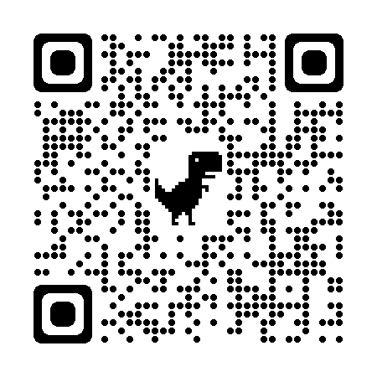  30-Second Expert  https://bit.ly/3xM5DZp | 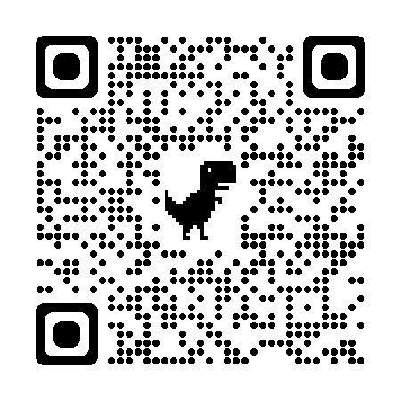  5W Cube  https://bit.ly/3Uykn81 | 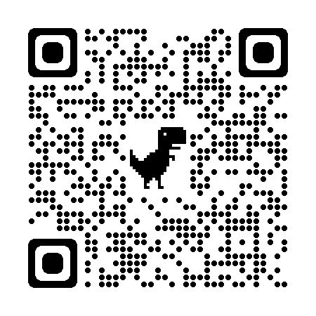  Affinity Process  https://bit.ly/3xM5ncY | 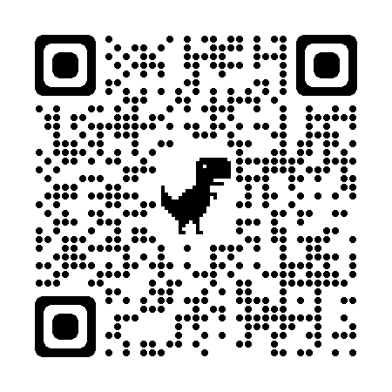  Airplane Landing  https://bit.ly/3DOdl9l
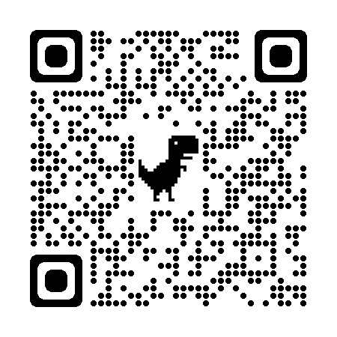  Always, Sometimes, Or Never True  https://bit.ly/3y9ZLcP | 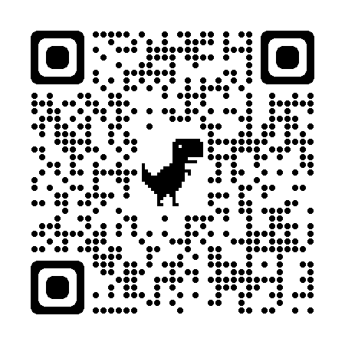  Chain Notes  https://bit.ly/3UxuXfk | 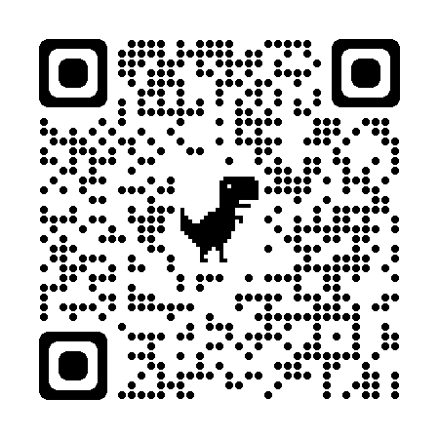  Chalk Talk  https://bit.ly/3BCqQWJ | 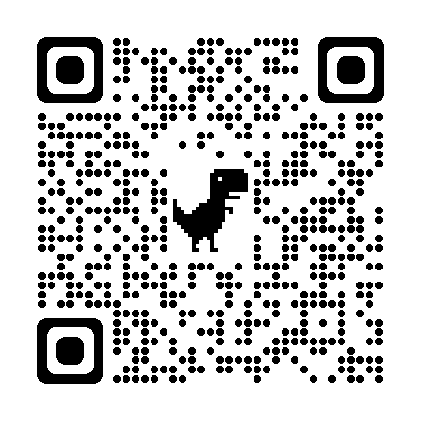  Chant It, Sing It, Rap It  https://bit.ly/3R9fGi7
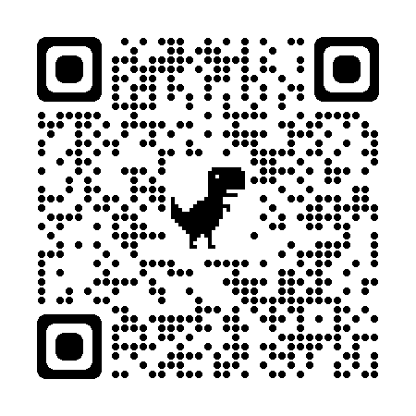  Claim Cards  https://bit.ly/3SquERF | 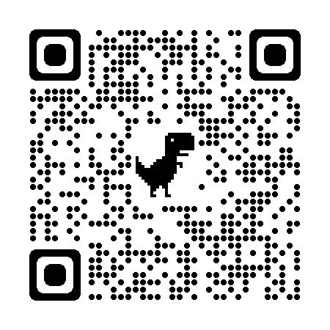  Collaborative Word Clouds  https://bit.ly/3BHKVeg | 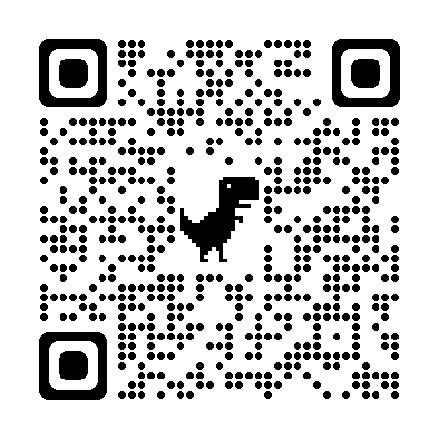  Collective Brain Dump  https://bit.ly/3dB8ZHI | 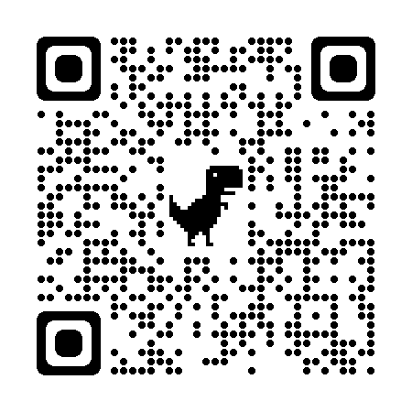  CUS and Discuss  https://bit.ly/3dAIDpt
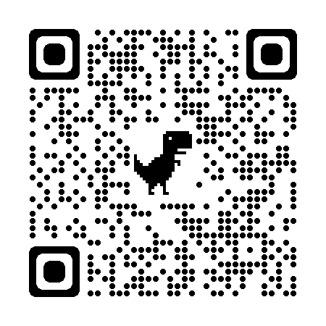  Debate Team Carousel  https://bit.ly/3Rg8Yac | 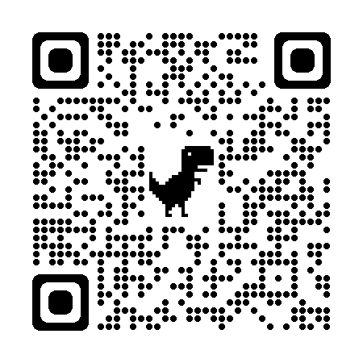  Elbow Partners  https://bit.ly/3fd5kAm | 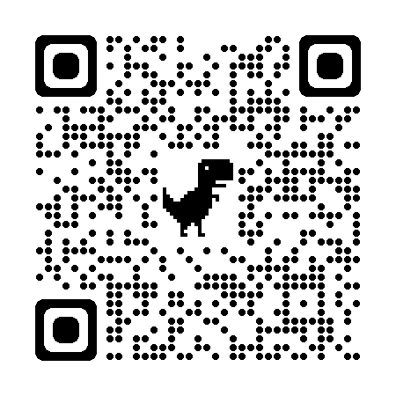  Exclaim and Question  https://bit.ly/3SsWZqB | 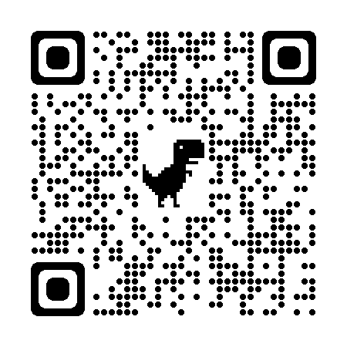  First Turn / Last Turn  https://bit.ly/3xMbC0o
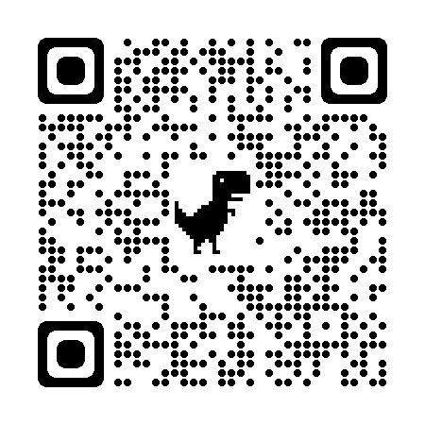  Fold the Line  https://bit.ly/3S9vcvG | 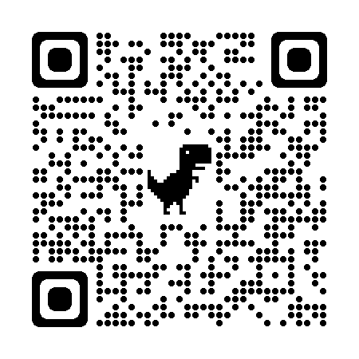  Four Corners  https://bit.ly/3R293hz | 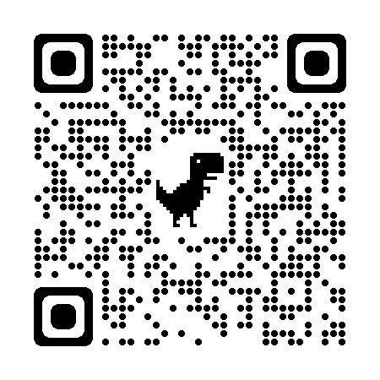  Give, Get, Reflect  https://bit.ly/3dFV5UP | 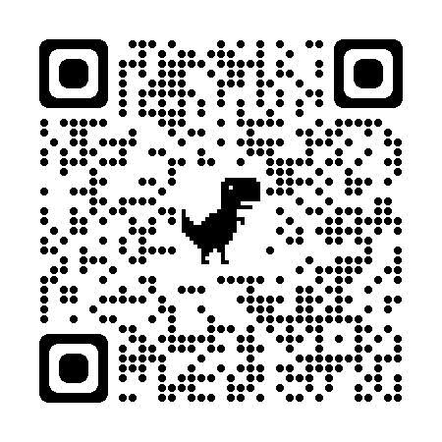  I Think / We Think  https://bit.ly/3SwVmZb
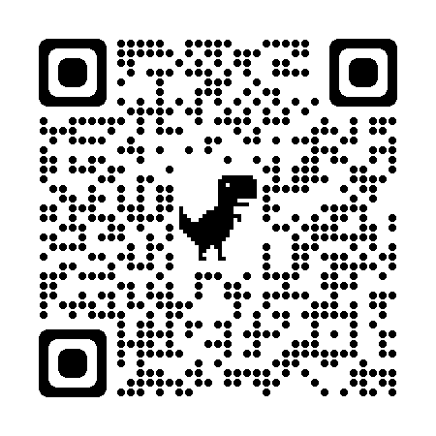  Jigsaw  https://bit.ly/3xQEZP1 | 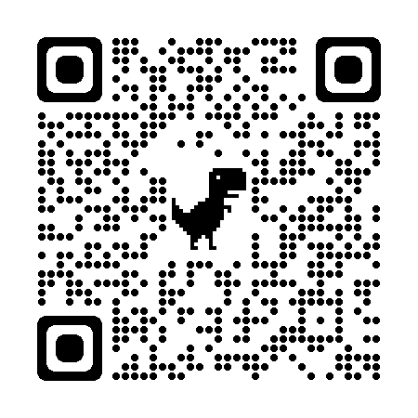  Magnetic Statements  https://bit.ly/3fby4JO | 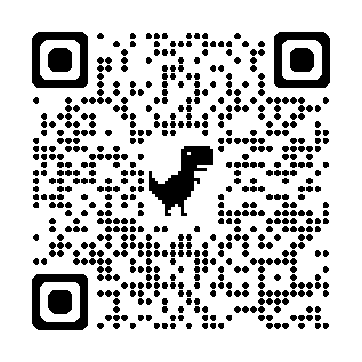  Partner Speaks  https://bit.ly/3SaOVeu | 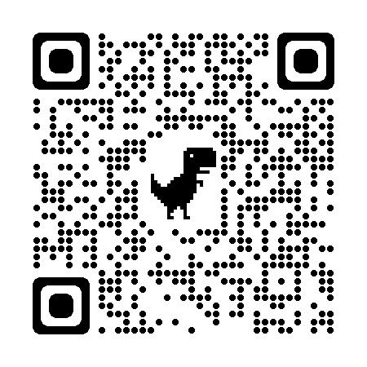  Philosophical Chairs  https://bit.ly/3S8UgTD
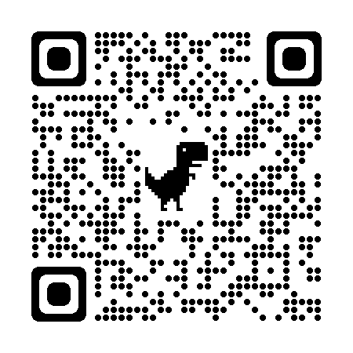  Roundabout Conversations  https://bit.ly/3RbWMaa | 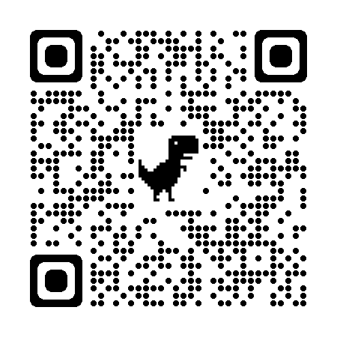  Say Something!  https://bit.ly/3dxVB7v | 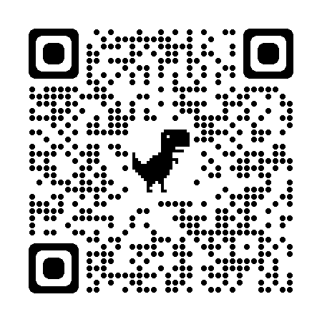  Socratic Seminar  https://bit.ly/3SKCLJh | 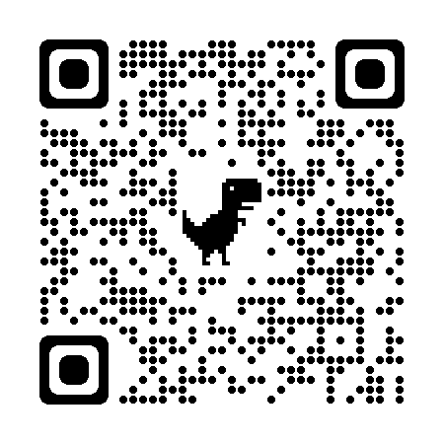  Two-Minute Documentaries  https://bit.ly/3LH8fO6
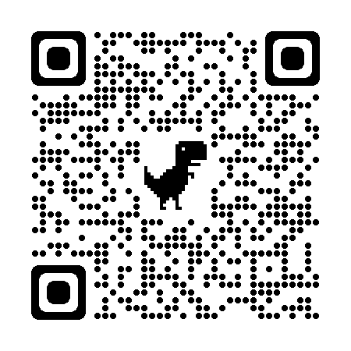  Walk and Talk  https://bit.ly/3xO6IQu | 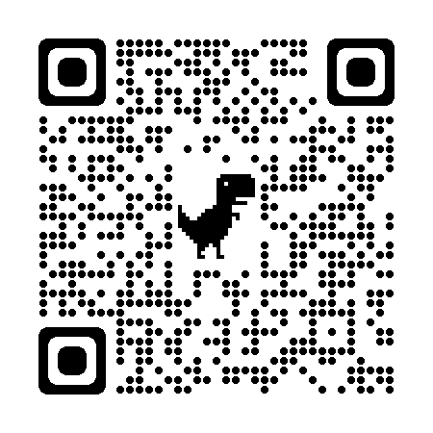  Yes, Because . . .  https://bit.ly/3S9Yuu8

