QC2E Science Strategy
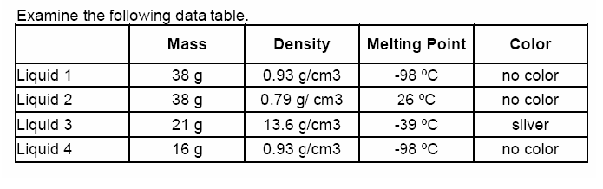
Question:
Are any of the liquids in the data set below the same substance?
Claim | Evidence
Explanation

