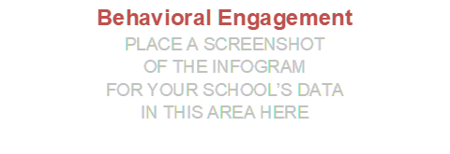

- I am willing to put in extra effort without being asked.
- I often go above what is expected of me to help my team be successful.
- I really push myself to work beyond what is expected of me.
- I work harder than expected to help the school be successful.

It Says… (What does the data say?)
I Say… (What are your personal thoughts, experiences, or reflections related to the data?)

And So… (What key insights do you take away from this data? What can we do as a result of this data?

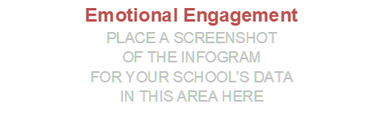
- I am proud to tell others that I work for the school.
- I believe in the mission and purpose of the school.
- I care about the future of the school.
- I feel a strong sense of belonging at school.
- Working at the school has a great deal of personal meaning to me.
It Says… (What does the data say?)
I Say… (What are your personal thoughts, experiences, or reflections related to the data?)

And So… (What key insights do you take away from this data? What can we do as a result of this data?

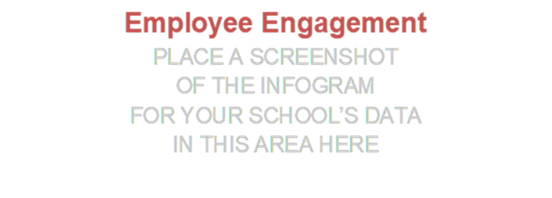
- I am enthusiastic about my job.
- I am immersed in my work.
- I am proud of the work that I do.
- I feel happy when I am working intensely.
- When I get up in the morning, I am excited to go to work.
It Says… (What does the data say?)
I Say… (What are your personal thoughts, experiences, or reflections related to the data?)

And So… (What key insights do you take away from this data? What can we do as a result of this data?

