JOB DEMAND RESOURCES MODEL
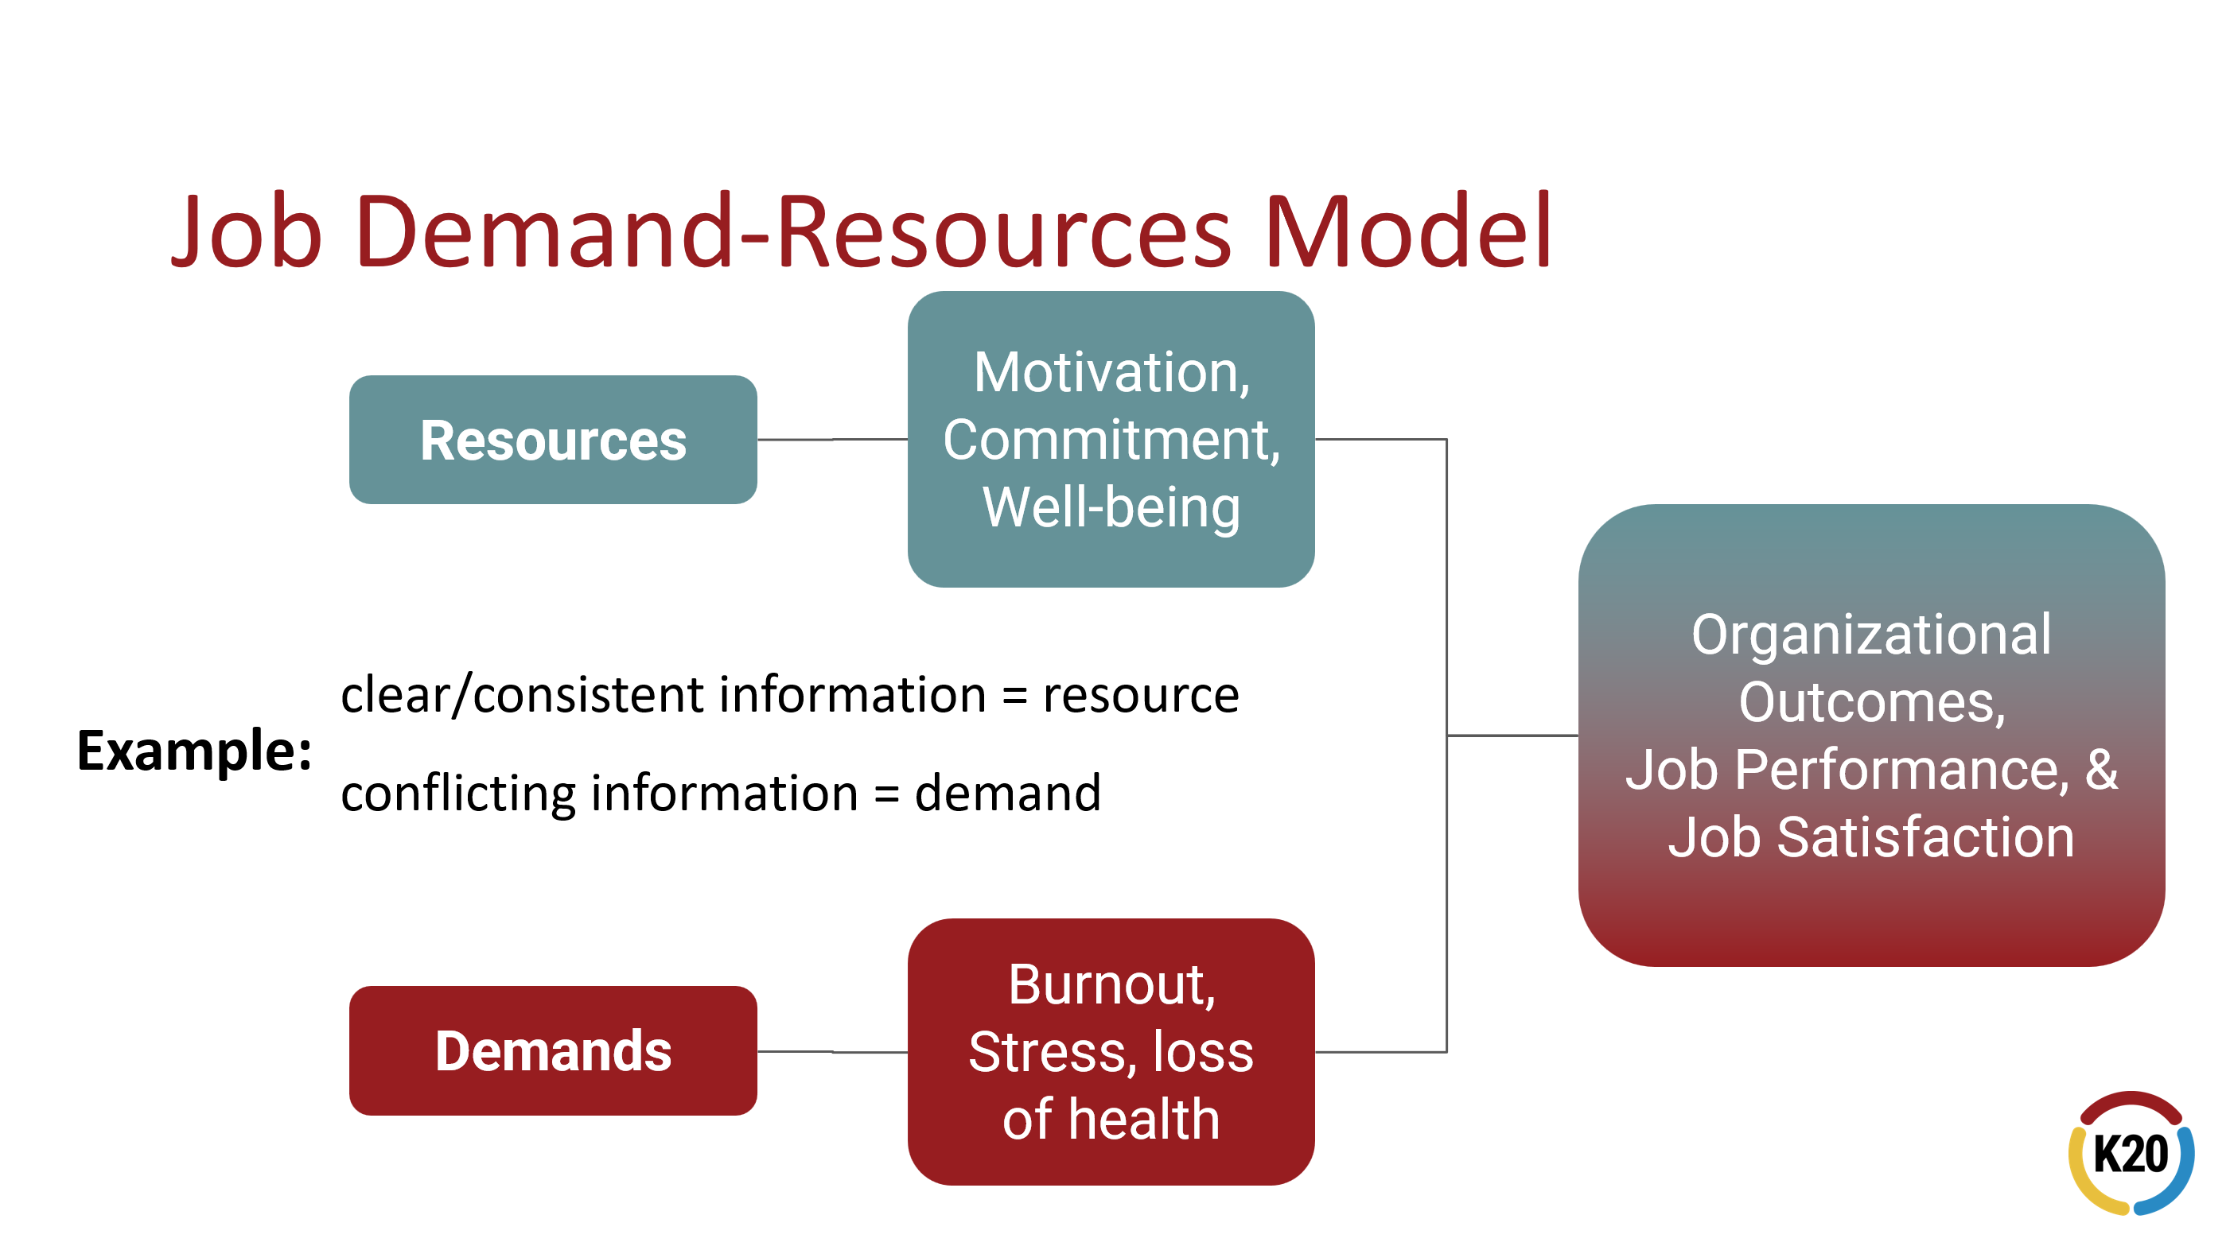

“Job resources are those physical, psychosocial, social, or organizational aspects of the job that are functional in achieving work goals and reducing job demands, or in stimulating personal growth, learning, and development.

Job demands are those physical, psychological, social, and organizational aspects of the job that require sustained physical and/or psychological effort or skills and are therefore associated with certain physical and/or psychological costs.”
(Bakker & Demerouti, 2007)

Bakker, A. B., & Demerouti, E. (2007). The job demands-resources model: State of the art. Journal of managerial psychology. 22(3), 309–328

