AUTHOR INFLUENCES

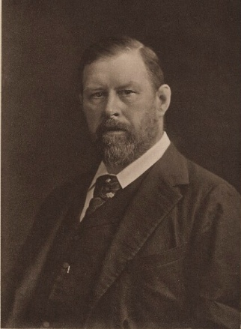
Bram Stoker
- Stoker was the author of Dracula.
- Dracula was inspired by:
  - Transylvanian folklore
  - Vlad the Impaler
  - Elizabeth Báthory
- Stoker chose the name “Dracula” because he thought it meant “devil” in Romanian.

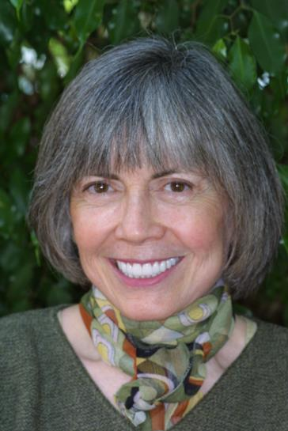
Anne Rice
- Rice was author of Interview with the Vampire (1976).
- She was born in New Orleans and raised by Irish Catholic parents.
- Her mother died of alcoholism when she was a teen.
- Her daughter died at six years old from leukemia, a form of blood cancer.
- Interview was inspired by Stephen King’s Firestarter.

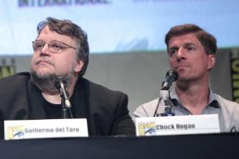
Guillermo del Toro & Chuck Hogan
- Authors of The Fall, which was the inspiration for the television show “The Strain.”
- The Strain aired from 2014–2017.
- Guillermo del Toro was raised a strict Catholic in Mexico.
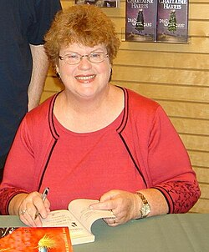
Charlaine Harris
- Harris was author of The Southern Vampire Mysteries series of novels.
- The television series “True Blood” adaptation aired from 2008–2014.
- Rather than acknowledging the legend that vampires are deceased humans who have risen from the dead to prey on the living, the vampires insist they are simply the victims of a medical condition that makes them allergic to sunlight and affects their dietary needs.
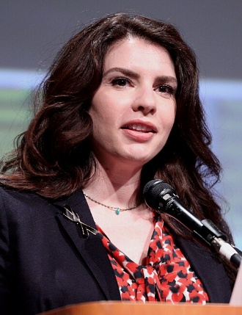
Stephanie Meyer
- Meyer was author of the Twilight saga.
- Her Mormon faith influenced certain
themes in her writing:
  - Moral dilemma of mortal temptation
  - Overcoming the natural man
  - Immortality and eternal life
- She was also influenced by literary classics:
  - Twilight: Pride and Prejudice by Jane Austen
  - New Moon: Romeo and Juliet by William Shakespeare
  - Eclipse: Wuthering Heights by Emily Brontë
  - Breaking Dawn: A Midsummer Night’s Dream by William Shakespeare

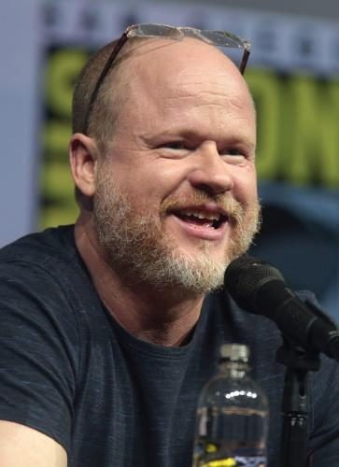
Joss Whedon & David Greenwalt
- Whedon and Greenwalt created the character Angel for the television show Buffy the Vampire Slayer.
- The series aired from 1997-2003.
  - The spin-off series, Angel, aired from 1999-2004.
- The series offered a dichotomous look at good versus evil
  - Angel is an Irish-Catholic from 18th century Ireland.
  - Angel is a vampire whose human soul was restored to him by a curse as a punishment.
  - This restored soul torments him with guilt and remorse.
  - According to Whedon, the story takes place in Los Angeles because “there are a lot of demons in L.A. and a wealth of stories to be told.”
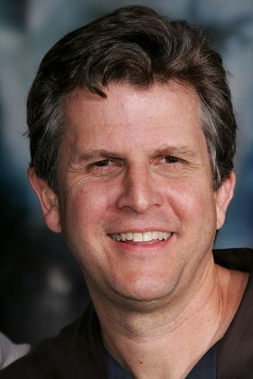
Sources:
Rights and Images Department, National Portrait Gallery London. (2017). Bram Stoker photogravure [image]. Wikimedia commons. https://commons.wikimedia.org/wiki/File:Bram_Stoker_photogravure_by_Downey_%28cropped%29.jpg
Rice, A. (2006). Anne Rice [image]. Wikimedia commons. https://commons.wikimedia.org/wiki/File:Anne_Rice.jpg
Skidmore, G. (2015). SDCC 2015 - Carlton Cuse, Guillermo del Toro & Chuck Hogan [image]. Wikimedia commons. https://commons.wikimedia.org/wiki/File:SDCC_2015_-_Carlton_Cuse,_Guillermo_del_Toro_%26_Chuck_Hogan_(19600034330).jpg
OmahaStar. (2008). Charlaine Harris [image]. Wikimedia commons. https://commons.wikimedia.org/wiki/File:Charlaine_Harris.JPG
Skidmore, G. (2012). Stephanie Meyer [image]. Wikimedia commons. https://commons.wikimedia.org/wiki/File:Stephenie_Meyer_by_Gage_Skidmore.jpg
Skidmore, G. (2018). Joss Whedon speaking at the 2018 SDCC [image]. Wikimedia commons. https://commons.wikimedia.org/wiki/File:Joss_Whedon_by_Gage_Skidmore_8.jpg
Smeal, J. (2005). David Greenwalt [image]. Shutterstock. https://www.shutterstock.com/editorial/image-editorial/david-greenwalt-550592ai?trackingId=tjWDgC17obaP-_y4nklygA&listId=searchResults

