CARD MATCHING
 | 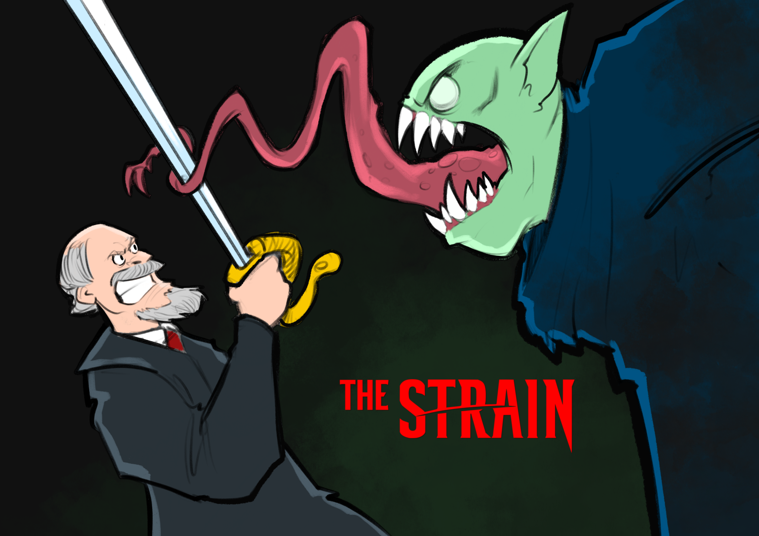
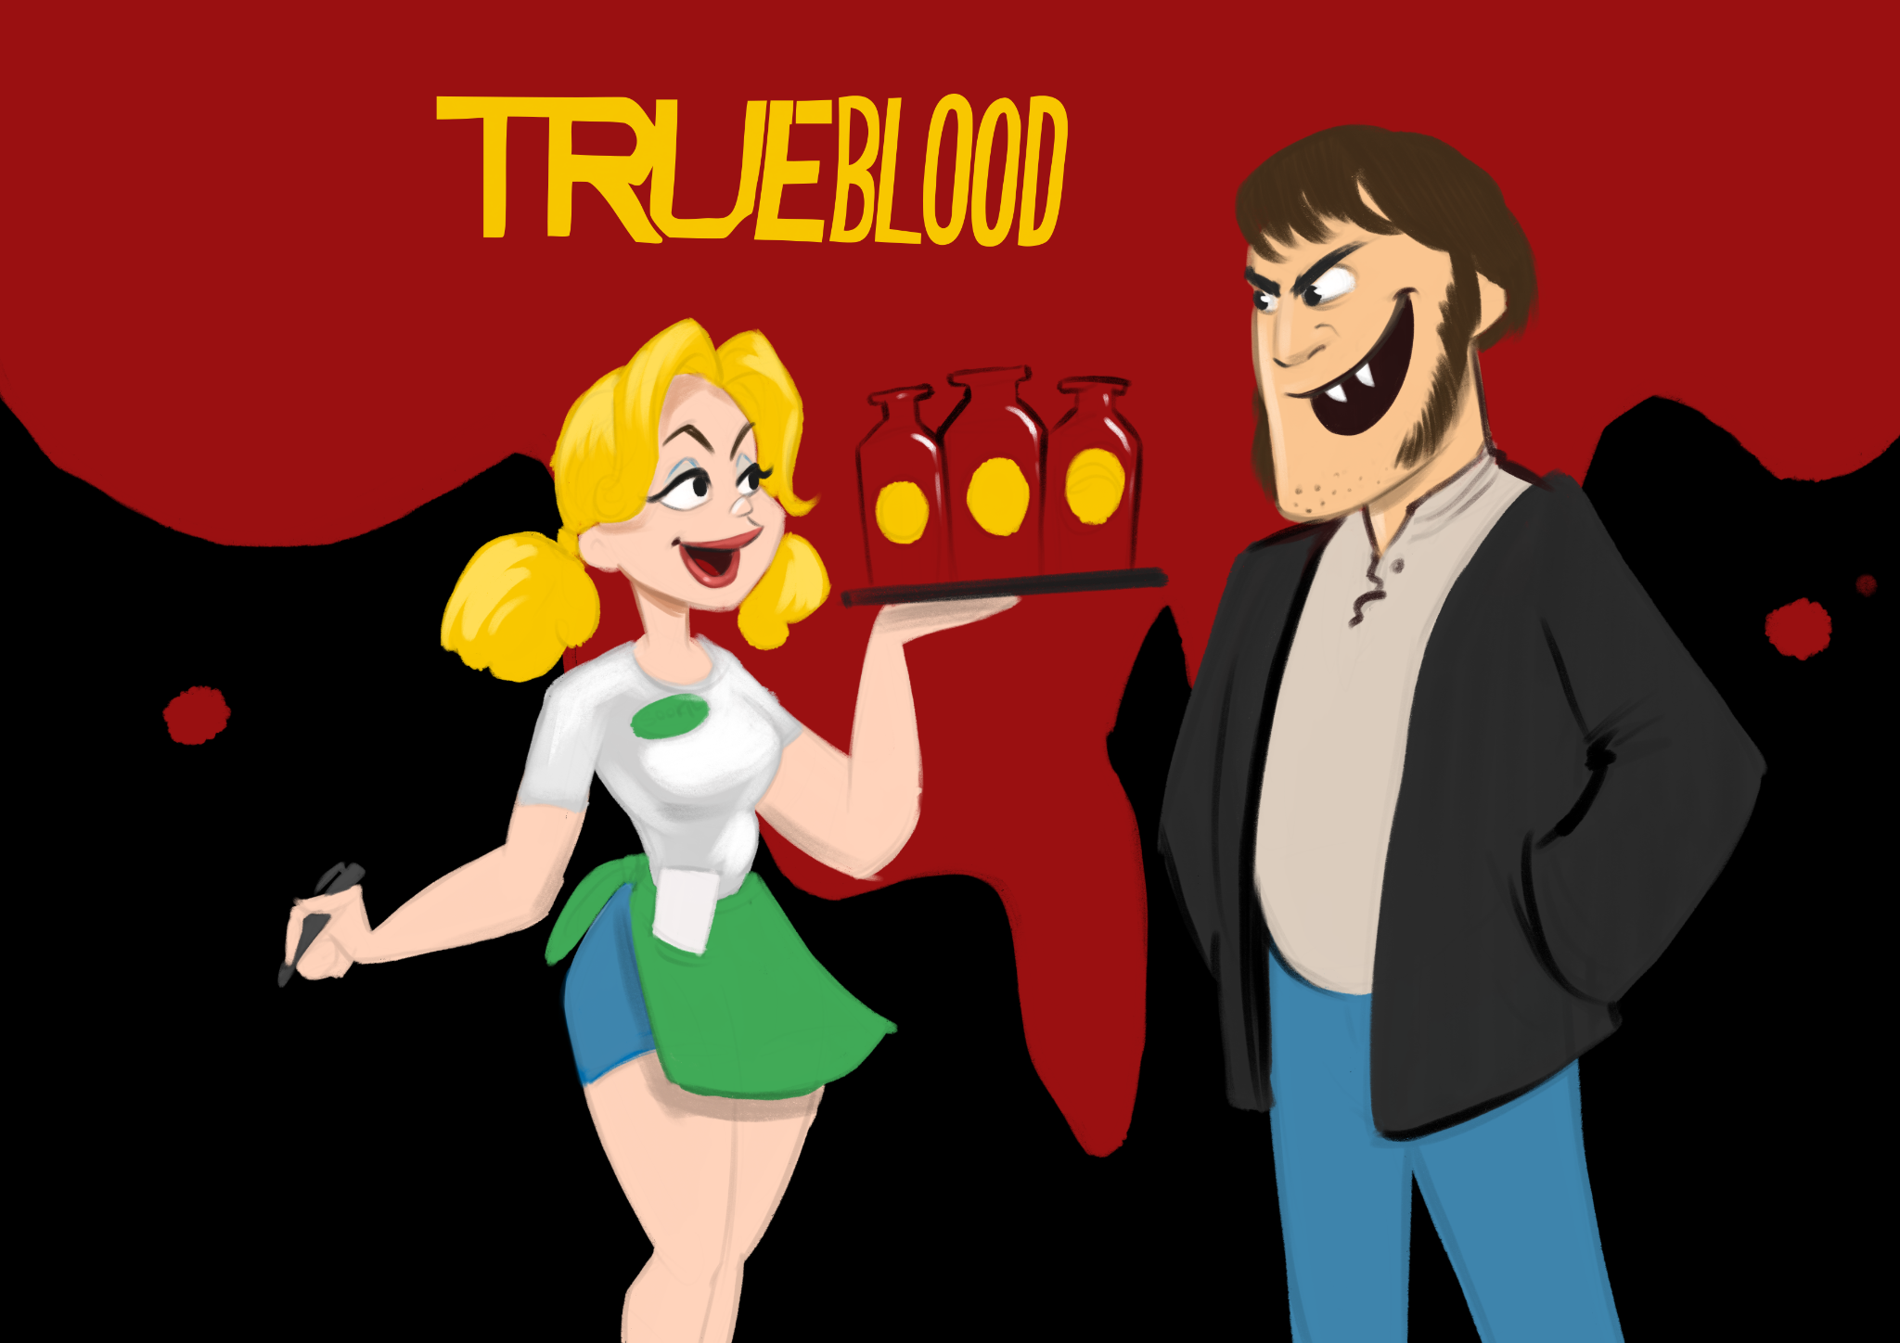 | 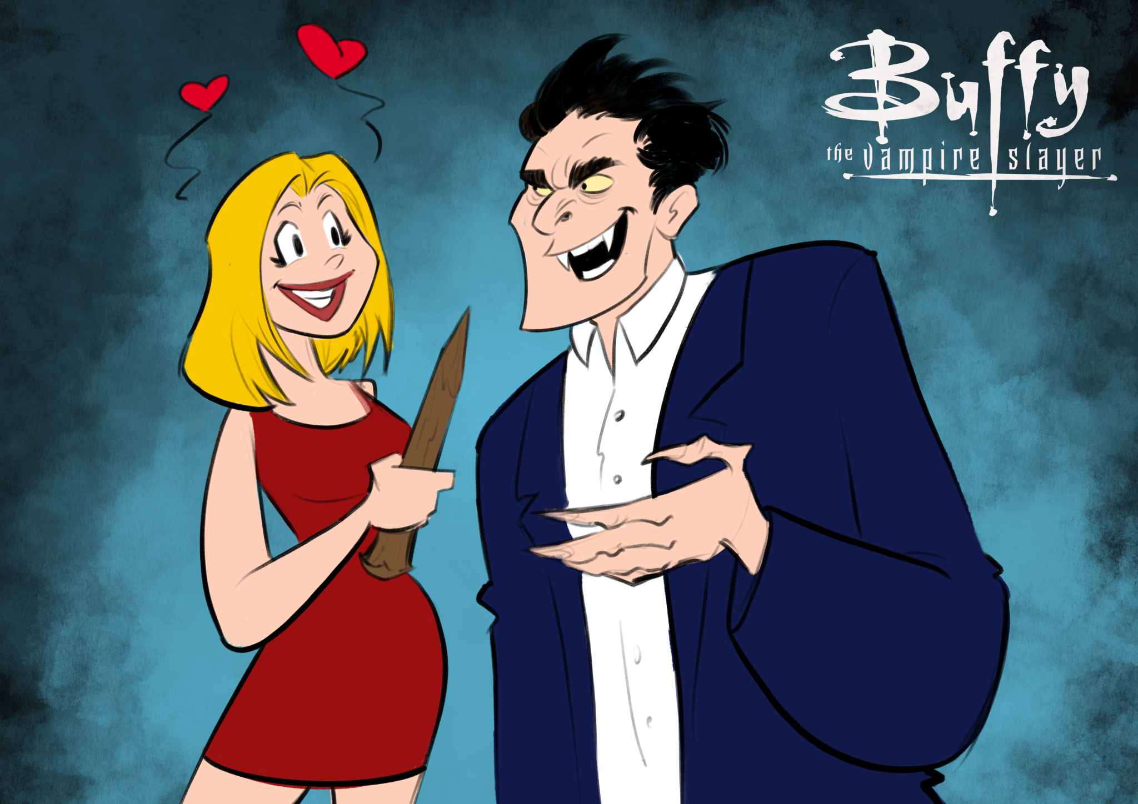
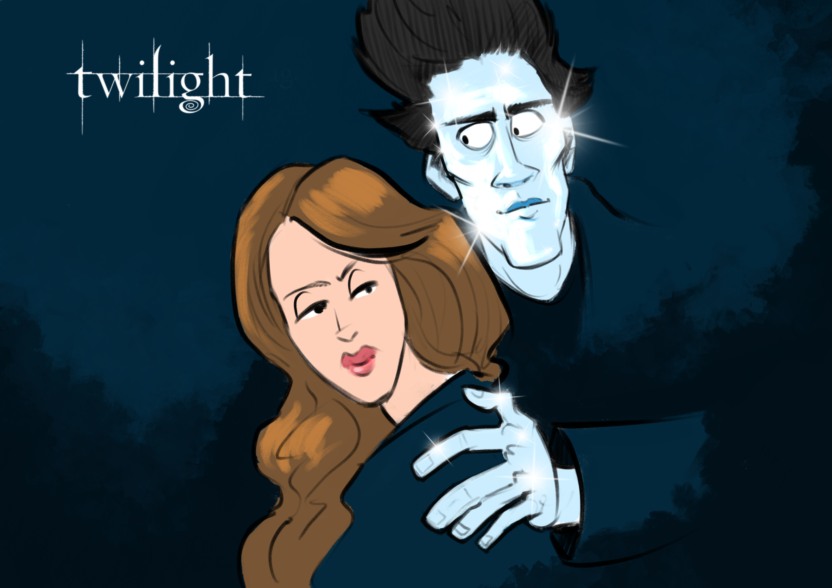 | 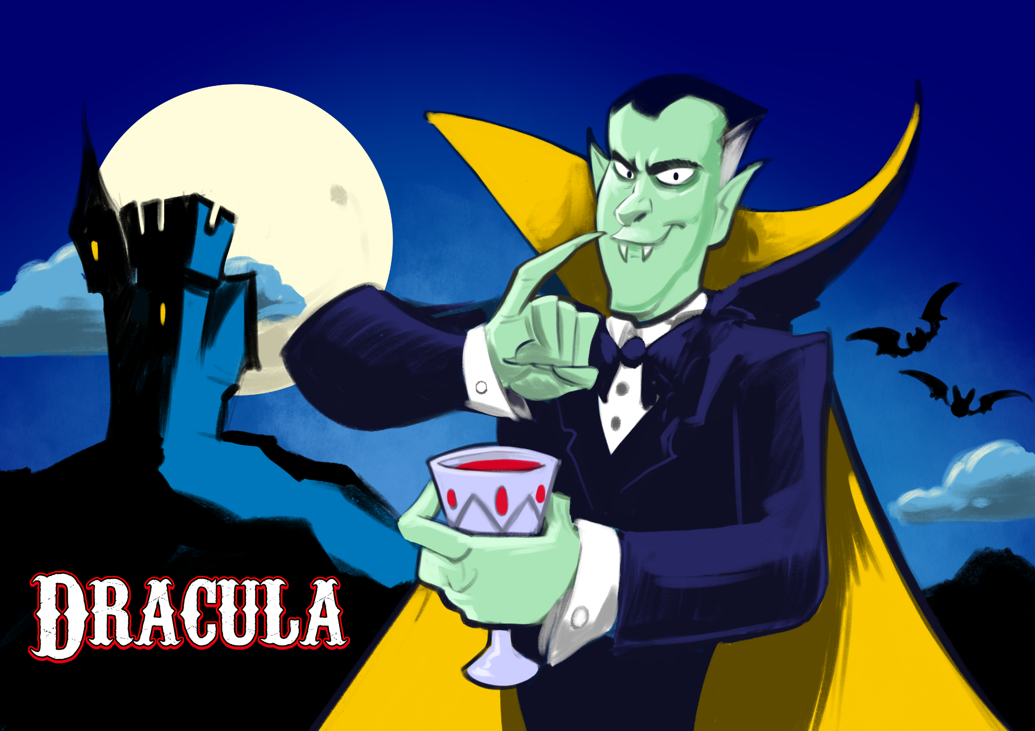

Vampires have pale skin. | Child vampire based off of a child who recently passed away. | Alluring | Vampires have pale skin.
Weakness to sunlight | Vampires can’t be recorded. | Based on America’s fascination with youth and staying young as long as possible. | Weakness to sunlight
Vampires can’t go outside during the day. | Vampires are restricted from entering homes without permission. | Religion- Catholicism | Weakness to sunlight
Weakness to fire | Vampires are restricted from entering homes without permission. | Religion- Mormonism | Beautiful
Vampires are restricted from entering homes without permission. | Faster than normal. | Vampirism is a sickness | Vampires are wealthy
Vampires form councils | Vampires hide in plain sight | Vampires are wealthy | Alluring
Vampires are disfigured / inhuman | Vampires are wealthy | Vampires form councils | Alluring
Vampires are wealthy | Associated with creatures of the night (bats and rats) but can’t shapeshift | Vampires-to-detectives pipeline | Vlad the Impaler
Elizabeth Báthory | Associated with sorcery or super powers | Vampires are restricted from entering homes without permission. | Vampires can’t be seen in mirrors.

