LEARN TASK CARD – 5E LESSONS

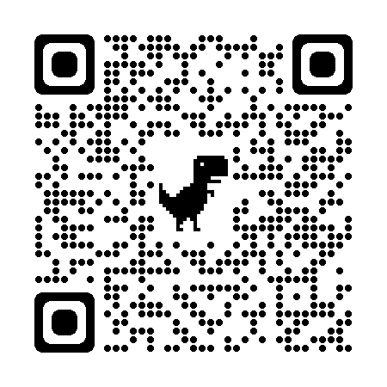
Description:
- LEARN offers a free repository of curated 5E lessons that are user friendly. Lessons include all necessary handouts, resources, strategies, and links.

Filter Function – Using the filter function, find lessons for:
https://bit.ly/5ELessons

- Different content areas
- Grade level
- Subject
- Course
- Standards

Explore a 5E lesson of your choice:
- Where can you find the number of class periods the lesson may take?
- Locate where the lesson PowerPoint is.
- Are learner handouts available in Spanish?

Closing Questions:
- After touring the LEARN repository, which aspect do you like best? Why?
- What lesson(s) are you excited to teach?

Notes:

