LEARN TASK CARD – Instructional Strategies

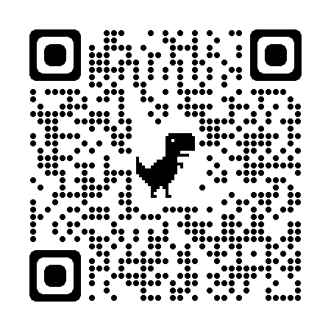
Description:
- Choose an Instructional Strategy, click on the card to turn it over and see more information, and scroll down for more information including lessons that use this strategy.

Filter Function – Using the filter function, find different strategies for different purposes.
https://bit.ly/LEARNstrategies

- Group Size
- Placement in Lesson
- Time to Complete
- Intention or Purpose
- Grade Level

Explore a 5E lesson of your choice:
- What group size is this strategy for?
- Find where the “Placement in Lesson” and “Intention/Purpose” are located.
- Challenge: Check out the interactive version of the 3-2-1 strategy.

Closing Questions:
- How do Instructional Strategies improve engagement in the classroom?
- What are your most effective go-to strategies this year?
- What are some strategies you want to implement in your classroom?

Notes:

