RESOURCES FOR E-BOOKS AND E-READERS
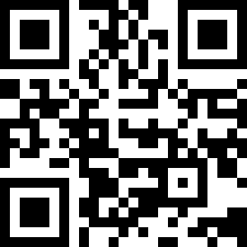

- Project Gutenberg—a free repository of over 59,000 downloadable e-books; mostly classics and older books for which the copyright has expired.
  - www.gutenberg.org

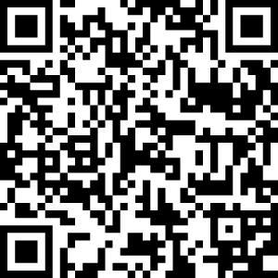
- Mercury Reader—Chrome extension to declutter online articles; allows you to save a .pdf copy of the article to upload to Kindle.
  - https://bit.ly/2vfnI42

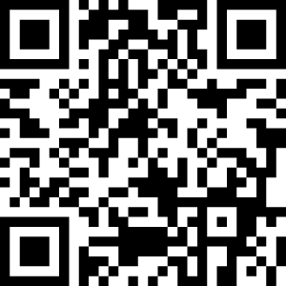
- Metropolitan Library System—Using the OverDrive platform, students can use their free library accounts to digitally check out e-books. Students can either wirelessly send the book to the Kindle, or directly upload from a Chromebook.
  - catalog.metrolibrary.org

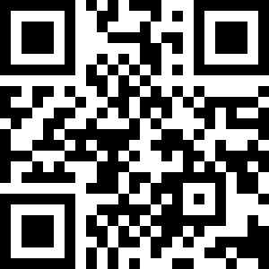
- Audiobook Sync—a free summer audiobook program for teens. Students can
pair the free audio selections to e-books that can be checked out through the library.
  - https://www.audiobooksync.com/

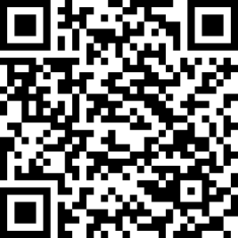
- LibriVox—Public domain audiobooks read by volunteers. Huge library, but more difficult to place on Kindle. Download and YouTube which are widely available.
  - Librivox.org

