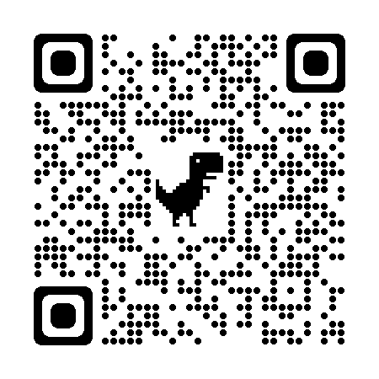
LESSON CLOSURE READING:
CHOOSE YOUR OWN ADVENTURE
Choose a closure strategy from the Exit Strategies Collection to practice with
the following excerpt. Share which strategy you tried and your answer from it.
Strategy name:
Your response:

Excerpt from: Ganske, K. (2017). Lesson closure: An important piece of the Student Learning Puzzle. The Reading Teacher, 71(1), 95–100.
What Do We Know
About Lesson Closure?
These experiences have piqued my wonderings about lessons, which end, but often without closure. By closure, I mean, as described in one Merriam-Webster definition, a “satisfying ending” (Closure, n.d.), not just an ending. The medical definition of closure provides a useful analogy. Here, closure refers to “a drawing together of edges or parts to form a united integument” (Closure, n.d.), or outer whole. I believe that five minutes of closure can be sufficient pause to help students bring together key takeaways from the lesson, to think about what was important in the lesson, and to consider how their learning can help them be better readers and writers beyond this lesson and this day. This boost of awareness is important for ensuring that students realize why the activities they engaged in and the time they spent matter.
Curious to discover what we know about closure, I searched Google Scholar and the ERIC database for articles that included the search terms lesson and closure. It was evident that closure matters. For instance, there was a piece published in Instructor, a popular practitioner journal, titled “Closure: The Fine Art of Making Learning Stick” (Phillips, 1987). In it, the author noted that “closure helps learners know what they learned, why they learned it, and how it can be useful” (p. 37). However, research findings were extremely limited, and like the piece just mentioned, those that did surface tended to be from decades ago—the 1980s and 1990s—or they related to physical education and sports. One study is interesting in the insight it yields into the importance of student involvement. This secondary science study found that closure increased student performance on next-day and weekly tests of content when students were actively involved in the closure; namely, writing responses rather than passively looking and listening while the teacher read and projected key takeaways (Cavanaugh, Heward, & Donelson, 1996).
Most of the articles that I uncovered addressed teaching ideas, not research; online articles followed a similar pattern, although some of the ideas presented seemed worthwhile and engaging. Check outcome of the 36 closure techniques presented by Wolf and Supon (1994), the 22 described in an Edutopia blog post (Finley, 2015), or the five technology-related ideas detailed by The Techie Teacher (Smith, 2016).
Because my quest to uncover a research base turned up few results, I reached out to colleagues in the field to see if I was overlooking something; their conclusions were the same. “So, why the dearth of research?” I wondered, when classroom practice does not validate that effective lesson closure is the norm. On the contrary, closure is often squeezed into a mere ending: “We’ll take this up again tomorrow,” or “It’s time to put away ___.” Do we assume that closure has been addressed by the investigations that followed Hunter and Russell’s (1977) inclusion of closure in lesson design or that it is currently being taken care of by the widely accepted Understanding by Design model for instruction (Wiggins & McTighe, 2005)? Is there a perception that any ending is closure, or have we largely forgotten about closure? Regardless of the why, lesson closure is critically important. Students need closure to help them give their learning lasting relevance for their lives, to reflect, to solidify and internalize what they’ve learned (e.g., Lia, 2014; Pollock, 2007; Wolf & Supon, 1994). This requires more than statements by teachers of what has been learned and why; students need to be actively involved, as Cavanaugh et al. (1996) concluded.
With activities like[a student-written classroom newsletter], students engage in closure and synthesis through writing, which serves as a tool for their thinking and sharing of their thinking (Applebee, 1977; National Council of Teachers of English, 2016). The young newsletter writers were motivated through what Brophy (2008) termed social milieu, expectancy, and value. The social aspects of newsletter writing, the collaborative work, and the opportunity to talk through their thinking with peers and the teacher ignited students’ interests. The weekly routine enabled them to know what to expect and to build a sense of competence. This sense of competence, the sharing of their product, and the collaboration made the experience pleasurable and one in which students were eager to reengage, thereby fueling a positive learning cycle.

Concluding Comments
As in a puzzle, an effective lesson has many pieces that must fit together. We typically give considerable thought to how we initiate lessons: activate or build background knowledge, teach essential vocabulary, engage learners, and set a purpose for the lesson. And we carefully select tasks or activities and texts for use during the lesson. But closure is often given short shrift or omitted entirely. We need to be sure we plan time to cycle back to the what, why, and how of students’ learning to help them actively synthesize the parts into a whole. Lesson closure provides space for students to digest and assimilate their learning and to realize why it all matters. Closure is a component of planning and teaching that we can’t afford to
leave out.

