Math Reading
From the LEARN Lesson “ADA Accessibility”

To Whom It May Concern,
The United States Department of Education and the ADA are starting an initiative to make certain that all high school campuses in the United States are wheelchair accessible. Due to a budgeting crisis, the department is unable to check all campuses, which means we are relying on students to do some of the legwork for us. Your task is to pair up with a partner and check two wheelchair ramps on your campus to make sure that they are up to code. This means that the ramp must be at an incline of a certain angle.
Here is what you’ll need to do:
1. Research appropriate wheelchair angles and regulations.
2. Use appropriate resources to check two ramps on your campus to see if they meet the standard.
3. Create a redesigned ramp proposal and generate a list of other things around the school that need redesign to make it more accessible.
4. Write a letter back to the United States Department of Education stating what you did, what you found, and whether or not the ramps were acceptable.
Thank you for being willing to help our initiative.
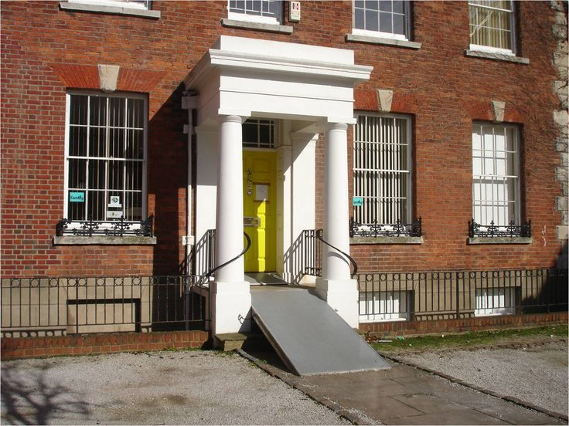
Sincerely,
Ima Phony Department of Education Building
400 Maryland Ave, SW
Washington, DC 20202
Contact: 1-800-514-0301 www.ada.gov

A ramp outside an old school building
POWER TOOLS FOR COMPREHENSION

