Science Reading
From the LEARN Lesson “Cystic Fibrosis: A DNA Case Study”

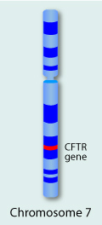
What is cystic fibrosis?
Cystic fibrosis is a genetic disorder that affects the respiratory and digestive systems.
People with cystic fibrosis inherit a defective gene on chromosome 7 called CFTR (cystic fibrosis transmembrane conductance regulator). The protein produced by this gene normally helps salt (sodium chloride) move in and out of cells. If the protein doesn't work correctly, that movement is blocked and an abnormally thick sticky mucus is produced on the outside of the cell. The cells most seriously affected by this are the lung cells. This mucus clogs the airways in the lungs, and increases the risk of infection by bacteria.
The thick mucus also blocks ducts in the pancreas, so digestive enzymes can't get into the intestines. Without these enzymes, the intestines cannot properly digest food. People who have the disorder often do not get the nutrition they need to grow normally.
Finally, cystic fibrosis affects the sweat glands. Too much salt is lost through sweat, which can disrupt the delicate balance of minerals in the body.

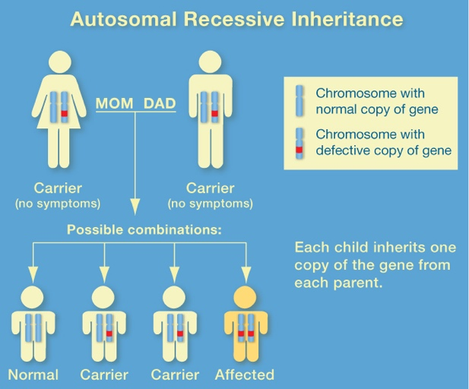
How do people get cystic fibrosis?
Cystic fibrosis is a recessive disorder, which means that both parents must pass on the defective gene for any of their children to get the disease. If a child inherits only one copy of the faulty gene, he or she will be a carrier. Carriers don't actually have the disease, but they can pass it on to their children.

What are the symptoms of cystic fibrosis?
Symptoms of cystic fibrosis can include coughing or wheezing, respiratory illnesses (such as pneumonia or bronchitis), low weight, salty-tasting skin, and greasy stools. Because the lungs are clogged and repeatedly infected, lung cells don't last as long as they should. Therefore, cystic fibrosis patients who don't receive treatment have shortened lifespans.

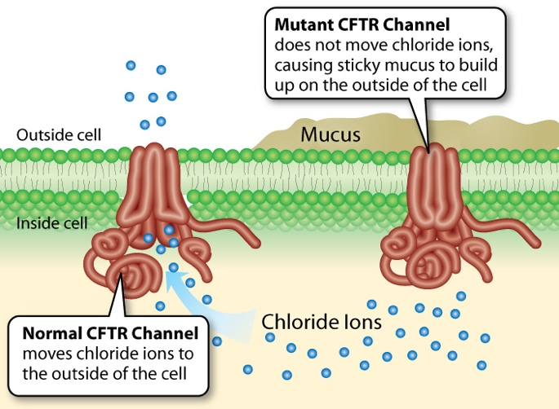
How do doctors diagnose cystic fibrosis?
People with cystic fibrosis have between 2 and 5 times the normal amount of salt in their sweat. Thus, doctors can use a sweat test to measure the amount of salt (sodium chloride) in a person's sweat. Sweat is collected from the person's arm or leg and taken to a laboratory to be analyzed.
In newborns, doctors can measure the amount of a protein called trypsinogen in the blood. The level of this protein is higher than normal in people with cystic fibrosis.
Finally, genetic tests can identify a faulty CFTR gene using a sample of the patient's blood.

How is cystic fibrosis treated?
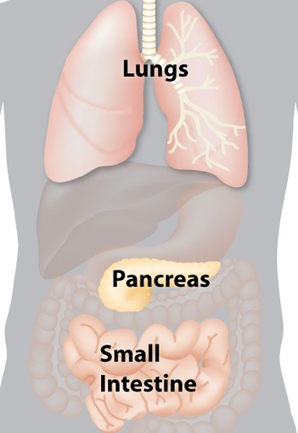
Although there is no cure for cystic fibrosis, new treatments are helping people with the disease live longer than before. Most treatments work by clearing mucus from the lungs and preventing lung infections. Common treatments include:
- Chest physical therapy, in which the patient is repeatedly clapped on the back to free up mucus in the chest
- Inhaled antibiotics to kill the bacteria that cause lung infections
- Bronchodilators (also used by people with asthma) that help keep the airways open
- Pancreatic enzyme replacement therapy to allow proper food digestion
- Gene therapy (a treatment currently in clinical trials), in which the healthy CFTRgene is inserted into the lung cells of a patient to correct the defective gene
Organs affected by cystic fibrosis

Interesting facts about cystic fibrosis
More than 1,000 different mutations in the CFTR gene have been identified in cystic fibrosis patients. The most common mutation (in 70% of cystic fibrosis patients) is a three-base deletion in the DNA sequence, causing an absence of a single amino acid in the protein product.
Some evidence suggests that cystic fibrosis carriers are resistant to certain types of bacterial infections.
About 2,500 babies are born with cystic fibrosis in the U.S. each year.
More than 10 million Americans carry the cystic fibrosis gene but don't know it.

Genetic Science Learning Center. (2014). Single gene disorders. University of Utah. Retrieved from http://learn.genetics.utah.edu/content/disorders/singlegene/

