APPOINTMENT CLOCKS
Use the prompts below to find who you have “an appointment” with. Then write their name next to the corresponding time.
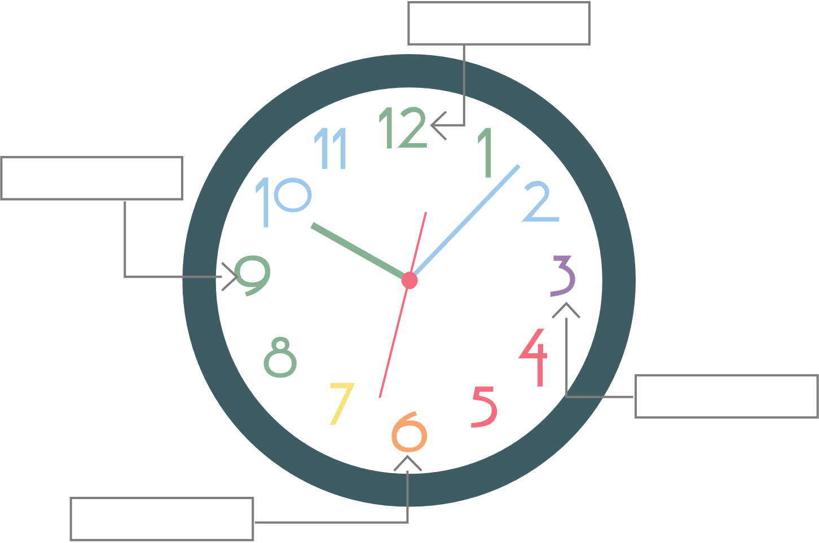

12 o’clock
Find your opposite and write their name in the 12 o’clock space above.

3 o’clock
Find someone from another grant.

6 o’clock
Find someone with a similar Sonic order as yours.

9 o’clock
Find someone who has the same severe weather procedures as yours.

