APPOINTMENT CLOCKS

Use the prompts below to find who you have “an appointment” with. Then write their name next to the corresponding time.

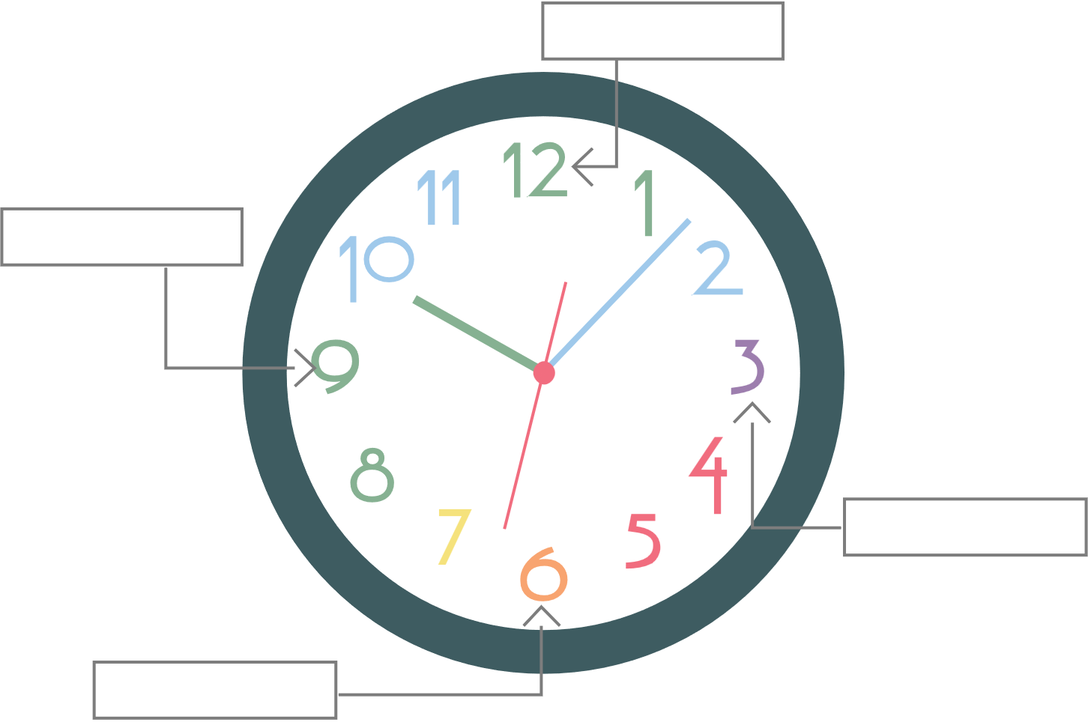

# 12 o’clock

Find your opposite and write their name in the 12 o’clock space above.

# 3 o’clock

Find someone from another grant.

# 6 o’clock

Find someone with a similar Sonic order as yours.

# 9 o’clock

Find someone who has the same severe weather procedures as yours.