Exploring Solutions

Thinking Hats: Roles
Detective (White) Hat | Creative (Green) Hat
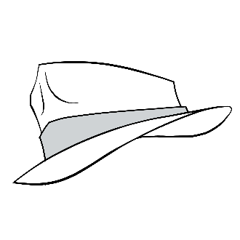  - Questions  - Analyzes  - What info is needed?  - What facts do we know? | 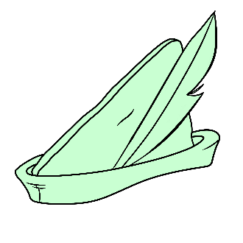  - Thinks outside the box  - Imagines  - What new ideas do we have?  - What creative solutions exist?
Thoughtful (Red) Hat | Cautious (Black) Hat
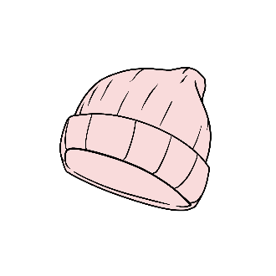  - Thinks with one’s heart  - Shares gut instincts and hunches  - How do I feel about this?  - How might our decision make others feel? | 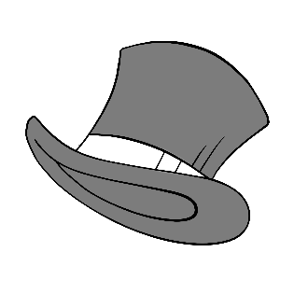  - Plays devil’s advocate  - Identifies potential risks, concerns, and cons  - What difficulties might arise?  - Is this actually going to work?

This page is intentionally left blank.

Chat Stations
Visit each station with your group and examine the image on the poster. Choose a Thinking Hat role to play and discuss the image with your group members from your role perspective. Rotate stations and change your role at each one, recording comments from each person’s perspective at every station.

Station 1
Role | Comments
White
Green
Red
Black

Station 2
Role | Comments
White
Green
Red
Black

Station 3
Role | Comments
White
Green
Red
Black

Station 4
Role | Comments
White
Green
Red
Black

