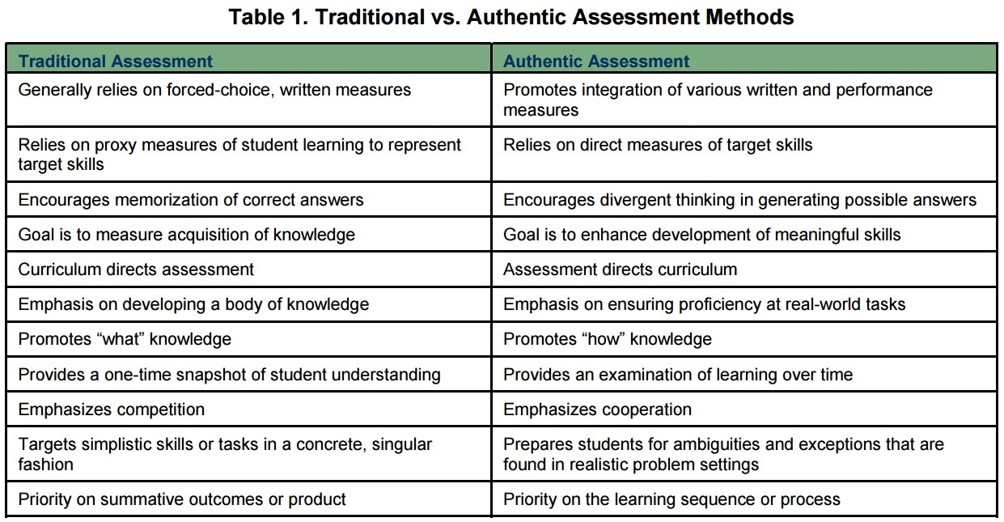
Rubrics: Traditional vs Authentic
Note: Reprinted from Lombardi, M. M. (2008, January). Making the grade: The role of assessment in authentic learning (ELI Paper 1: 2008, p. 6). Retrieved from https://library.educause.edu/~/media/files/library/2008/1/eli3019-pdf.pdf. Copyright 2008 by Educause. For educational use.

© (2008)
For educational use.

