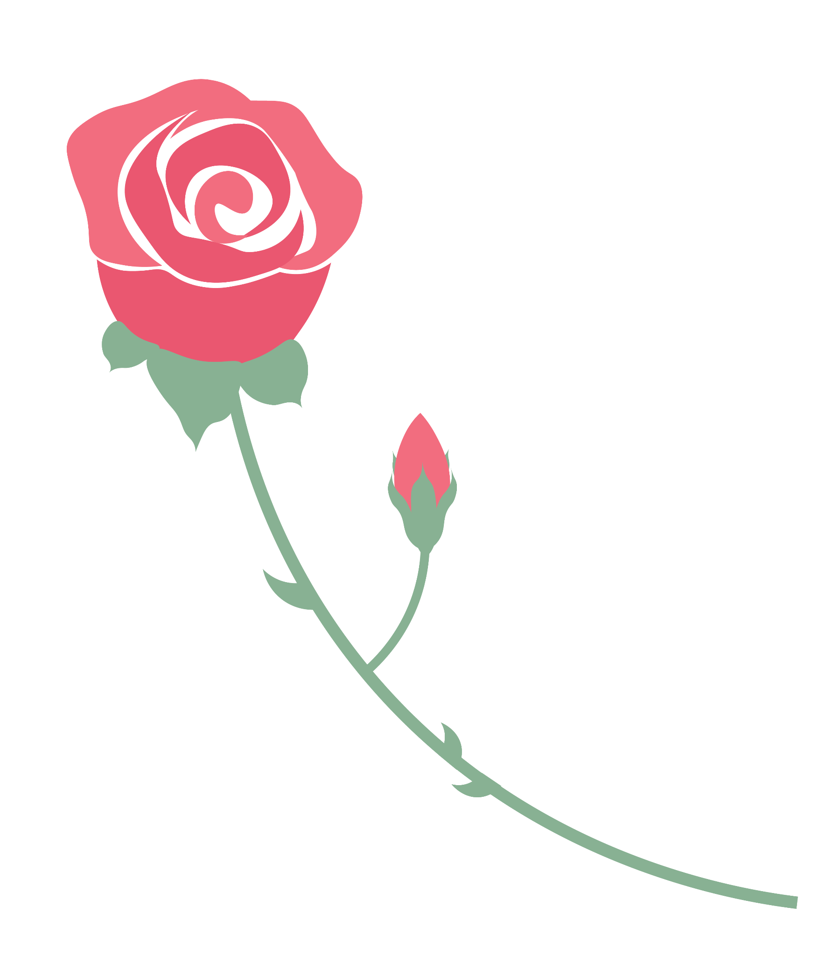
ROSE, BUD, AND THORN
_______________________Rose
___________________Bud
______________________Thorn

