INSTRUCTIONAL STRATEGY CAFÉ MENU

# ………………………. Appetizers …………………………

## (Strategies for Engagement & Assessing Prior Knowledge)



### Commit & Toss

Learners are presented a prompt, then write   
their response on a paper, crumple it, and toss it across the room. Another learner will pick it up   
and read it.

[*k20.ou.edu/committoss*](https://learn.k20center.ou.edu/strategy/119)

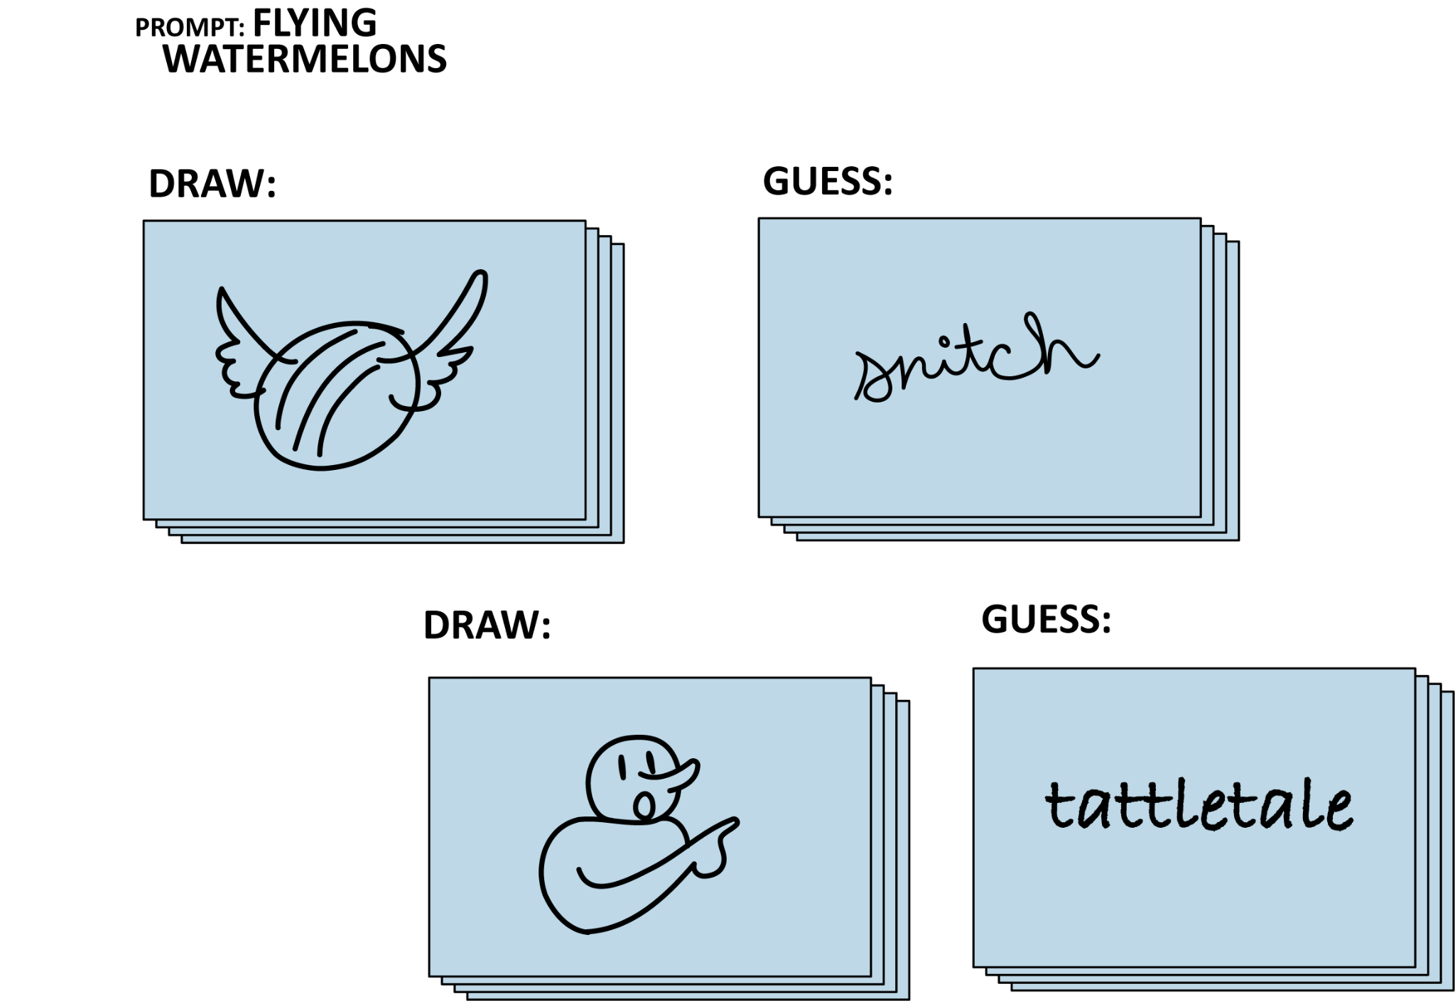

### Paper Telephone

It’s like the whispering game and Pictionary made a baby.

[*k20.ou.edu/3477*](https://learn.k20center.ou.edu/strategy/3477)

### A pair of dice with black dots AI-generated content may be incorrect.Take a Chance

This strategy is a great way to get students to synthesize their thoughts. Students are divided into groups and given one die. The teacher provides the students with a prompt, and they take turns rolling the die and using the number to represent the number of words used to answer the question.

[*k20.ou.edu/take*](https://learn.k20center.ou.edu/strategy/3480)

# ………………………. Main Courses …………………………

## (Strategies for exploring & extending content understanding)

### Detective Board

This instructional strategy turns the classic corkboard and string into a tangled, three-dimensional visualization of connections across multiple topics.

[*k20.ou.edu/detective*](http://k20.ou.edu/detective)

### 

### A cartoon of a yellow hat AI-generated content may be incorrect.Thinking Hats

This strategy is a role-playing model that has students discuss a topic using the lens or perspective represented by their “hat.” It can be used for brainstorming, decision-making, giving feedback, reading comprehension, or problem-solving. Thinking Hats supports active participation from all group members, the need for having healthy disagreements, and the exploration of different perspectives.

[*k20.ou.edu/hats*](http://k20.ou.edu/hats)

### A cartoon of a person drawing on canvas AI-generated content may be incorrect.Picture Yourself

This strategy asks students to draw a picture from an event or place and add themselves to the illustration. Students then discuss their illustrations and the content with their peers. Based on the conversation, students modify their illustration to show what they learned or how their ideas have changed.

[*k20.ou.edu/3426*](http://k20.ou.edu/3426)

# ………………………. Desserts …………………………

## (Strategies for Evaluation & Reflection)

### A light bulb with a shining sun AI-generated content may be incorrect.Aha! Huh? Uh-uh.

This strategy guides students to reflect on an experience or reading by identifying key takeaways, points of confusion, and areas of disagreement or discomfort.

[k20.ou.edu/aha](http://k20.ou.edu/aha)

### A group of hands holding a piece of paper AI-generated content may be incorrect.Give, Get, Reflect

This strategy reflection is used to get students thinking about what they are grateful for and what they look forward to. Or you can use it after a project to reflect on what they are proud of and what they hope to improve on.

[*k20.ou.edu/give*](http://k20.ou.edu/give)

|  |
| --- |
| List of 8 List of 8 invites students to improve their listening and speaking skills while focusing on content-specific prompts. This strategy is helpful for reviewing and activating prior knowledge.  [*k20.ou.edu/list8*](http://k20.ou.edu/list8) |