EXTENSIONS, WEB APPS, AND ADD-ON TOOLKIT
EXTENSION | DESCRIPTION | HOW CAN THIS BE USED? | SAMR/Authenticity/DOK Level
  MERCURY READER | The Mercury Reader extension for Chrome removes ads and distractions, leaving only text and images for a clean and consistent reading view on every site.
  HEMINGWAY EDITOR | Hemingway makes your writing bold and clear. It’s like a spellchecker, but for style. It makes sure that your reader will focus on your message, not your prose.
  GRAMMARLY | Grammarly can fix hundreds of complex grammatical errors, including subject-verb agreement, article use, and modifier placement, to name just a few.
  GOOGLE KEEP | Found a webpage, image, or quote that you want to save for later? Easily save the things you care about to Keep. Take notes for additional details and add labels to quickly categorize your note for later retrieval.
  COMMONLIT | CommonLit delivers high-quality, free instructional materials to support literacy development for students in grades 3-12.
  SCREENCASTIFY | Free screen recorder extension for Chrome. Capture, edit and share screencasts.
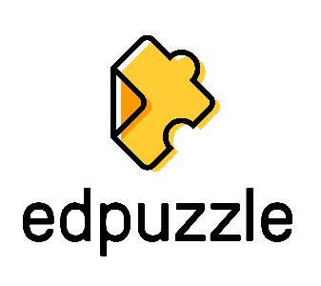  EDPUZZLE | Choose a video, give it your magic touch and track your students' comprehension.
  PEAR DECK | Welcome to Pear Deck Slides Add-on! Now you can add Formative Assessments and interactive questions to your Google Slides.
  EVERNOTE | Goodbye, bookmarks. Hello, Web Clipper! Clip the web pages you want to keep. Save them in Evernote. Easily find them on any device.  - Great for research—clip any article or web page  - Clip to a specific notebook and assign tag
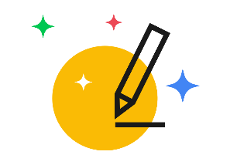  AUTODRAW | AutoDraw is a new kind of drawing tool that pairs the magic of machine learning with drawings from talented artists to help everyone create anything visual, fast.
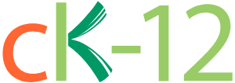  CK-12 | Create digital classrooms, customize textbooks, and learn K-12 STEM concepts.
  HHMI-BIOINTERACTIVE | At BioInteractive, you can find award-winning multimedia resources, including apps, animations, videos, interactives, and virtual labs, to bring the excitement of scientific discovery into your classroom.
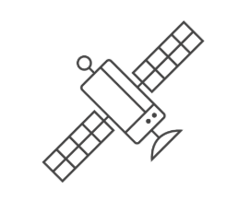  GOOGLE EARTH TIMELAPSE | Google Earth TimeLapse combines a multi-petabyte catalog of satellite imagery and geospatial datasets with planetary-scale analysis capabilities and makes it available for scientists, researchers, and developers to detect changes, map trends, and quantify differences on the Earth's surface.
    NATGEO MAPMAKER INTERACTIVE | Start with a blank world map that allows you to zoom in and pan around. On the right side, you have the ability to select different base maps and create different map layers.
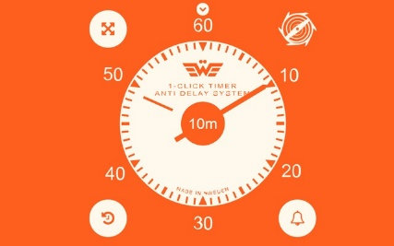  1-CLICK TIMER | A slick and reliable timer app for Google Chrome.

