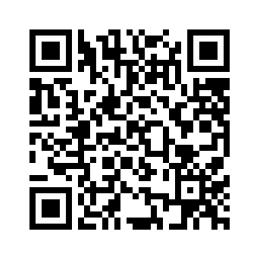
HOW BIG SHOULD I BE?

PROPORTIONAL REASONING (MATH)
Link: https://bit.ly/2TEq1d3

Summary
Students will take accurate measures of themselves and then use what they know about proportions to find new dimensions of themselves if they were the same height as something else (a character for a video game, Barbie, a Hobbit, Hagrid, etc.). After finding their new dimensions, students will create an accurate model or visual of their new “self.” Throughout the process, students will also focus on the idea of why proportional reasoning is important for animators or toy makers and how they might use it to distort and to mimic.

Essential question

How and why do animators and toy makers use proportions in their craft?

Lesson Snapshot

Engage

Students will watch a short video preview of “The Sims” animated video game. Then they will discuss whether the avatars look “real” and why or why not. They will then discuss other games, animated movies, or toys with real-looking people and discuss what they have in common.

Explore
Using a Barbie Doll and Ken Doll (or other action figures like Monster High or superheroes), have students determine if the doll/figure “looks” real based on the average measurements (height, waist, arms, legs) of those in their group.

Explain
The class will use their collective data to determine if one of the dolls/action figures is mathematically proportional. Students will be asked to write a short reflection about why and when toy makers or animators would choose to use correct proportions or not.

Extend
Students will be asked to find their own dimensions if they were going to be as tall as the Barbie Doll (or another figure/character).

Evaluate
Students will use their calculations to create, draw, or somehow model themselves as a figure/character. These can be graded for accuracy and understanding of mathematics.

