How to use desmos

Creating a Graph
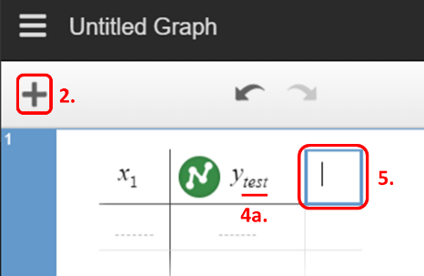
- Navigate to www.desmos.com/calculator.
- Click on the + (plus button) in the top left corner of the left-side panel.
- Select the “Table” option from the menu that drops down. The top row of the table is your variable header.
- Name your X and Y variables with a one-word (no spaces) subscript: X_{variable} or Y_{variable}. You must keep the X and Y or Desmos will not recognize the data.
  - To make a subscript, click to the right of the letter X or Y in your variable header.
  - Press shift and minus (-) at the same time and then type your variable name.
- To add a new Y variable,
  - With your cursor in the variable header, click Tab on the keyboard. Or, Click in the blank box to the right of the current variable header.
  - Type Y to add a new variable. Don’t forget to name it using a subscript.
    - Click to the right of the Y in your variable header.
    - Press shift and minus (-) at the same time and then type your variable name.

Editing Graph Appearance

Data Points and Lines
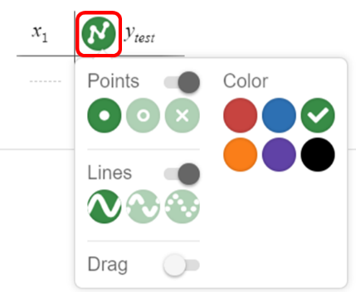
- To make changes to the look of your data on the graph, left click and hold (left long click) the colored circle next to your variable name. A menu will pop up.
- Points changes the shape of your data points; Color changes the variable color; Lines connects your data points and allows you to change the line shape (solid, dashed, dotted).

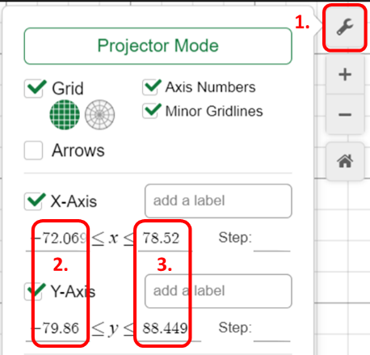
Scale of the Graph
- Click on the wrench icon in the upper right corner of the graph area. This opens an options menu.
- For each axis, change the minimum value to -1 or 0.
- For each axis, change the maximum value to something greater than your largest data value.

