IMPACTS OF MUSIC

# MIX TAPE

**Directions:** On the cassette below, write the name of your chosen “walk-up” song. A “walk-up” song is music that represents you, motivates you, or makes you feel confident. Choose a song that represents you! Include the name of the song and the artist on the cassette.

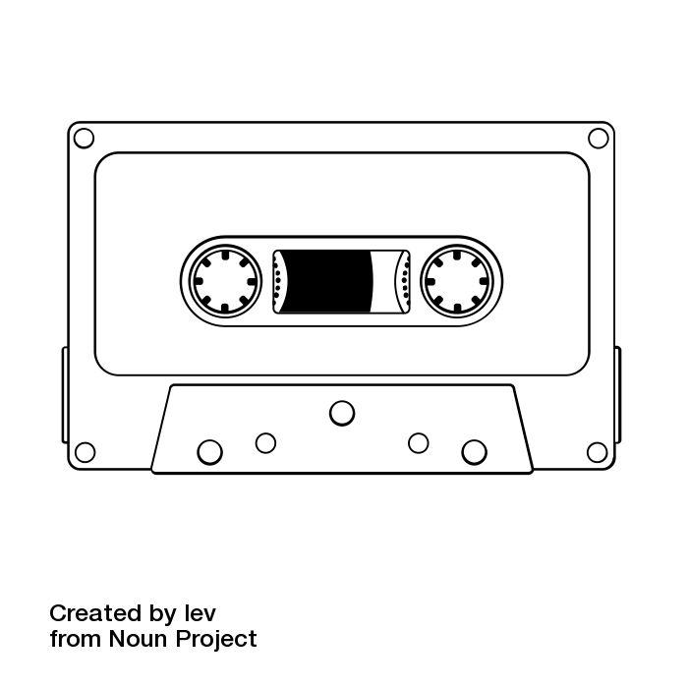

# MUSIC AND MOOD

**Directions:** Listen to the different extracts of music used throughout the video. As you listen to each extract, record one word that describes how that piece of music made you feel.

|  |  |  |  |
| --- | --- | --- | --- |
| **Examples** | **Descriptive Word** | **Examples** | **Descriptive Word** |
| No sound |  | Example 4 |  |
| Example 1 |  | Example 5 |  |
| Example 2 |  | Original |  |
| Example 3 |  |  |  |