HOW TO CREATE GOOGLE WEB STORE
Following is the task list from the G Suite & Google Classroom presentation with accompanying screenshots. Work through the list to familiarize yourself with Google Web Store.

Task List
- Go to chrome.google.com/webstore.
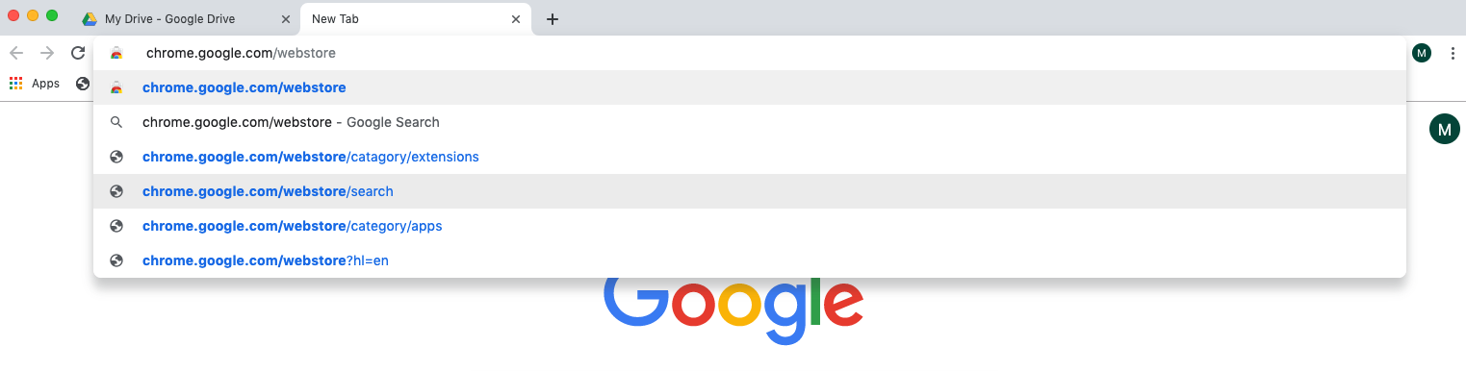

- Select the “Extension” option.
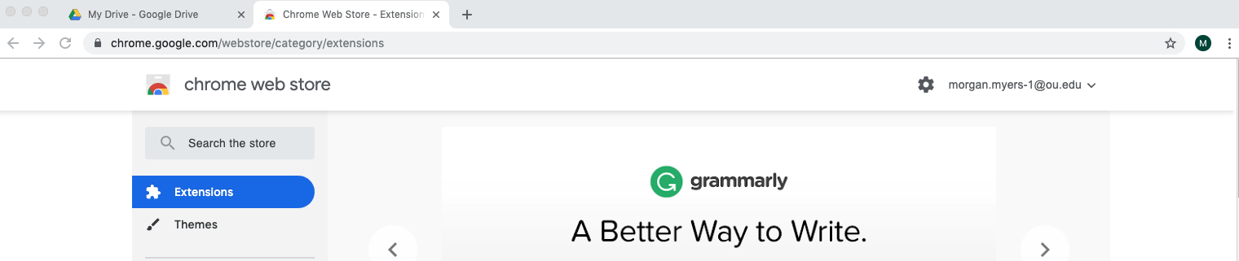

- Using the search bar, search for “Fluany.”
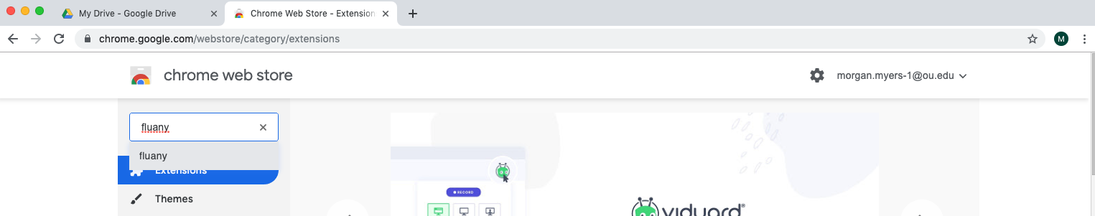

- Select “Add to Chrome.”
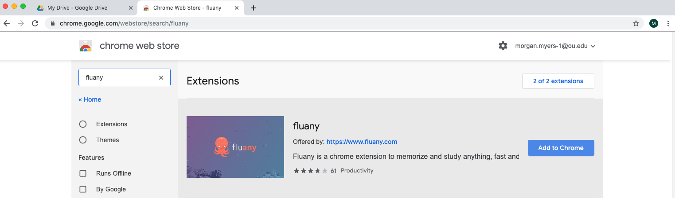

- Open a new tab and select the new Fluany extension icon in the upper right hand corner.

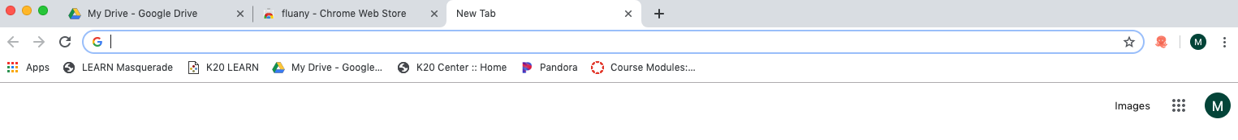

- When prompted, create a new study list and explore the extension.
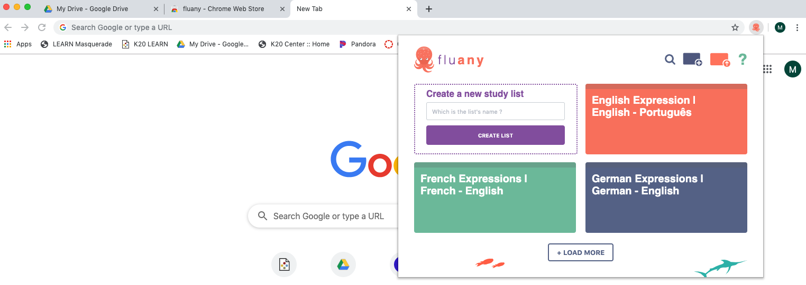

- To remove the extension, click on the three vertical dots in the upper right hand corner.
- Select “More Tools” then “Extensions.”
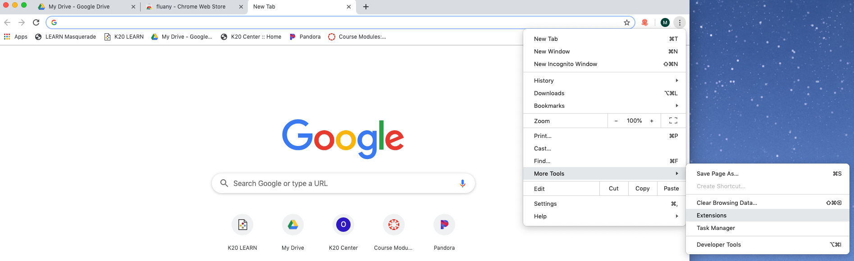

- To disable, move the blue slide bar. To delete, select “Remove.”
