HOW TO CREATE GOOGLE DOCS
Following is the task list from the G Suite & Google Classroom presentation with accompanying screenshots. Work through the list to familiarize yourself with Google Docs.

Task List
- Click on “New,” choose Google Docs, and title.
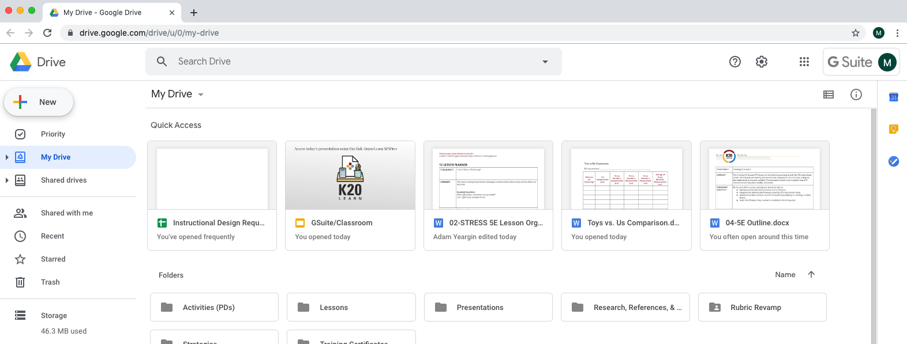

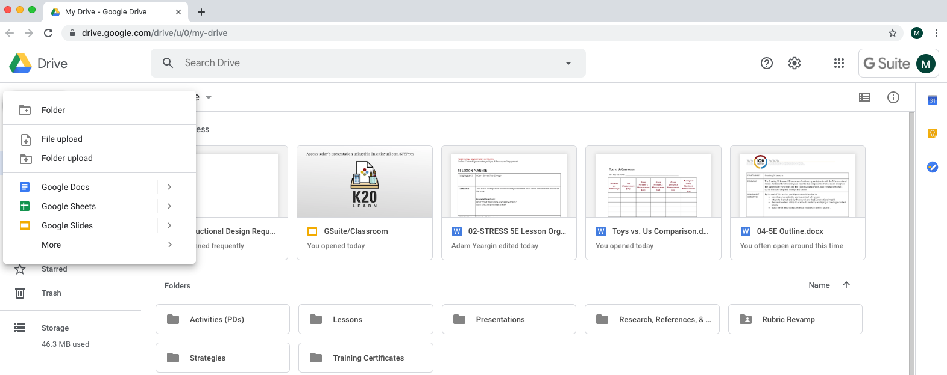

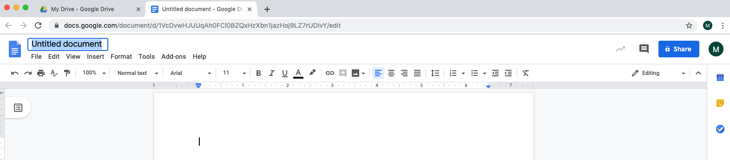

- Share it with everyone in your group.
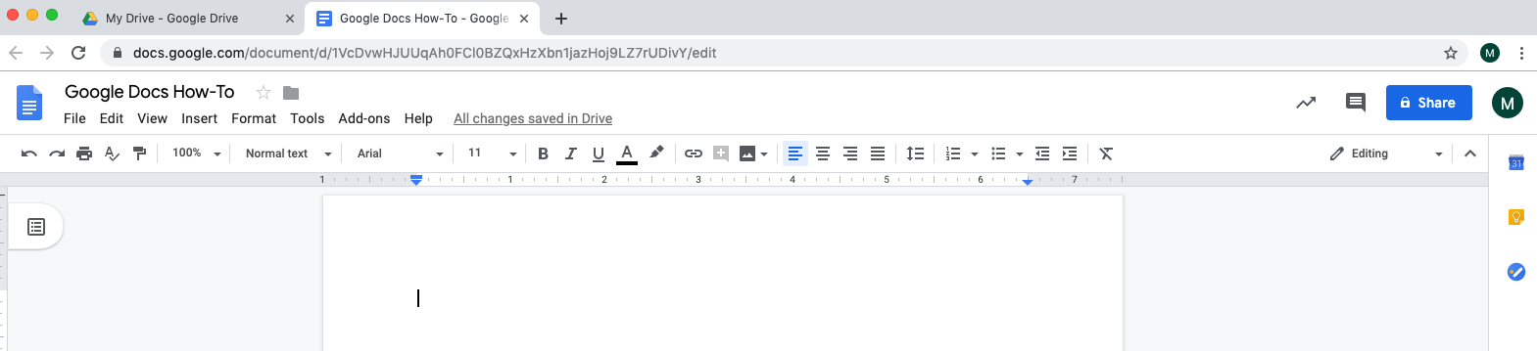

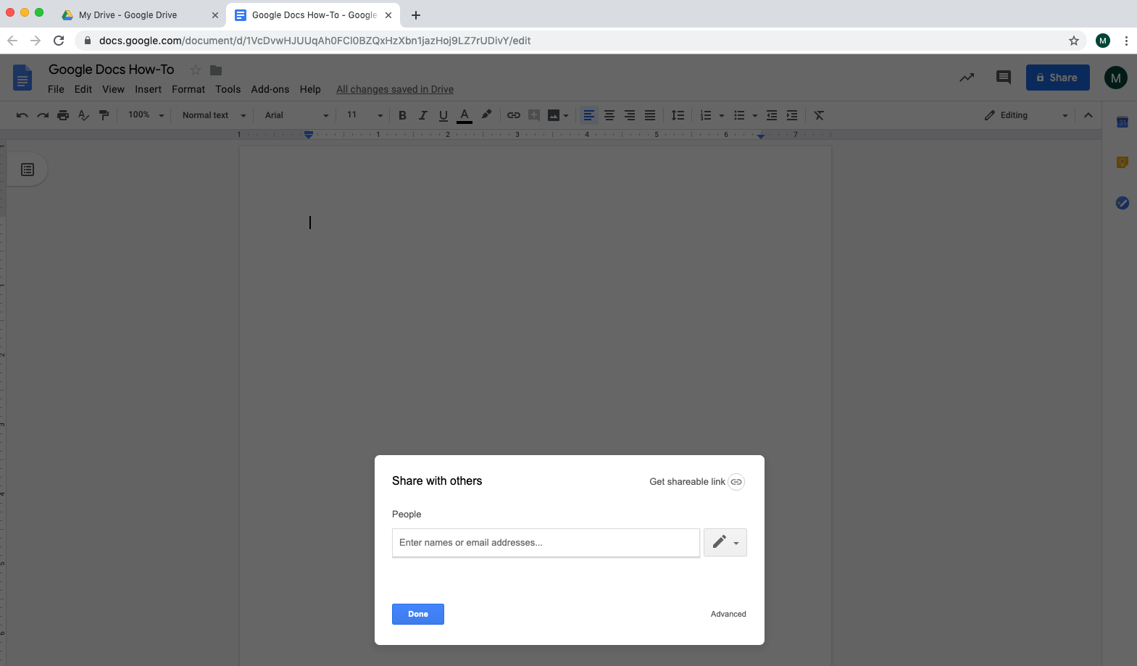

**To find a shared document, go to Drive > Shared with me
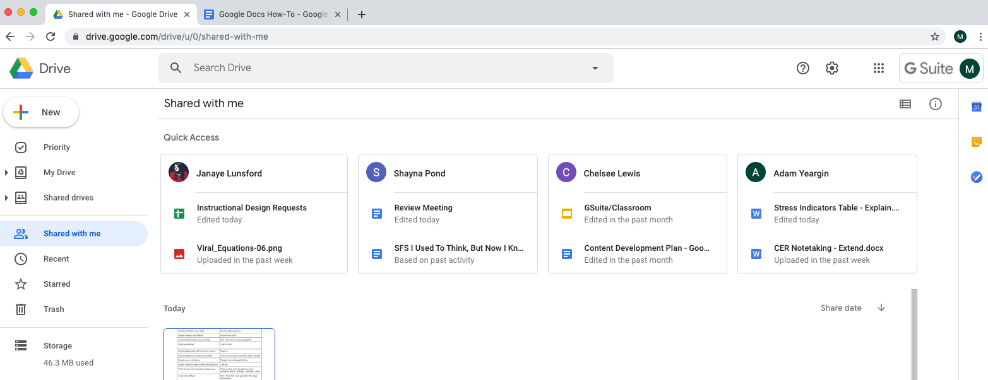

- Insert a table with information about animal traits fur, feathers, and scales
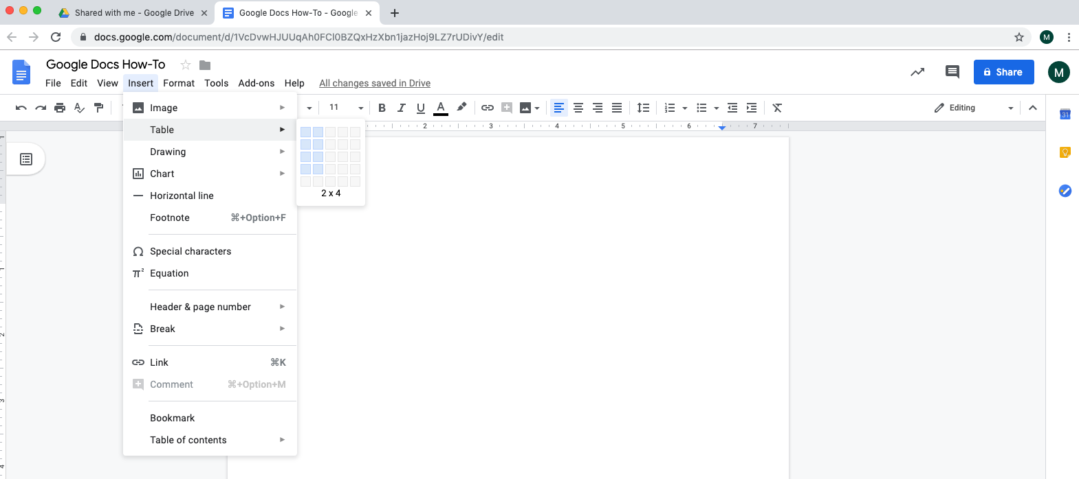

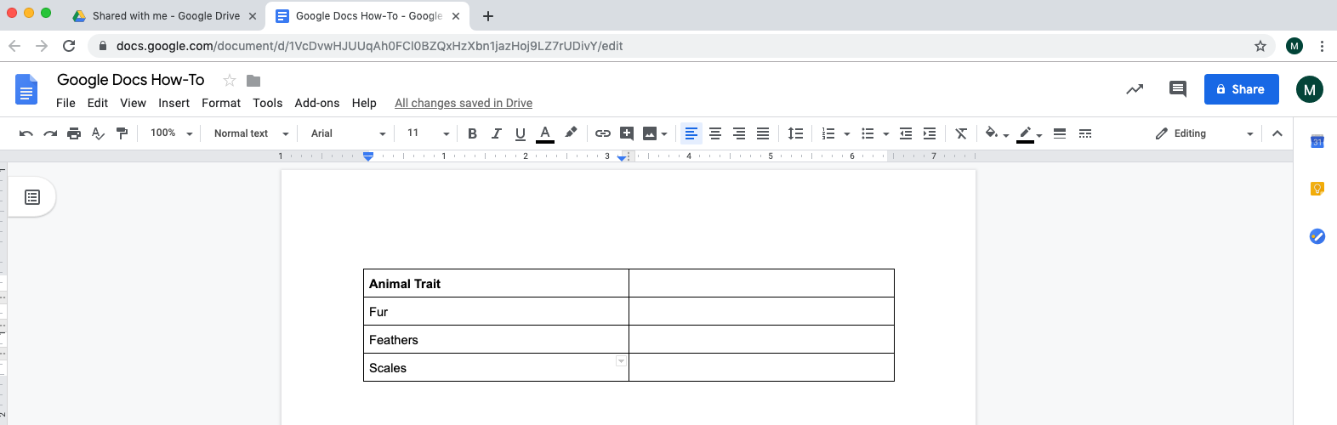

- Have group members edit the table at the same time
  - Use bullets or numbers

  - Insert an image with a link to a webpage
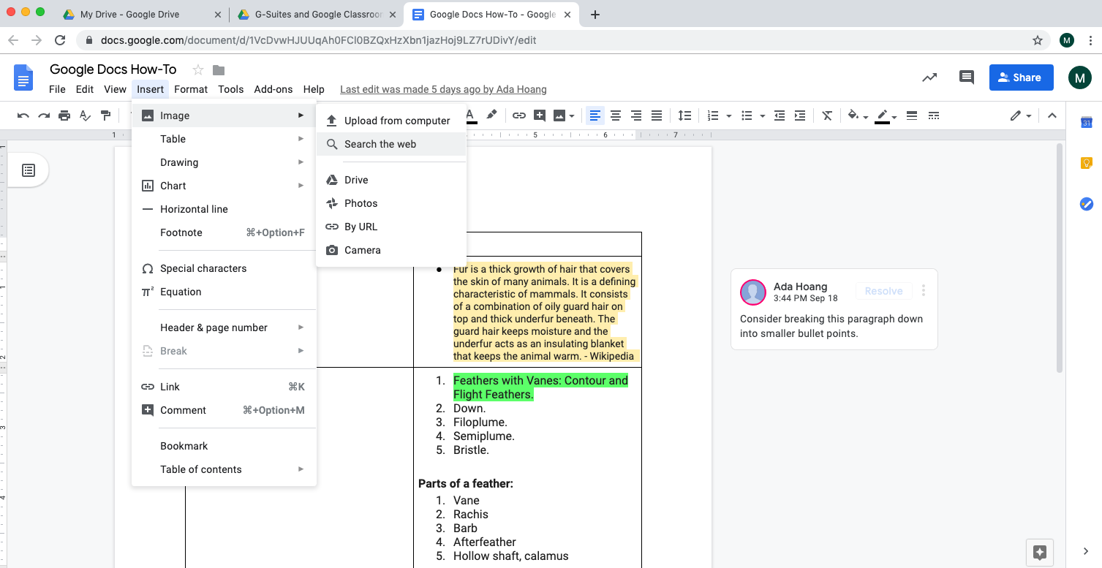

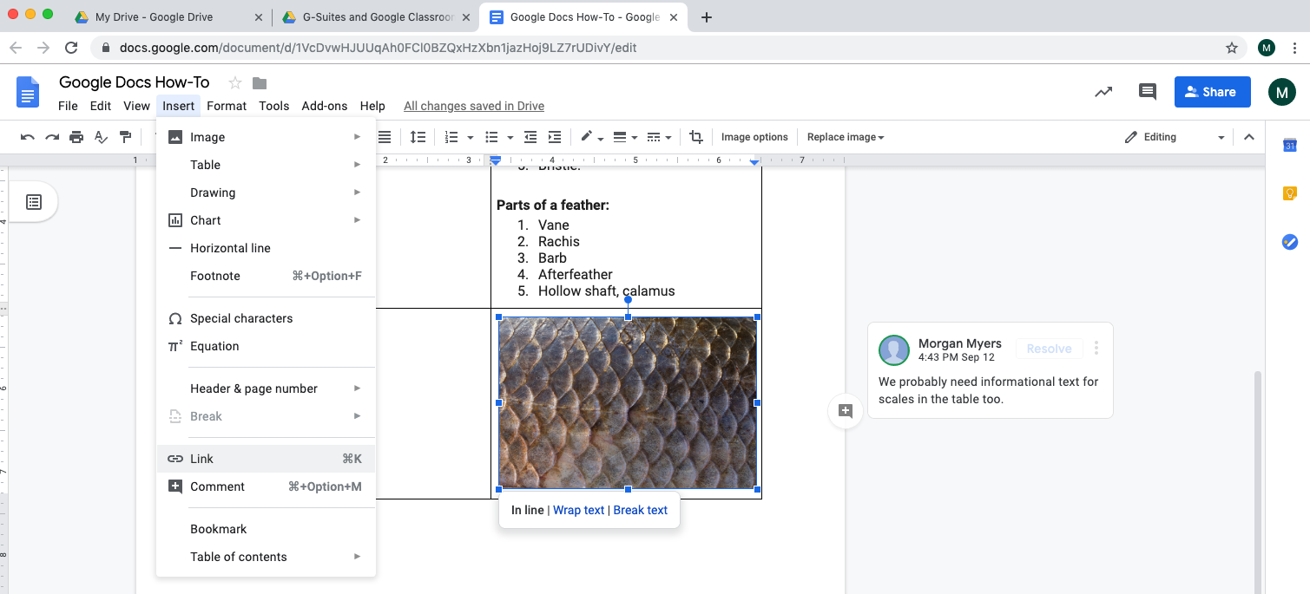

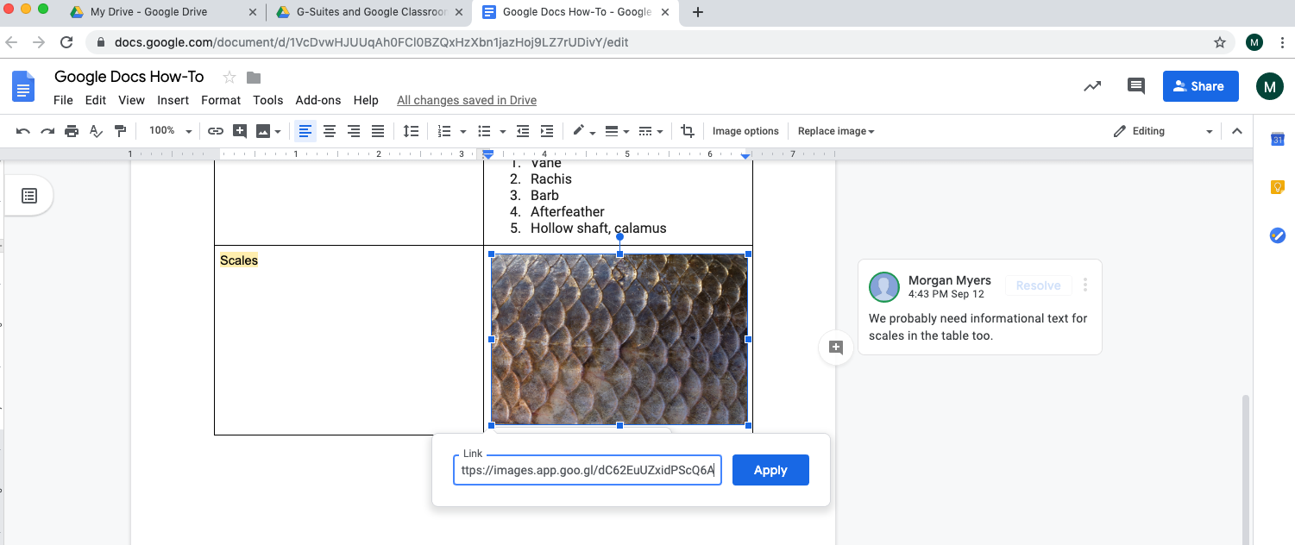

- View revision history
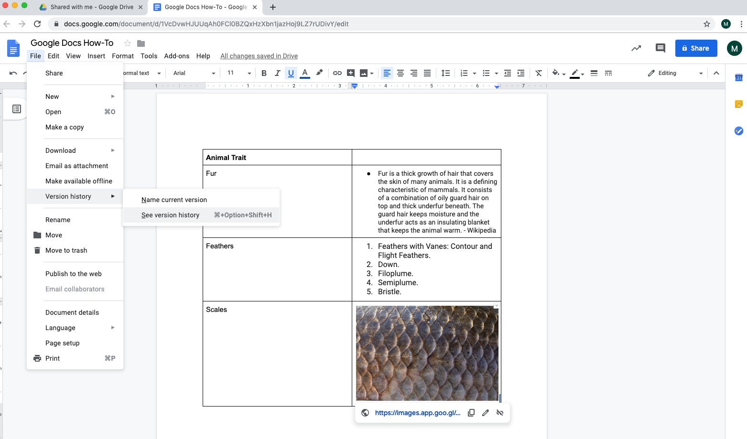

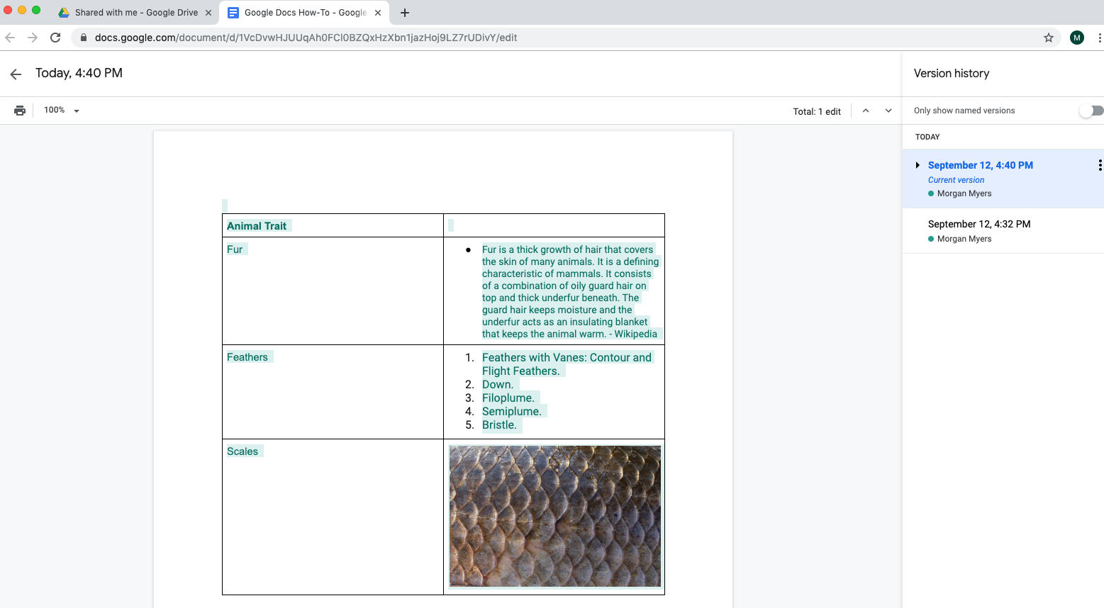

- Make a comment
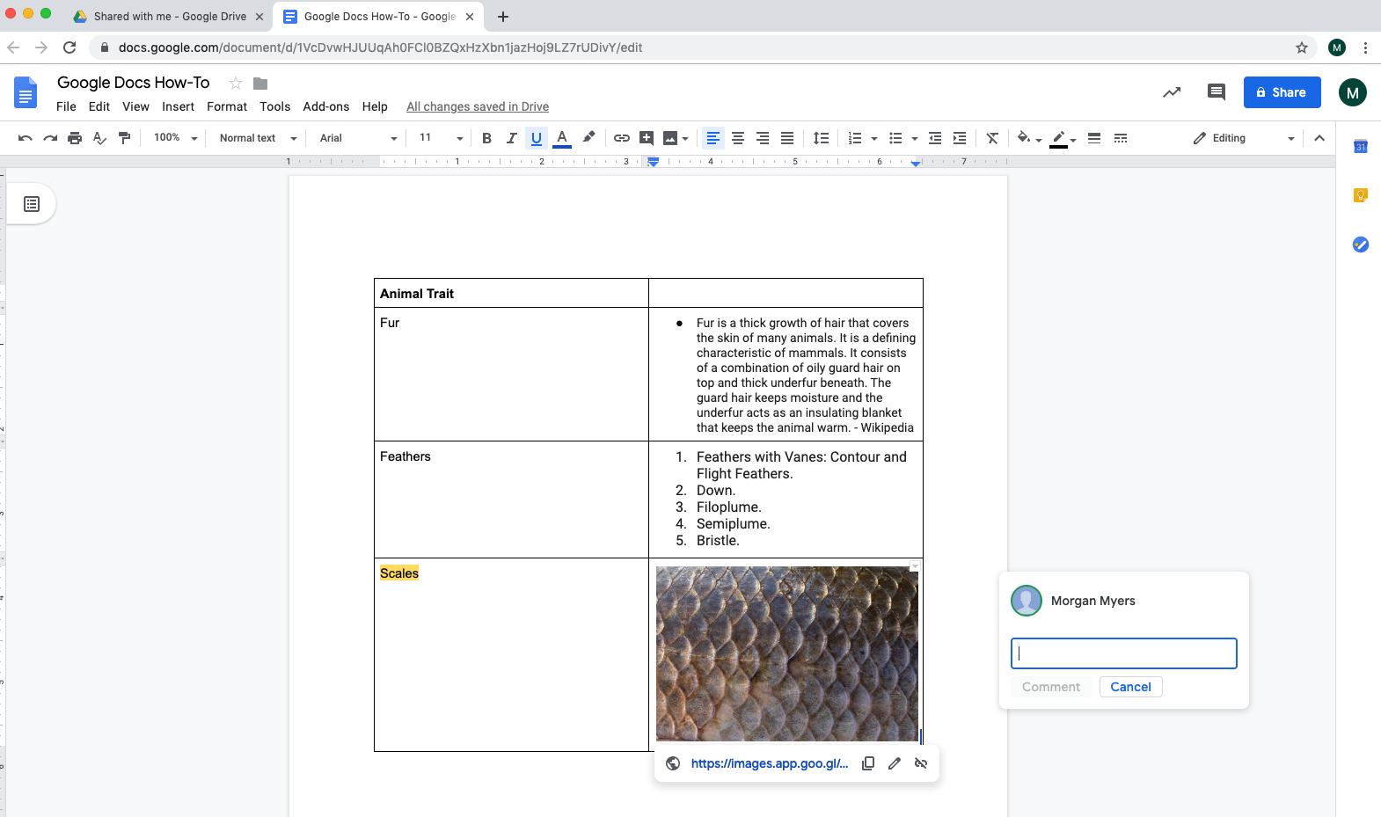

- On your own Doc: Select Add-ons > Get add-on > search for Highlight Tool > Free +

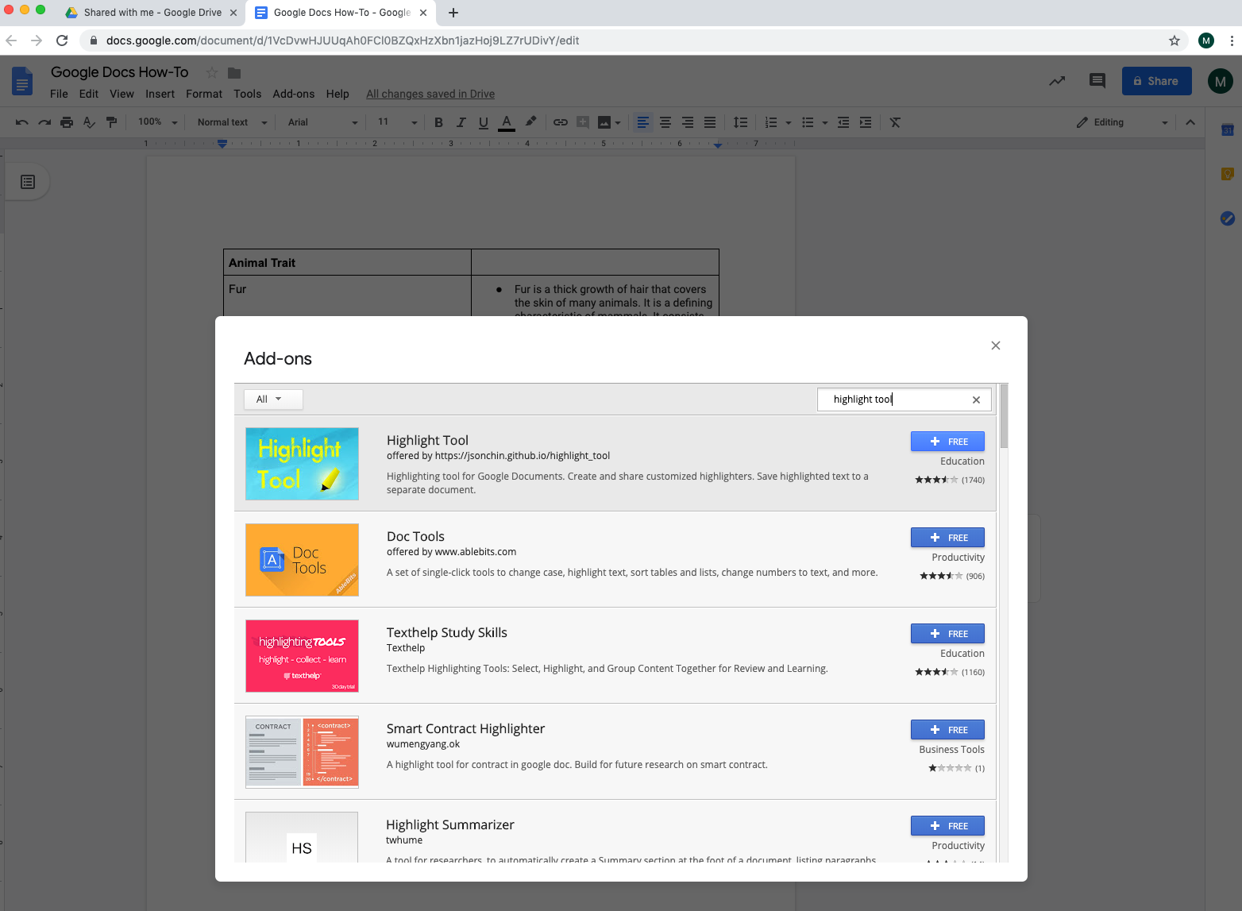

- Explore how to use the highlight tool
