HOW TO CREATE GOOGLE DRAWINGS
Following is the task list from the G Suite & Google Classroom presentation with accompanying screenshots. Work through the list to familiarize yourself with Google Drawings.
Task List
- Click New, go to more, and choose Google Drawings
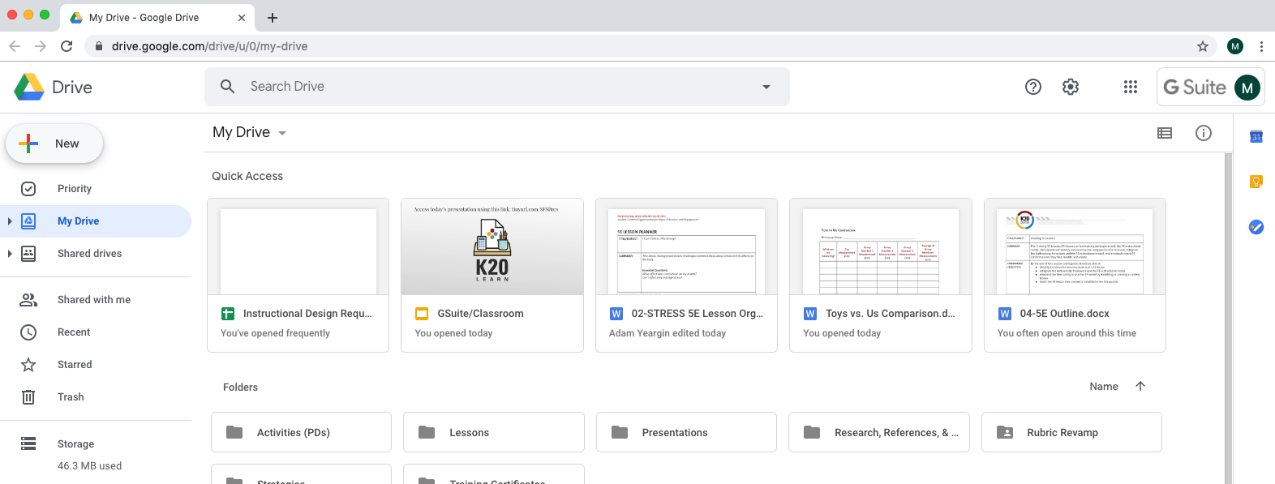

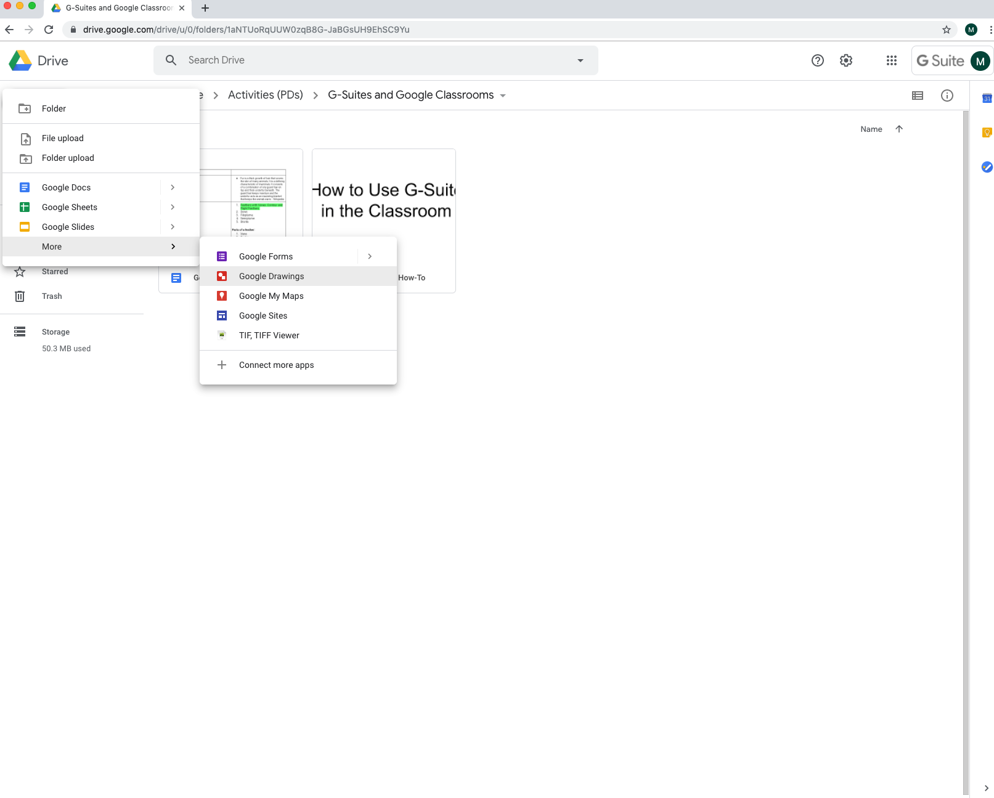

- Create a flowchart of a subject of your choice (example: Hierarchy of an organization or life events). Templates are available under Diagrams (or you can make your own using shapes and lines).
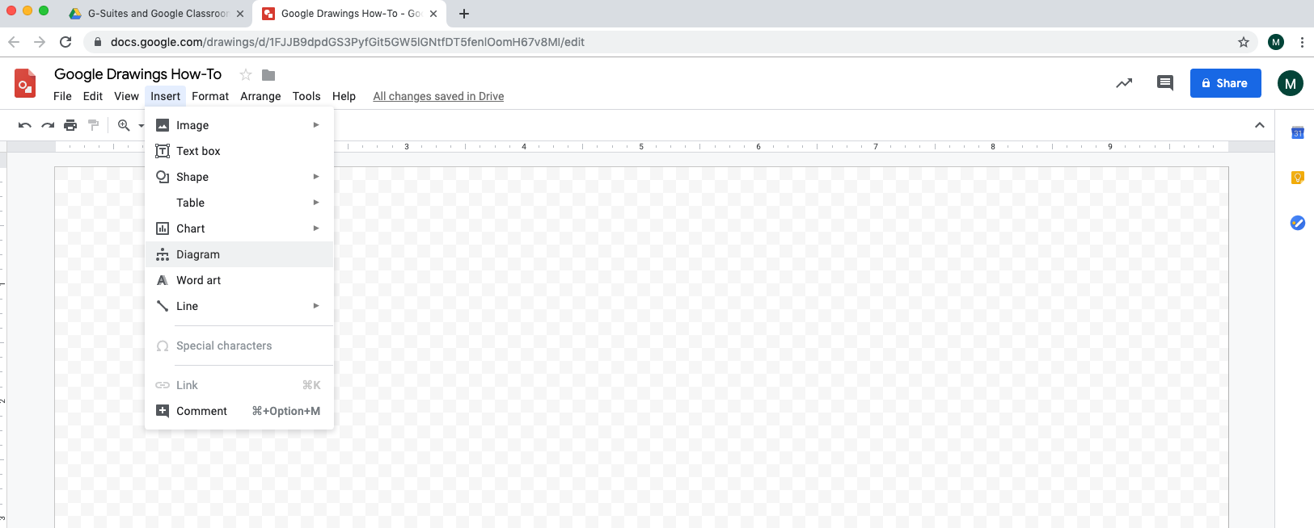

- Give it a title
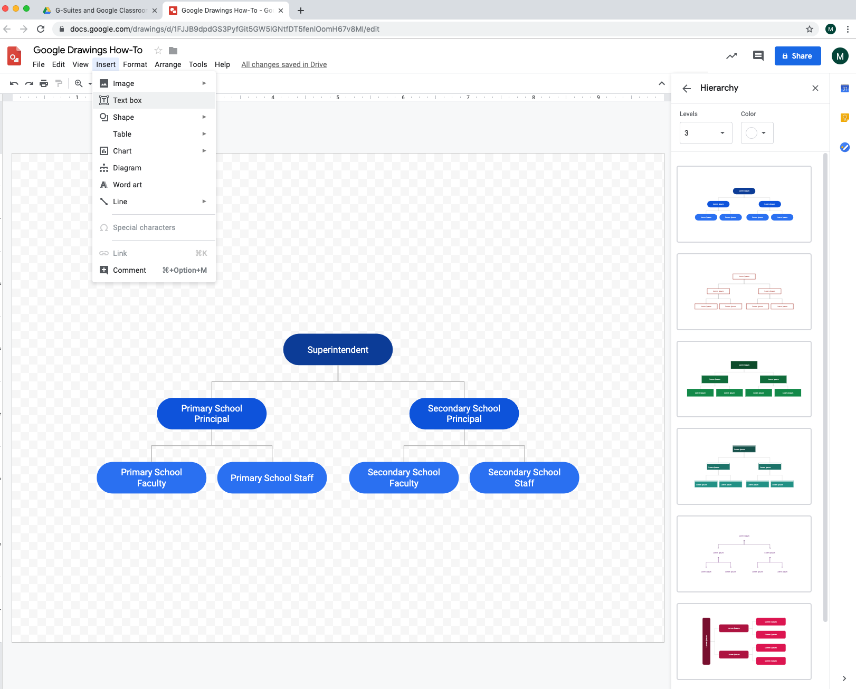

- Include lines, shapes, text, and images
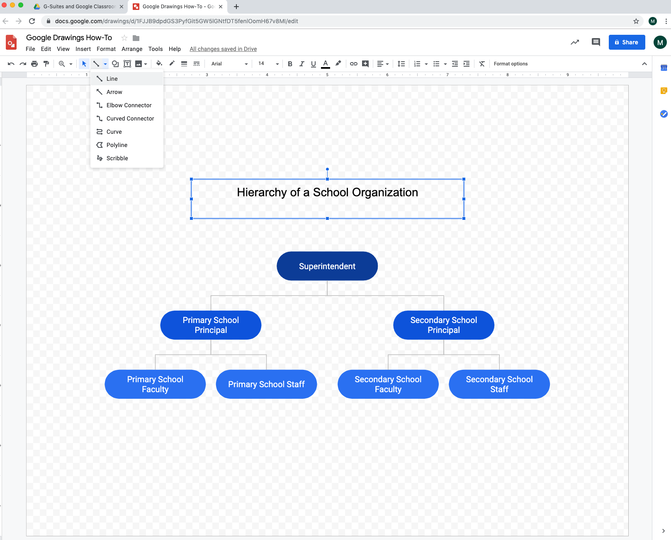

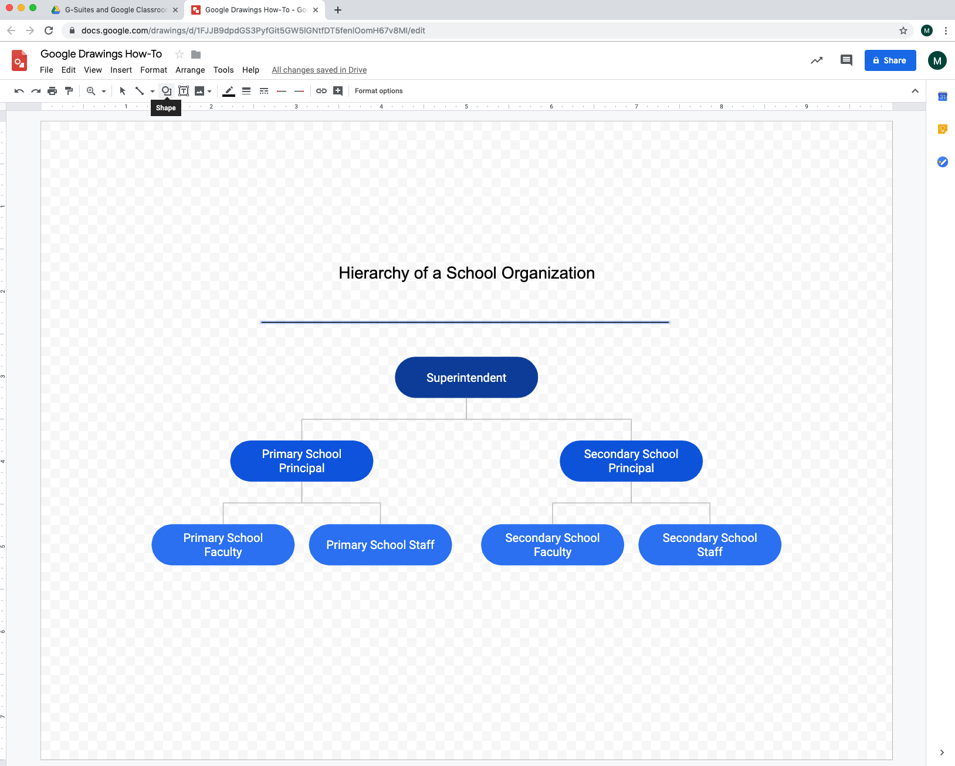

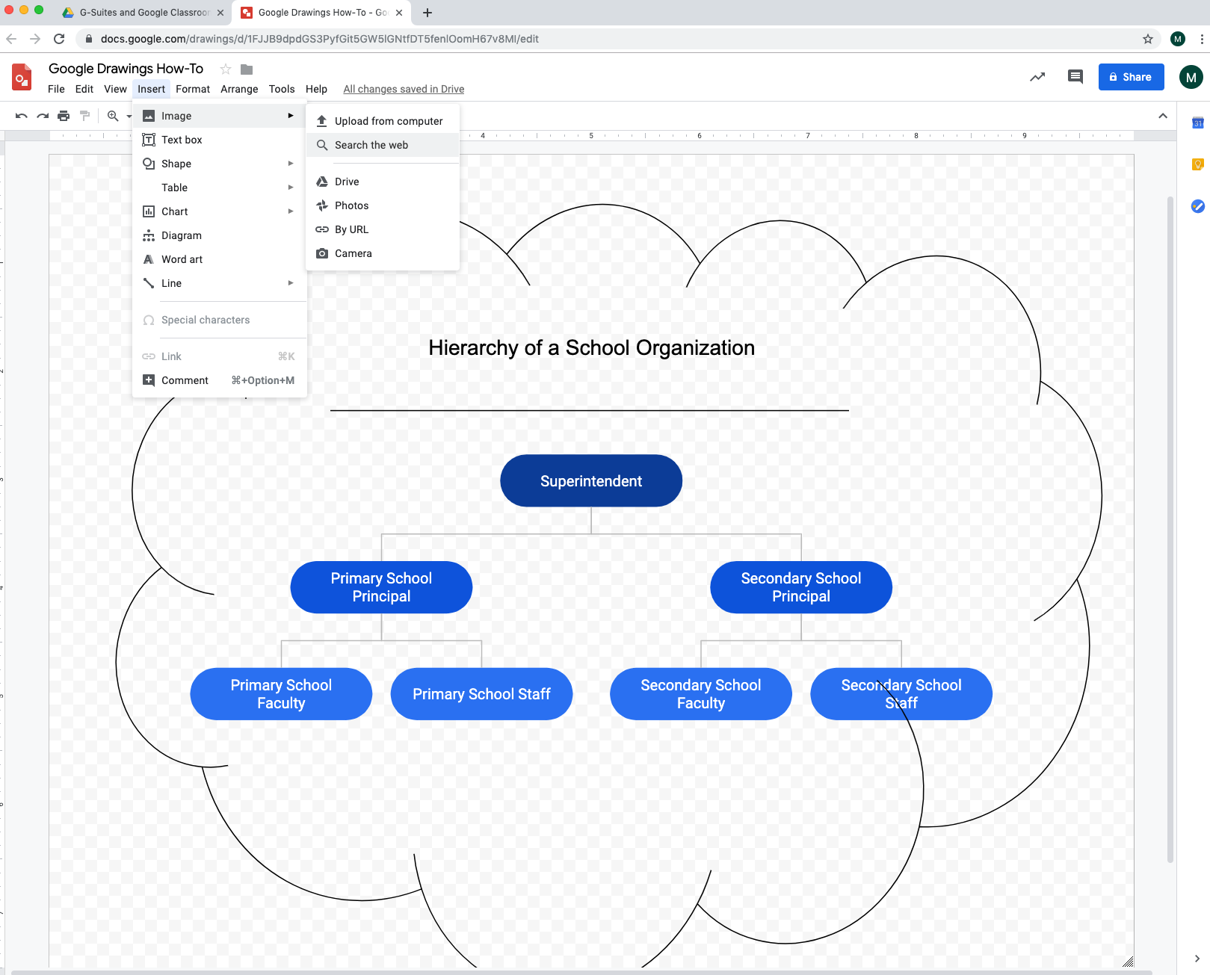

- Insert a link to a shape or text
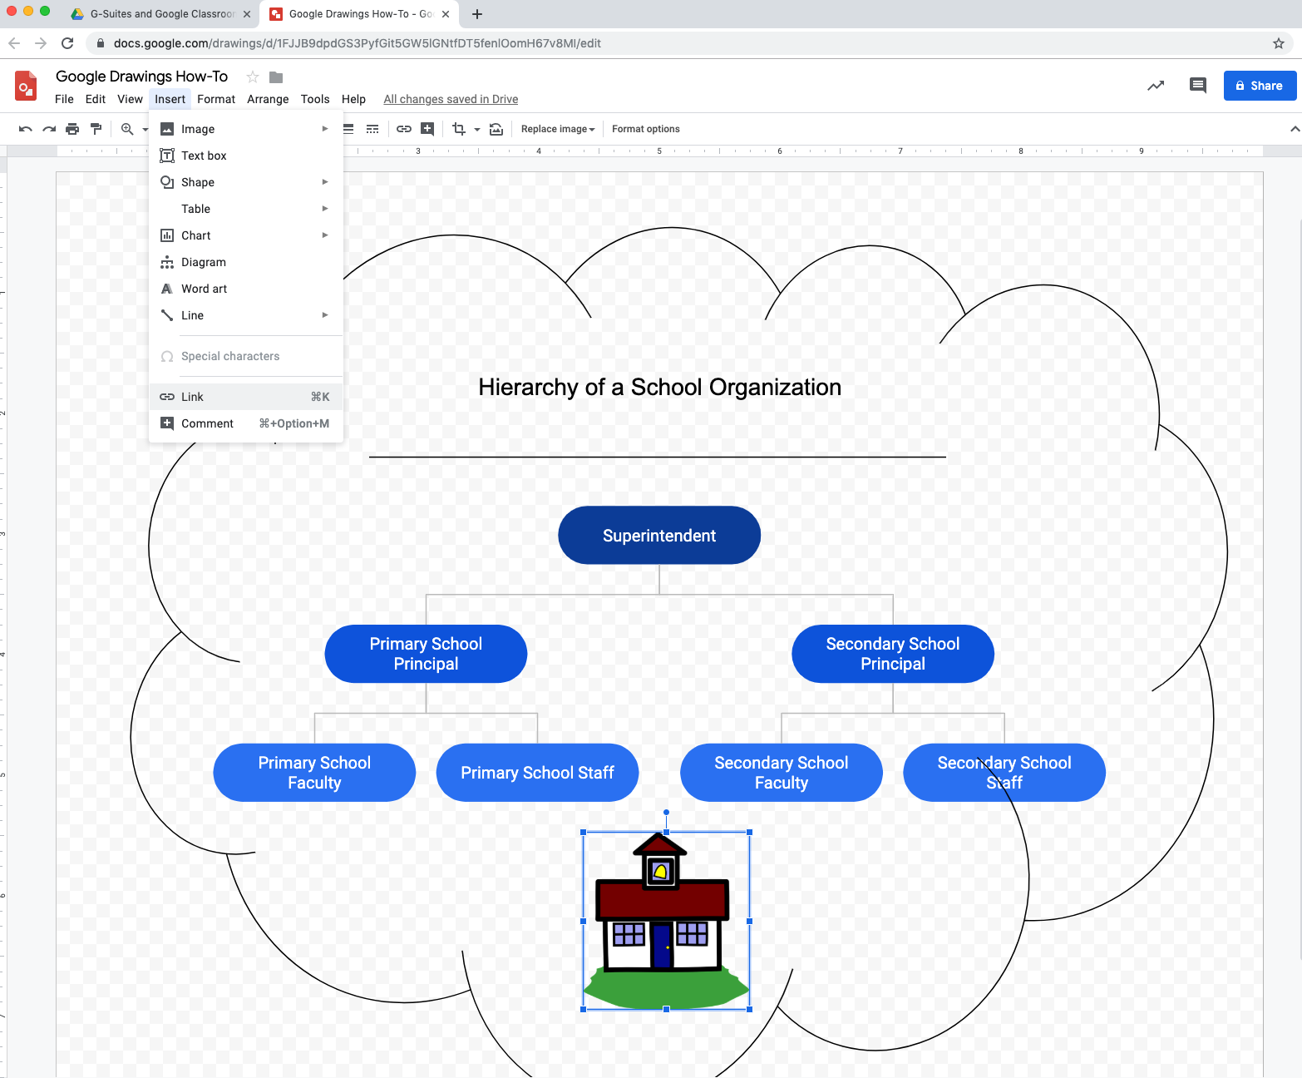

- Share with group members to comment only
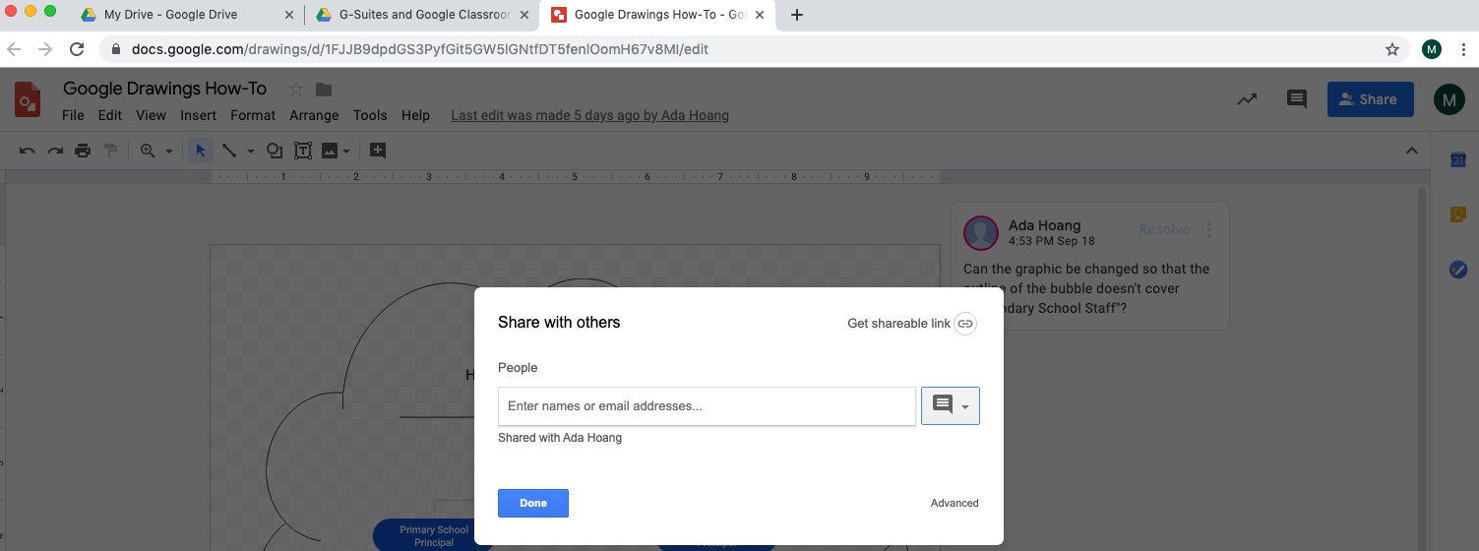

- Check out these graphic organizers. Make a copy and save it to your drive.
**To find a shared document, go to Drive > Shared with me
