HOW TO CREATE GOOGLE EXPLORE
Following is the task list from the G-Suite & Google Classroom presentation with accompanying screenshots. Work through the list to familiarize yourself with Google Explore.

Task List
- Open a new Doc.
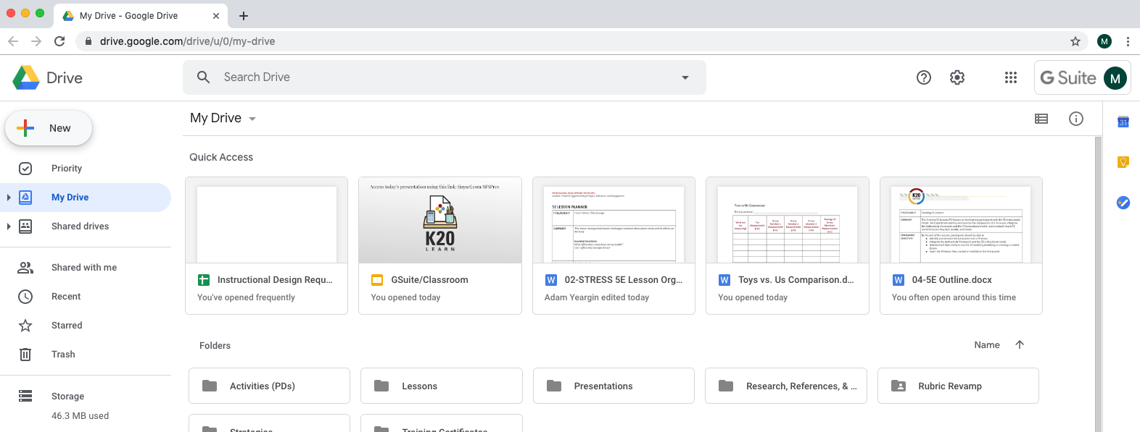

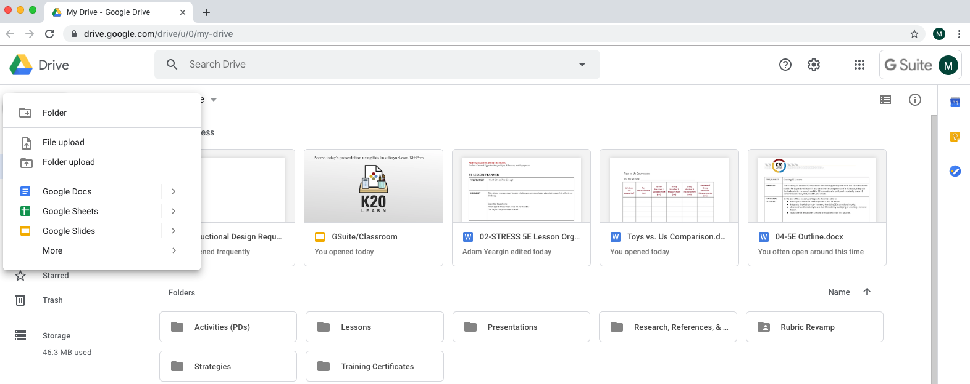

- Title it “World History Notes.”
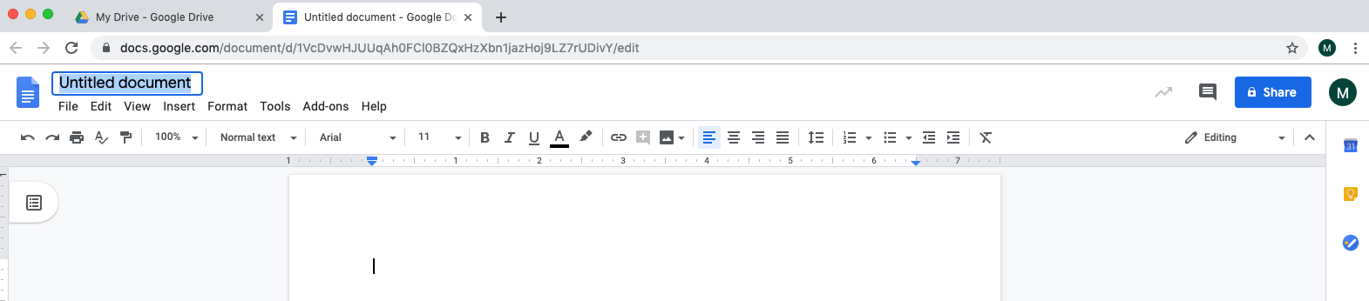

- Using a bulleted list, jot down anything you know about Christopher Columbus.
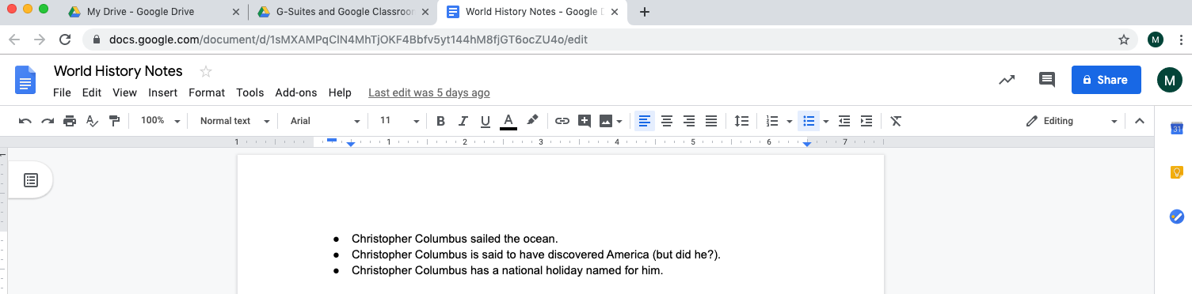

- Select the “Explore” button in the bottom right corner of your screen.
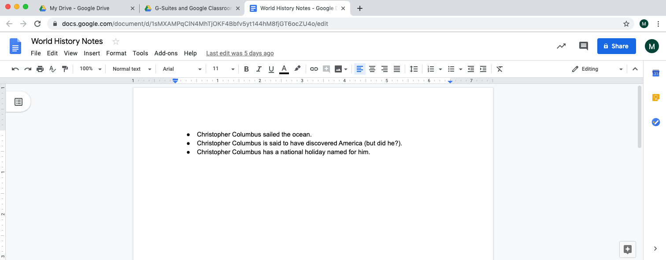

- Using the “Web” tab, find more information about Christopher Columbus.
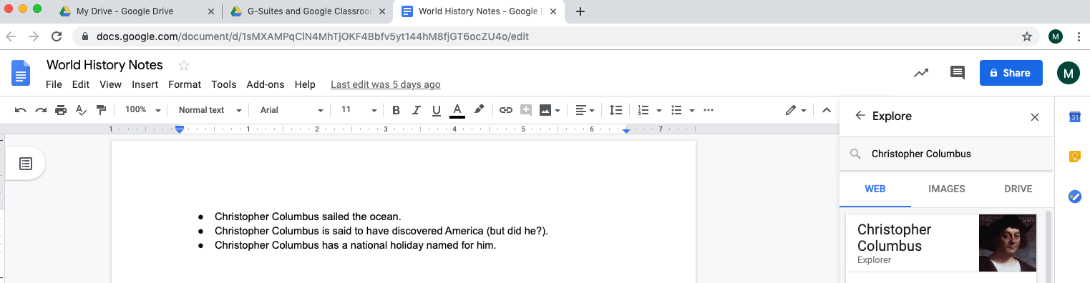

- Using the “Images” tab, drag and drop an image into your notes.
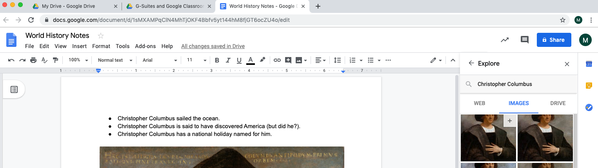

- Using the “Drive” tab, search for any other notes you might have.
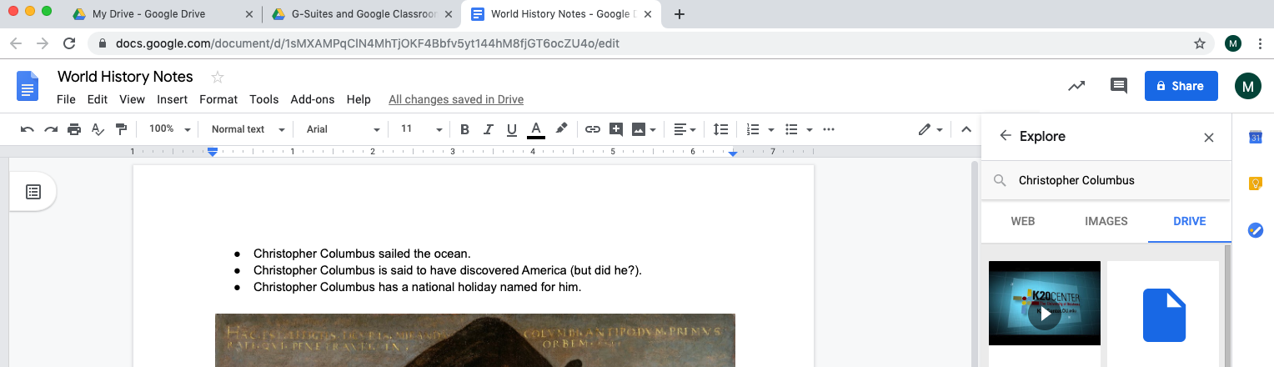

- Don’t forget to push the Explore button in other Google apps!

