HOW TO CREATE GOOGLE FORMS
Following is the task list from the G-Suite & Google Classroom presentation with accompanying screenshots. Work through the list to familiarize yourself with Google Forms.

Task List
- Click New, go to “more”, choose Google Forms and title
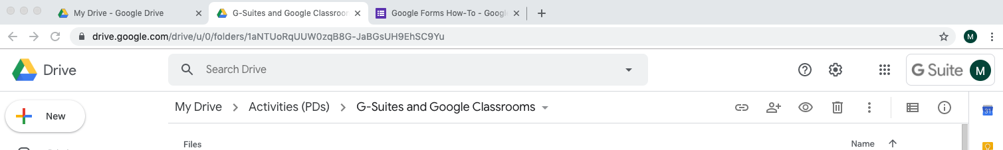

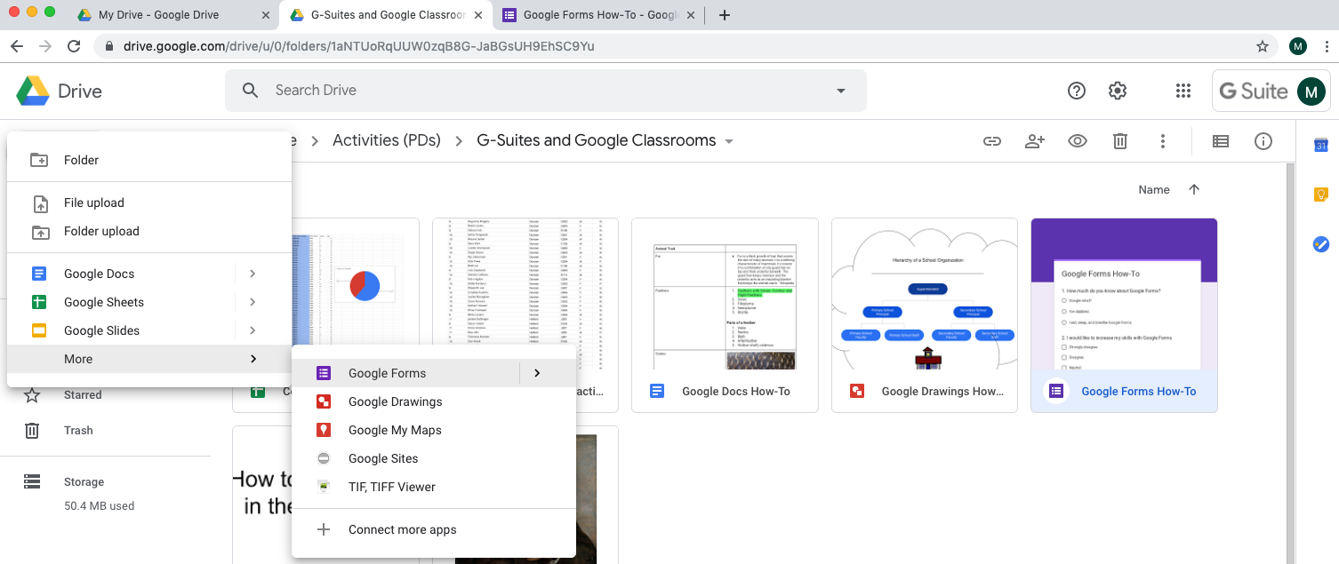

- Add 5 questions of your choice using at least 3 different question types.
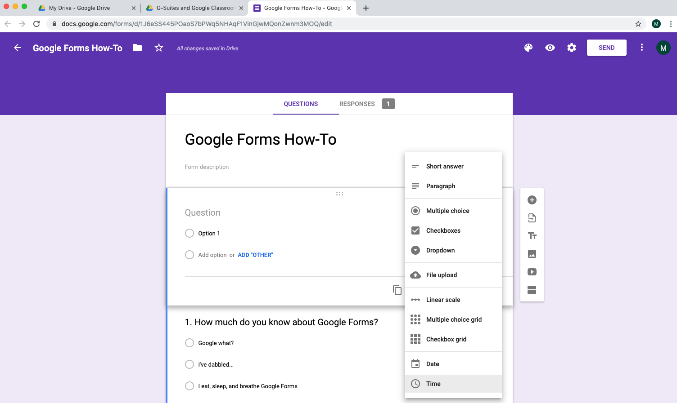

- View Live form

- Share and have group members submit answers to form

- View summary of responses
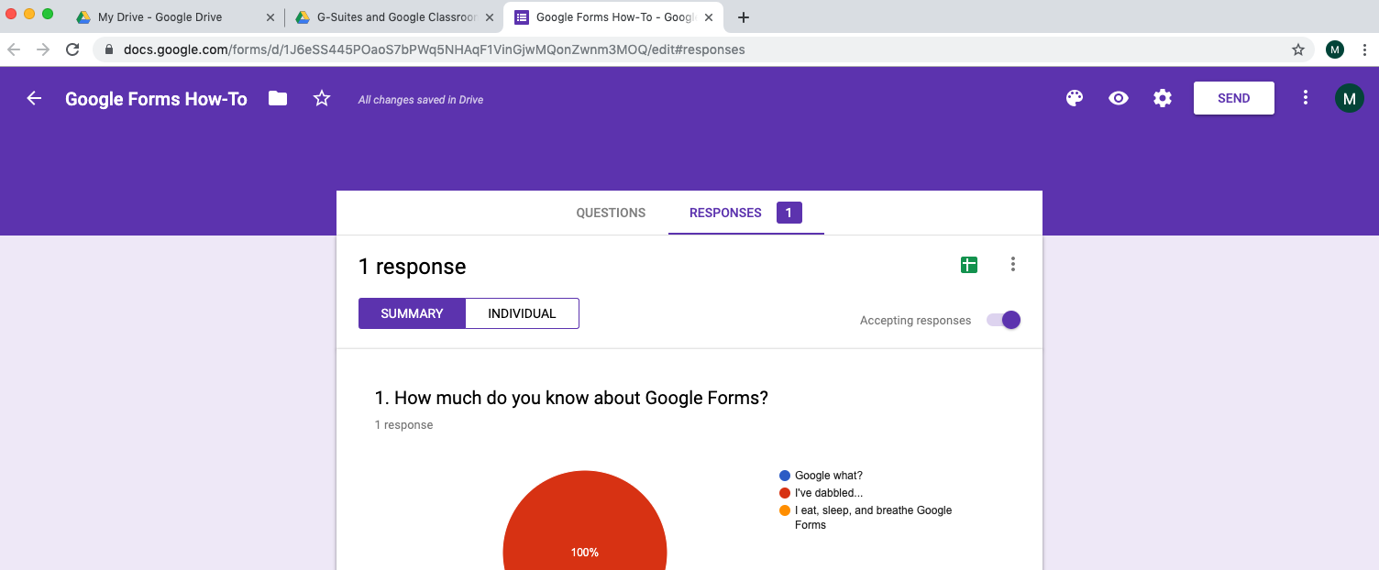

- Create Spreadsheet and view responses

