HOW TO CREATE GOOGLE SHEETS
Following is the task list from the G Suite & Google Classroom presentation with accompanying screenshots. Work through the list to familiarize yourself with Google Sheets.

Task List
- Go to tinyurl.com/SFSSheets
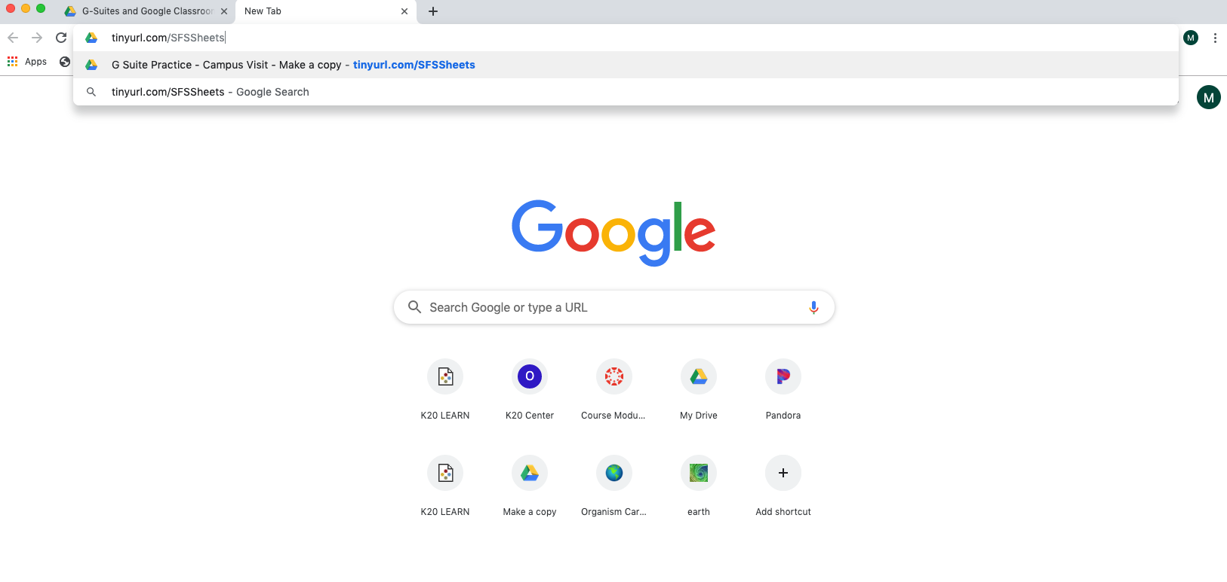

- Make a copy of the “Campus Visit” Spreadsheet
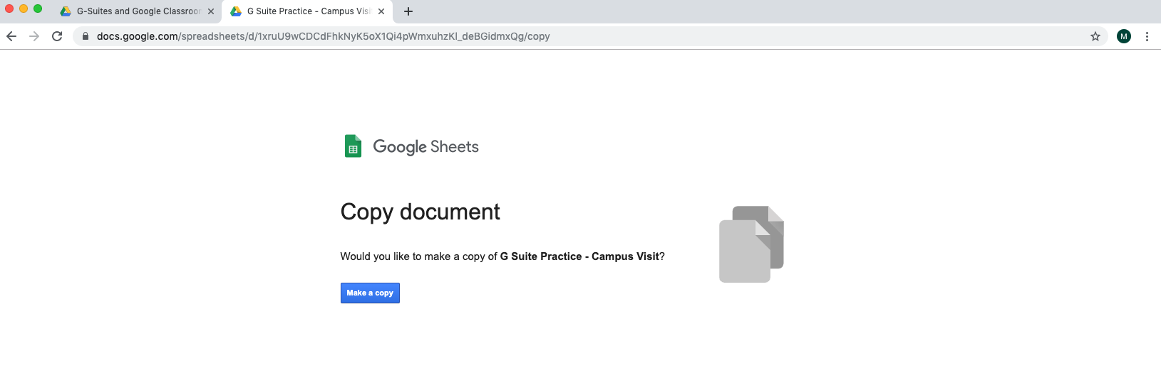

- Sort the information by teacher (it will be helpful to freeze the top row first)
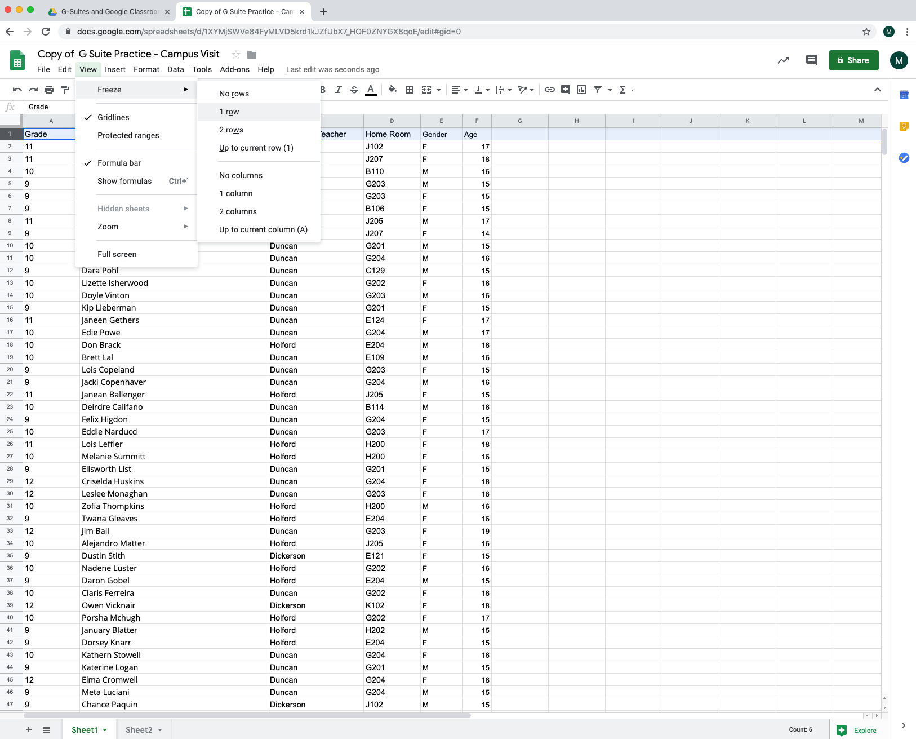

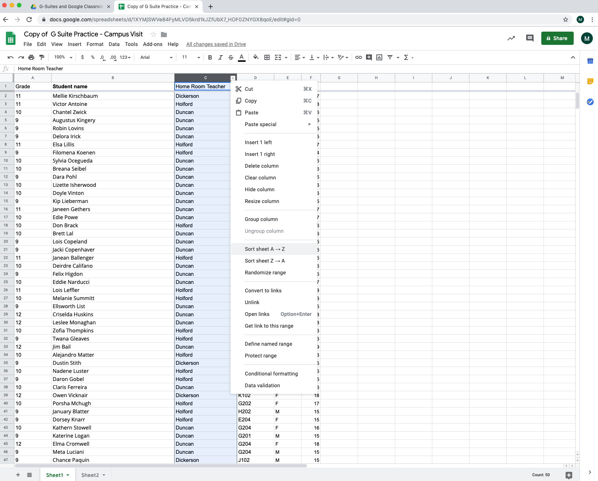

- Fill one of the columns with a color
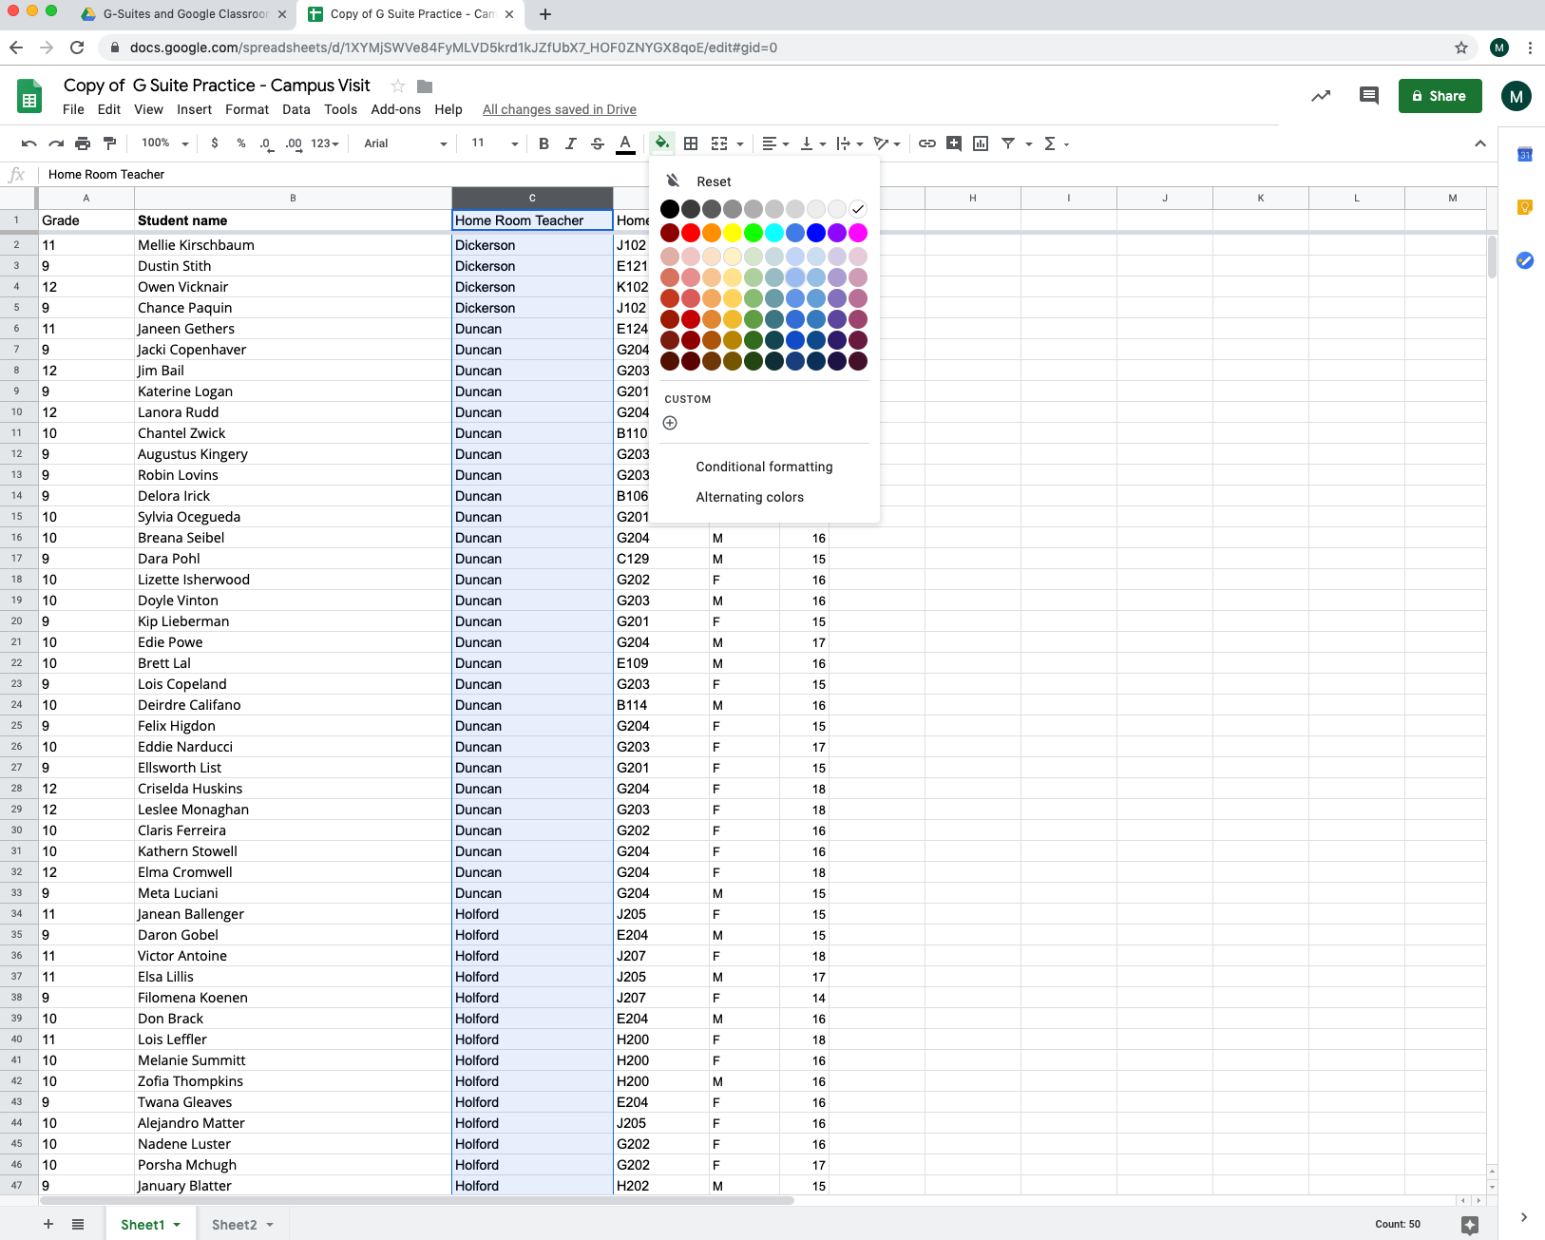

- Select Column E and create a graph
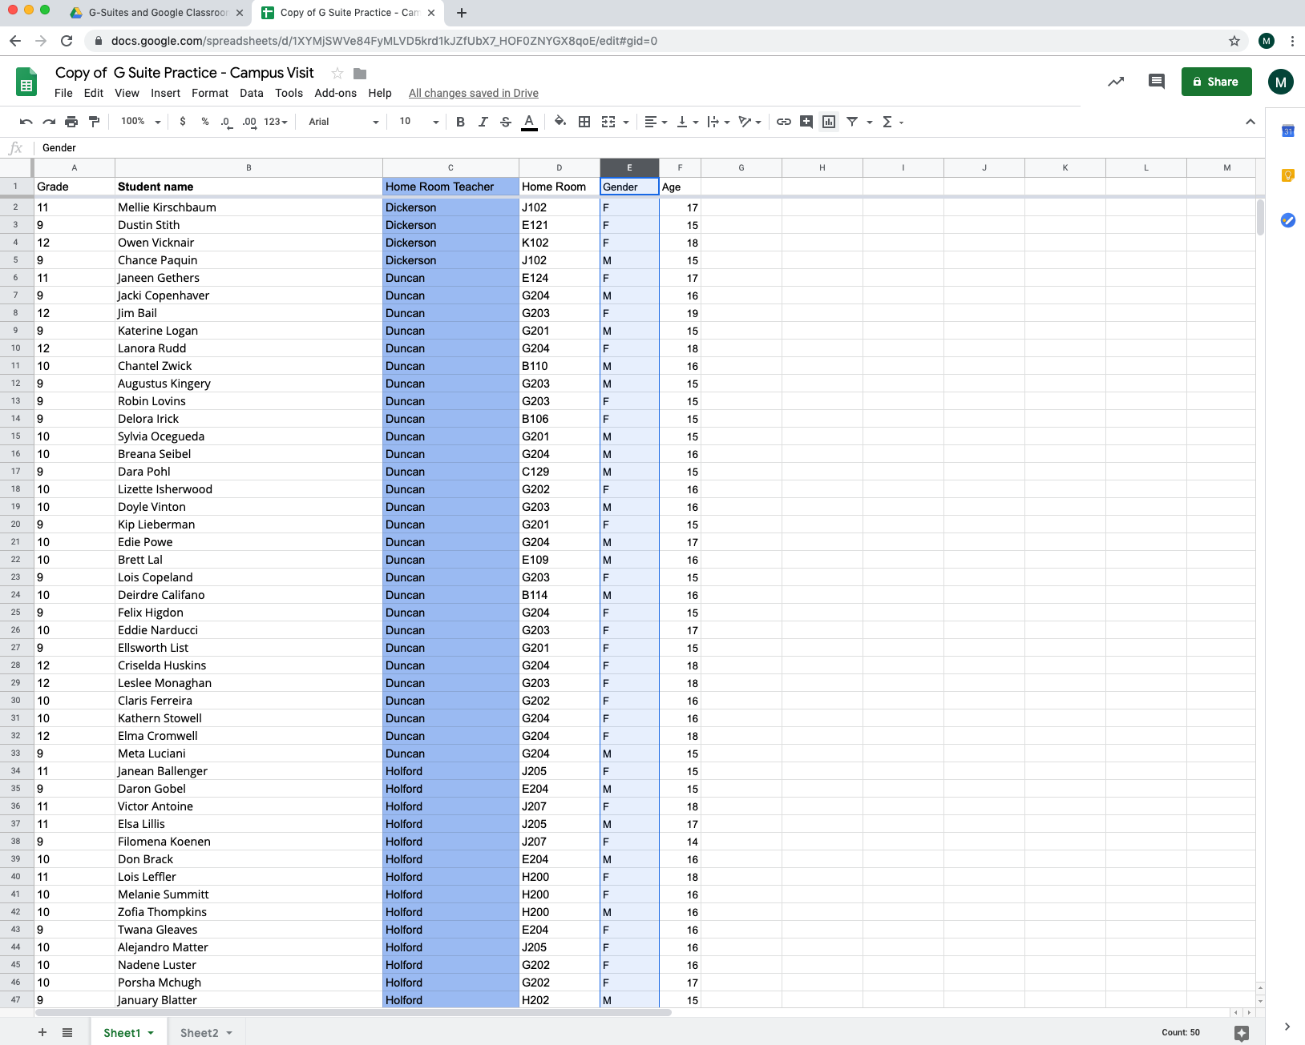

- Copy all the students of a particular teacher and add them to a second sheet in the same file and rename the sheet
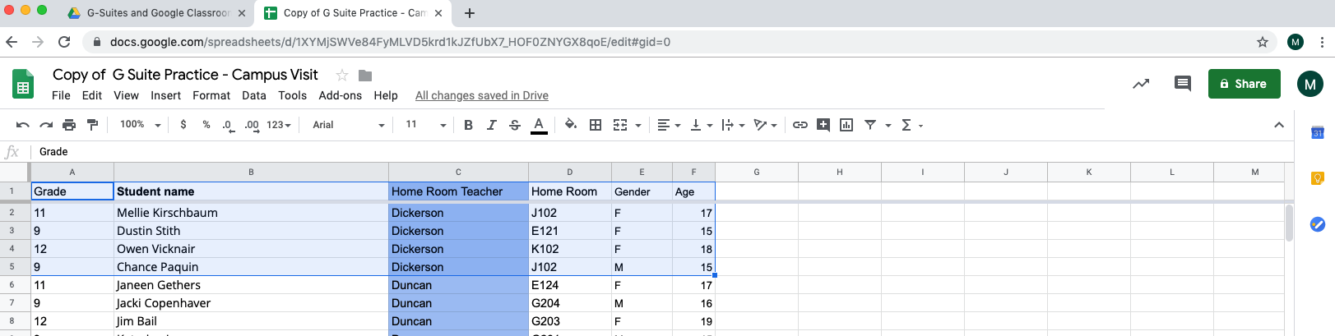

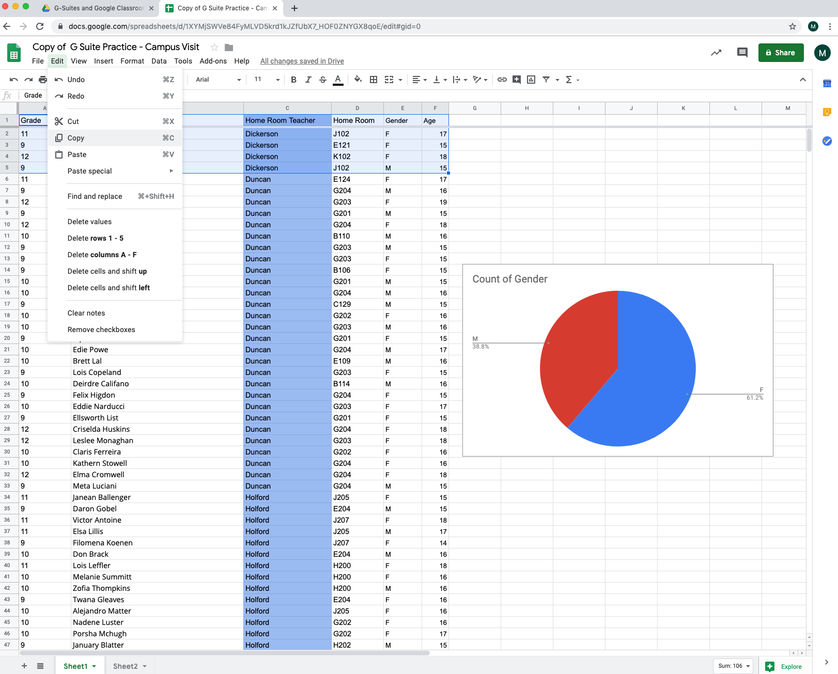

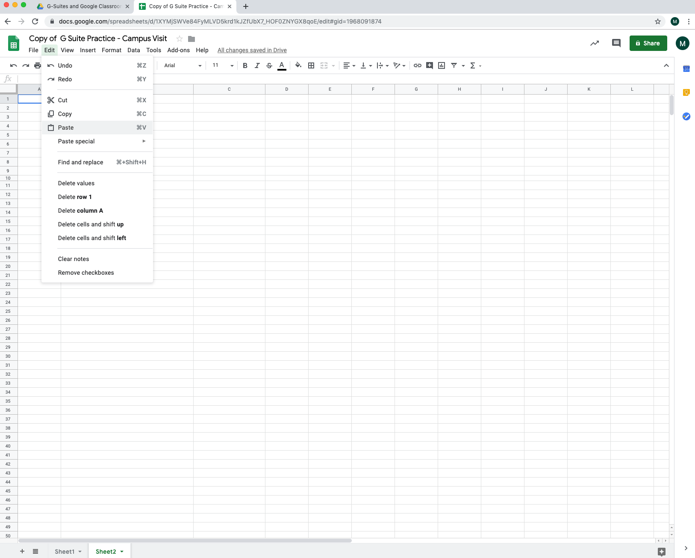

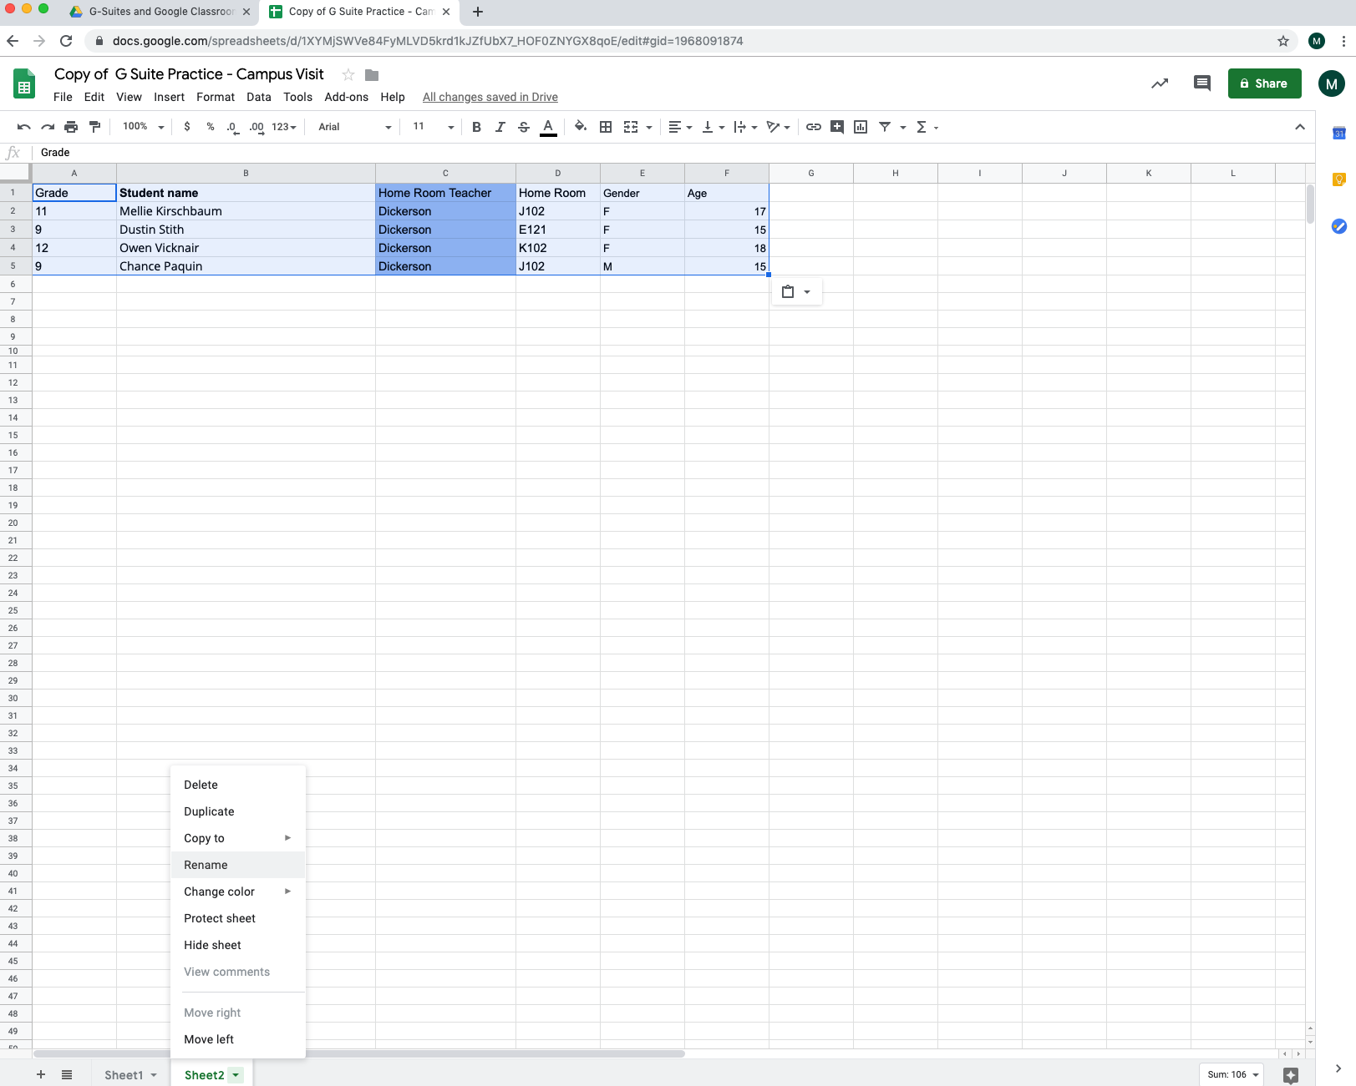

- Find the average age
