 | Elicit and use  evidence of thinking.
Effective teaching of mathematics uses evidence of student thinking to assess progress toward mathematical understanding and to adjust continually in ways that support and extend learning.
Gallery Walk |  | Rose, Bud, Thorn
 |  | 

 | Support productive  struggle in learning mathematics.
Effective teaching of mathematics consistently provides students, individually and collectively, with opportunities to engage in productive struggle as they grapple with mathematical ideas and relationships.
My Favorite Mistake |  | Fishbowl
 |  | 

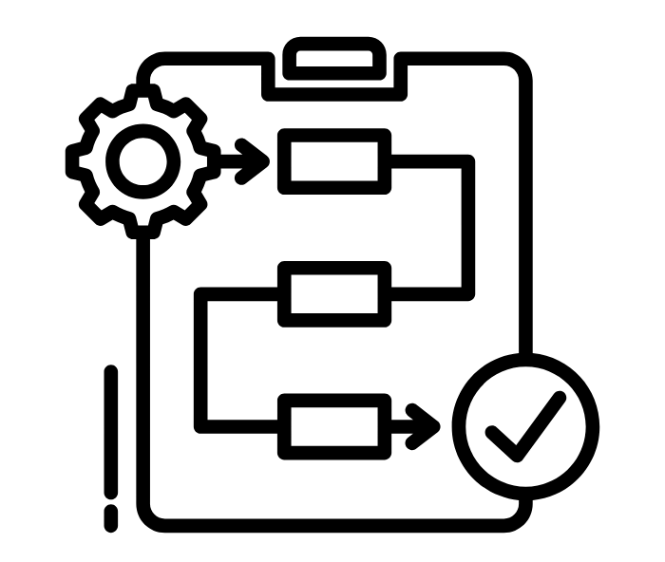 | Build procedural fluency  from conceptual understanding.
Effective teaching of mathematics builds fluency with procedures on a foundation of conceptual understanding so that students, over time, become skillful in using procedures flexibly as they solve contextual and mathematical problems.
Pass the Problem |  | Bellringers and Exit Tickets
 |  | 

 | Pose purposeful  questions.
Effective teaching of mathematics builds fluency with procedures on a foundation of conceptual understanding so that students, over time, become skillful in using procedures flexibly as they solve contextual and mathematical problems.
Exclaim and Question |  | DOK Question Stems
 |  | 

 | Facilitate meaningful  mathematical discourse.
Effective teaching of mathematics facilitates discourse among students to build shared understanding of mathematical ideas by analyzing and comparing student approaches and arguments.
Concept Speed Dating |  | Partner Speaks
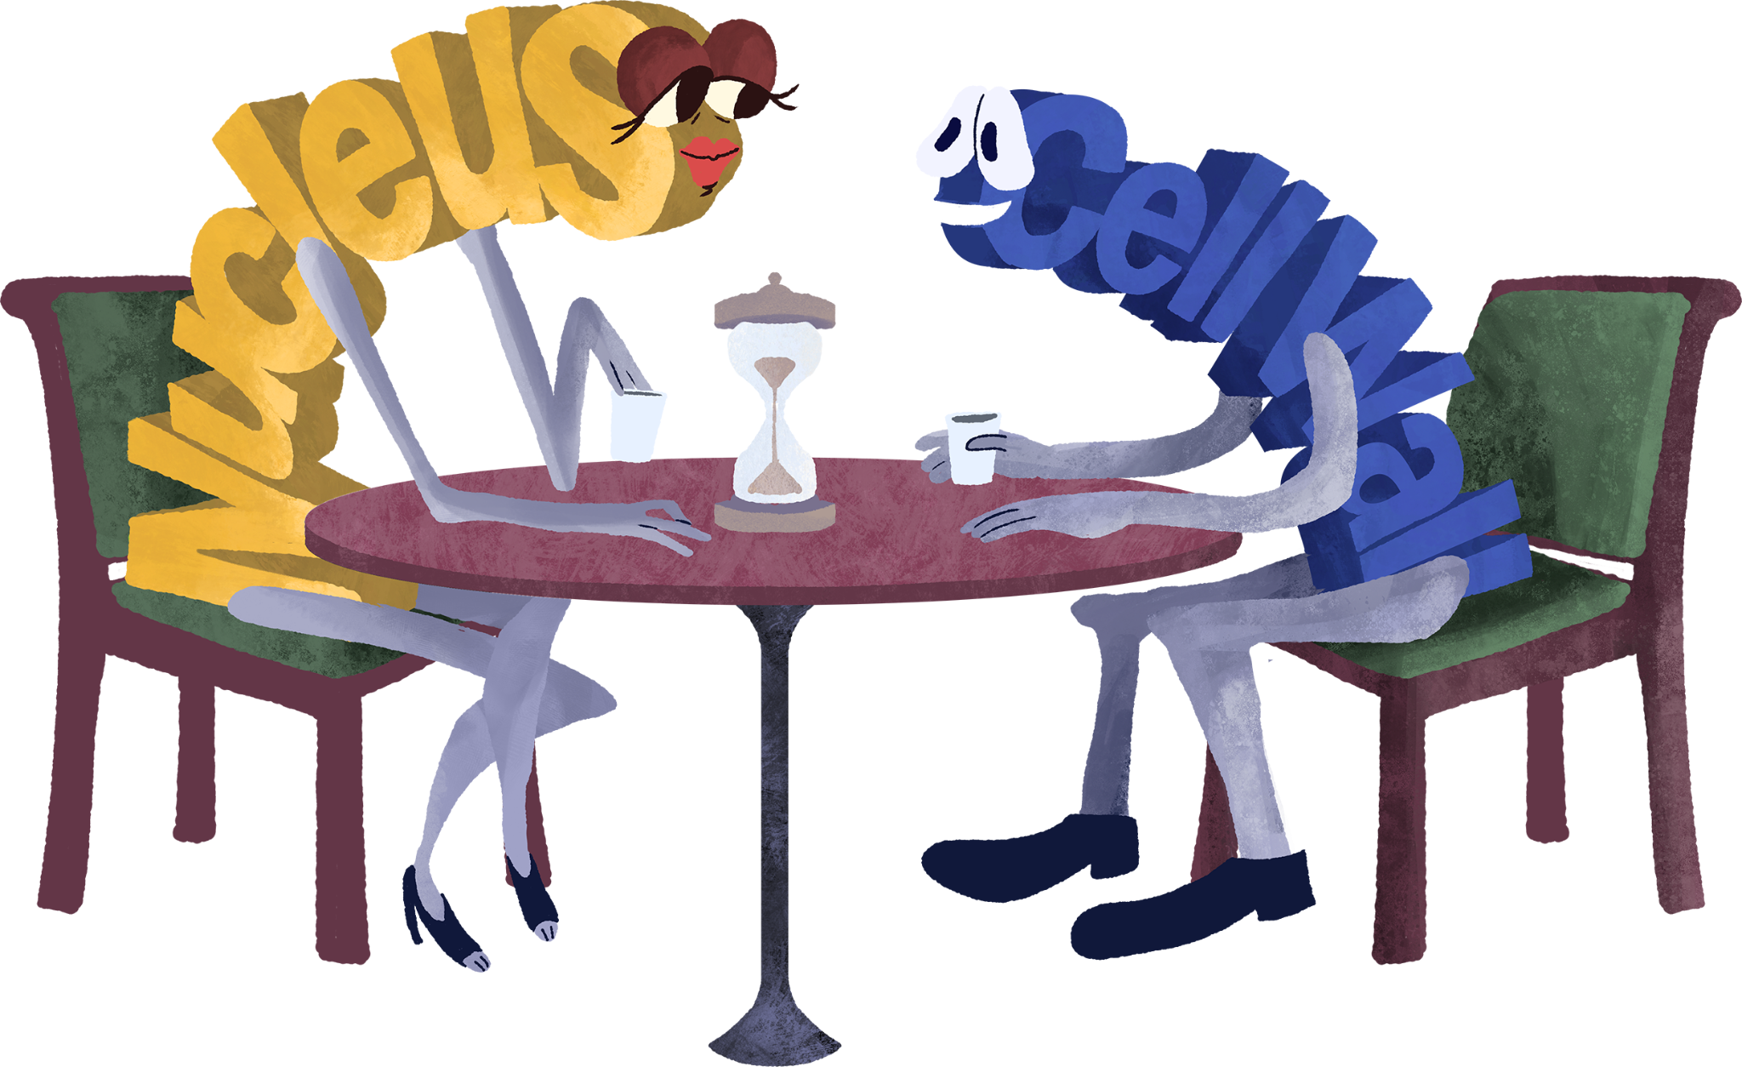 |  | 

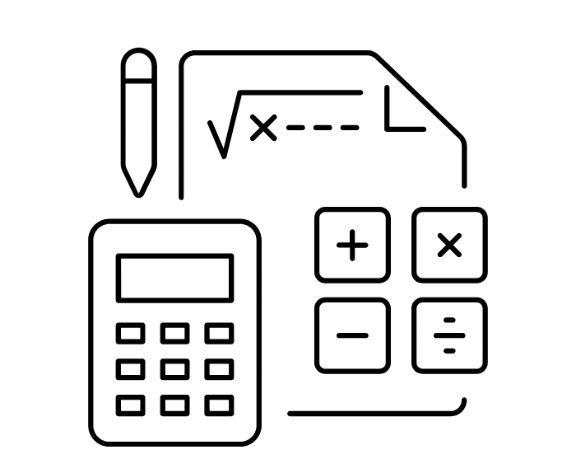 | Use and connect  mathematical representations.
Effective teaching of mathematics engages students in making connections among mathematical representations as tools for problem solving and to deepen understanding of mathematical concepts and procedures.
Critical Thinking Cube |  | Caption This
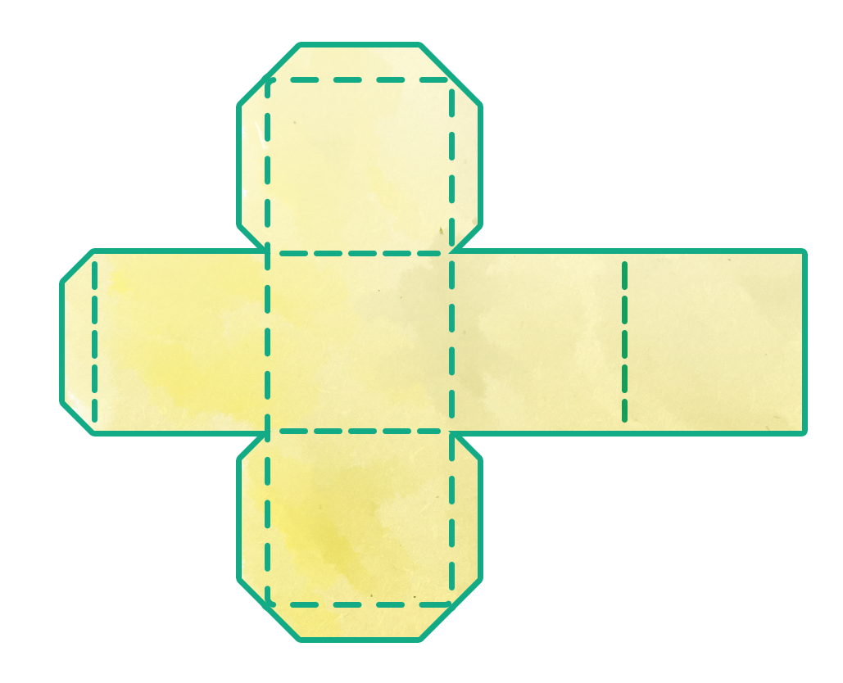 |  | 

 | Implement tasks that  promote reasoning and problem solving.
Effective teaching of mathematics engages students in solving and discussing tasks that promote mathematical reasoning and problem solving and allow multiple entry points and varied solution strategies.
Card Matching |  | Four Corners
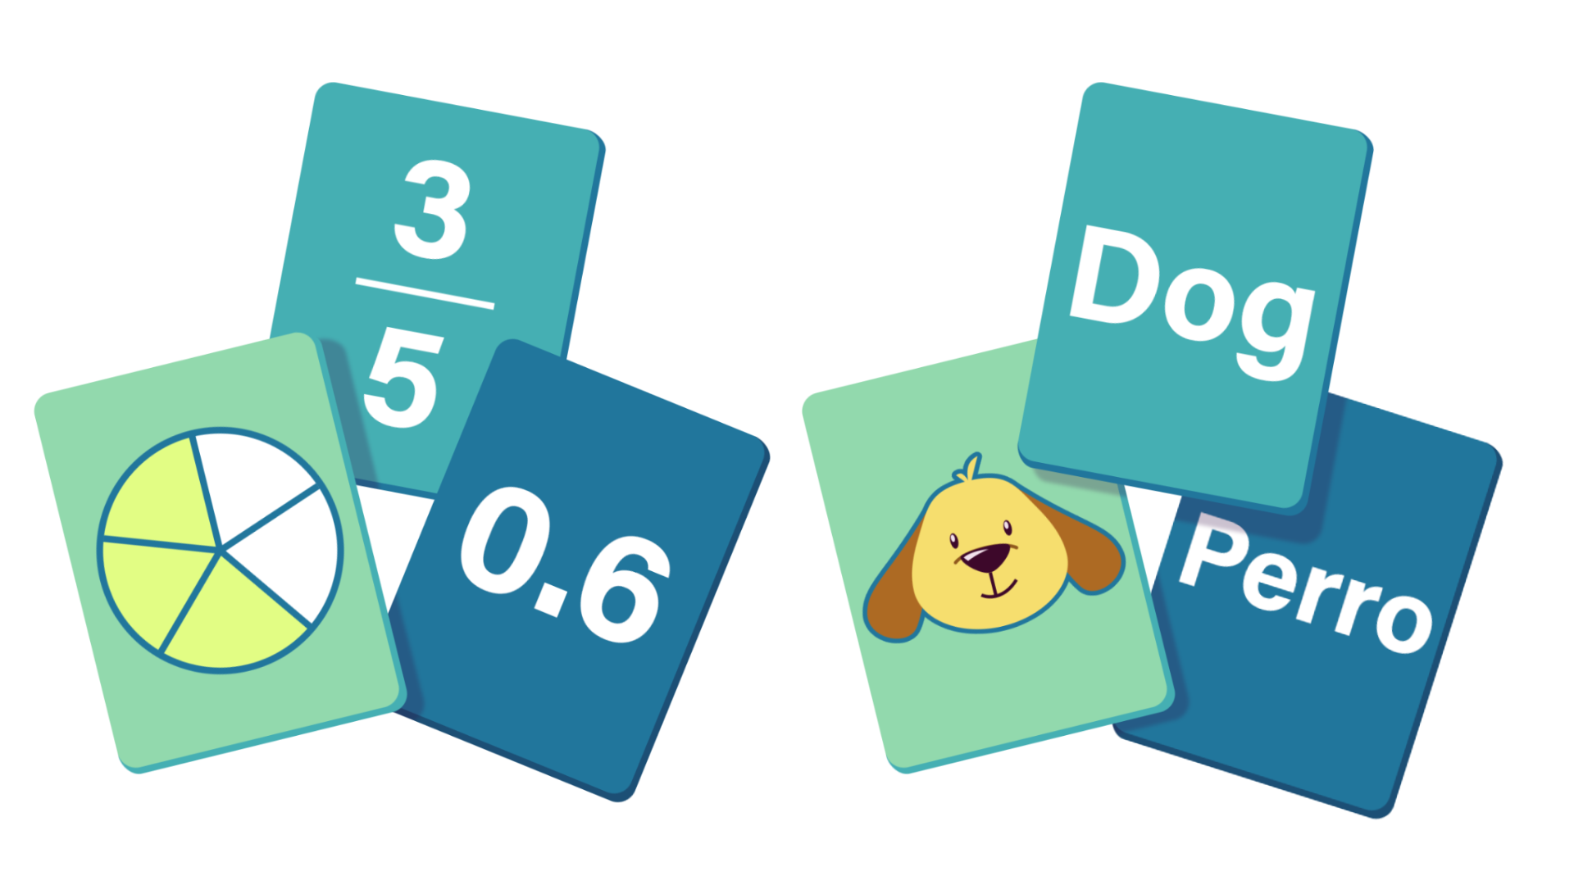 |  | 

 | Establish mathematics  goals to focus learning.
Effective teaching of mathematics establishes clear goals for the mathematics that students are learning, situates goals within learning progressions, and uses the goals to guide instructional decisions.
Try it, Talk it, Color it, Check it |  | Choice Board
 |  | 

