SESSION NOTE CATCHER
Strategy or Tool | How was it used? | How could I use it?
Chalk Talk
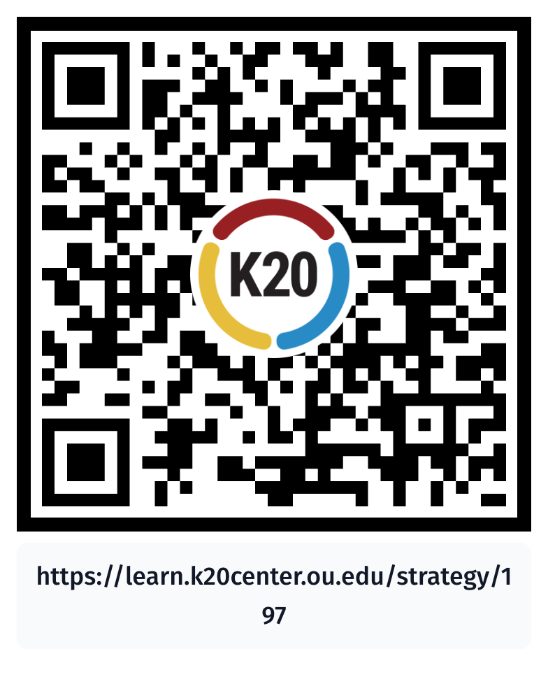
AI Chatbot
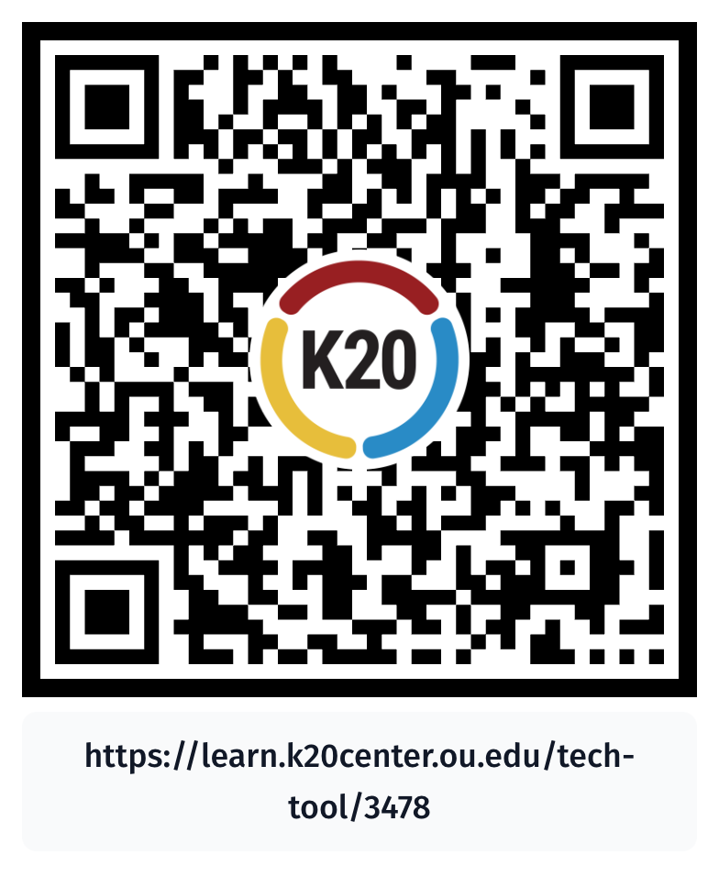
S-I-T
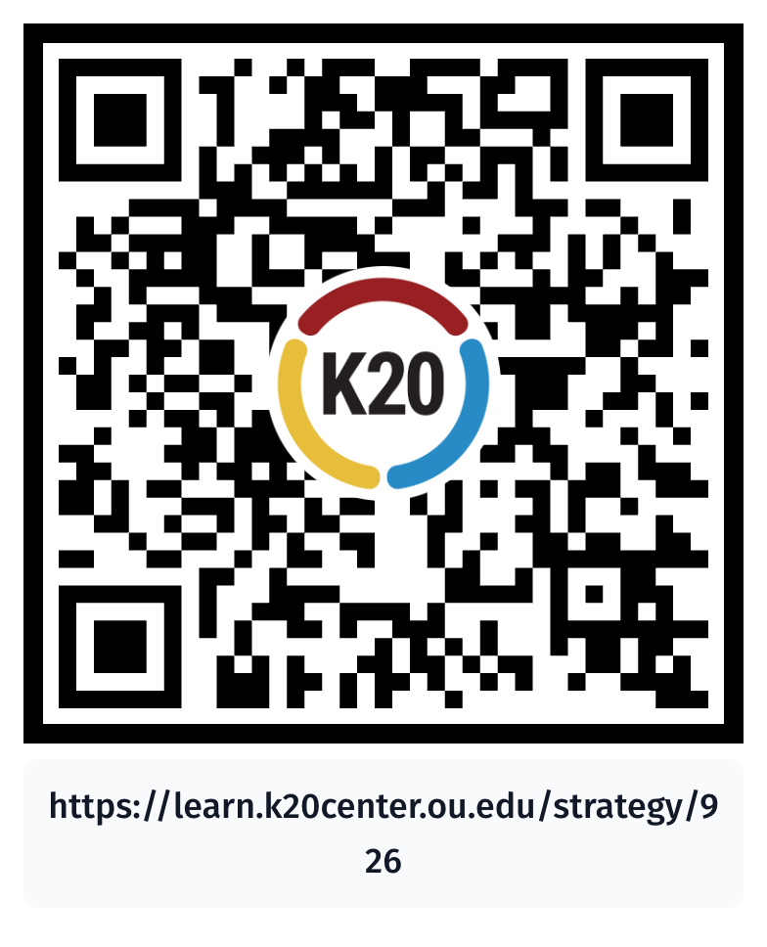
Categorical Highlighting
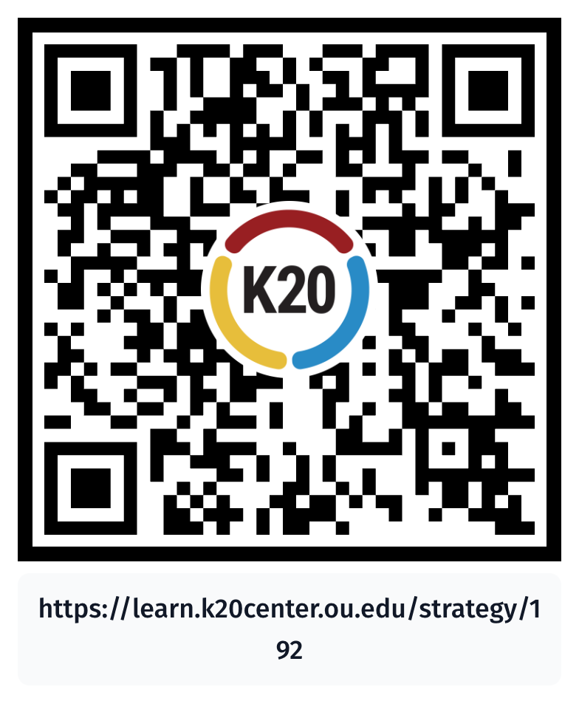
How Am I Feeling? What Am I Thinking?
