# Instructions

First, review and discuss with your group the different types of fingerprints and characteristics.

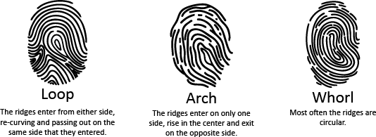

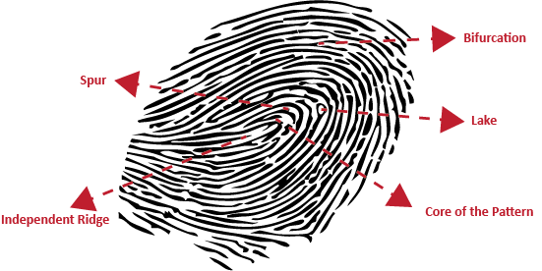*Fingerprint Characteristics*

**Ridge Characteristics:**

**Ridge Ending:** Where a ridge ends abruptly.

**Bifurcation:** A ridge splits into two.

**Lake:** A single ridge separates and then rejoins, forming a small oval shape within the ridge.

**Independent Ridge:** Small ridges found between ridges on both sides.

**Spur:** Where a short section of a ridge separates from a continuing ridge and ends in the space between two parallel ridges.

# Leave Your Print

1. Using the provided ink pad, gently press the pad of your index ﬁnger straight down onto the ink. Don’t roll or move it around.
2. Carefully lift your ﬁnger straight up from the pad.
3. Place your inked ﬁnger ﬂat on a clean piece of paper. Press down ﬁrmly and evenly, then lift straight up.
4. Label any ﬁngerprint types and characteristics you notice in your own print.

The following image is of a right index ﬁngerprint lifted from a bag at a crime scene.

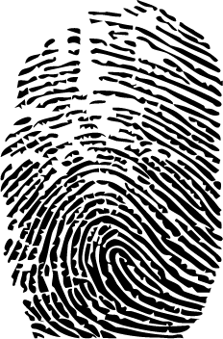

Below are ﬁngerprints of the right index ﬁngers of four key suspects in this crime.

1. Analyze the ﬁngerprints.
2. Match and identify the suspect responsible for the crime.
3. Referencing the Fingerprint Characteristics handout, match the ridge characteristics of the identiﬁed suspects and the ﬁngerprint lifted at the crime scene.
4. Discuss as a group the matching characteristics and the process of identifying and matching ﬁngerprints.

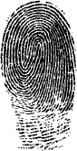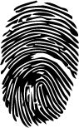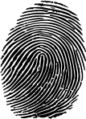

Suspect #1 Suspect #2 Suspect #3 Suspect #4