


Notecatcher
AI ACT

Synopsis: During this presentation participants will…
- Determine an appropriate strategy to identify AI-generated content.

- Analyze the credibility of platforms, creators, and especially the content they distribute.
- Cultivate ethical consumption and creation of content.


Use the space below for notes. Reflect on the following: how can I help students use AI responsibly for college readiness?

What are some “markers” or AI indicators you noticed in each article?
Article 1:

Article 2:
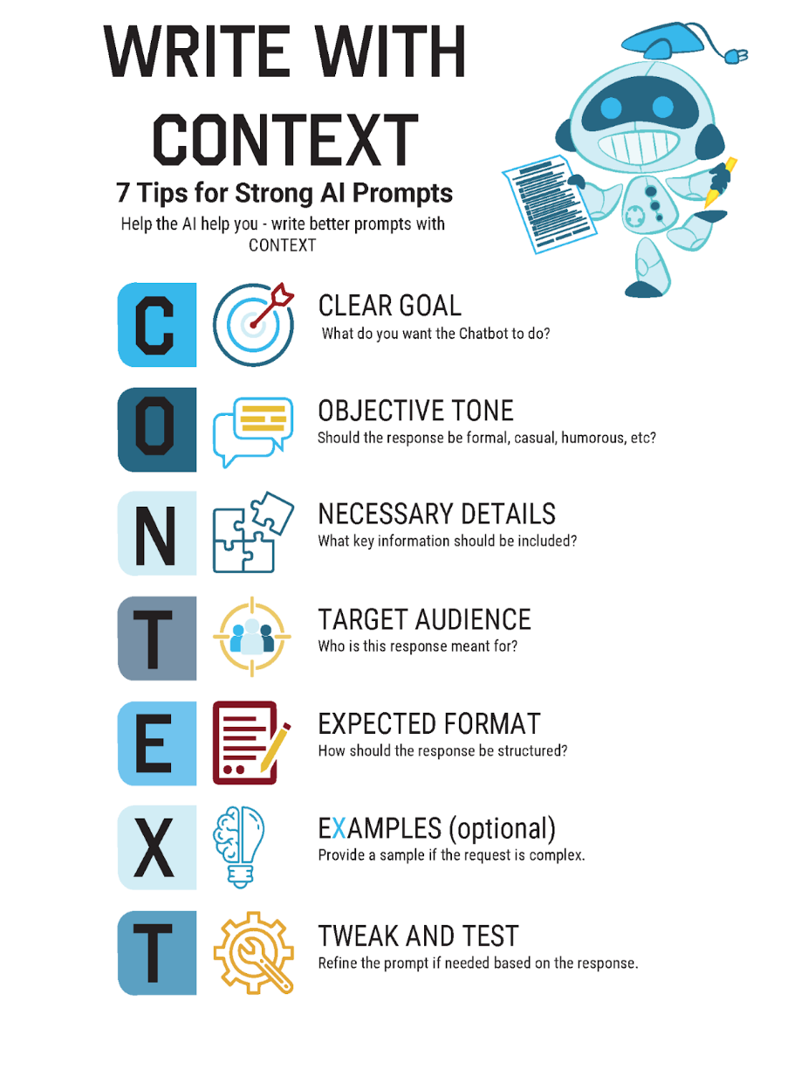
Example & Non-Example. Use the CONTEXT prompt writing guide to determine which prompt is the best example of how students can use AI as a tool to brainstorm compared to a tool to write their essay for them.
Example 1: I'm a high school senior interested in the University of Oklahoma's meteorology program. Can you help me figure out how to outline an admissions essay that needs to be less then a page and addresses the following prompts: Discuss an accomplishment, event, or realization that sparked a period of personal growth and a new understanding of yourself or others. I used to attend OU's weather center summer camp every year, so I thought about adding that somehow.

Example 2: Write an essay to help me get into college. I like weather, but I don’t know what I want to major in.

The Show Must Go On
Here are some other helpful K20 resources. Visit our website https://k20center.ou.edu/
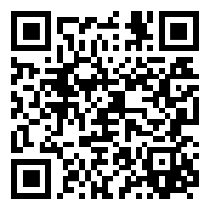  AI Tech Tool Collection | 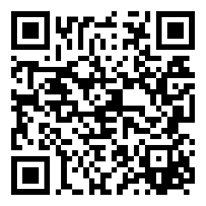  AI Instructional Strategies Collection | 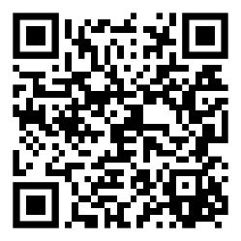  Professional Learning Collection

