High Expectations: What You Believe


Overview
Welcome to the College and Career Culture Tool Kit. This resource is specifically designed for administrators, counselors, and educators who are dedicated to strengthening their school's commitment to college- and career-readiness. Building this culture requires a unified vision and actionable strategies, and this is why this guide is organized into three powerful, interconnected sections: Visual Cues, Making Connections, and High Expectations.
This section provides resources to establish and maintain a pervasive belief that all students are capable of attending college, enrolling in advanced training, and achieving high-wage, high-demand careers. It offers strategies for communicating, modeling, and reinforcing academic rigor and ambitious goal-setting across all grade levels and subjects.
Pick and choose the resources you want to use from this High Expectations: What You Believe section of the tool kit to support a college-going and career-focused culture in your school building.

Table of Contents
 | Mission Statement | pages 2–7
 | Student-Centered Resources | pages 8–9
 | FAFSA Workshop Flyer | pages 10–11
 | FAFSA Completion Progress Tracker | pages 12–13
 | PSE Pathways Icons | pages 14–23

College-Going and Career-Focused Mission Statement

Resource Overview
A prominently displayed mission statement that reflects a school’s commitment to career readiness and postsecondary success is a powerful cultural signal. It communicates shared values, sets clear expectations, and inspires action among students, staff, and the community. When students see their school’s mission reflected in hallways and classrooms, they begin to internalize those expectations. It helps normalize planning for the future and helps align daily practices with long-term goals.

Audience
These mission statement resources are intended for administrators to collaborate with school staff for display throughout the physical and digital school spaces.

How to Use
If you are interested in creating a more robust college-going and career-focused culture in your school, begin by revisiting your school’s mission statement. Does it adequately communicate your values (beliefs) and goals?
If creating from scratch or revising your school’s mission statement, consider hosting a mission statement workshop and using the agenda on page 3.
For the Values and Beliefs activity, print and have staff follow the directions on pages 4–5 to facilitate the Identifying Core Values activity. Here, staff go through the process of identifying values that speak to them, then find common values within groups. Small groups merge into larger groups, repeating this process of identifying common values. Once everyone present is satisfied with a representative list of 3–4 schoolwide core values, post them on a poster (or sticky chart paper) at the front of the room.
For the Portrait of a Graduate activity, hang a poster (or sticky chart paper) at the front of the room; use it to record responses for the who (ideal graduate) and the how (school support).
In closing, facilitate a discussion regarding when you will meet again and any action steps that need to be taken in the meantime.
Drafting a mission statement will take time and reflection, but once finished, it will give powerful direction to your work. During the workshop, consider brainstorming at tables, showing some exemplars (use pages 6–7), giving time to step away from the draft, to sleep on it, and to come back the next day for fresh eyes.
If your current mission statement captures your school's values, you may simply consider selecting one of the mission statement templates on page 6 or 7 and updating the given text to meet your needs.
Once your college-going and career-focused mission statement is ready, post it publicly on your school website, in hallways, and in classrooms. Use it to guide decision-making, program development, and resource allocation to support student outcomes.

Mission Statement Workshop: Agenda

Welcome and Purpose
- Objectives: [Provide 1–2 clear goals of the workshop.]
- Purpose: [Provide a statement explaining why a mission statement matters for school culture.]

Values and Beliefs Discovery
The purpose of this activity is to identify and articulate the core values and beliefs that define our school community.
- Identifying Core Values activity
- Record results from activity:
Portrait of a Graduate Activity (Creating a Vision)
By creating a clear portrait of a graduate, we establish a shared understanding of the outcomes we strive to achieve for every student. This vision will guide our decisions, instructional practices, and school culture, ensuring that we prepare students not only for academic success but for life beyond school.
- Portrait of a Graduate activity
  - Describe the ideal graduate from our school.
    - What skills, mindsets, and experiences should they have?
  - Describe how we, as educators, can develop successful graduates.
    - How does the school help them get there?
Mission Statement Drafting
A mission statement should clarify what is important. It should provide direction and guide the school towards clear goals for growth and development.
- Use the following prompts as a helpful starting point:
  - What is going to be done?
  - Who is going to be served?
  - How will this be accomplished?
  - Why is it done?

Closing and Next Steps
- How do we make our new mission statement visible?

Identifying Core Values: Activity
- Core values are the principles that guide everyday decisions. They are the aspects of life that matter most to you. What behaviors are non-negotiable, no matter what you are doing?
- Core values can help define the school’s culture and how it operates. It should be obvious how our decisions align with our values.
Keep these ideas in mind as you complete the steps below.
- Circle values from the list below that speak to you. If you think of a value that is not listed, write it.

Accountability
Achievement
Ambition
Appreciation
Caring
Challenge
Collaboration
Commitment
Communication
Community-Minded
Compassion
Cooperation
Courage
Creativity
Critical Thinking
Curiosity
Dedication
Doing Your Best
Empathy
Ethics
Excellence
Fairness
Flexibility
Generosity
Goal-Oriented
Gratitude
Growth
Happiness
Here to Learn
High Expectations
Honesty
Humility
Independence
Individualism
Innovation
Integrity
Intelligence
Justice
Kindness
Leadership
Motivation
Open-Mindedness
Optimism
Participation
Performance
Perseverance
Positivity
Preparedness
Pride
Professionalism
Punctuality
Reflectiveness
Resourcefulness
Respect
Responsibility
Risk Taking
Safety
Self-Control
Service
Stability
Success
Teamwork
Thankfulness
Thoughtfulness
Truthfulness
Understanding
Welcoming
Wisdom

- Sort the values you circled into at most five groups. Words can be sorted however you prefer.

- Within each group of values, select one word to represent that group of words. Put a star next to that word.

The words you selected to represent each group are your core values.
- With a small group at your table, share your core values to see if you have any that are aligned or matching.

- Within your group, identify the top two values that are common among the group and that could best serve as guiding principles for the whole school and the students you serve.

- Join another group and repeat steps 5–6 until the whole group is satisfied with a representative list of 3–4 schoolwide core values.

Our College-Going  and Career-Focused  Mission Statement | 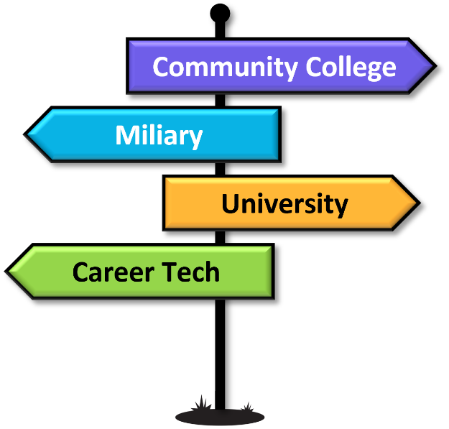
Our mission is to prepare students for the future by [connecting classroom learning with career pathways and postsecondary opportunities]. We equip every student with [the skills, knowledge, and confidence] to [excel in college, technical training, or the workforce, and to make a positive impact on their communities].

Our College-Going
and Career-Focused
Mission Statement
We are committed to [helping students design their futures]. Through [relevant learning experiences, career exploration, and college readiness] we ensure that every student graduates with [a clear plan, the skills to achieve it, and the mindset to keep growing and contributing] in an ever-changing world.

STUDENT-CENTERED RESOURCEs

Resource Overview
Using a growth mindset with interactive learning experiences helps educators promote a high-expectation, college-going, and career-focused culture by addressing the foundation of student motivation and belief in potential. By helping students recognize that intelligence and skills can be developed through effort, the activity teaches that success in college and careers isn’t reserved for a few—it’s achievable for all with persistence and learning.

Audience
This learning experience is intended for counselors or educators to facilitate with students.

How to Use
Use the Student-Centered Resource on page 9 to meet your needs. What’s Mindset Got to Do With It? is a great resource to foster a growth mindset over a fixed mindset.

Student-Centered Resource: Learning Experience
 | What’s Mindset Got to Do With It?
Shifting a Fixed Mindset to a Growth Mindset
learn.k20center.ou.edu/educator-resource/5019

Summary
This interactive inquiry-based learning experience focuses on how our mindset impacts how we engage and approach different situations throughout life. Students will reflect on their own mindset and current beliefs that affect growth and fixed mindset. Students will develop a plan to foster a growth mindset.

Essential Question
- How can our thoughts and beliefs about failure affect our success in school and life?

Learning Objectives
- Students will reflect on their own mindset and current beliefs that affect a growth mindset.
- Students will develop a plan to foster a growth mindset.

Snapshot
- Engage: Students reflect upon a personal challenge within school or life and how their beliefs impacted their approach to that experience.
- Explore: Student pairs sort statements into two categories: growth mindset and fixed mindset.
- Explain: Students watch mindset video(s) and apply their new knowledge to revisit the Card Sort.
- Extend: Students articulate their understanding of the two types of mindsets and construct real-life examples for both using the Frayer Model.
- Evaluate: Students evaluate their own mindset and how they can develop their growth mindset in a variety of situations.

FAFSA Workshop Flyer

Resource Overview
Navigating the Free Application for Federal Student Aid (FAFSA) can be a daunting task for students and families. This FAFSA workshop flyer is designed to help educators support students in accessing financial aid opportunities. By sharing this flyer, educators can raise awareness and increase participation by inviting students and their families to a workshop where they can receive help with successfully completing the application process.

Audience
This flyer is intended for principals or counselors to display in areas where students can easily see it or to distribute it to students for them to take home to parents.

How to Use
Add the date, time, and location for your upcoming FAFSA workshop to the flyer on the following page (page 11). Consider using the FAFSA Checklist resource from the Making Connections section of the tool kit.



Date | Time
Location
The FAFSA (Free Application for Federal Student Aid)
is required for most types of financial aid, including scholarships. We can help you fill out this important document.
In order to work efficiently at this workshop, please create your FSA ID at least 3 days before the date and bring it with you.

FAFSA Completion Progress Tracker

Resource Overview
Using a progress-to-completion graphic signals a college-going culture. It communicates that your school expects every student to pursue postsecondary opportunities, including financial readiness, as part of that journey. Tracking progress publicly and consistently conveys that completing the FAFSA is a measurable school goal; it is the norm, not the exception. The graphic promotes accountability, and highlighting completion milestones can build community energy and collective pride.

Audience
This progress tracker is intended for principals or counselors to display in areas where students can easily see it.

How to Use
Enlarge FAFSA Completion Progress Tracker graphic on the following page (page 13). Print it using your printer’s “poster” setting, or consider having the progress graphic drawn on butcher paper (by an art teacher, for example) and hang it in the hallway, as shown below. Alternatively, consider using glass chalk and sketching the progress graphic on the glass walls of the main office, entry way, or any prominent area in the school building. The progress graphic could also be used on a slide deck if that is how announcements or celebrations are made at your school.
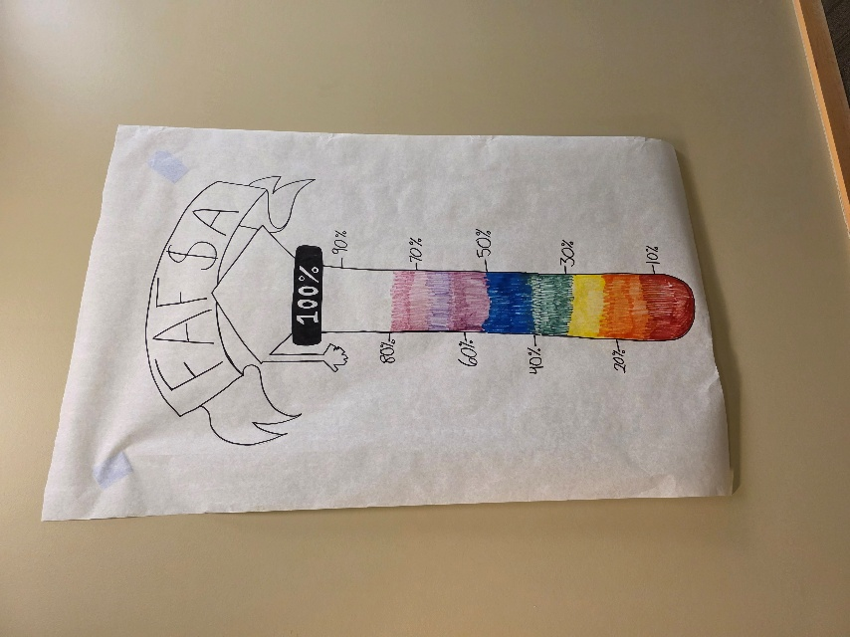
After communicating a clear goal, use the FAFSA Completion Progress Tracker (on the following page) to help monitor progress.

FAFSA Completion Progress Tracker
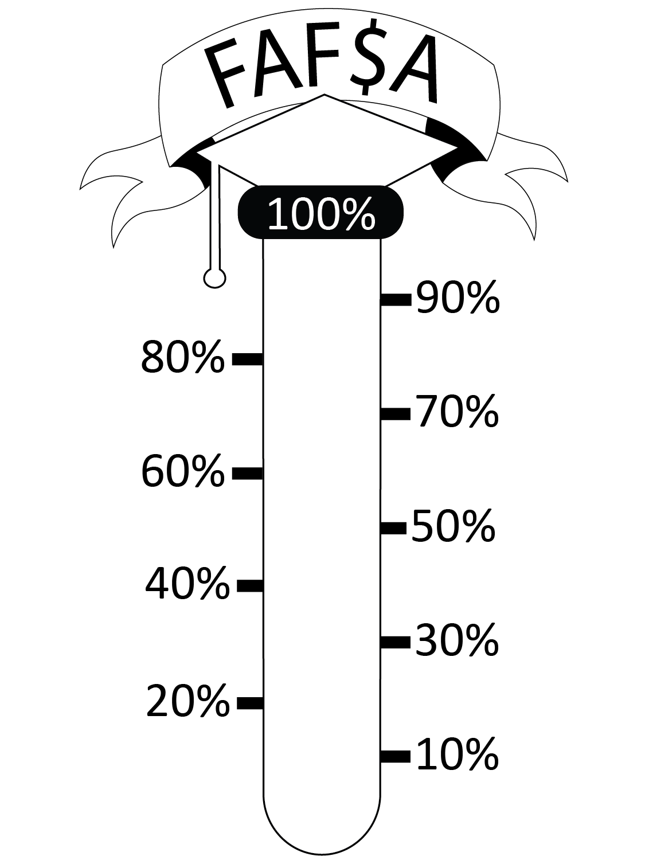

PSE Pathways Icons

Resource Overview
Creating an “Accepted, Enlisted, Employed” wall in your school is a dynamic and visual celebration of student success that reinforces a college-going and career-focused culture. It sends a powerful message that every student’s postsecondary plan is worthy of recognition. Publicly honoring these achievements sets high expectations and normalizes the pursuit of postsecondary goals for all students. This display promotes diverse post-graduation pathways, inspires other students, engages families and the community in recognizing student milestones, and lays a foundation for a future-focused school culture where students are motivated to plan, prepare, and pursue their goals.

Audience
These icons are intended for counselors to display in areas where students can easily see them.

How to Use
To create a celebration of students pursuing postsecondary options, print the hexagons on the following pages (pages 15–23), write student names on the hexagons, and create a tessellation on a prominent wall in the school building. There are three different hexagons formatted in three different ways.
- Accepted: Celebrate students who are accepted to career technical centers, colleges, and universities.
- Enlisted: Celebrate students who have joined a branch of the military.
- Employed: Celebrate students who have found a job to begin after graduation (or have already started).
For each of these pathways, you will find a full color option, a partial color option, and a black and white option.
- The full color accepted, enlisted, and employed hexagons are on pages 15, 16, and 17, respectively.
- The partial color accepted, enlisted, and employed hexagons are on pages 18, 19, and 20, respectively.
- The black and white accepted, enlisted, and employed hexagons are on pages 21, 22, and 23, respectively.

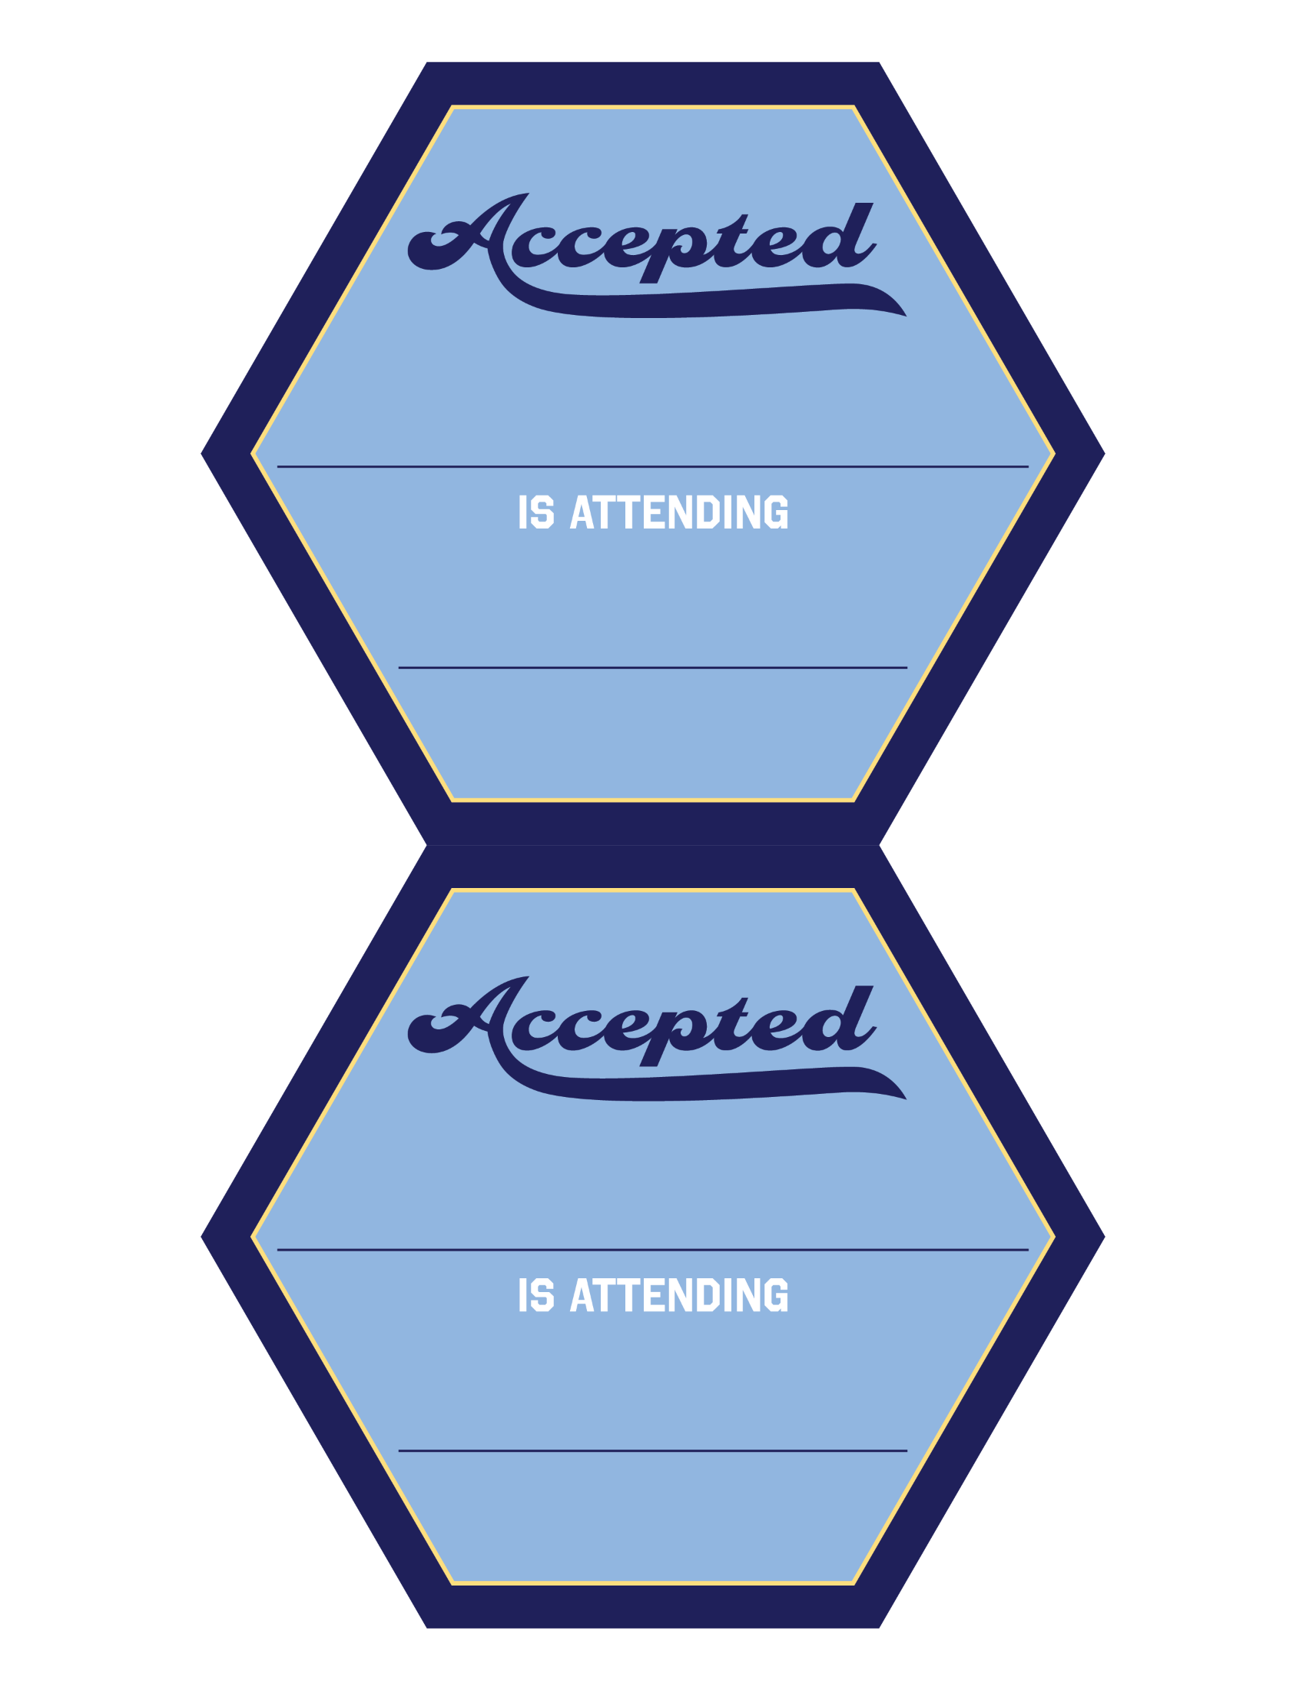
PSE Pathways Icons: Full Color, Accepted

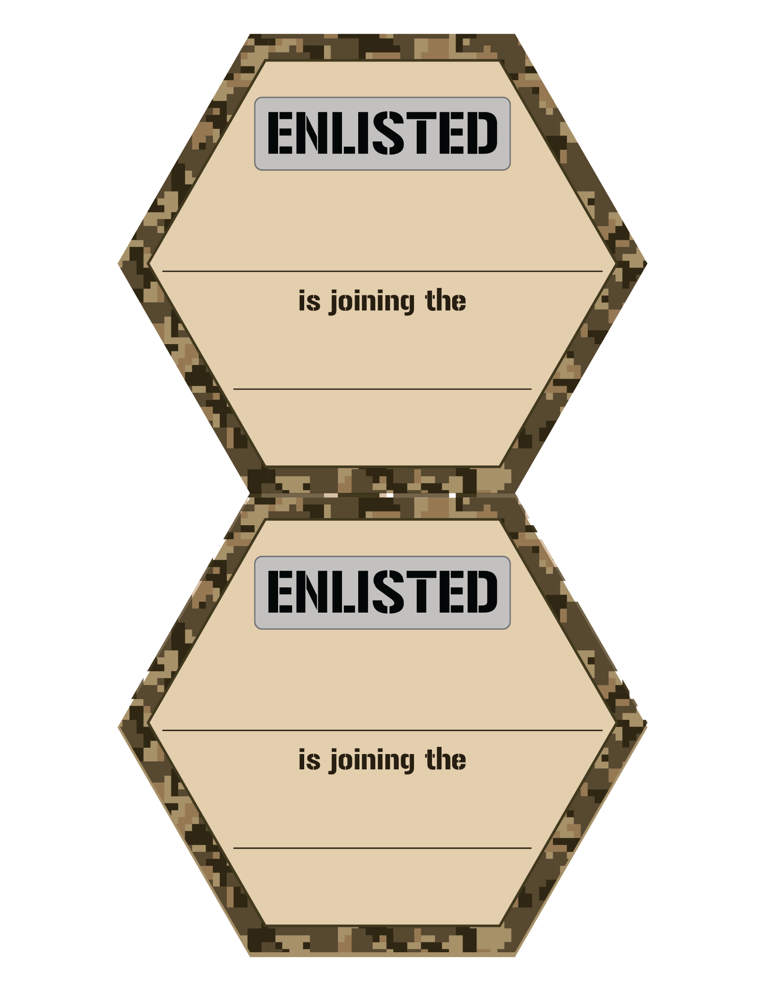
PSE Pathways Icons: Full Color, Enlisted

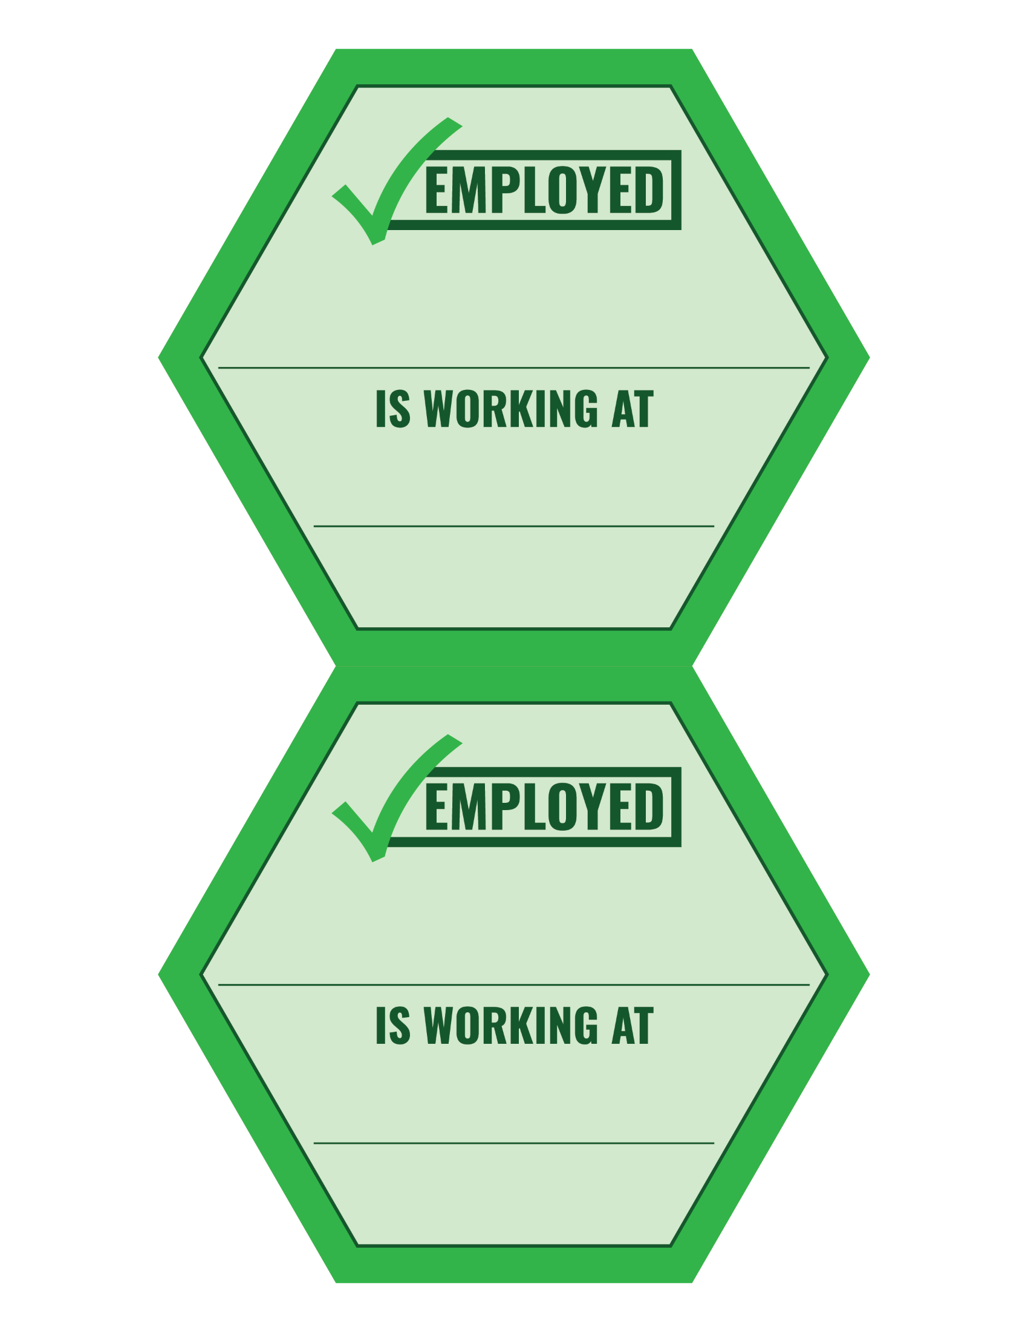
PSE Pathways Icons: Full Color, Employed

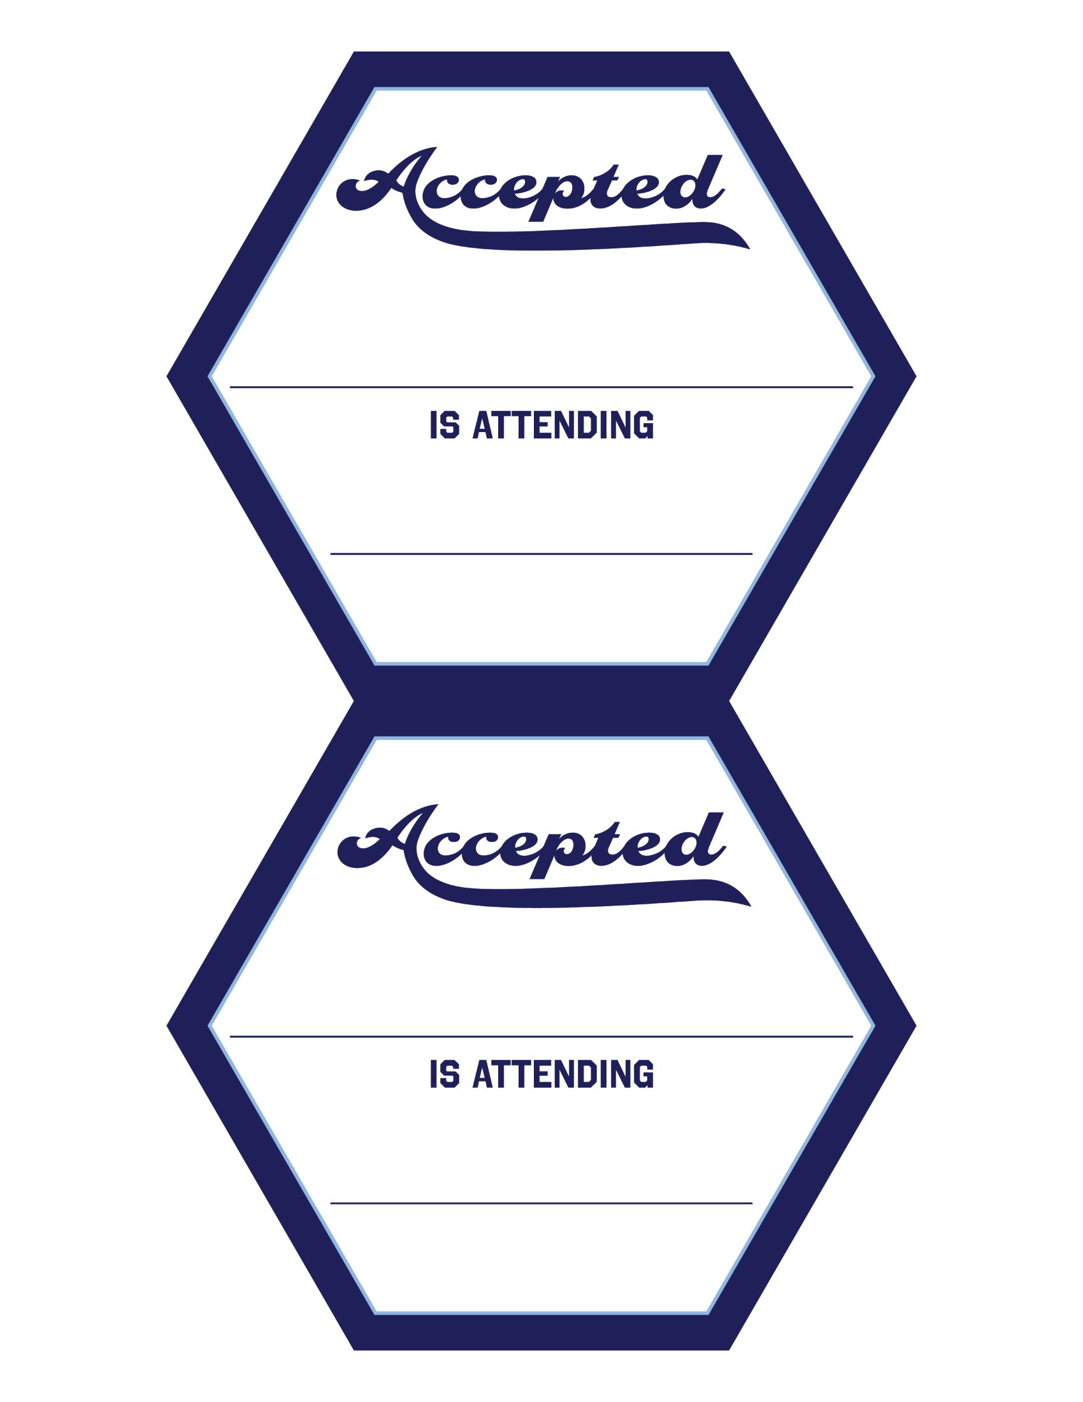
PSE Pathways Icons: Partial Color, Accepted

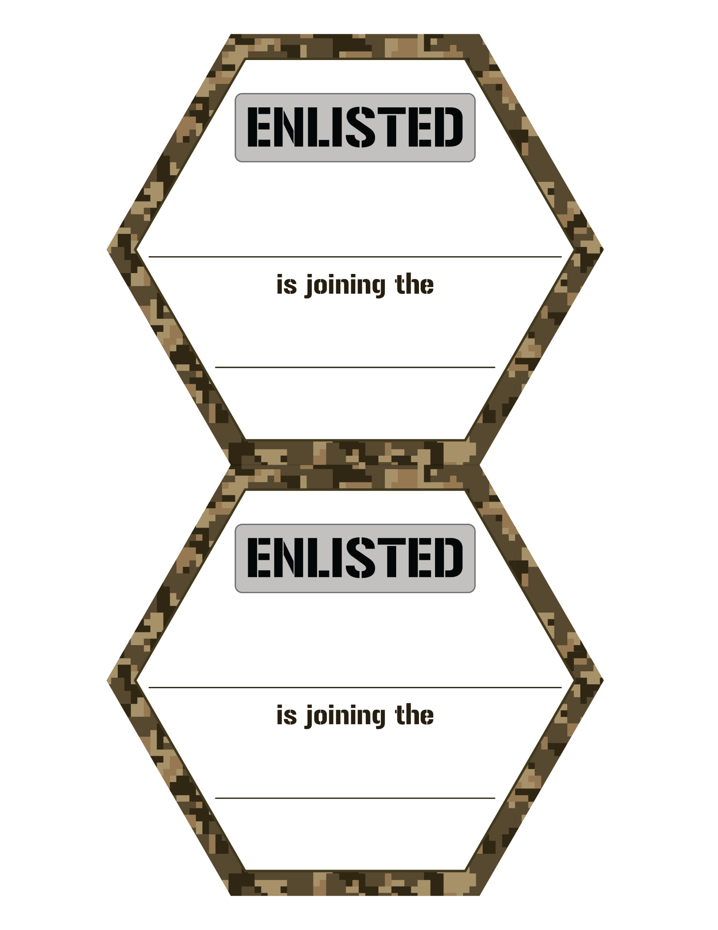
PSE Pathways Icons: Partial Color, Enlisted

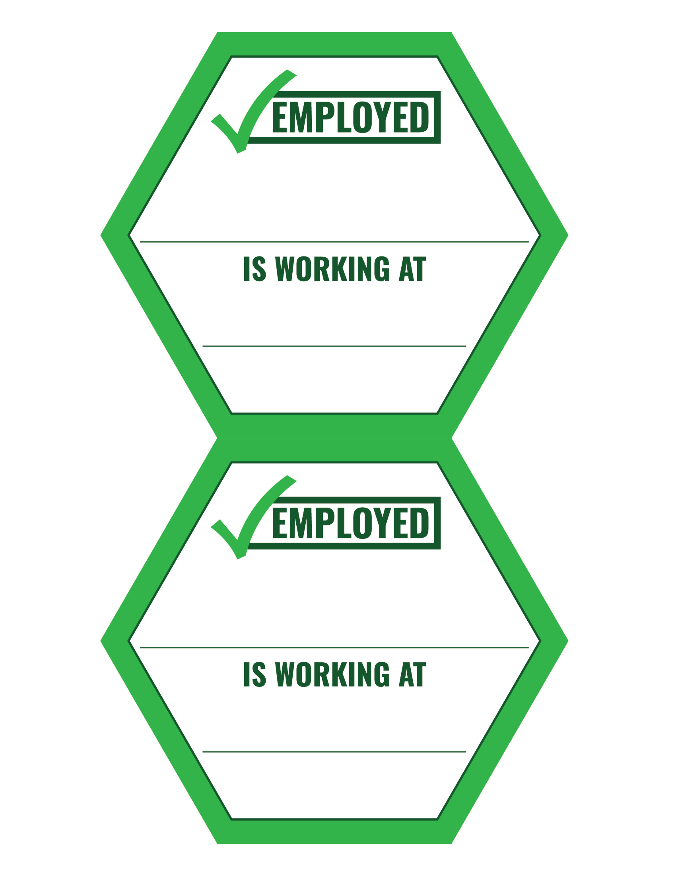
PSE Pathways Icons: Partial Color, Employed

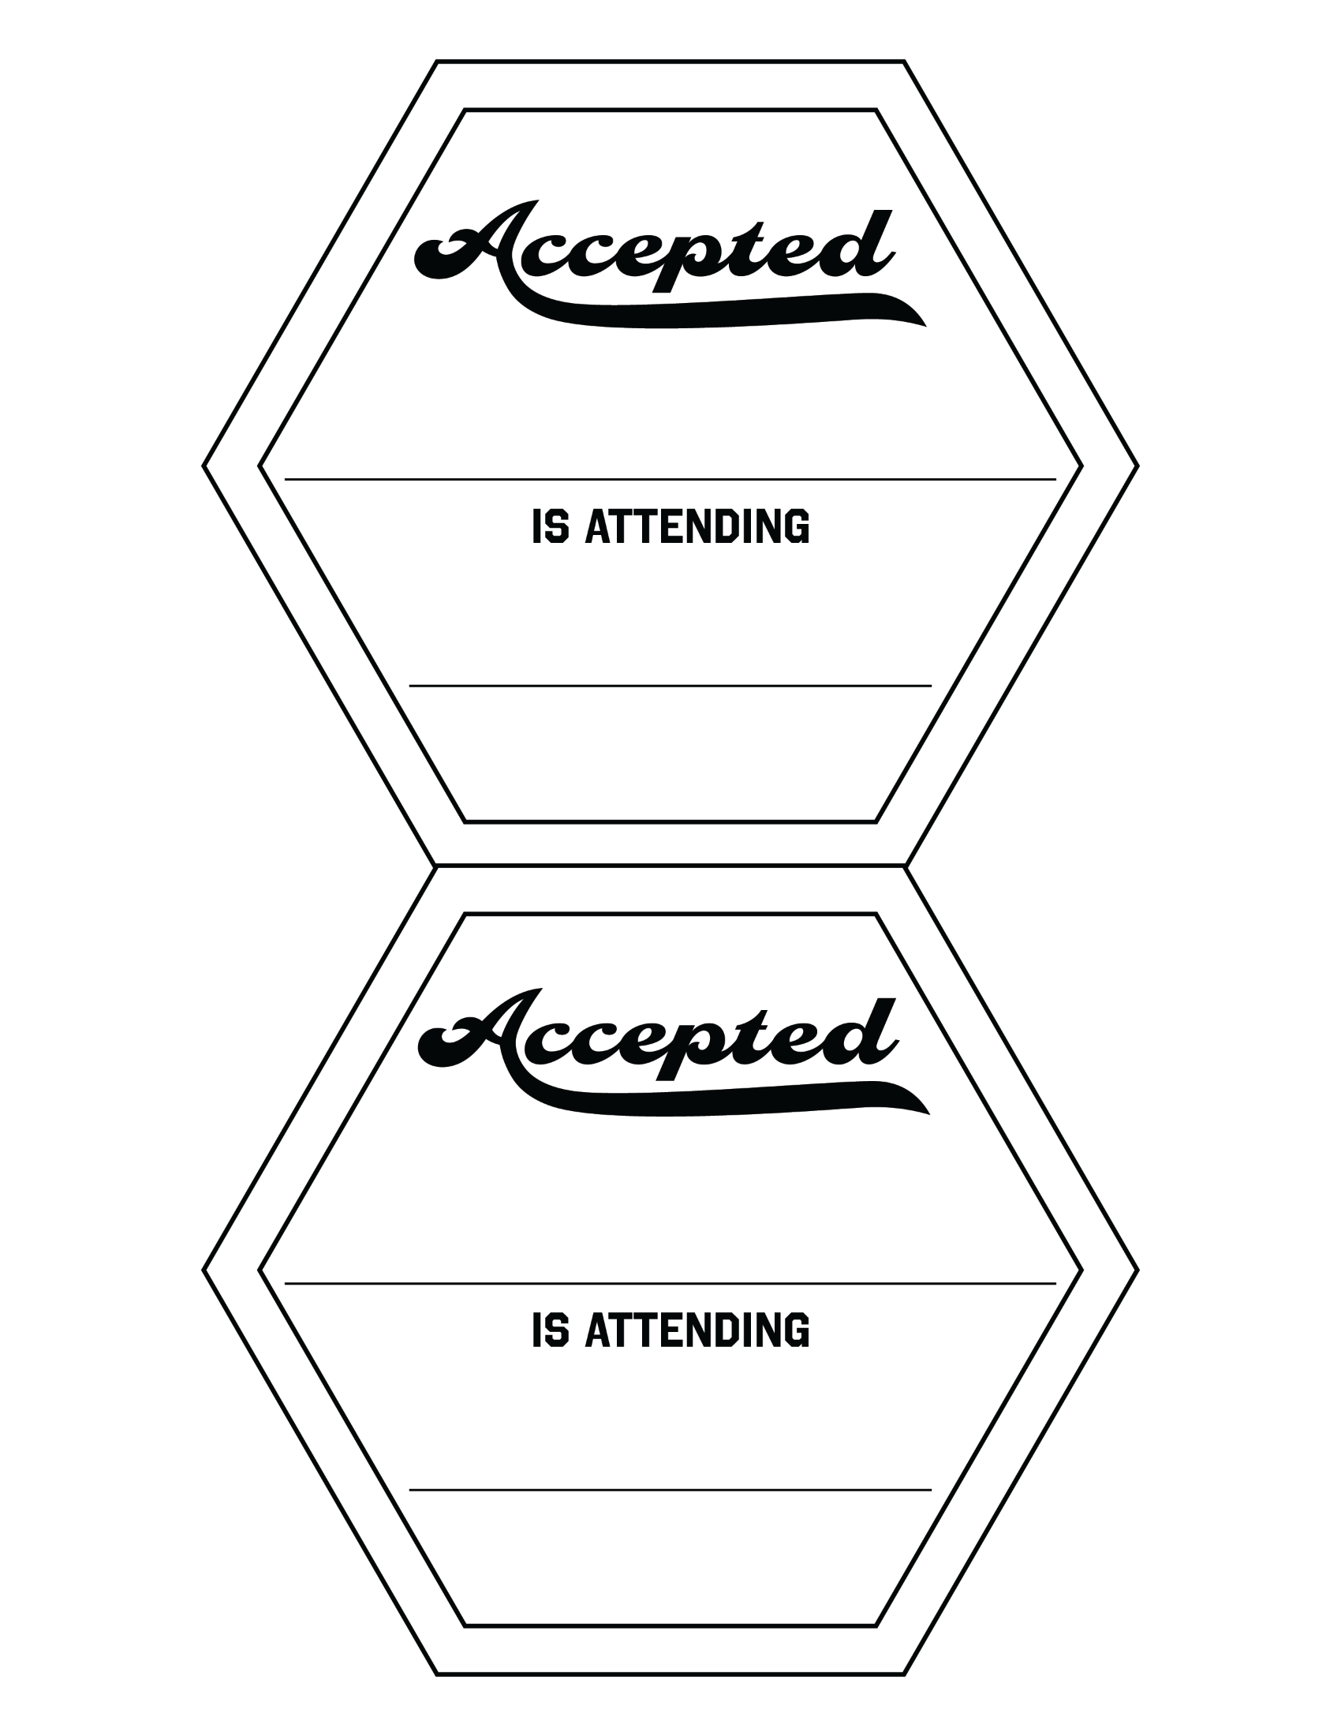
PSE Pathways Icons: Black and WHite, Accepted

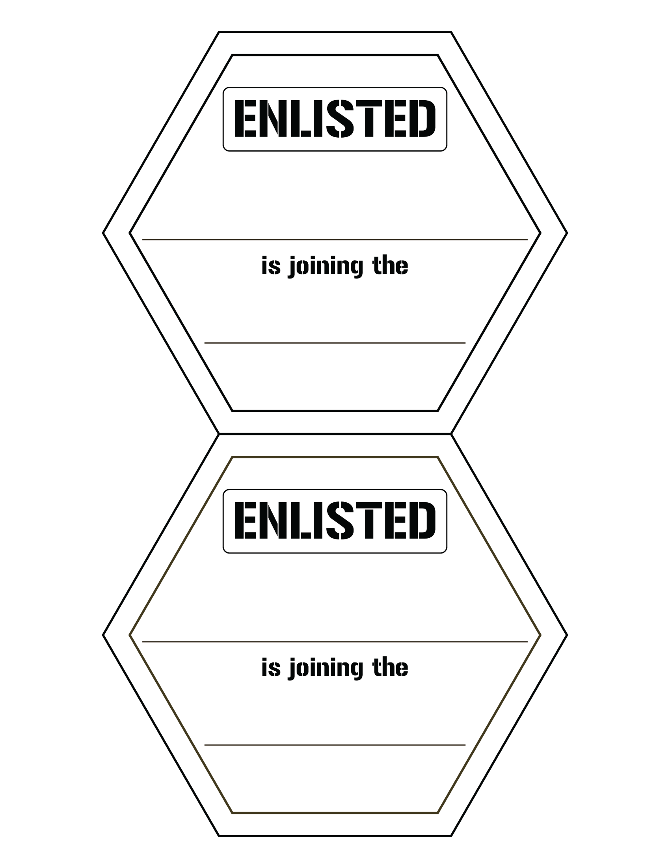
PSE Pathways Icons: Black and WHite, Enlisted

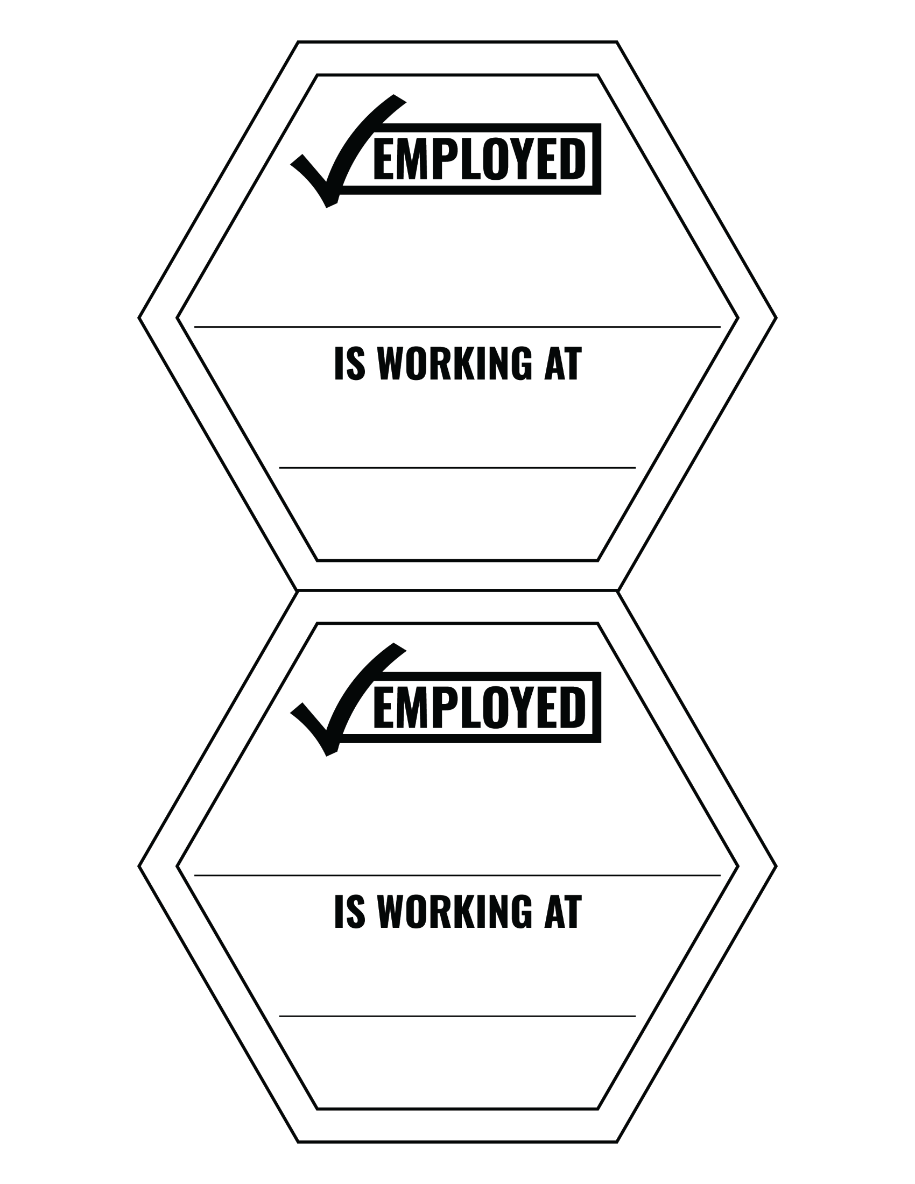
PSE Pathways Icons: Black and WHite, Employed

