Visual Cues: What You See


Overview
Welcome to the College and Career Culture Tool Kit. This resource is specifically designed for administrators, counselors, and educators who are dedicated to strengthening their school's commitment to college and career readiness. Building this culture requires a unified vision and actionable strategies, and this is why this guide is organized into three powerful, interconnected sections: Visual Cues, Making Connections, and High Expectations.
The environment itself is a powerful teacher. This section emphasizes the importance of making the path to college and career visible and tangible. From subtle hallway displays to prominent signage, these resources help you create a constant, positive visual narrative of achievement and possibility throughout the school building.
Pick and choose the resources you want to use from this Visual Cues: What You See section of the tool kit to support a college-going and career-focused culture in your school building.

Table of Contents
 | Entry Sign | pages 2–3
 | Top 10 PSE Benefits Posters | pages 4–15
 | ABC College and Career Posters | pages 16–42

Entry Sign

Resource Overview
Displaying signage with educators’ backgrounds and inviting students to ask questions can spark conversations that lead to a better understanding of different academic paths. This may inspire students to consider their own educational and career goals, as well as thoughts about various universities and fields of study. It also creates a more personal environment where students see teachers as individuals with distinct backgrounds. The goal is to make higher education seem accessible and relatable.

Audience
This entry sign is intended for administrators to distribute to school staff for display.

How to Use
Print the entry sign template on the next page (page 3) for each staff member. Ask everyone to complete the template, sharing where they graduated from and their major. Then ask each staff member to hang it outside their door to welcome and encourage students to ask about their alma mater and their degree of study.

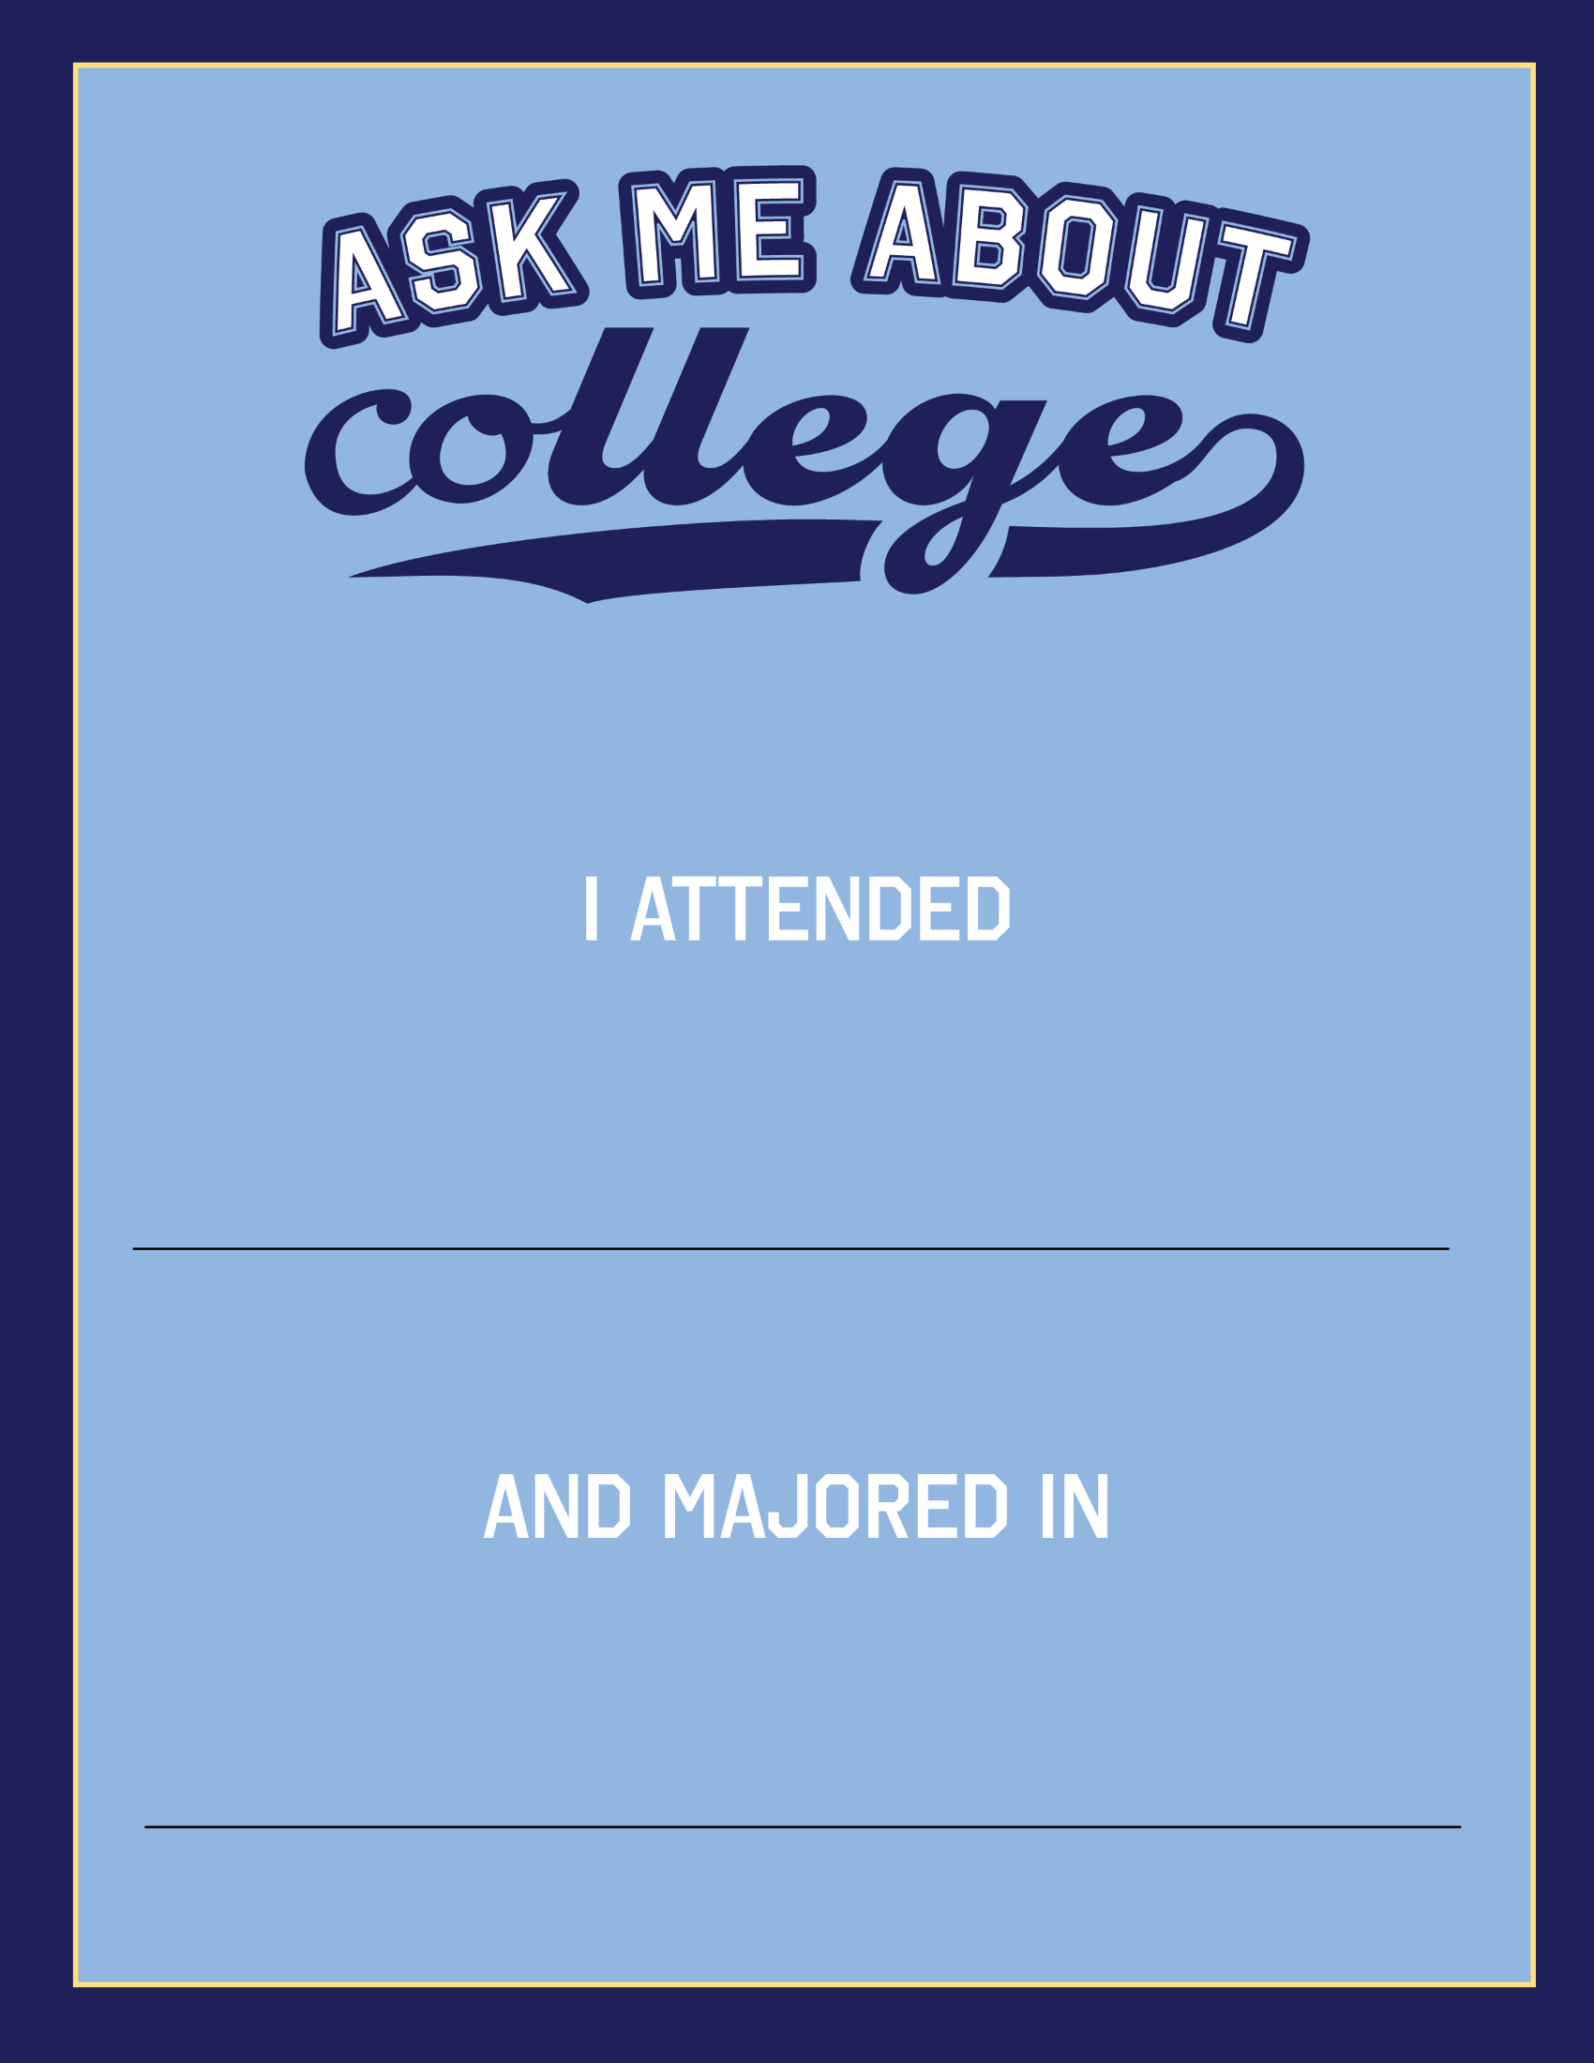

TOP 10 PSE BENEFITS Posters

Resource Overview
Provide students with a visual reminder of the benefits of continuing education after high school. Posters enable educators to place information in high-traffic areas, meeting students where they are and making it accessible. They serve as informational signposts that students can reference in a controlled space.
Research suggests that if you have a postsecondary degree, you are more likely to:
- Live longer and healthier
- More satisfying family life
- Make a difference in your community
- Understand the world better
- Be prepared for success in a technology-driven world
- More likely to be employed
- Be happier in your job
- Increase your job options
- Connect with peers and mentors
- Earn $1 million more in your lifetime

Audience
These posters are designed for counselors and educators to display in areas where students can easily see them.

How to Use
Print the 10 posters on pages 6–15. Consider printing these in full color and laminating them. Hang these in a common area, such as your counseling or college and career office, or use them to create a college and career hallway in a high traffic area of your school.
For more information on how to integrate this resource into a learning experience, check out the GEAR UP for LIFE Student Kickoff (Assembly Version) resource from LEARN: learn.k20center.ou.edu/educator-resource/3648.

Sources:
Abel, J. R. & Deitz, R. (2014). Do the benefits of college still outweigh the costs? Current Issues in Economics and Finance, 20(3), 1–9.
Baum, S., Ma, J., & Payea, K. (2013). Education pays 2013: The benefits of higher education for individuals and society. The College Board.
Brand, J. E. (2010). Civic returns to higher education: A note on heterogeneous effects. Social Forces, 89(2), 417-433.
Campbell, C. M., Smith, M., Dugan, J. P., & Komives, S. R. (2012). Mentors and college student leadership outcomes: The importance of position and process. The Review of Higher Education, 35(4), 595–625. https://muse.jhu.edu/article/478995
D’Agostino, S. (2022, August 4). Leveling the playing field for social capital. Inside Higher Ed. https://www.insidehighered.com/news/2022/08/05/how-colleges-can-level-playing-field-social-capital
Harper, S., Riddell, C. A., & King, N. B. (2021). Declining life expectancy in the United States: Missing the trees for the forest. Annual Review of Public Health, 42, 381–403.
Ishitani, T. T. & McKitrick, S. A. (2013). The effects of academic programs and institutional characteristics on postgraduate civic engagement behavior. Journal of College Student Development, 54(4), 379-396.
Oreopoulos, P. & Petronijevic, U. (2013). Making college worth it: A review of the returns to higher education. The Future of Children, 23(1), 41–65.
Perrin, A. J., & Gillis, A. (2019). How college makes citizens: Higher education experiences and political engagement. Socius, 5, 2378023119859708.
Reynolds, M. (2024, July). The Misery Bomb. https://asteriskmag.com/issues/07/the-misery-bomb
St. Louis, A. T., Thompson, P., Sulak, T. N., Harvill, M. L., & Moore, M. E. (2021). Infusing 21st century skill development into the undergraduate curriculum: The formation of the iBEARS network. Journal of Microbiology & Biology Education, 22(2), 1–8.
Starrett, A., Irvin, M. J., Limberg, D., & Ferguson, S. (2022). Rethinking the college-for-all ethos. Theory Into Practice, 61(4), 443-453.
Sutton, H. (2017). Learn to articulate the value of college beyond dollar signs. Recruiting & Retaining Adult Learners, 19(7), 6-7.
Wolniak, G. C. & Engberg, M. E. (2019). Do “high-impact” college experiences affect early career outcomes? The Review of Higher Education, 42(3), 825-858.
U.S. Bureau of Labor Statistics. (2022, March 9). High school graduates with no college had unemployment rate of 4.5 percent in February 2022. The Economics Daily. https://www.bls.gov.opub.ted/2022/high-school-graduates-with-no-college-had-unemployment-rate-of-4-5-percent-in-febraury-2022.htm

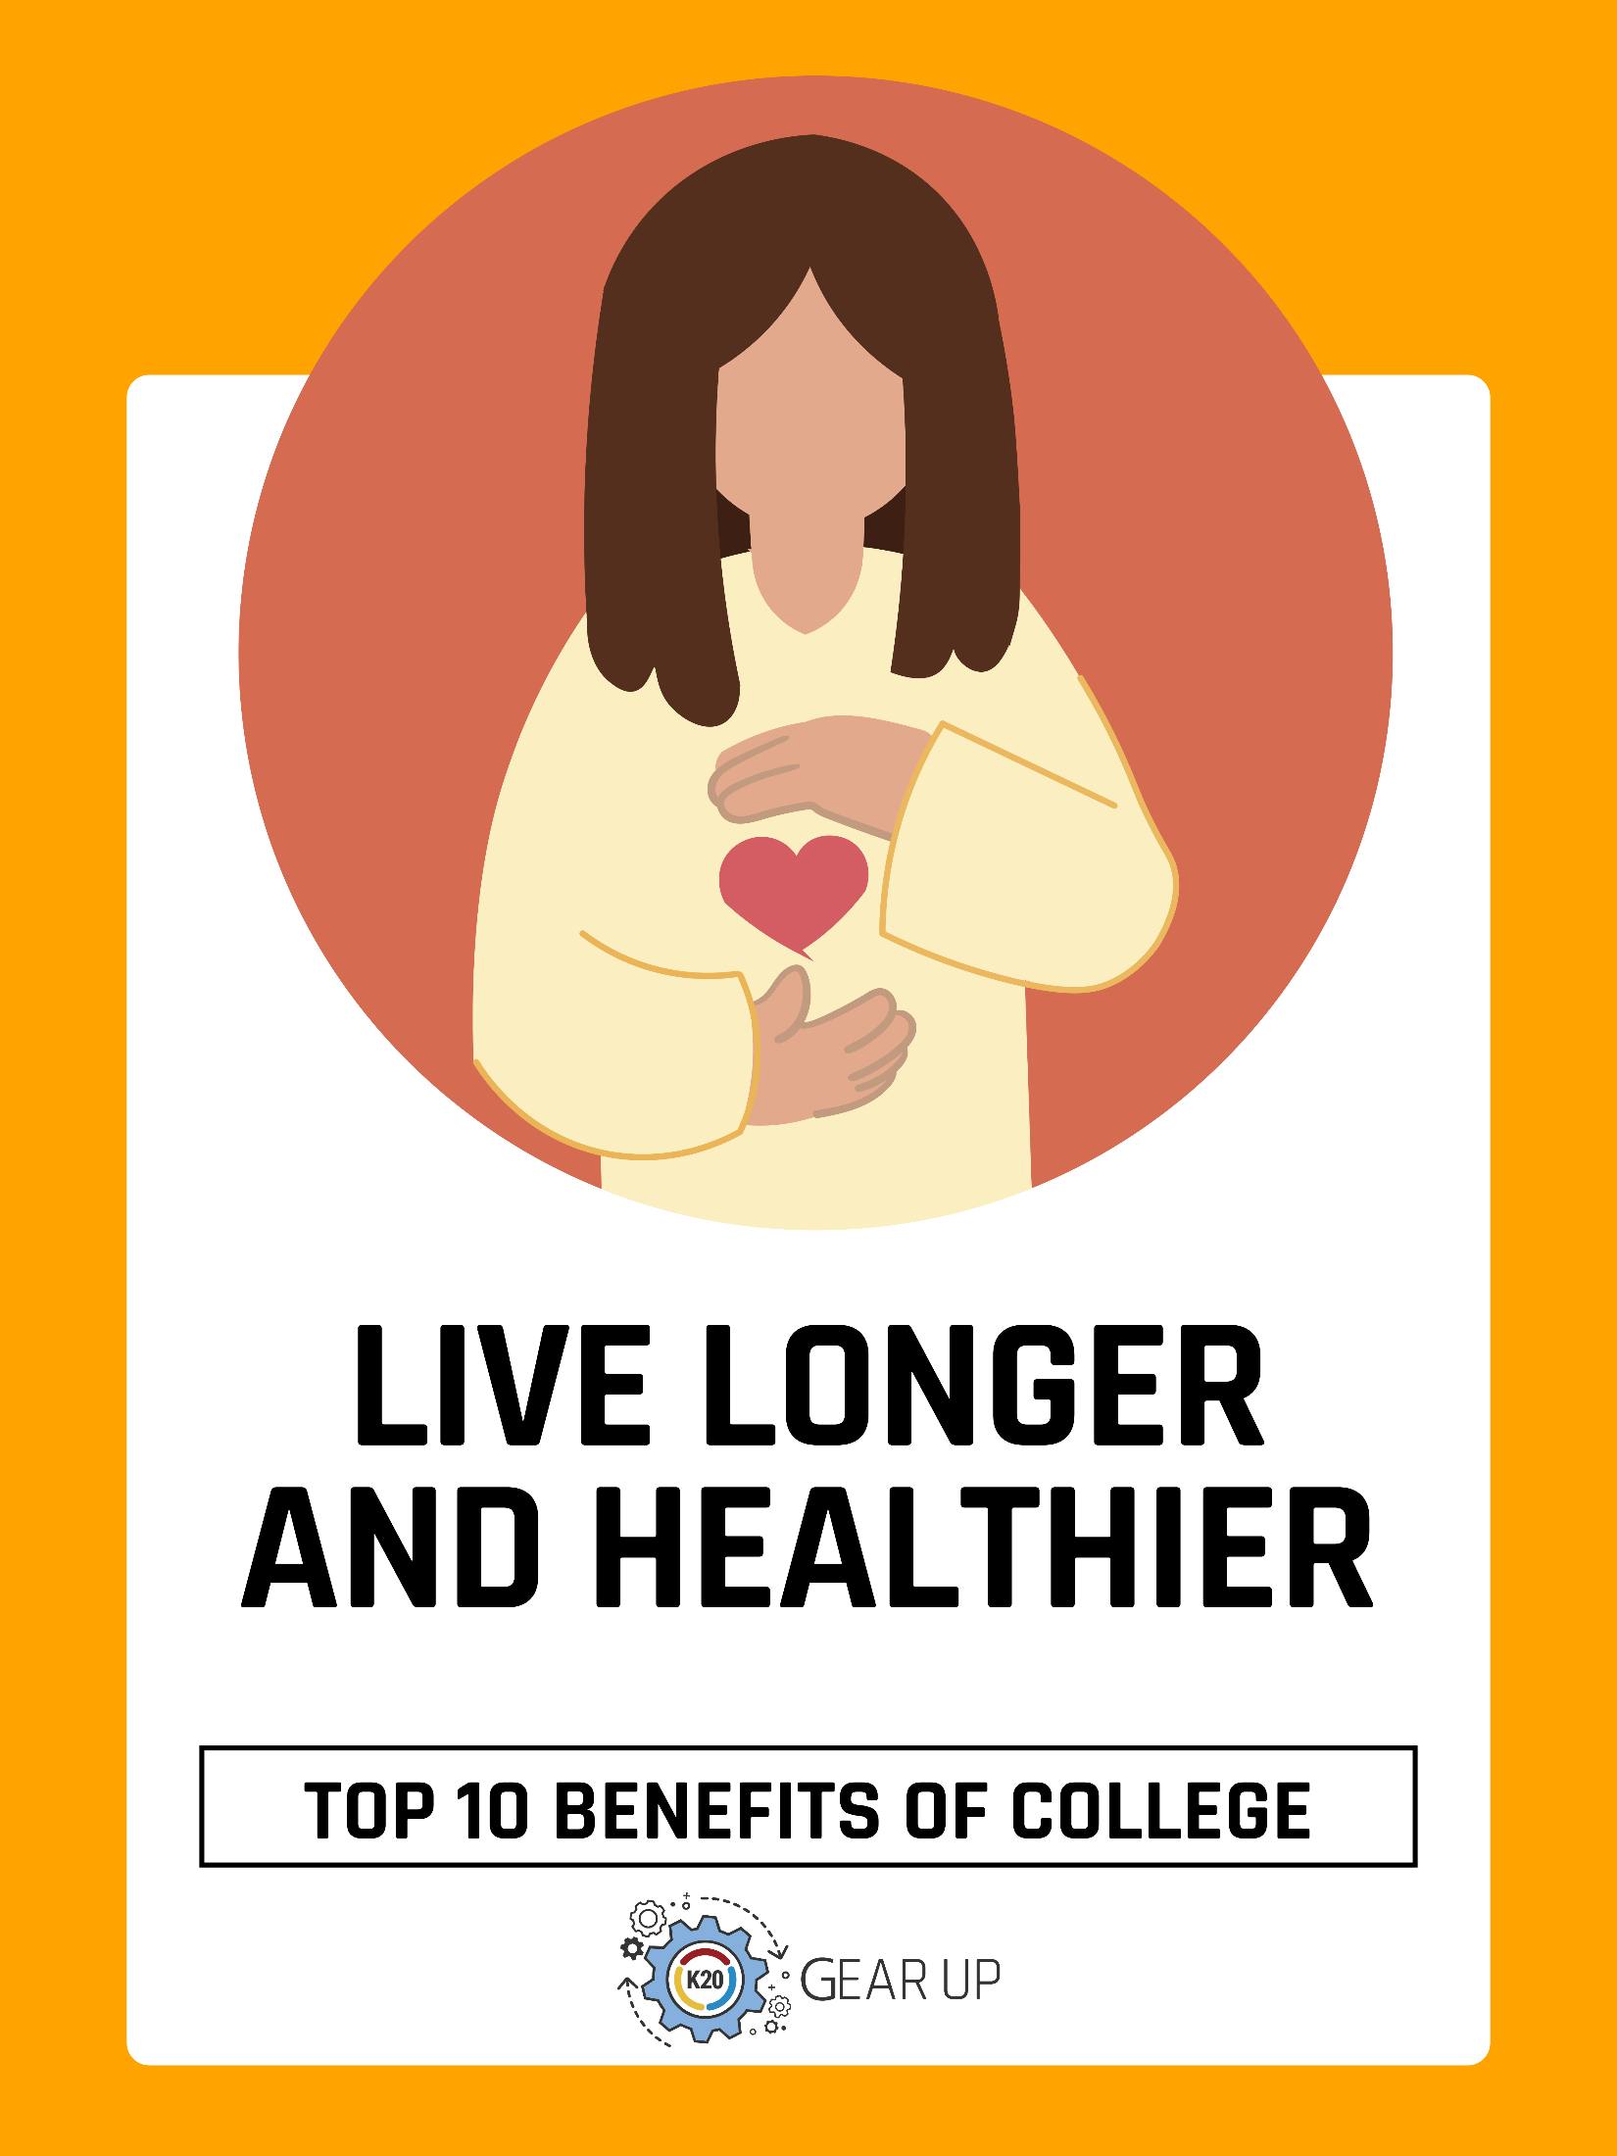
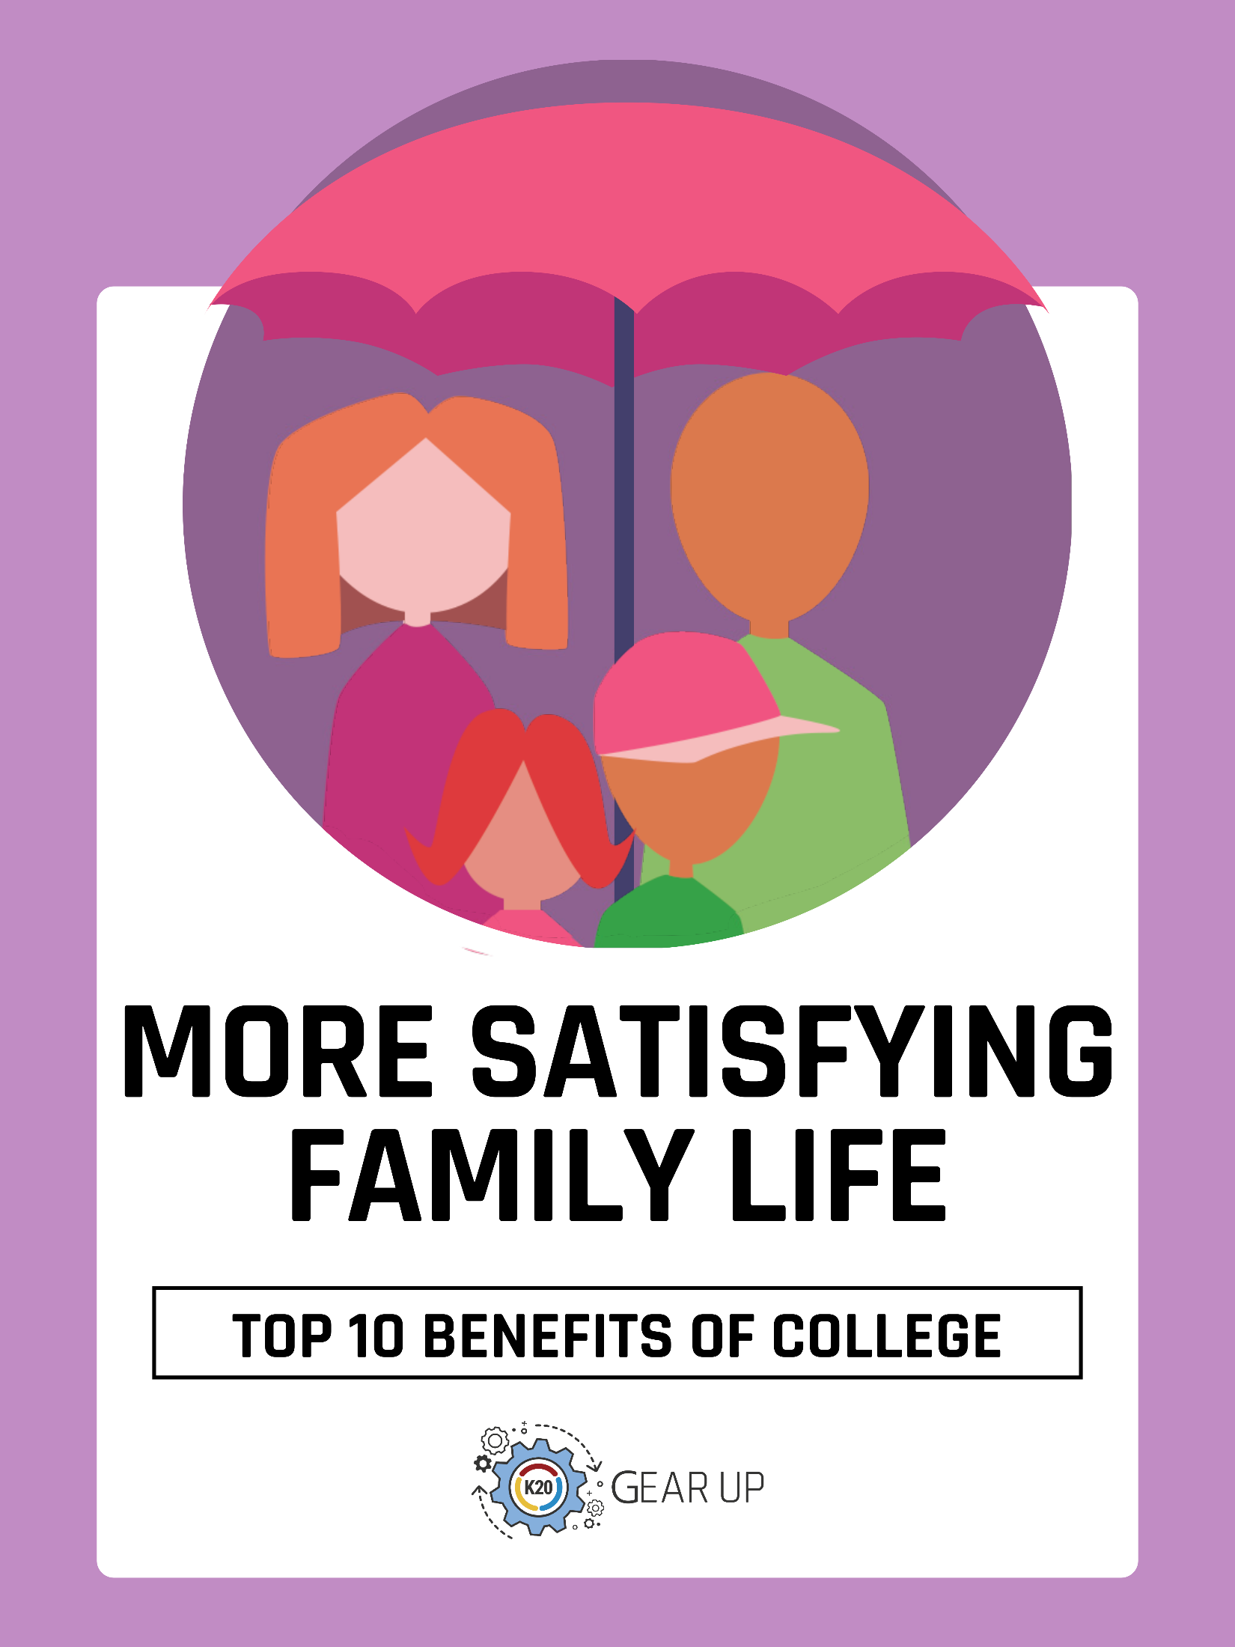
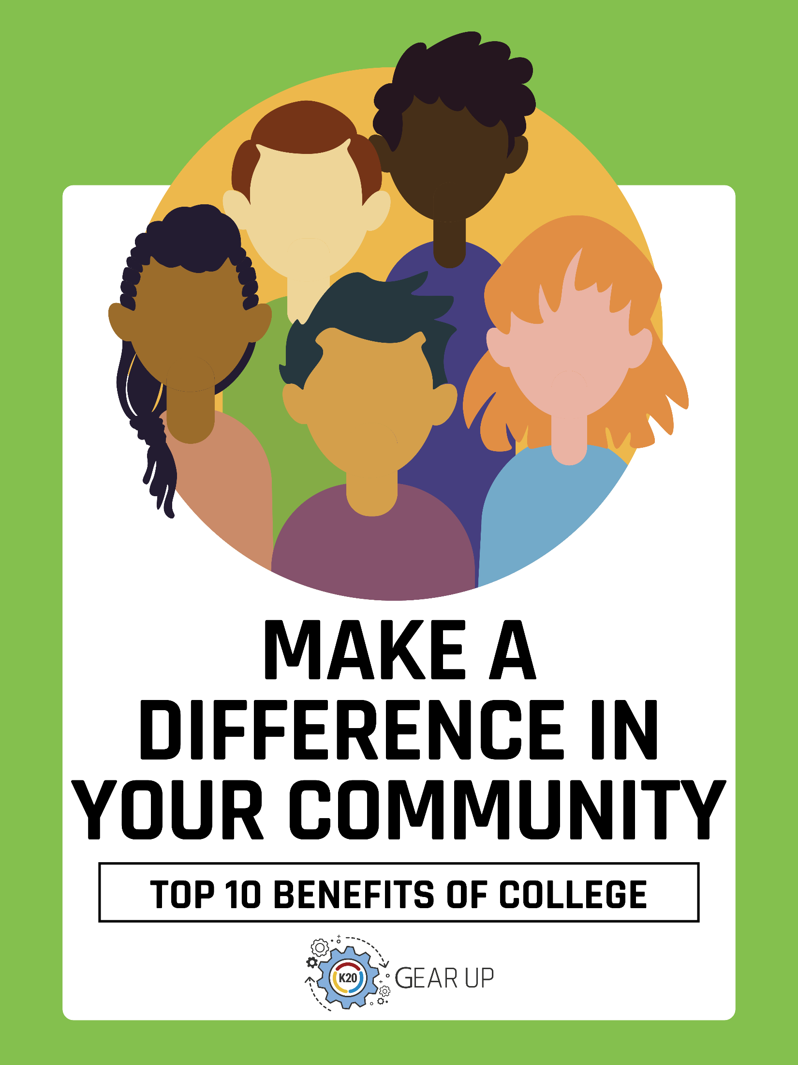
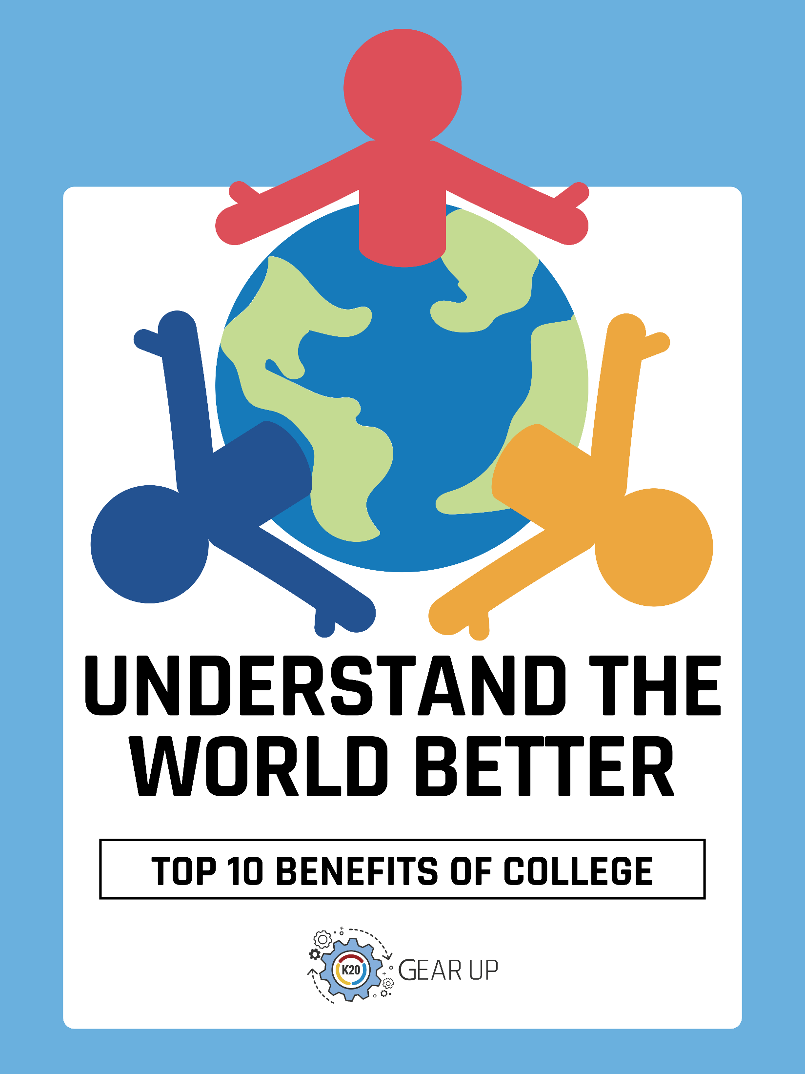
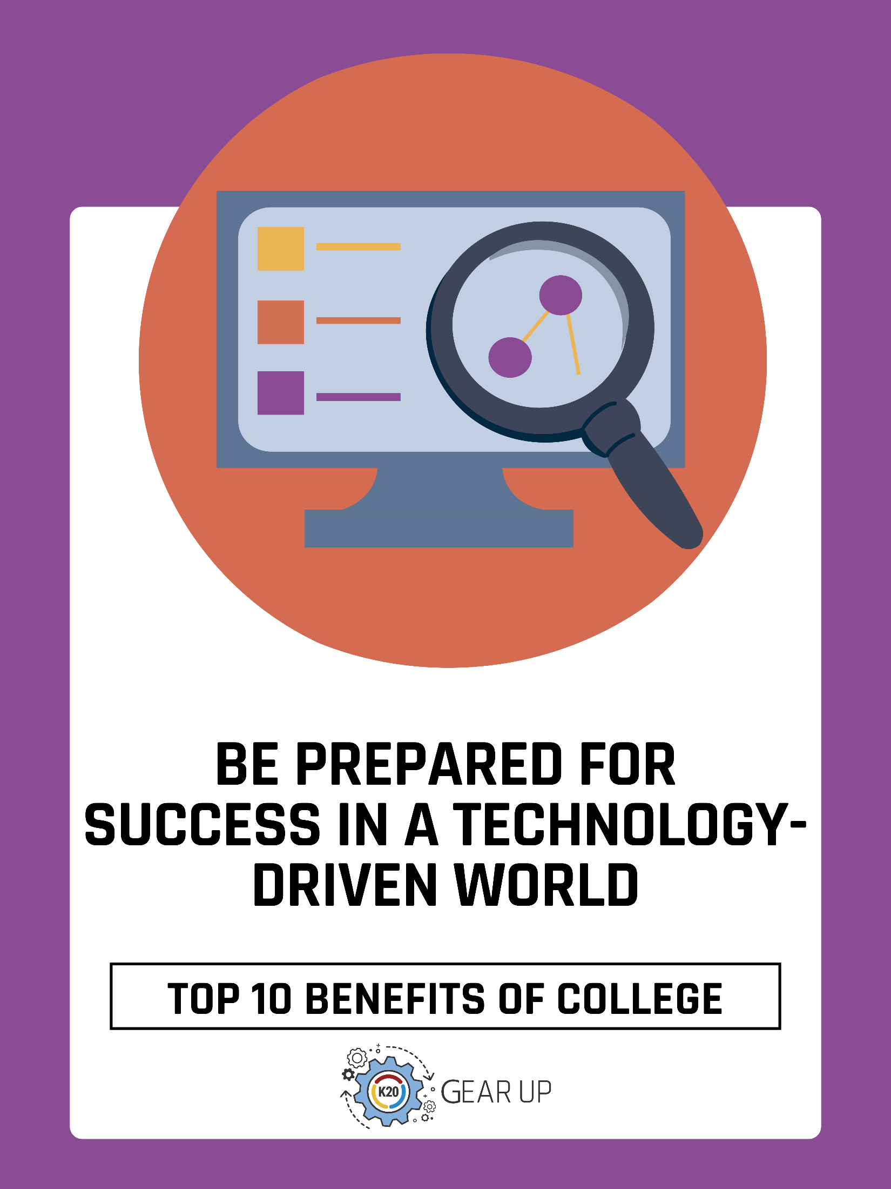
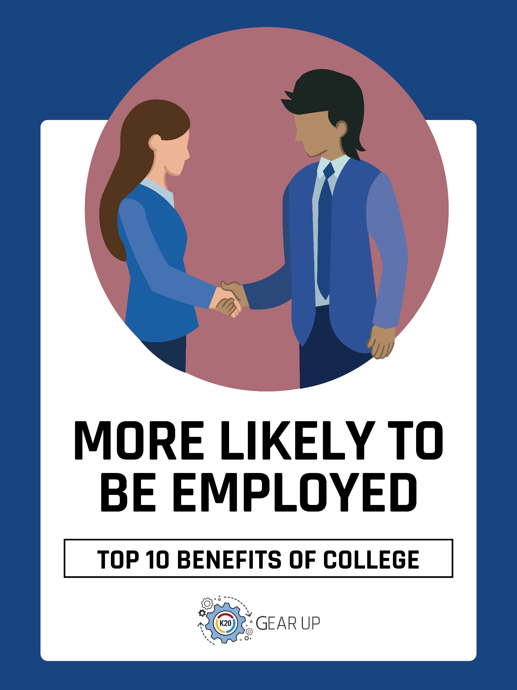
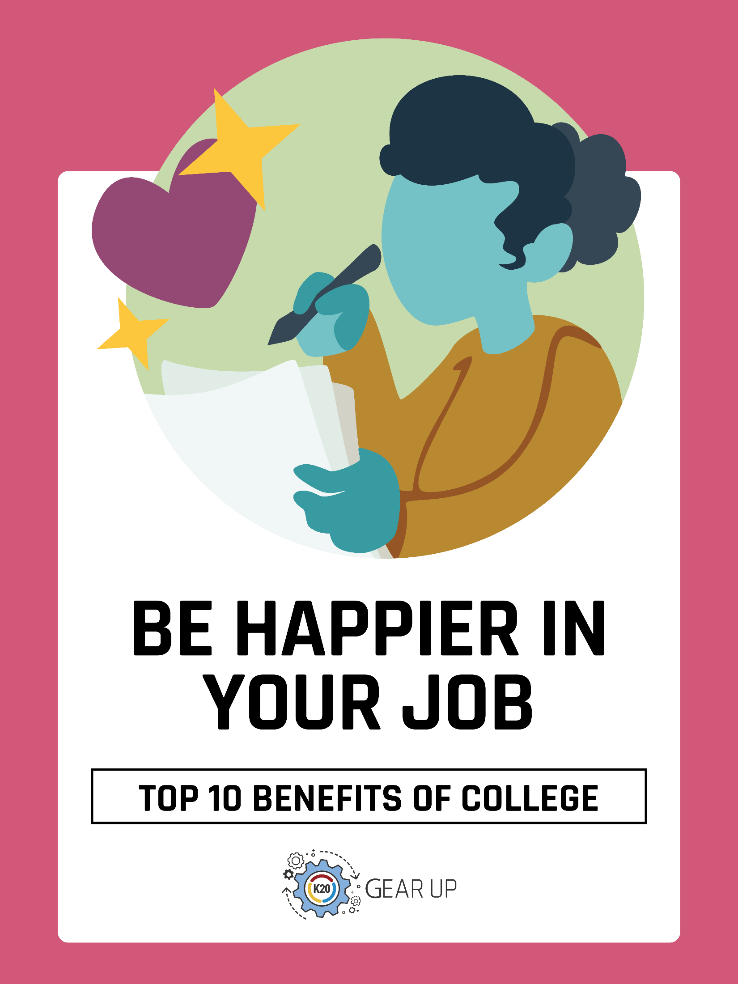
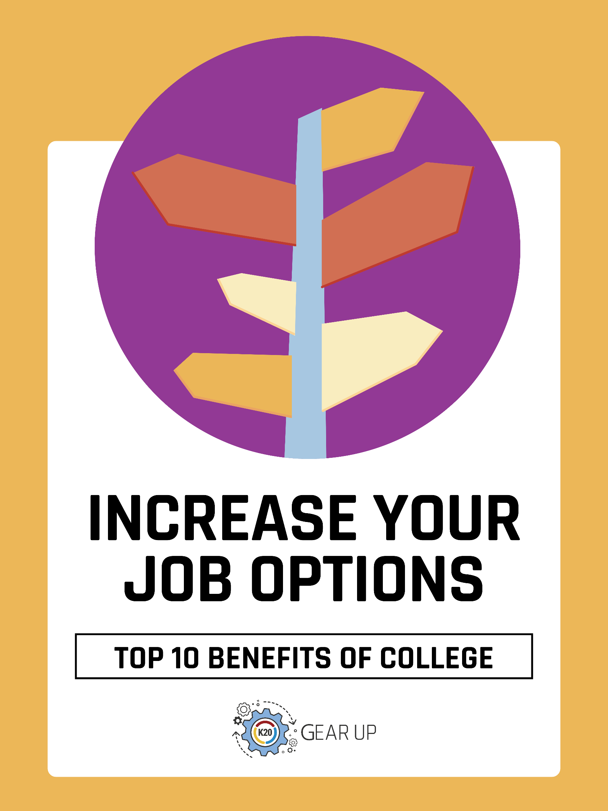
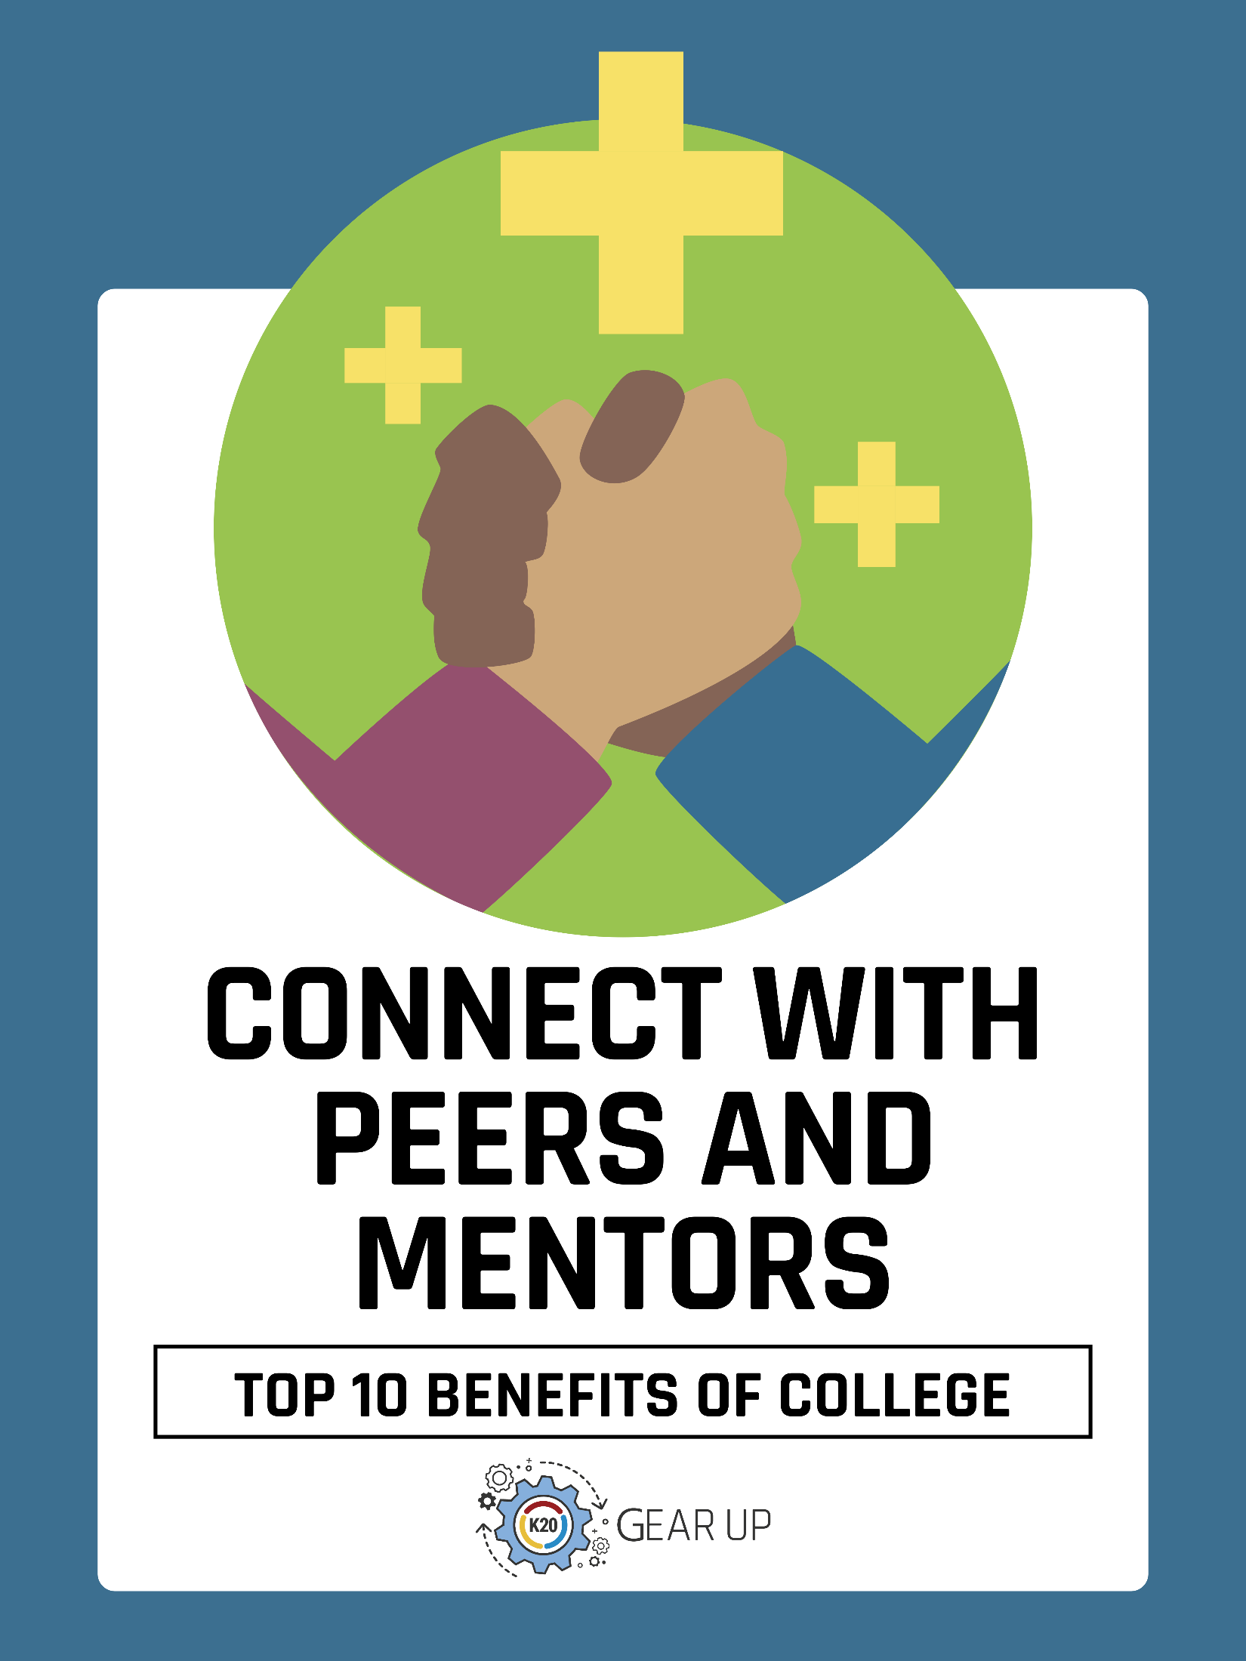
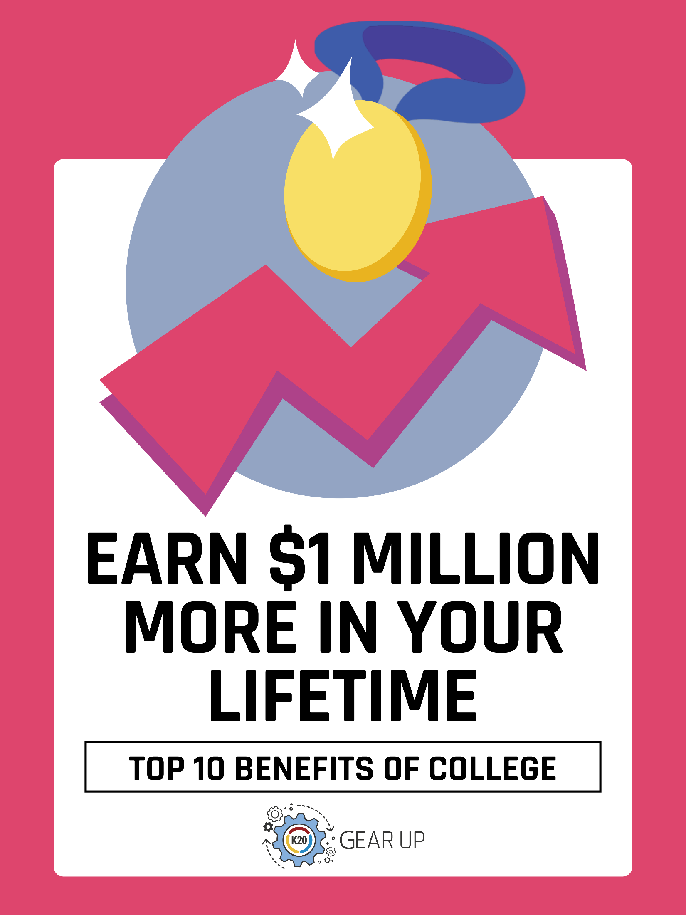

ABC College and Career Posters

Resource Overview
The ABCs of college majors and careers foster 24/7 awareness and engagement with postsecondary options. These posters can help students associate letters with college programs and diverse fields of study that they may never have considered without a visual cue. Displaying the posters in a common area also reinforces the school’s commitment to postsecondary education and increases familiarity with college and career topics.

Audience
These posters are designed for counselors and educators to display in areas where students can easily see them.

How to Use
Print the 26 posters on pages 17–42. Consider printing these in full color and laminating them. Hang these along the perimeter of a classroom or counseling office where students can easily see them.

