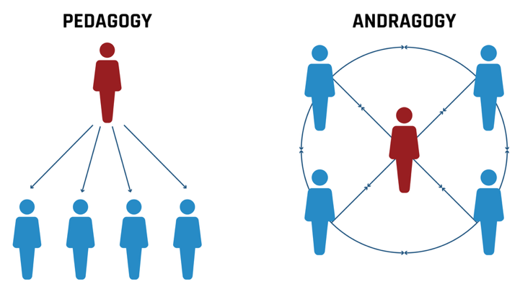
COMPONENTS OF ANDRAGOGY

As teachers, you may be very familiar with pedagogy, or the science and art of teaching children, but how does this compare with andragogy? Pedagogical approaches assume that learners are dependent: they rely on the instructor as the primary authority; they learn through subject-centered instruction, and they are motivated by external rewards or consequences.

Andragogy is an adult learning framework defined by Malcolm Knowles that identifies characteristics needed for adult learning to take place. There are six assumptions that Knowles makes about adult learning which make up the process known as andragogy. Below you will find those six assumptions synthesized into four components that are considered foundational to quality adult learning experiences.

Autonomy & Choice
Andragogical approaches are built on the principle that learner’s interests and motivations are at the center of their engagement in the learning process. This is not a unique trait to andragogy, but it is emphasized because adult learners are developmentally ready for autonomy in their learning. Instead of instructor-led learning, andragogy leans on facilitation as the primary tool because it gives adult learners the time and opportunity to be in control of their learning.

Example: Rather than assigning the same set of math problems to all participants, a mathematics facilitator provides several real-world application options, such as budgeting and personal finance, data analysis, construction and measurement, or probability in sports.

Honoring Experience
Adult learners come with their own experiences. The reality of this assumption is that all learners come with experiences and misconceptions when learning new processes or content, but adult learners have far more experience than child learners. Therefore, adult learner experiences cannot be neglected and need to be addressed or synthesized for new learning to occur.

Example: Before introducing a new strategy for teaching fractions, the facilitator asks participants to share methods they have used successfully in their classrooms and discuss common student misconceptions they have encountered. These experiences become the foundation for exploring and refining new instructional approaches.

Practical Application
Andragogy is considered a pragmatic process of learning. To respect adults, they need to be oriented to the learning in a way that allows for a wide application. Clair notes that “[a]dults are life-centered (or task-centered or problem-centered) in their orientation to learning” (2024). To be able to motivate and engage adults in learning, they need to see the practical application to the content and processes being taught. This concept assumes that adults must be ready to learn and that learning must be applicable to real-life situations.

Example: Participants learn a new instructional strategy and then use planning time to incorporate it into an upcoming lesson. By connecting the content to a real classroom task, the learning becomes immediately useful and transferable to practice.

Relevance
Another assumption of adult learners that Knowles makes relates to the why of learning. Clair argues that adults have a “need to know. Adults need to know why they need to learn something before undertaking to learn it” (2024). The reason behind learning something new ties to adult motivation, both the external (better jobs) and internal motives (self-esteem), which help how adults respond to the learning and learning environment.

Example: Rather than immediately introducing new content, the facilitator first explains how the learning will help participants solve a common classroom challenge, improve student outcomes, or meet a professional goal. Understanding the "why" behind the learning increases participants' motivation and engagement.

As you design learning for fellow educators, incorporating these foundational components of andragogy can help ensure professional learning is not only informative but also meaningful, applicable, and responsive to the needs of adult learners.

Source: Clair, R. S. (2024). Andragogy: Past and present potential. New Directions for Adult & Continuing Education, 2024(184), 7–13. https://doi.org/10.1002/ace.20546

