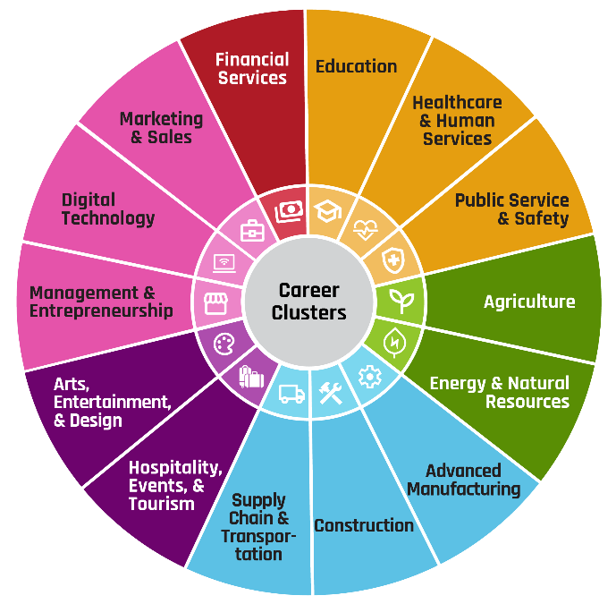
CAREER TALK ORGANIZER

Career Title
_________________________________

Complete During Career Interview
Presenter’s Name: _________________________________
Presenter’s Job Title: _______________________________

What does someone in this career do each day at work?

What do professionals in this career need to study?

Level of education needed after high school:

□ Certificate
□ Associate’s Degree
□ Bachelor’s Degree
□ Master’s Degree
□ JD
□ MD (or other medical degree)
□ PhD



Wanna see more career videos?
Check out the full Zoom Into Your Career YouTube playlist here.

