HELPFUL RESOURCES
YouTube Playlist
Visit the K20 Youtube Playlist to view all of our Virtual Career Expos.
K20 LEARN Site
To learn more about what the K20 Center does, and to explore our lessons and strategies, visit the K20 LEARN website.
K20 COVID Landing Page
At the start of the COVID quarantine, K20 committed itself to helping our schools and community through this difficult time. To do so, we provided online resources to work alongside, and as alternatives to, our in-person instructional materials. Visit our K20 COVID Landing Page to access these resources!
Roadmap to Careers
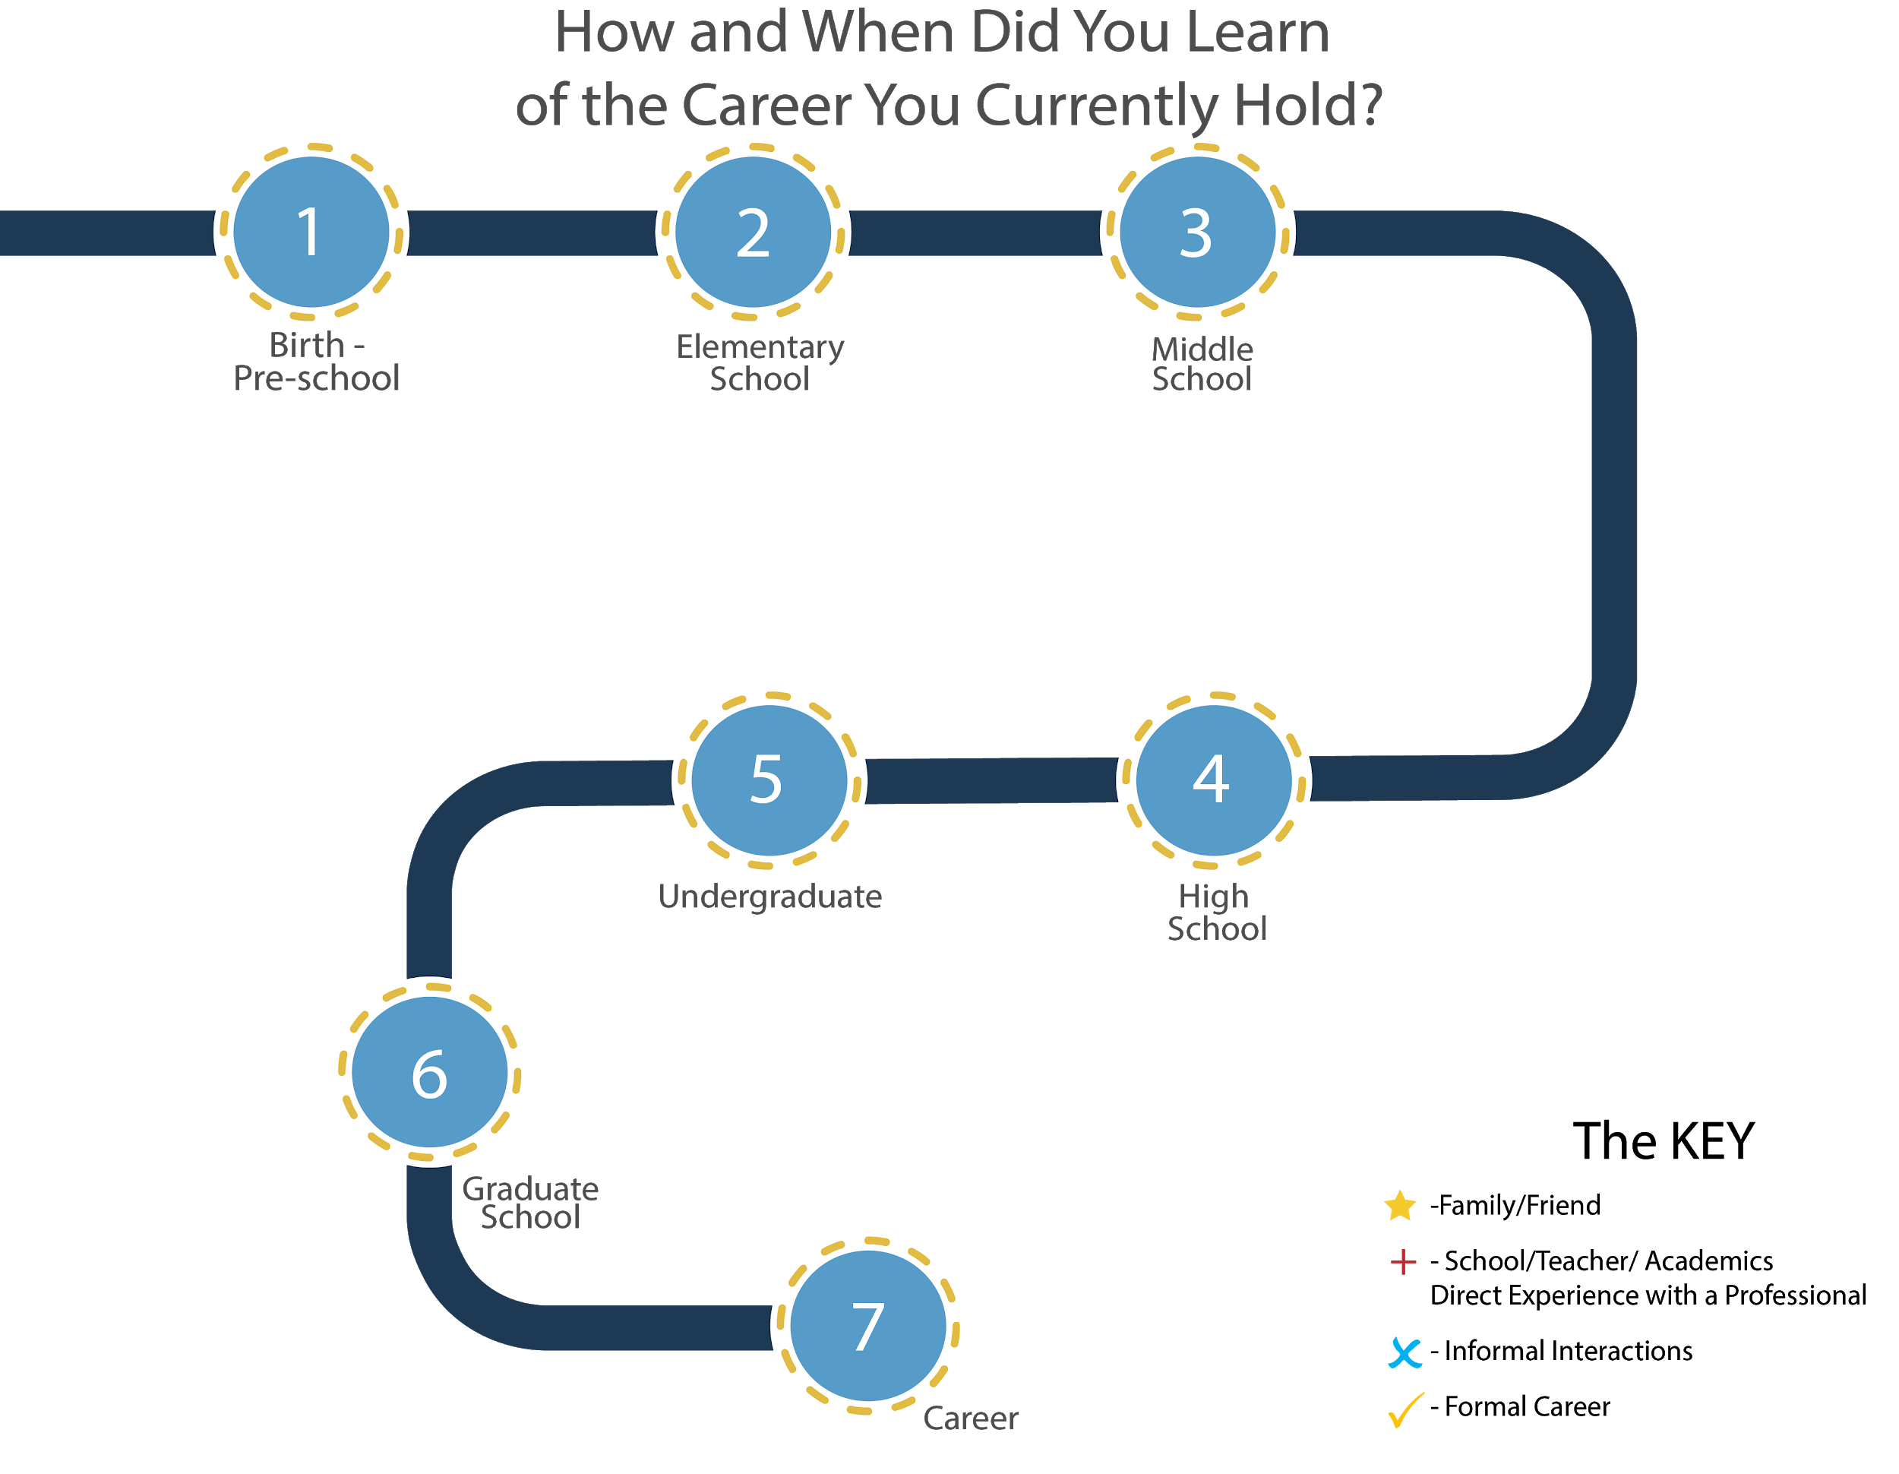

GENERAL GUIDE FOR VIRTUAL CAREER TALKS
- Assess students’ interests and needs.
  - Give students a career interest survey connected to individual state initiatives. This will help give your school an idea of what careers to target.
    - Here is a career interest survey activity:
      - Career Cluster Survey Step 1
      - Career Cluster Survey Step 2
      - Career Cluster Survey Step 3
  - Consider demographics and research. For example, STEM fields are often not shared with or discussed among specific groups of students. Based on research, which career opportunities are your student body less likely to hear about?

- Start thinking about logistics.
  - WHEN: When could you schedule a career talk (or talks)? Consider dates that would best fit on your school’s calendar, given holidays, parent-teacher conferences, etc.
    - What time will the career talk(s) be?
  - WHAT: What kinds of career clusters are best suited for your students?
  - WHO: Who is the target audience? Which grade levels and classes will participate?
  - WHERE: Where will you hold the virtual talk? Could it be in a library or classroom(s)?
  - HOW: Do you have a website or virtual platform that can be used to facilitate your school(s) career talk(s)? For example:
    - Zoom
    - Google Meet
    - Facetime

- Find potential speakers.
  - Start contacting universities, colleges, and tech programs for potential speakers inside and outside of their institutions.
  - Ask colleagues for volunteer referrals.
  - Find other organizations doing similar career events and contact them.
  - Decide on a vetting process for speakers. You may, for example, send a digital volunteer application or survey via Google Forms or similar.
    - For an example of a volunteer application, see the PDF linked in the Gear Up Summer School Files tab

- Communicate with speakers.
  - Contact professionals who have careers in the cluster you would like to cover. As you find interested professionals, begin your vetting process with each one.
  - Confirm the date and time of the career talk with each professional.
  - Let professionals know what their role and responsibility for the talk should be (i.e. how long they should speak, what they should cover, and if there will be time for questions).
    - For a number of speaker roles and responsibilities you might include, see the K20 Center’s example Volunteer Guide on pages 4-5 below.

- Prepare for the virtual meeting.
  - Create an account with the platform you will be using, if necessary.
  - Offer practice sessions for volunteers and school personnel.
  - Schedule a virtual meeting for the day and time of the talk.
  - Send the meeting information, such as the virtual meeting link and/or meeting ID, to the professional.
  - Have students prepare for the talk. This might include researching the career, writing down questions for the speaker, reading the speaker’s bio, etc.
  - Determine a system for the question and answer portion of the career talk. This might mean using the chat feature, using a microphone while on camera, etc.

- Enjoy the session.
  - Designate a facilitator (likely the teacher).
  - Greet and introduce the speaker, and then let them share.
  - Leave time for questions.
  - Thank the speaker.
  - Consider guiding students through a relevant activity during and/or after the talk.

- Follow up after the session.
  - Be sure to thank the speaker(s) for sharing via email. Ask the speaker if they have any additional resources to share with the students for more information (for example, a website, job application, internship opportunities, etc.).
  - If you want feedback on the experience from volunteers, staff, or students, create and distribute a survey form.
  - Consider gaging volunteers’ interest towards participating in future career events. Additionally, consider asking volunteers to refer others who may be interested in volunteering in future events.

Zoom Into Your Career: Volunteer Guide
Thank you for volunteering to share your career and experiences with students! Below are some suggestions to help make your virtual career talk a success. Every career and industry is unique, so use what works best for you. Before developing your talk, here are a few things to know about this volunteer opportunity:
- Purpose
  - Your main goal is to share information about either your career or another career opportunity in your industry that you think might interest students.
- Audience
  - Your audience is middle school students at schools across Oklahoma. For many, this may be their first time learning about your career field.
- Logistics
  - You’ll remain at your work location and connect to classrooms via Zoom, a video conferencing tool.
  - Your career talk session will run approximately 30–40 minutes, including:
    - 10 minutes to get all classrooms logged in and to test technology
    - 10–15 minutes for the presentation
    - 10 minutes for questions from students
Tips for Excellent Career Talks
- Broadcast from your home, office, conference room, or any space with minimum noise interference.
- Use headphones or earbuds to help reduce background noise.
- Create and incorporate PowerPoint slides or graphics highlighting key information. This could include salary, education requirements, and key job responsibilities (optional).
- Take students on a short virtual tour of your organization if your technology permits, or share a short premade tour video of your job (optional).
- Show students examples of the work, tools, equipment, etc. that you use for your job (optional).

Sample Talking Points (Note: You will not have time to cover every point.)
- Students will need to know the following information:
  - Your name and job title
  - Daily work responsibilities
  - Knowledge and skills needed for this career
  - Degrees, certifications, and/or training needed after high school
- Other things students might want to know (optional):
  - Personal reasons for choosing your career
  - What school subjects students should study to prepare for this career
  - Average salary of a professional in your field (entry-level to advanced)
  - What you like most/least about your job and why
  - Advice you would give someone interested in your field and why
  - Other types of jobs that exist within your career field
Questions that students might have for you:
- What are your main work responsibilities?
- Why did you choose this career? Are you happy with your career choice?
- What do employers in your career field look for when hiring new employees?
- Are jobs in this career field in demand? Is it hard to get a job in this career?
- Do jobs in this career exist in Oklahoma?
- How many hours do you work each week?
- Is your job physically, mentally, and/or emotionally draining?
- What kind of technology or tools do you use regularly for your job?
- What school course(s) in middle and high school (e.g., science, math, English, etc.) will help most in this career?
- What are other jobs related to your career field?
- What advice would you give a student considering this career field?

Zoom Conference Information
- For more information on using Zoom, please visit the website here.
- For Zoom tutorial videos, please visit the website here.
- The K20 Mentoring Team will reach out to offer a Zoom conference session to help you prepare.
- Please email the K20 Mentoring Team at gearupmentor@groups.ou.edu if you have questions.

