HOW TO CREATE A VISION BOARD
- Brainstorm
  - Think about the end of this school year. Where do you see yourself? What do you want your life to look like? How do you plan to get there?

- Create Your Board
  - Open Google Slides. Under “Start a new presentation,” select “Blank.”
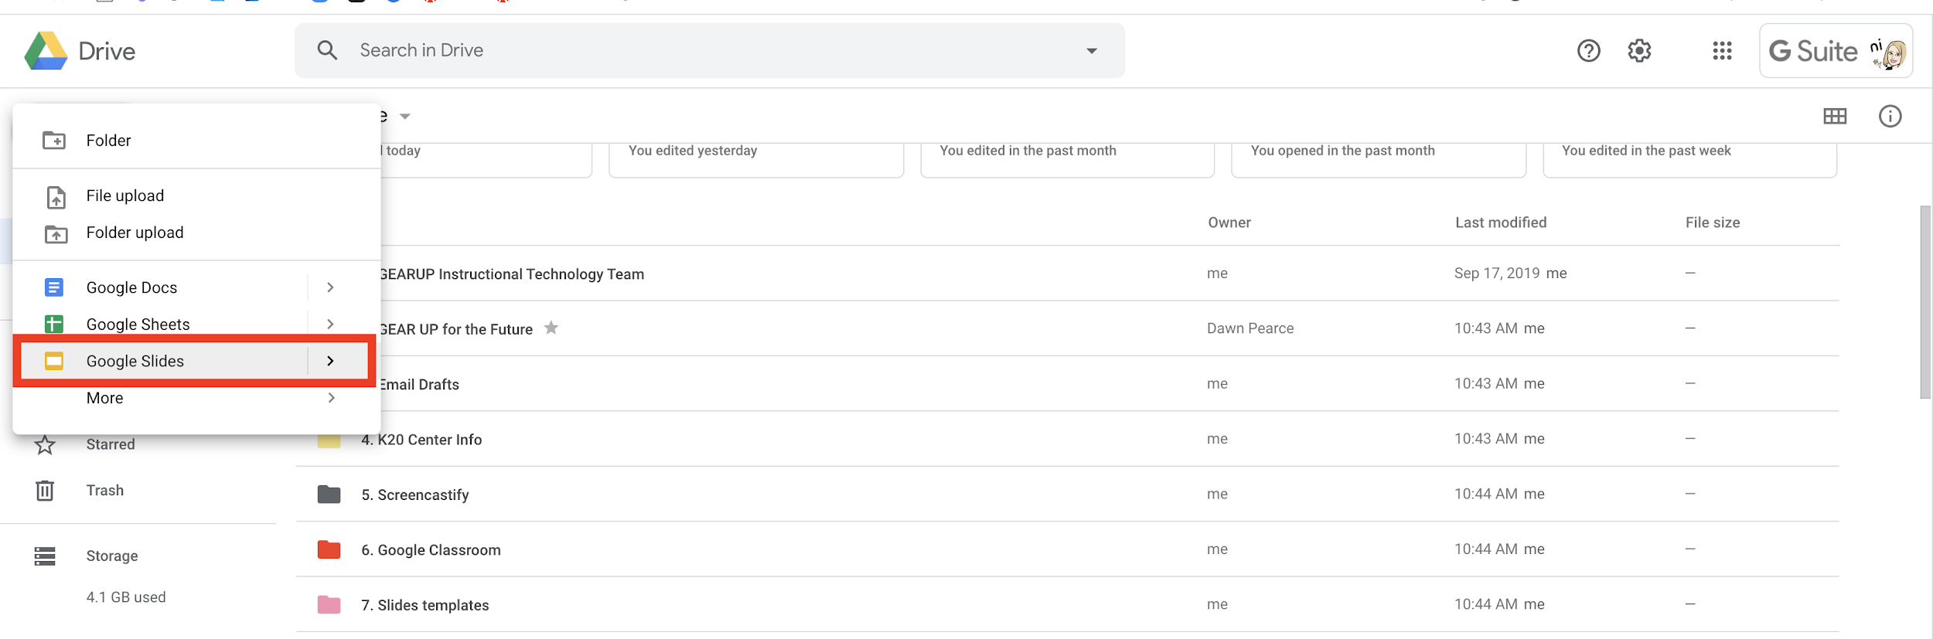
  - Select a theme.
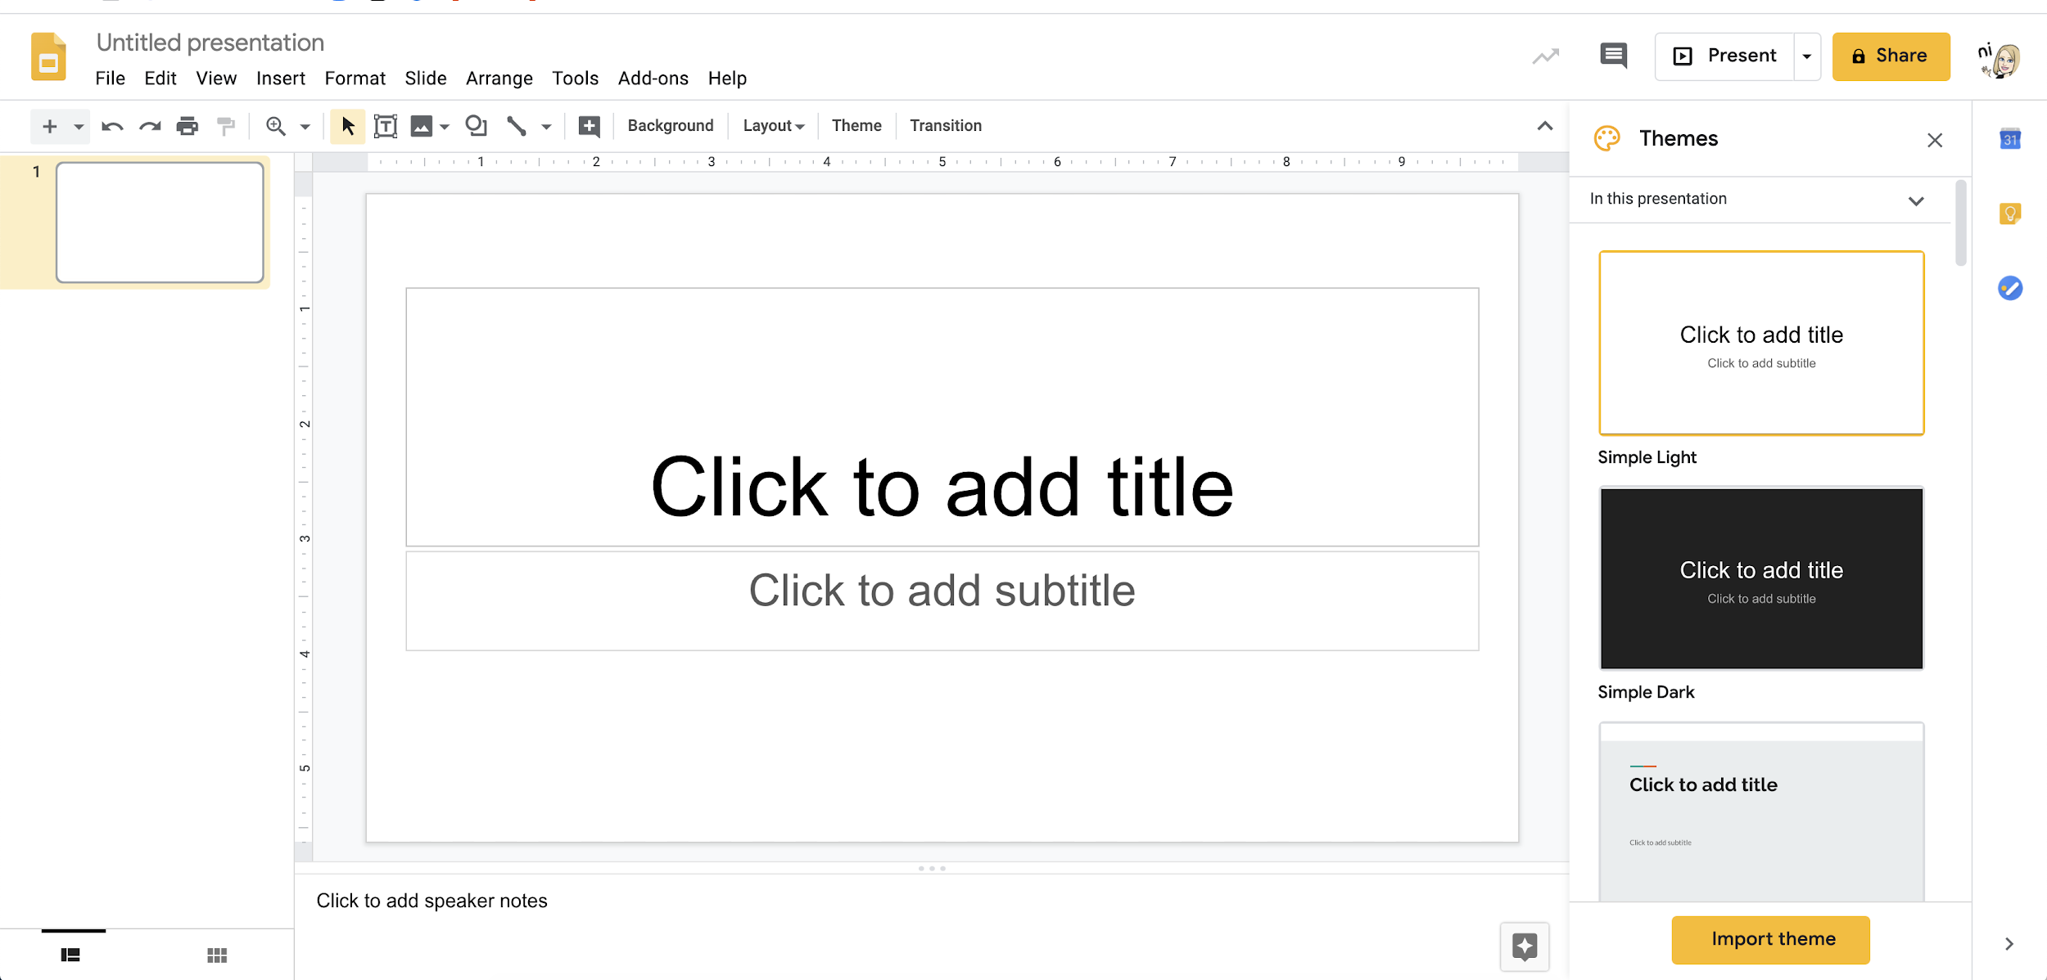
  - Change the background to the “Blank” background type.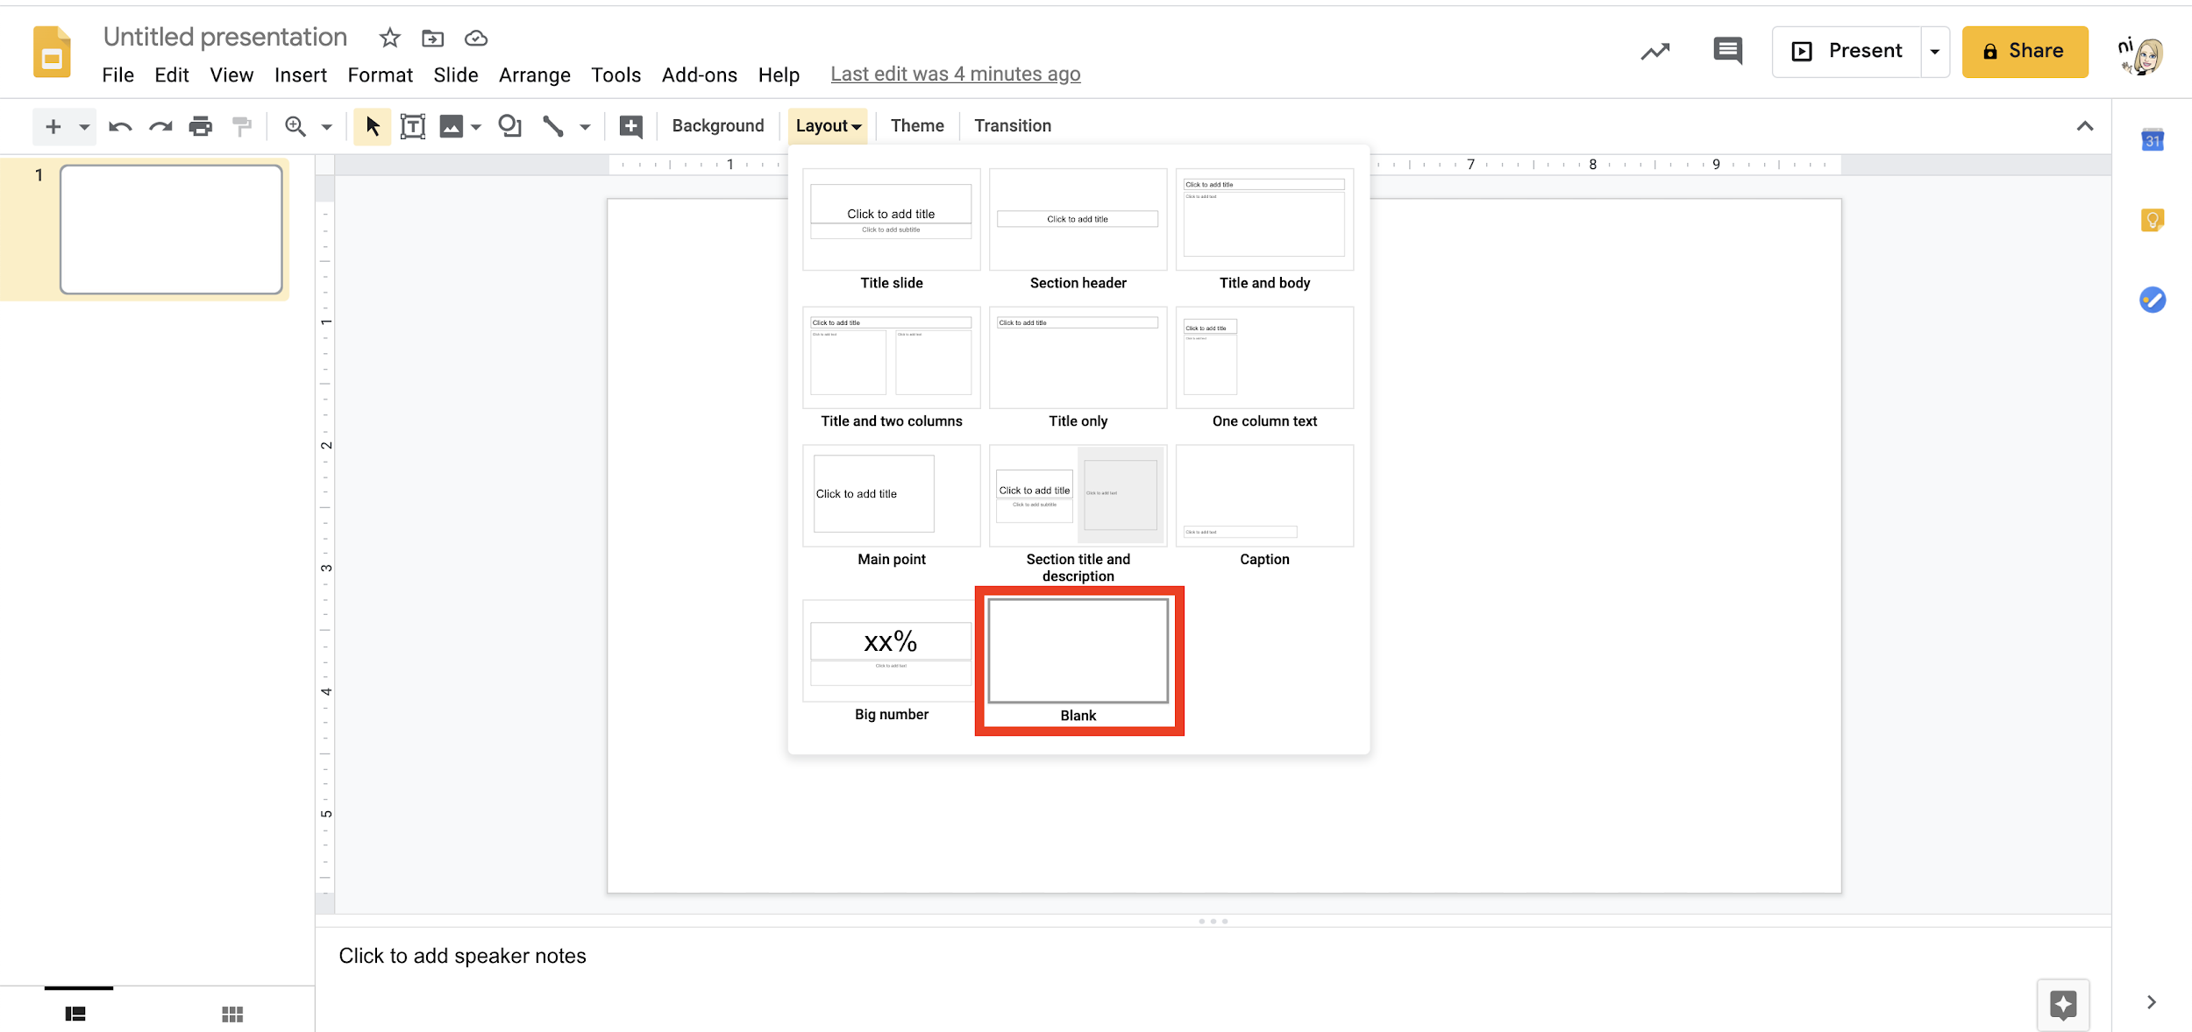
  - Insert a text box. You will use this as your title box.
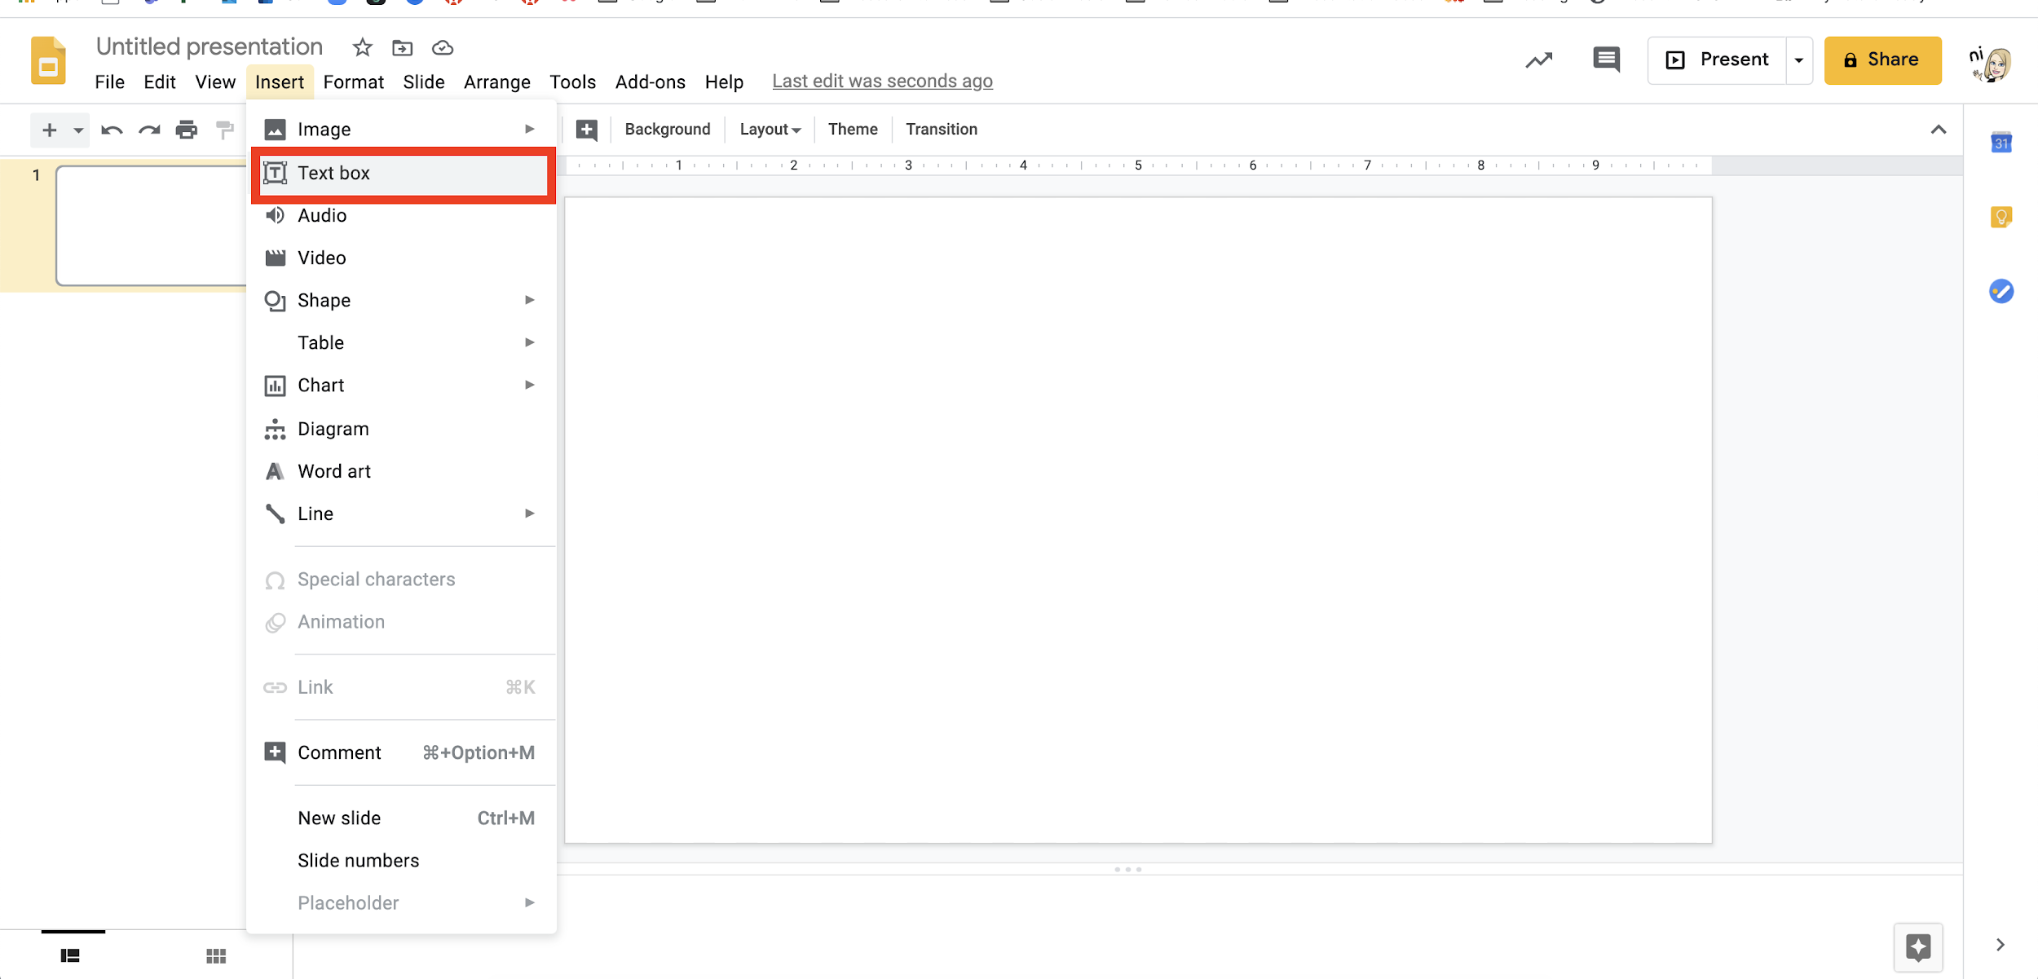
  - Title your vision board.
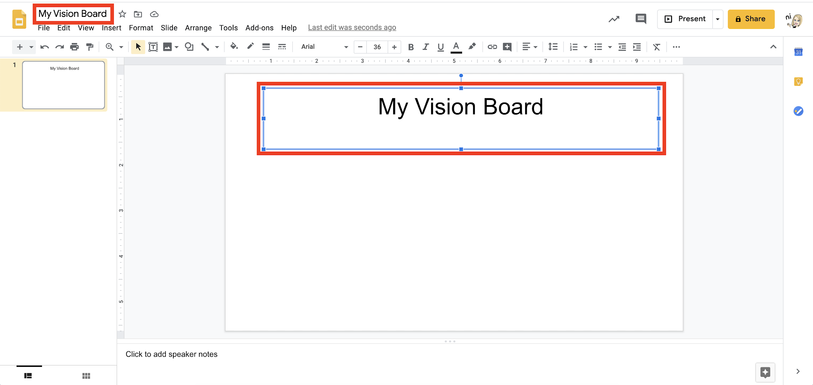
  - Go to File > Page setup. Select the “Custom” setting. Set your dimensions to 800 x 200 pixels.

  - Add images from Google:
    - Go to Tools > Explore. Type in a word and select the “Images” tab to search for an image. Select an image and select “Insert.”
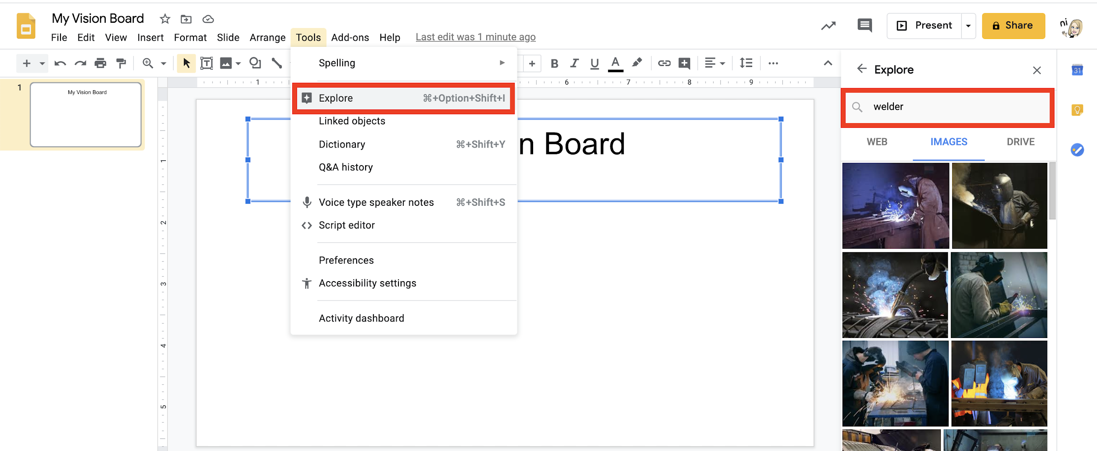
  - Add images from other sources:
    - Try navigating to a public domain photo source such as https://unsplash.com/. The pictures found here can be used without concern for copyright.
    - Save a picture to your computer, and add it to your vision board by going to Insert > Image > Upload from computer.
  - Add words, GIFs, lines, arrows, and more:
    - Add more text: Go to Insert > Text Box to insert a box into which you can type text.
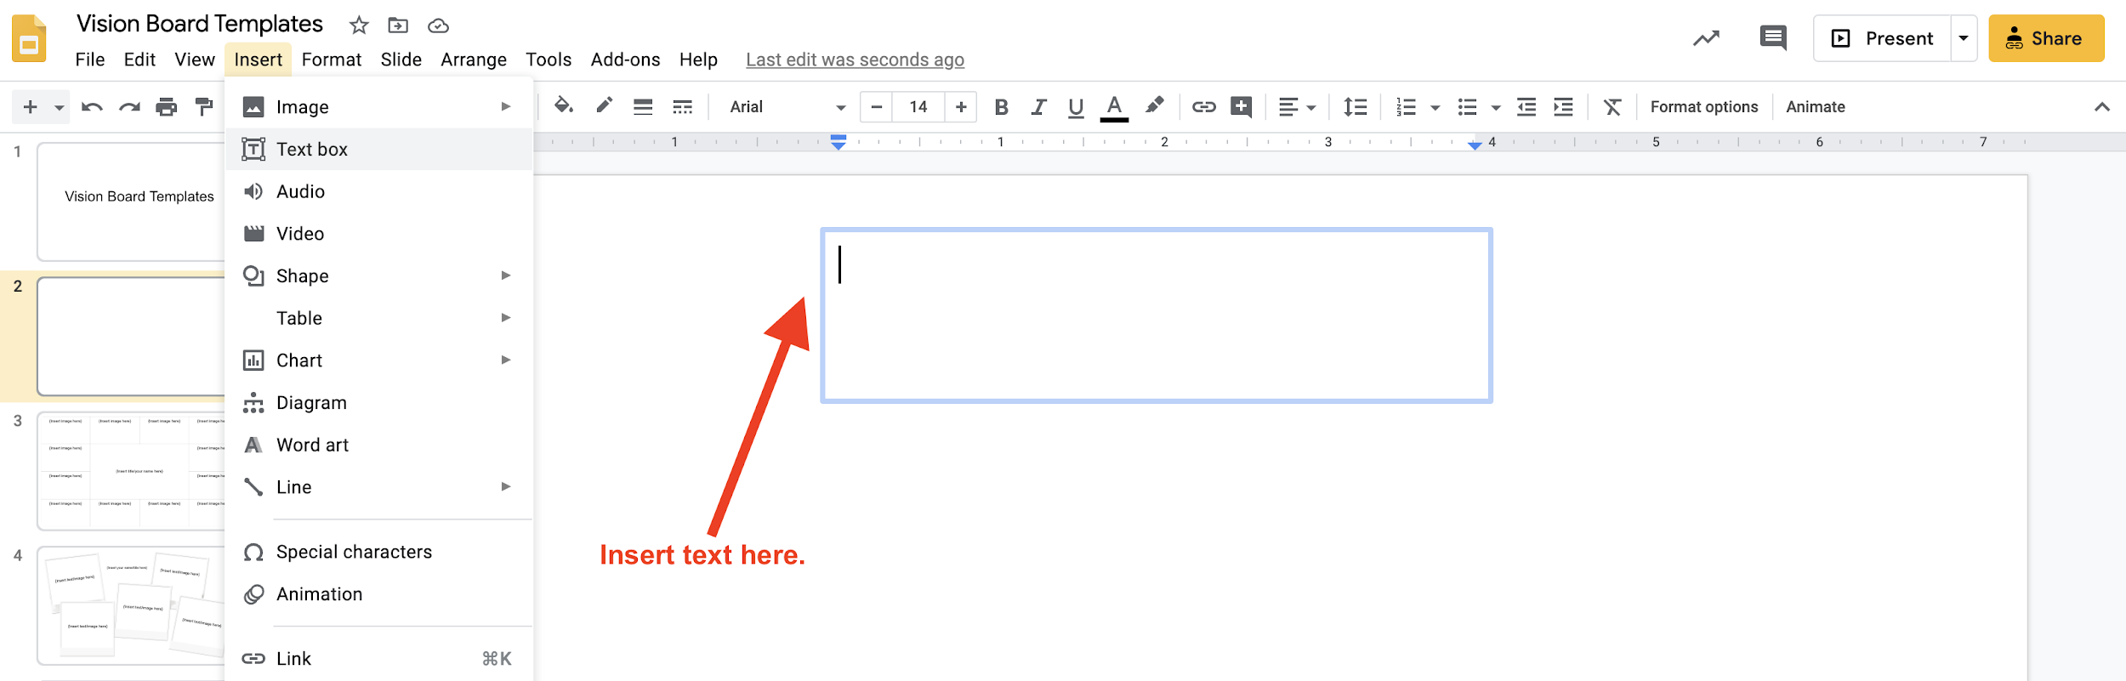
    - Add shapes and symbols: Go to Insert > Shapes to add shapes, arrows, speech bubbles, and symbols.

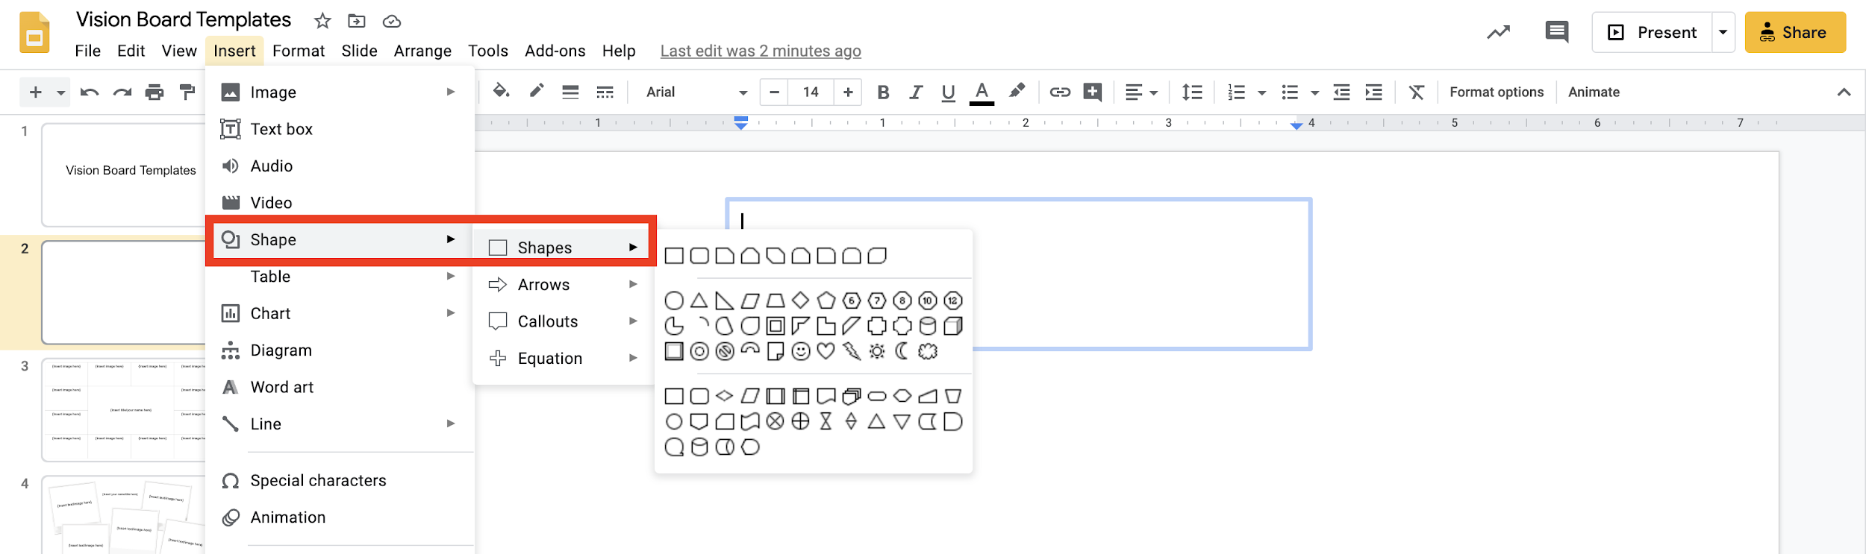
    - Add lines: Go to Insert > Line, select your preferred line type, and draw it directly into your vision board.
    - Other features: Try out other features in the “Insert” tab to add audio clips, videos, charts, diagrams, and more.
- Create a Header for Google Classroom
  - Complete your Google Slides vision board.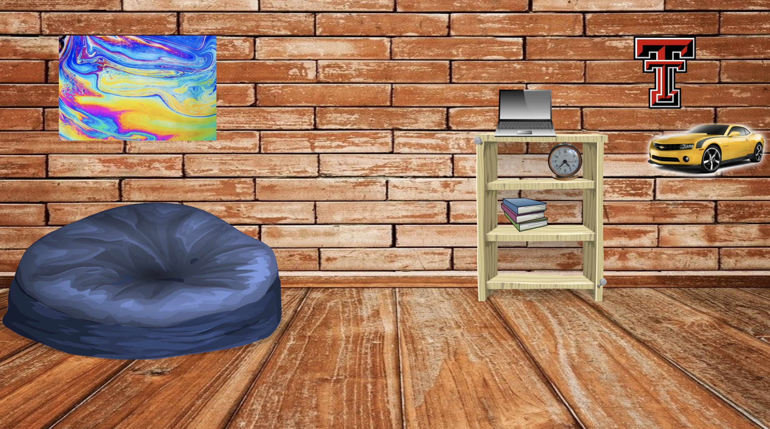
  - Go to File > Download and download your board as a JPEG or PNG to your device.
  - To upload your board image to your Google Classroom header, navigate to your Google Classroom. Select “Upload photo” near the current header, and select the vision board image from your device.
- Resources
  - Google Teacher Center
    - Google Slides Product Guide

