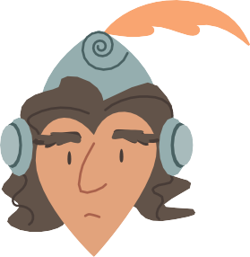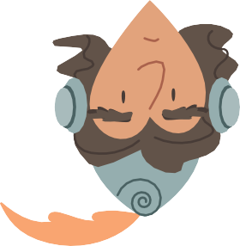

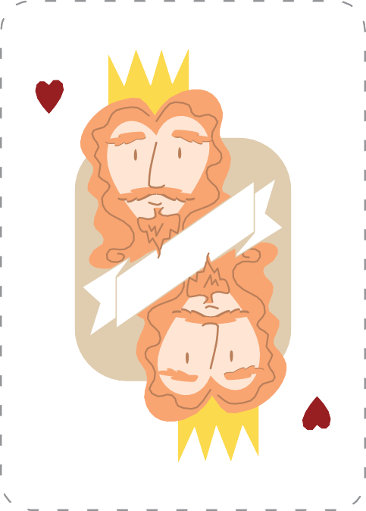

*K*

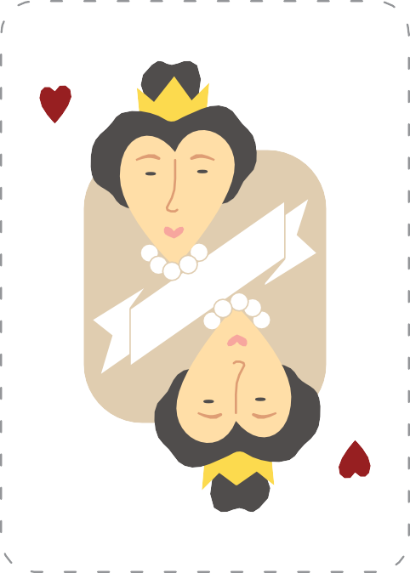

*Q*

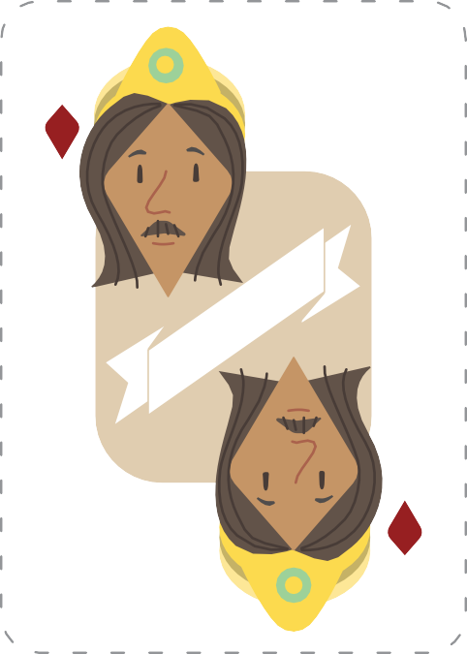

*K*

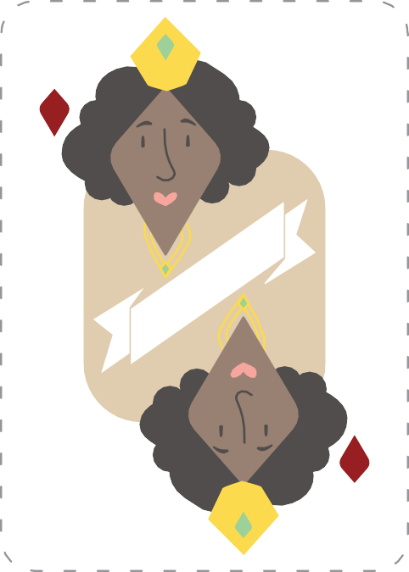

*Q*



*Joker*



*Joker*

*J*

*J*

*K*

*Q*

*J*

*K*

*Q*

*J*

*Joker*

*Joker*

King

Queen

Jack

King

Queen

Jack

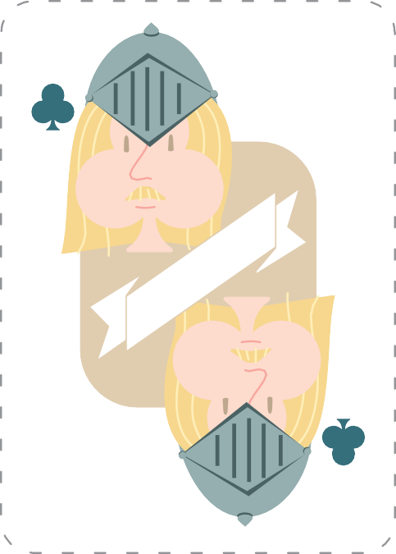

*J*

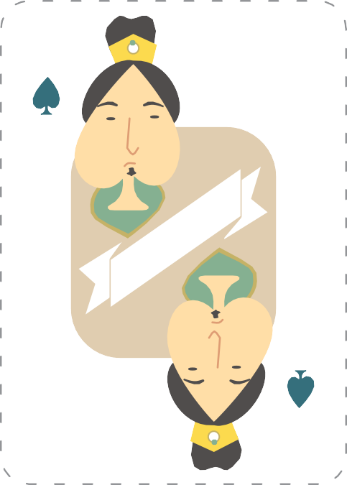

*K*

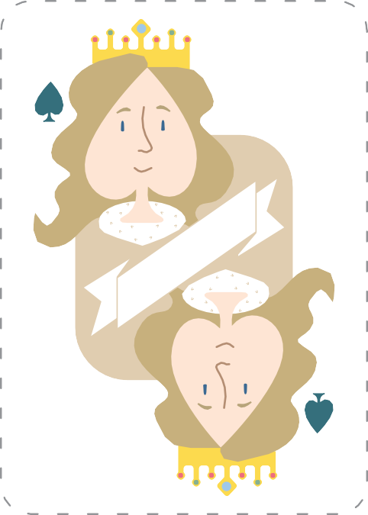

*Q*

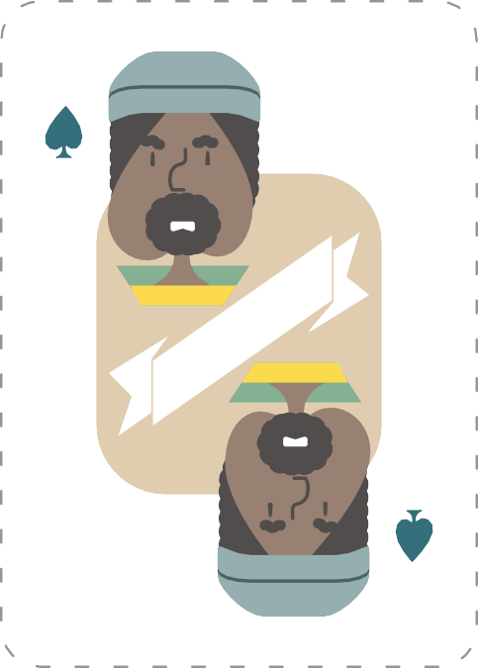

*J*

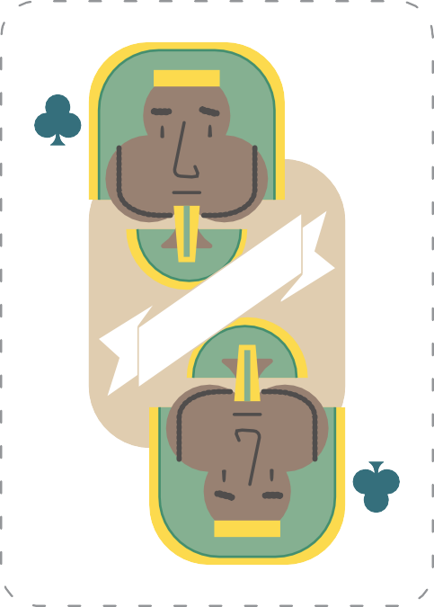

*K*

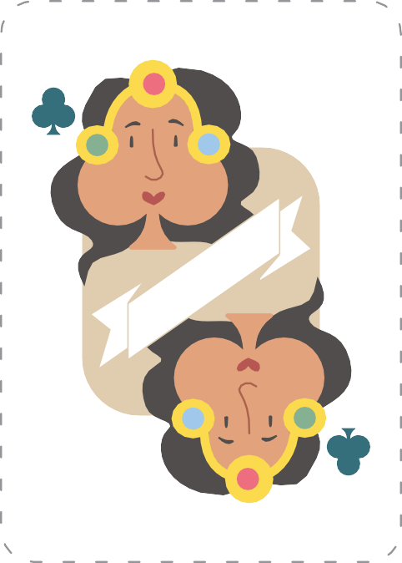

*Q*



*Joker*



*Joker*

*Q*

*K*

*J*

*Q*

*K*

*J*

*Joker*

*Joker*

King

Queen

Jack

King

Queen

Jack