Career café: A Recipe to Student Success
How to have a Career Café
- Identify potential speakers
- Identify dates for Career Cafés at your school
- Identify an on-site space large enough to accommodate the group
- Identify at least one staff member to attend with the students
- Once a date is settled and a speaker is confirmed, notify students and collect interest forms
- Order food
What You Need to Host a Career Café
- Posters
- Information/Sign-up Sheets
- Career Planning Note-Sheets (optional)
- Volunteers
- Lunch (approx. cost, $2–10 per student)
- Thank You Notes

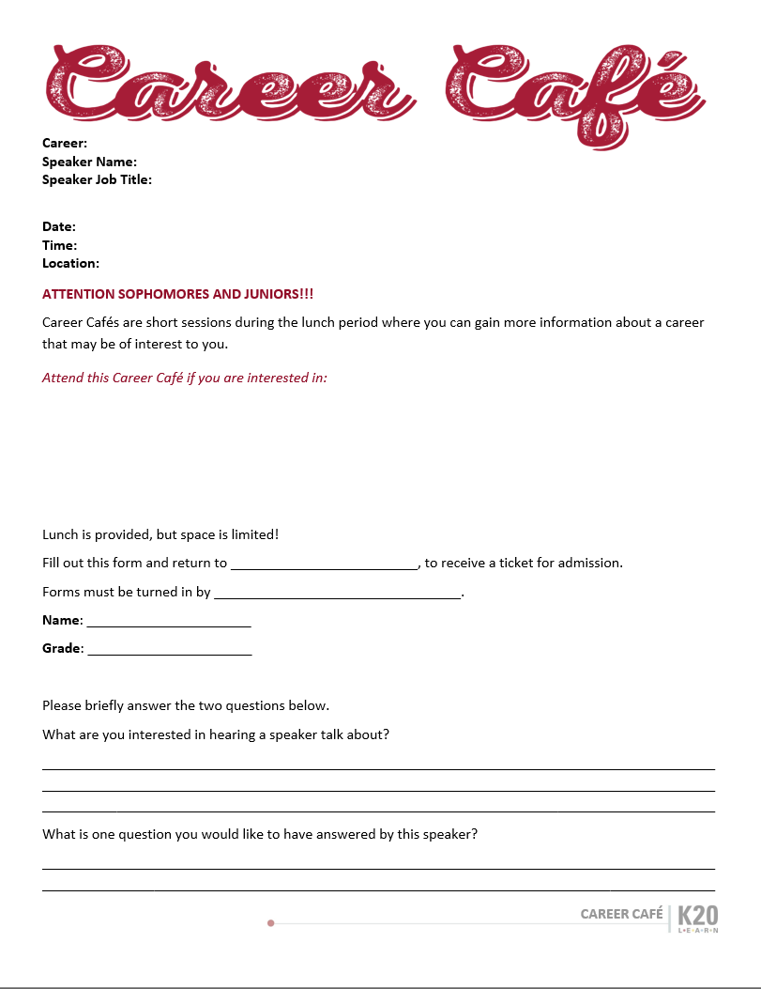
Monday, September 21, 2015
11:00 am – 12:00 am
Library

Your speaker will be:
Speaker Name
Speaker Title and Place of Employment (Forensic Scientist)

Attend this Career Café if you are interested in:
- Working with technology
- Helping to solve problems
- Reconstructing or analyzing crime scenes
- Working with others
- Using scientific methods to gather evidence



Career panel worksheet
Santa Cruz Country Regional Occupational Program: http://www.rop.santacruz.k12.ca.us/resources/career_planning/step3tool2.pdf

Finding potential speakers
- Alumni groups
- Sororities and fraternities
- Professional organizations (e.g., Oklahoma Bar Association, Alliance or Emerging Professionals, etc.)
- Service organizations (e.g., Lions Club, Rotary Club, Junior League, etc.)
- Local colleges and universities
- Acquaintances of parents or school staff
- Social media
- Volunteermatch.org
Career Clusters (http://www.iseek.org/careers/clusters.html)
- Agriculture, food, and natural resources
- Architecture and construction
- Arts, audio/video technology, and communications
- Business, management, and administration
- Education and training
- Finance
- Government and public administration
- Health science
- Hospitality and tourism
- Human services
- Information technology
- Law, public safety, corrections, and security
- Manufacturing
- Marketing, sales, and service
- Science, technology, engineering, and mathematics
- Transportation, distribution, and logistics

Briefing your speakers
- Provide an orientation (tell them about the program)
- When date is agreed upon send them information:
- School location
- Where to park
- Where and how to check in with the office
- Contact name and phone number
- Time of Café, estimated schedule, and room location
- Outline of important points to cover

Sample Speaker Outline
- School name
- School address
- Please arrive by 10:55 am
- Ask for _____________________
- [Room name and number where the café will be held]

Agenda
1st Lunch 2nd Lunch
11:10–11:15 Gather and grab lunch 12:05–12:10
11:15–11:30 Speaker 12:10–12:25
11:30–11:35 Q&A 12:25–12:30
11:35–11:40 Student Survey 12:30–12:35

Important Points to Cover
- Name
- Job title
- What they do in their job
- Why they chose the career
- What interests led them to the career
- What the educational and skill requirements for this profession are
- Description of their typical day
- Different types of jobs in their career field
- Whether it is difficult to find a job in this career field
- Salary range (beginning, middle/average, high)
- The pros and cons of the profession
- Their typical work hours within a week

What if I can’t get volunteers to my school?
- Video conference
  - Skype, Google Hangout, Facetime, Zoom, etc.
- Online career videos (these don’t capture the spirit of Career Cafés but provide great information and can be used for follow-up)
  - Virtual job shadow
  - Career one stop

Funding Career Café (sponsorships or donations)
- Alumni groups
- Local businesses
- Sororities and fraternities
- Professional organizations (e.g., Oklahoma Bar Association, Alliance of Emerging Professionals, etc.)
- Service Organizations (e.g., Lions Club, Rotary Club, local church, etc.)
- PTSA, PTO, PTA (i.e., parent-teacher organization at your school)

Sample questions to stimulate planning
- What are our first steps to organize the career café?
- Who is going to be the main contact person for the event?
- Should we make a sign-up sheet for teachers to take turns planning and organizing on specific dates?
- Which room or area of the school can we use to hold the café?
- How are we going to fund the lunch food for the event?
- How do we promote the event?
- How many students are we going to allow to attend each time?
- How many sessions do we need and how often?

