Fishbone

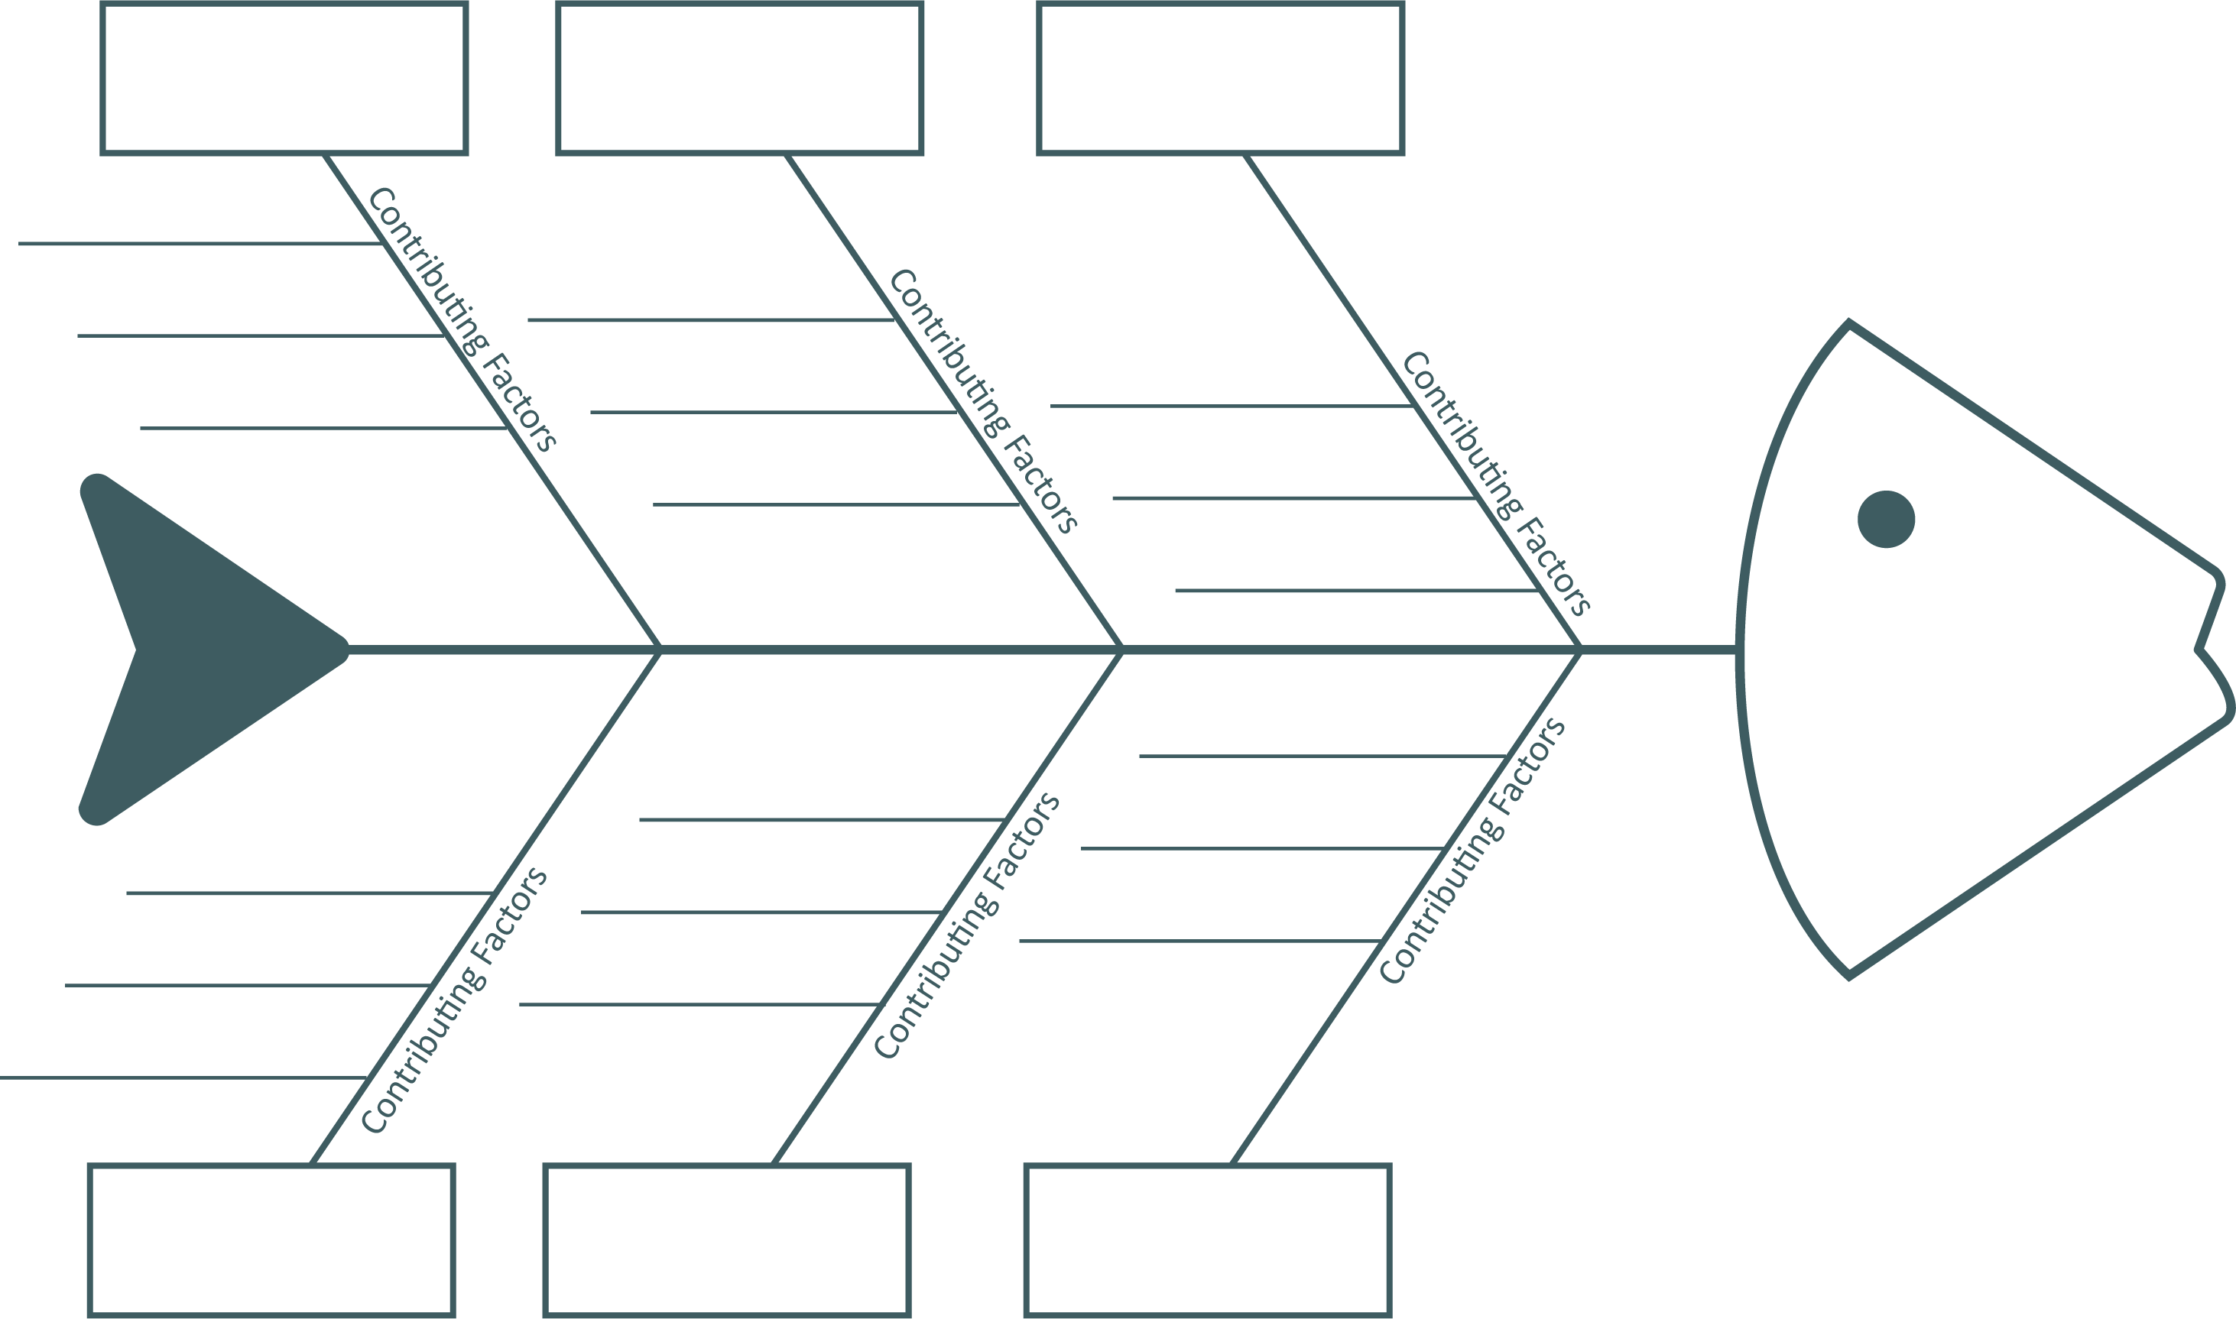

Cause #1

Cause #2

Cause #3

Cause #4

Cause #5

Cause #6

Outcome: