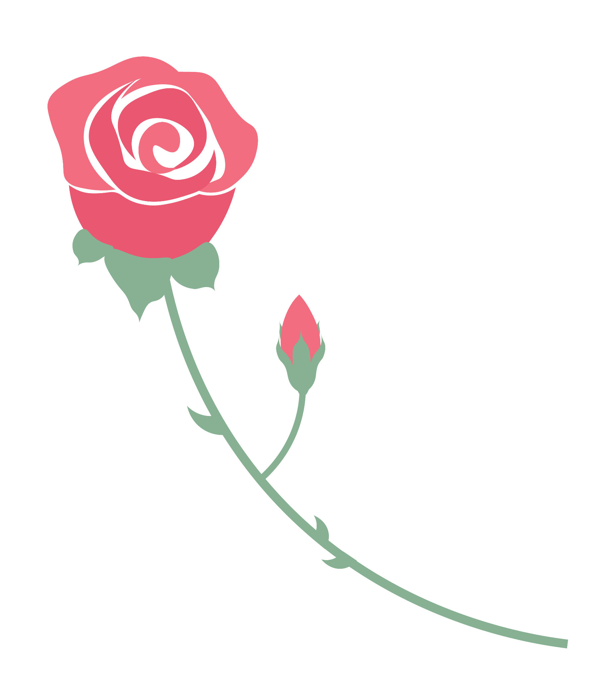
ROSE, BUD, AND THORN
Bud
What did you learn? What are you looking forward to? Where do you see room for further development?
Rose
What went well? What are you most proud of?

Thorn
What was the most challenging part? What did you struggle with?

