What are we discussing?

From my perspective, my opening statement is …
Hats and Descriptions
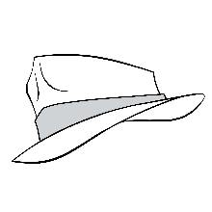  (White Hat) | Detective Hat  - Questions  - Analyzes  - What info is needed?  - What facts do we know? | 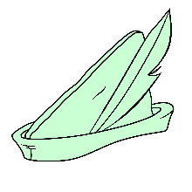  (Green Hat) | Creative Hat  - Thinks outside the box  - Imagines  - What new ideas do we have?  - What creative solutions are there? | 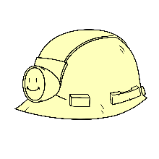  (Yellow Hat) | Optimistic Hat  - Finds the value  - Considers the pros of ideas  - Why is this idea useful?  - How can one benefit from the idea?
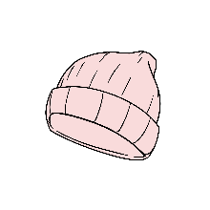  (Red Hat) | Thoughtful Hat  - Thinks with one’s heart  - Shares gut instincts and hunches  - How do I feel about this?  - How might our decision make others feel? | 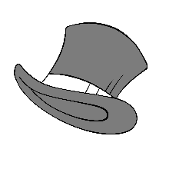  (Black Hat) | Cautious Hat  - Plays devil’s advocate  - Identifies potential risks/concerns/cons  - What difficulties might arise?  - Is this actually going to work? | 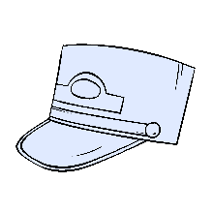  (Blue Hat) | Conductor Hat  - Listens  - Summarizes  - How do we stay on track?  - How does this move us toward our goal?
Adapted from deBono, E. (1999). Six thinking hats. Back Bay Books.

