C.O.N.T.E.X.T
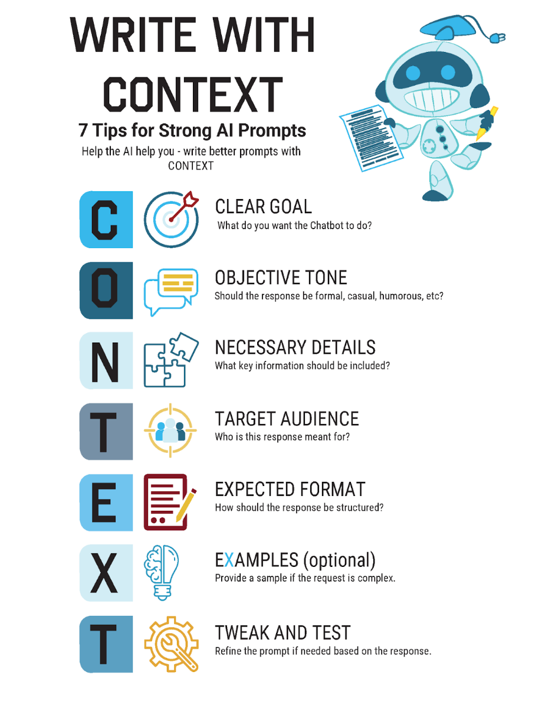
Use the following acronym as a checklist or guide for writing effective AI prompts.
Action | Notes
Clear Goal
Objective Tone
Necessary Details
Target Audience
Expected Format
Examples (optional)
Tweak and Test

