ROLL IT OUT

Question Set 1
Number | Question
 | If you could only eat one snack for the rest of the semester, what would it be?
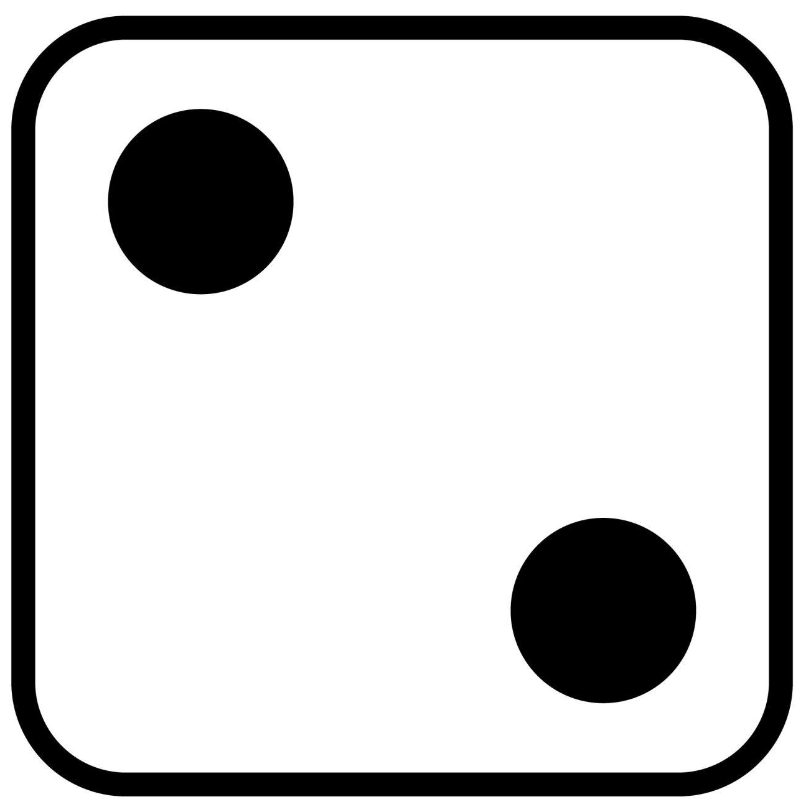 | What’s your most used emoji right now?
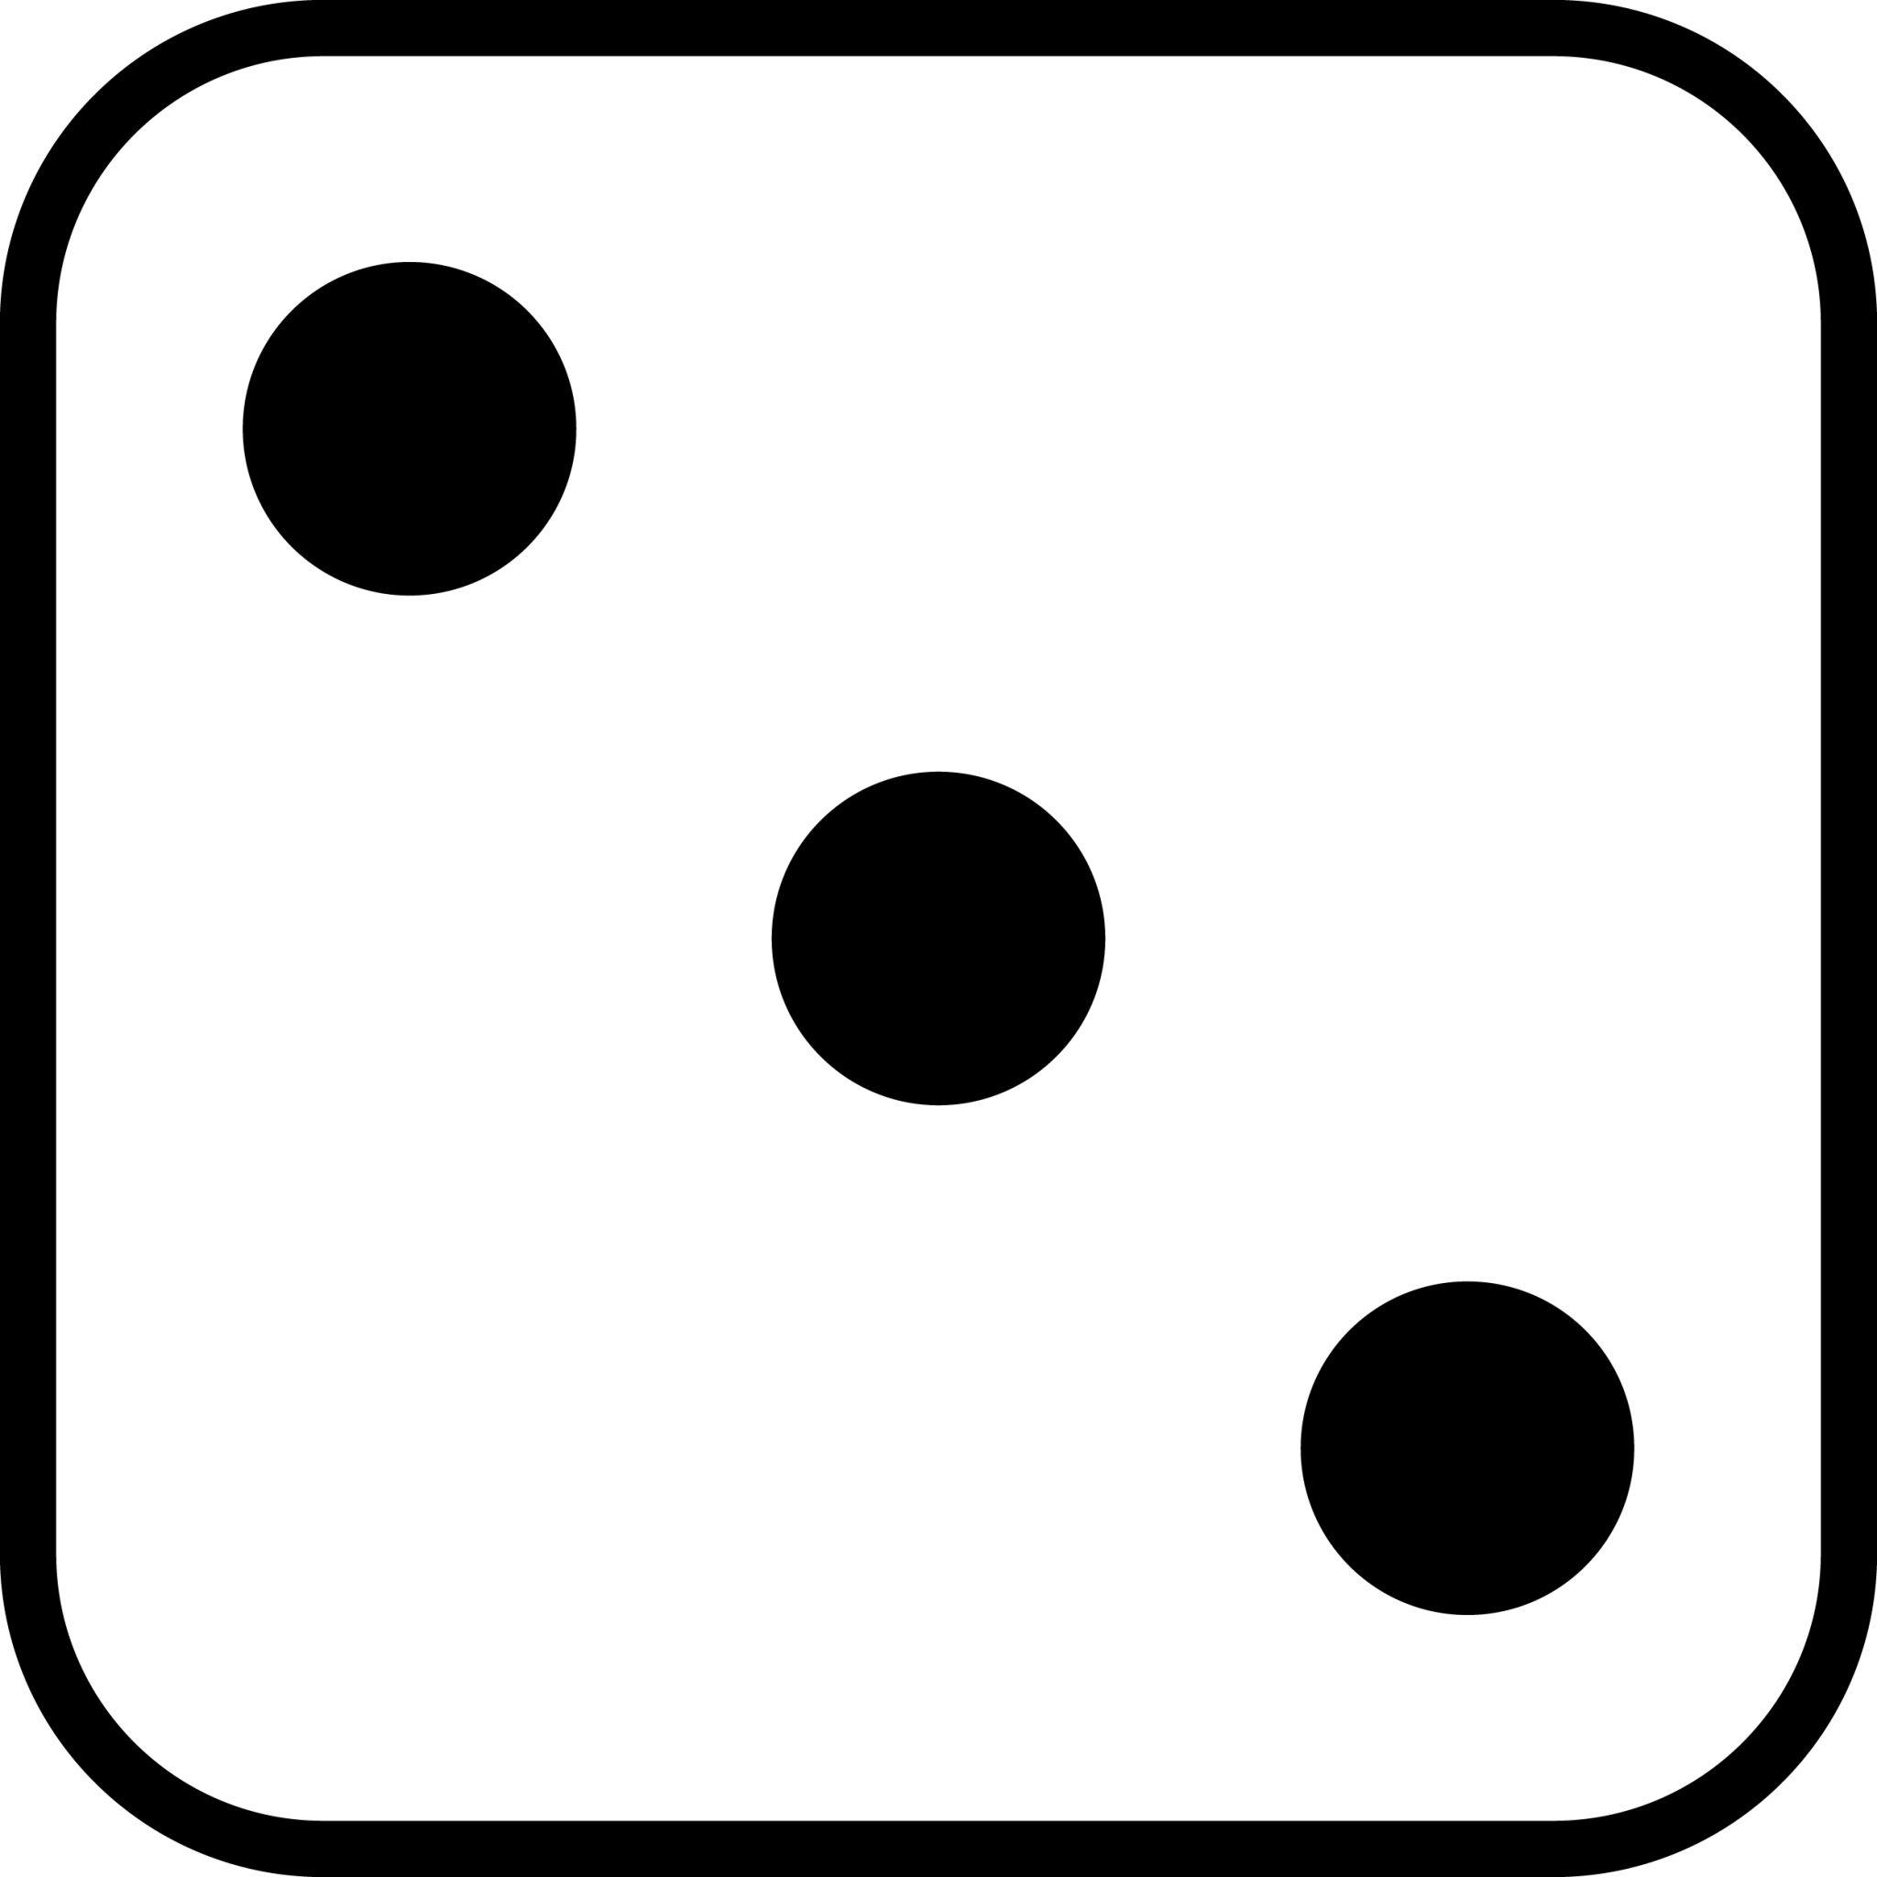 | If you had a theme song that played every time you walked into a room, what would it be?
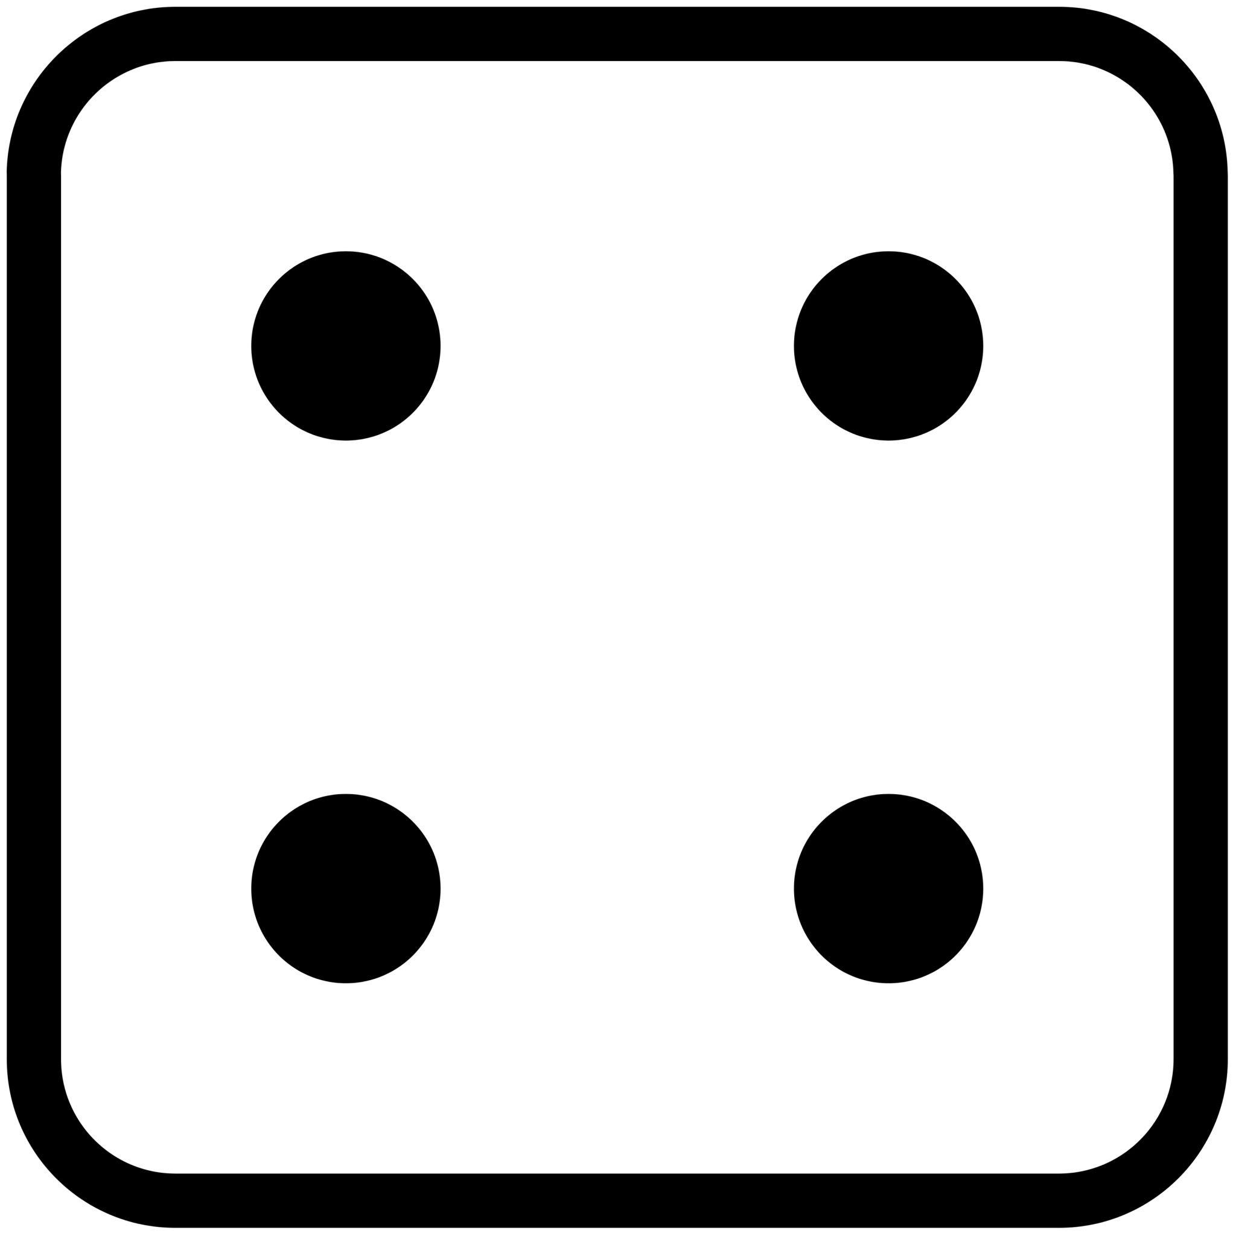 | Would you rather have your professor follow you on Instagram or your parents follow your roommate?
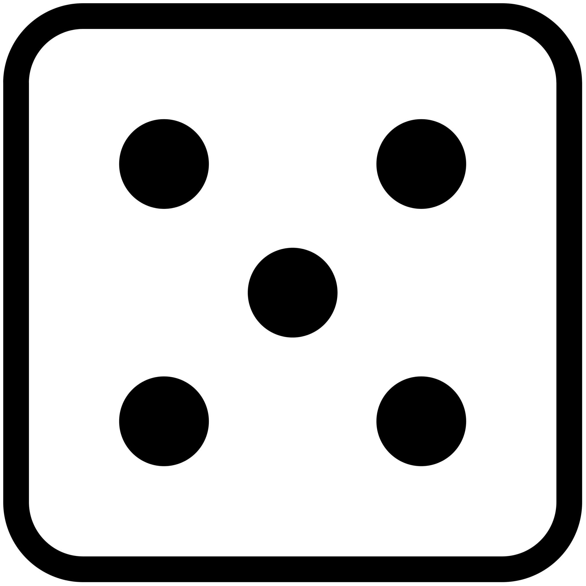 | What’s the funniest TikTok or meme you’ve seen this week?
 | If you had to give yourself a new nickname on campus, what would it be?
Question Set 2
Number | Question
 | If the dining hall let you create the menu for a day, what would you put on it?
 | If your life was a TV show, what would it be called?
 | If you could design your own class, what would it be about?
 | What’s the strangest thing you’ve seen in a dorm?
 | What’s your go-to hype song before a test, game, or big day?
 | Would you rather have your professor follow you on Instagram or your parents follow your roommate?

Question Set 3

Number | Question
 | What’s your must-have dorm room snack?
 | What’s the first thing you’d do if you were the college president for a day?
 | What’s the best campus event you’ve been to so far?
 | If you could instantly become amazing at one sport or activity, what would it be?
 | If you could study abroad anywhere, where would you go?
 | If you could only keep one app on your phone, which one would it be?
Question Set 4
Number | Question
 | What’s the most random item you brought with you to college?
 | If your dorm had a mascot, what would it be?
 | What’s your go-to binge-watch show when you’re procrastinating?
 | If your college experience had a tagline, what would it be?
 | What’s one thing you wished you learned in high school that you now need to know?
 | What’s the weirdest rule or tradition you’ve heard about on campus?

