ROLL IT OUT

Question Set 1
Number | Question
 | If you could only eat one food for the rest of your life, what would it be?
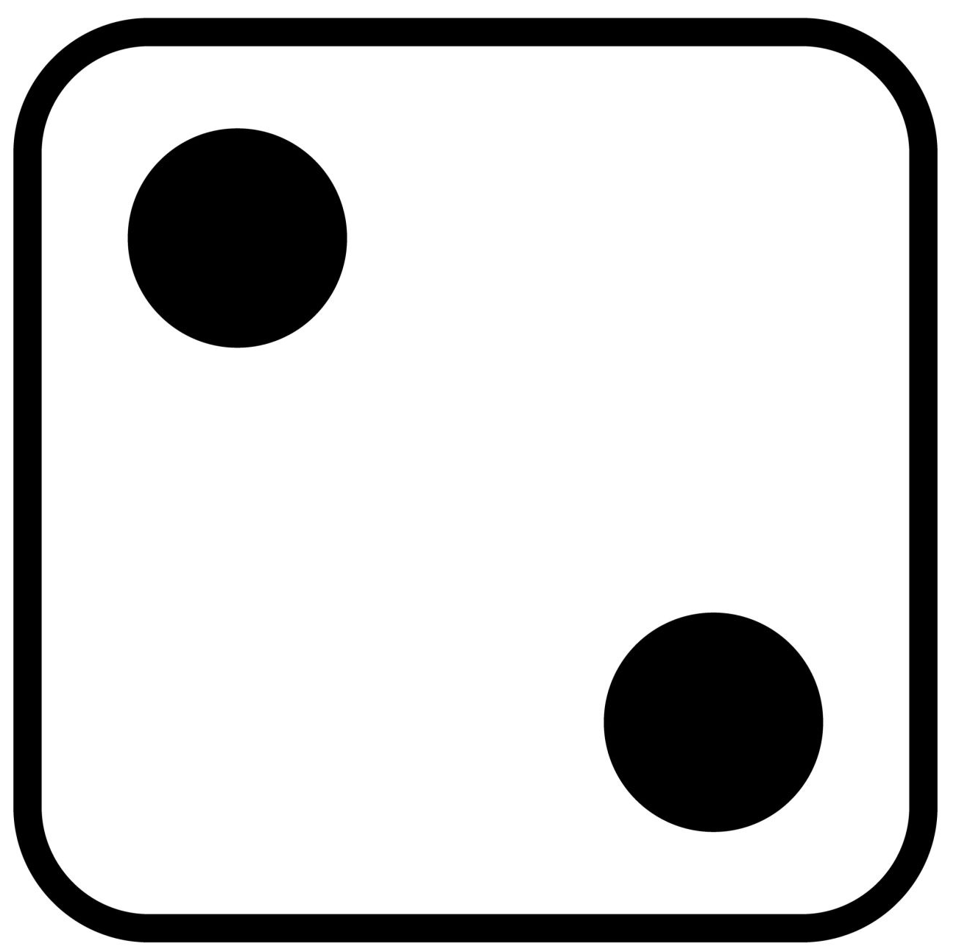 | What’s your most used emoji right now?
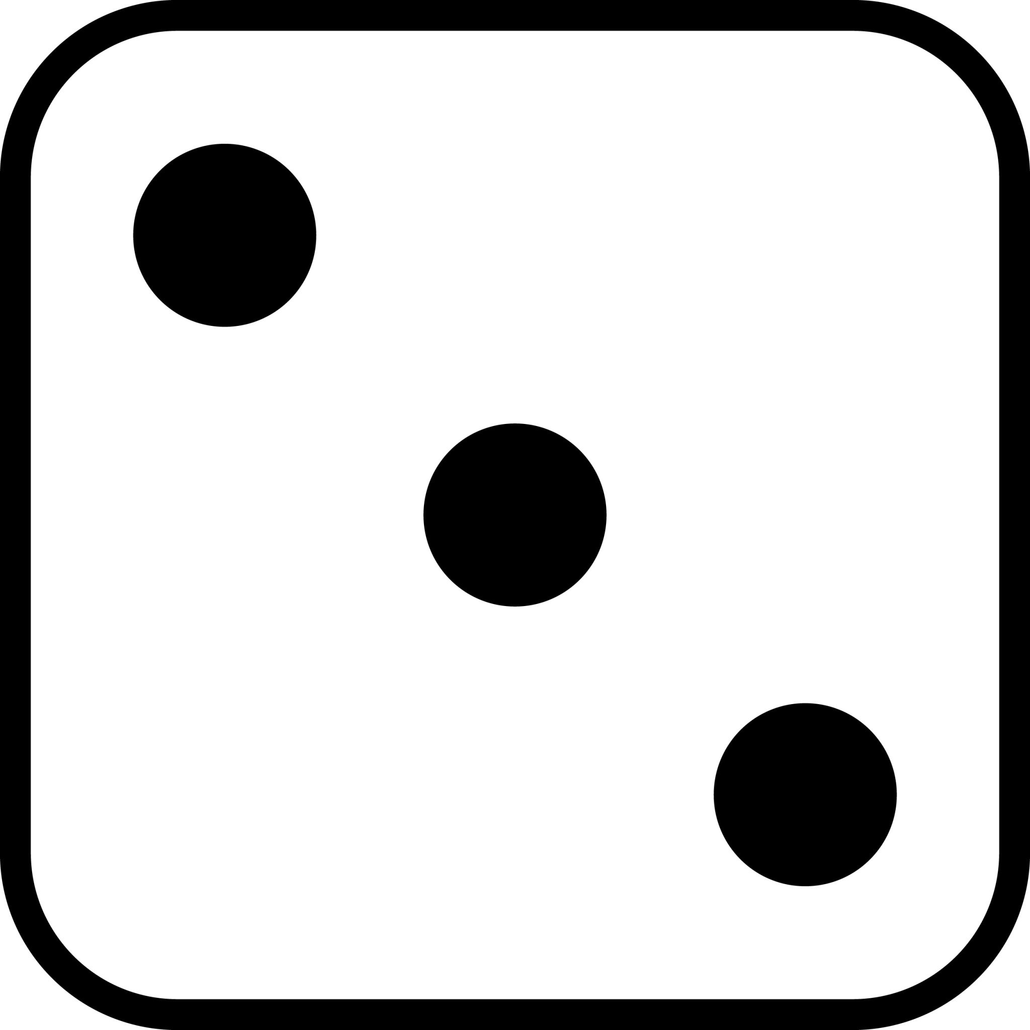 | If you had a theme song that played every time you walked into a room, what would it be?
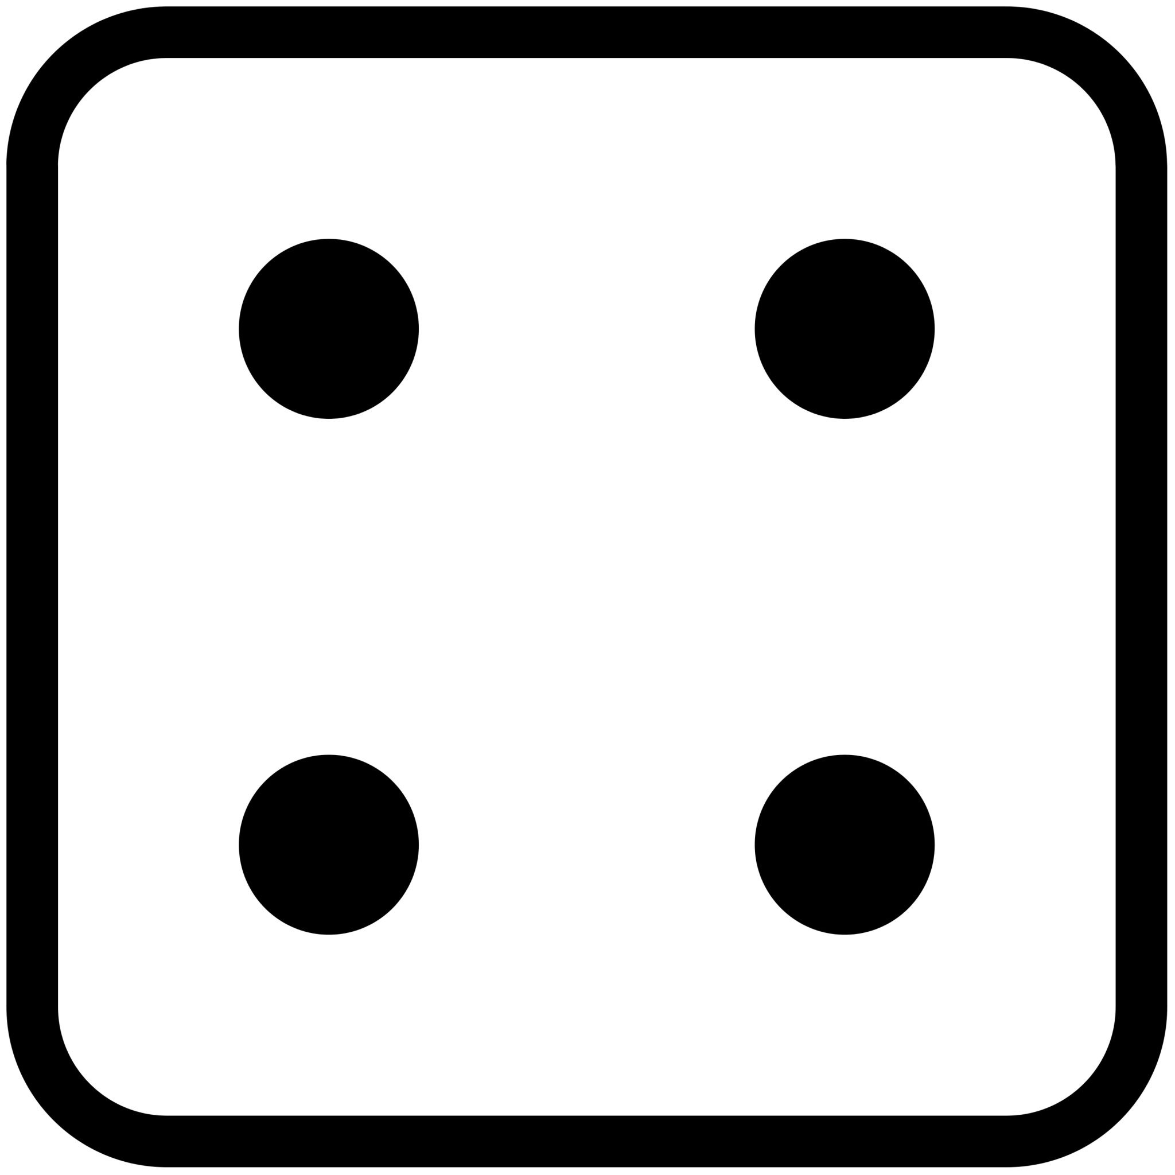 | Would you rather be a giant hamster or a tiny rhino?
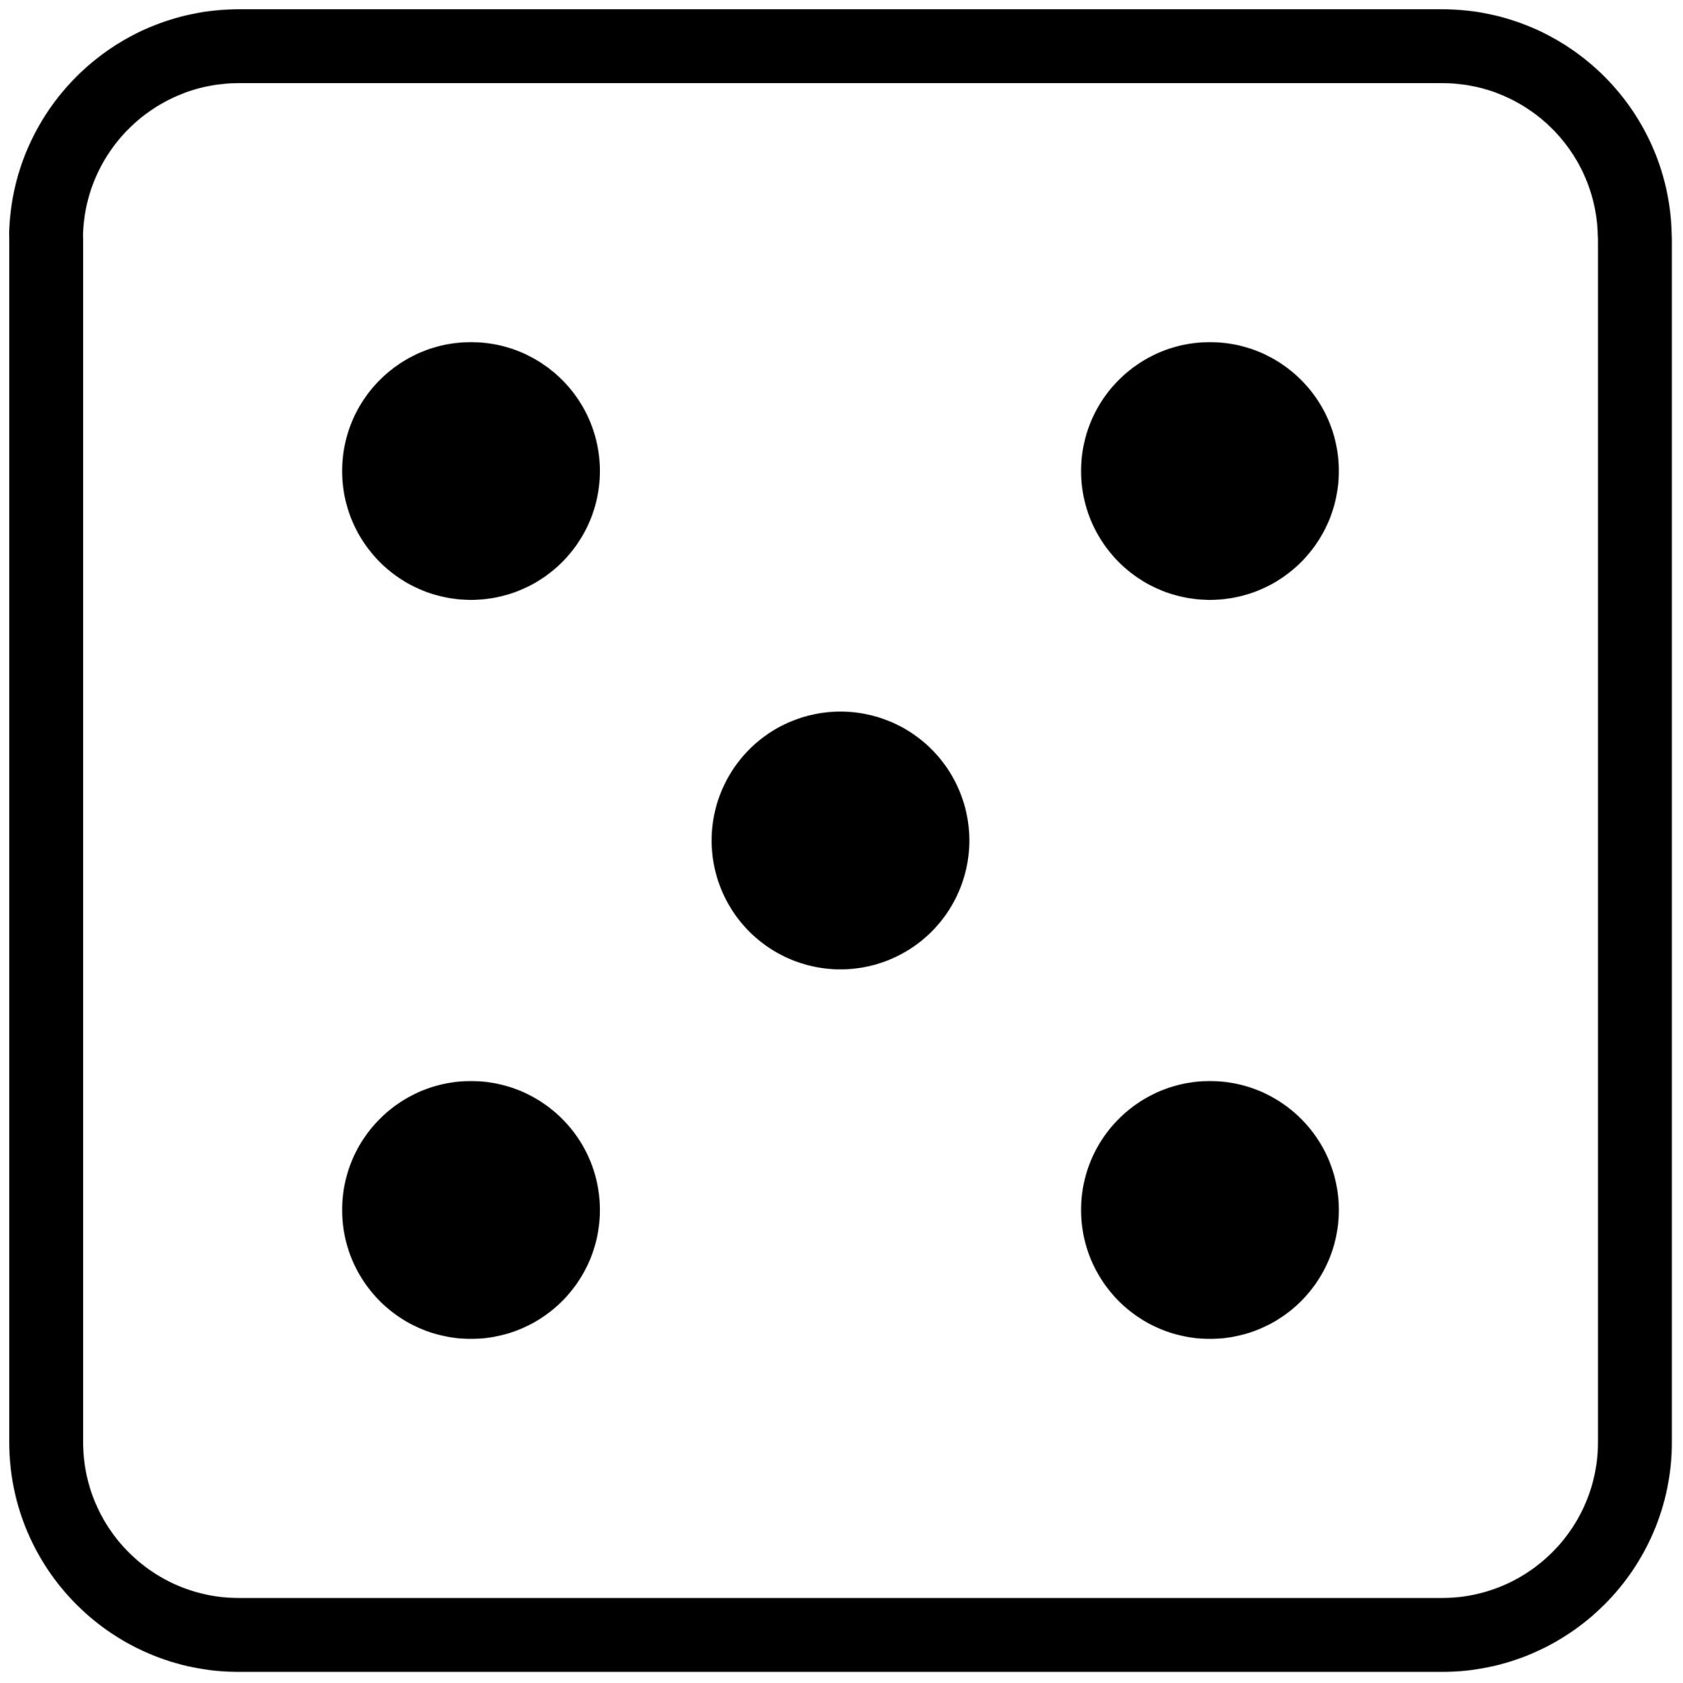 | What’s a favorite joke or funny thing that has happened to you?
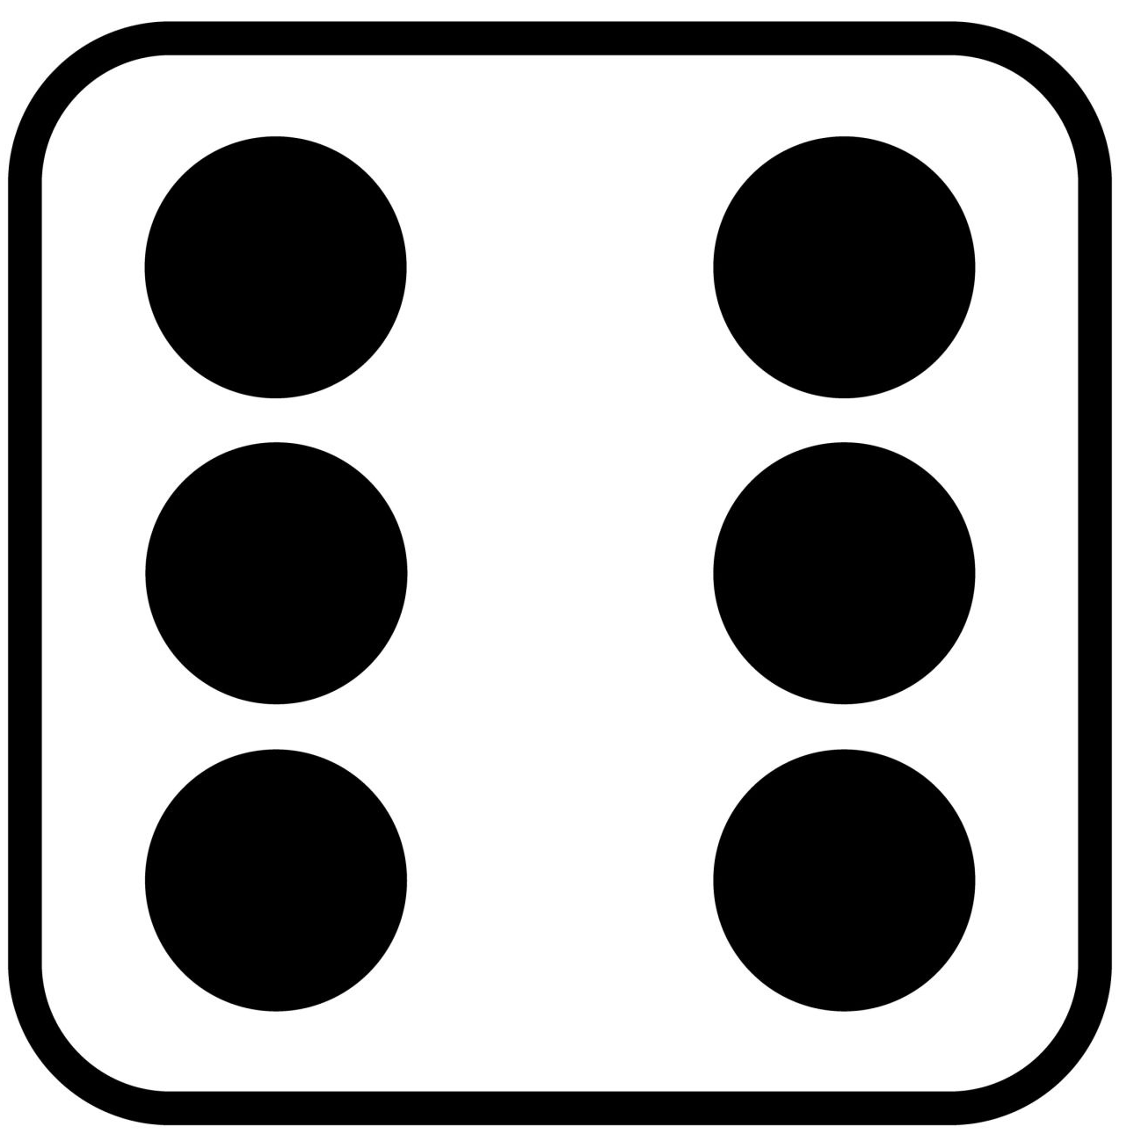 | If you had to give yourself a new school/work-related nickname, what would it be?

Question Set 2
Number | Question
 | If your life was a TV show, what would it be called?
 | If you had to give a 30-minute TED Talk with no prep, what topic could you confidently speak about?
 | What’s your go-to hype song before a test, game, or big day?
 | What’s your favorite holiday and why?
 | If you could instantly master one skill, what would it be?
 | If you could travel anywhere, where would you go?

Question Set 3
Number | Question
 | If you could only keep one app on your phone or computer, which one would it be?
 | What’s the most random item you like to take with you on trips?
 | What’s a TV show or movie you can watch over and over without getting tired of watching it?
 | If your life had a tagline, what would it be?
 | What’s something you’re almost embarrassed to admit you learned later in life?
 | What’s an unspoken rule or tradition you follow, but think is weird?

Question Set 4
Number | Question
 | Which mythical creature would you adopt as a pet?
 | If your backpack could magically produce one thing endlessly, what would it be?
 | If you could invent a silly new holiday, what would it celebrate?
 | What is your go-to way to unwind after a long day?
 | Which fictional world would you most like to live in?
 | What is the weirdest food combo you secretly love?

