Oh, The Places We’ll Go!
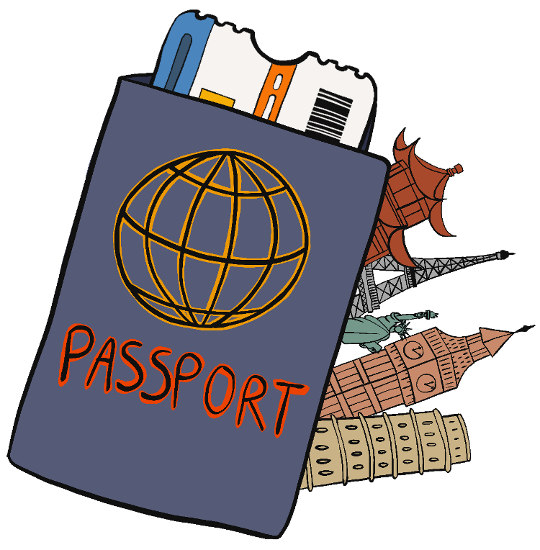

Contents
Oh, The Places We’ll Go Overview _____________________________________________ | 3
Materials
Instructions
Activity 1: Travel Task Cards __________________________________________________ | 5
Activity 2: Trip For Your Teacher ______________________________________________ | 10
Extend ___________________________________________________________________ | 11
Sources __________________________________________________________________ | 14

OH, THE PLACES WE’LL GO OVERVIEW
Do you enjoy traveling, learning about new places, and helping people? If these are qualities that describe you, a career as a travel agent might be for you! A career in hospitality gives you the opportunity to meet the needs of guests with kindness and goodwill, which is why this career falls under the Hospitality and Tourism career cluster.

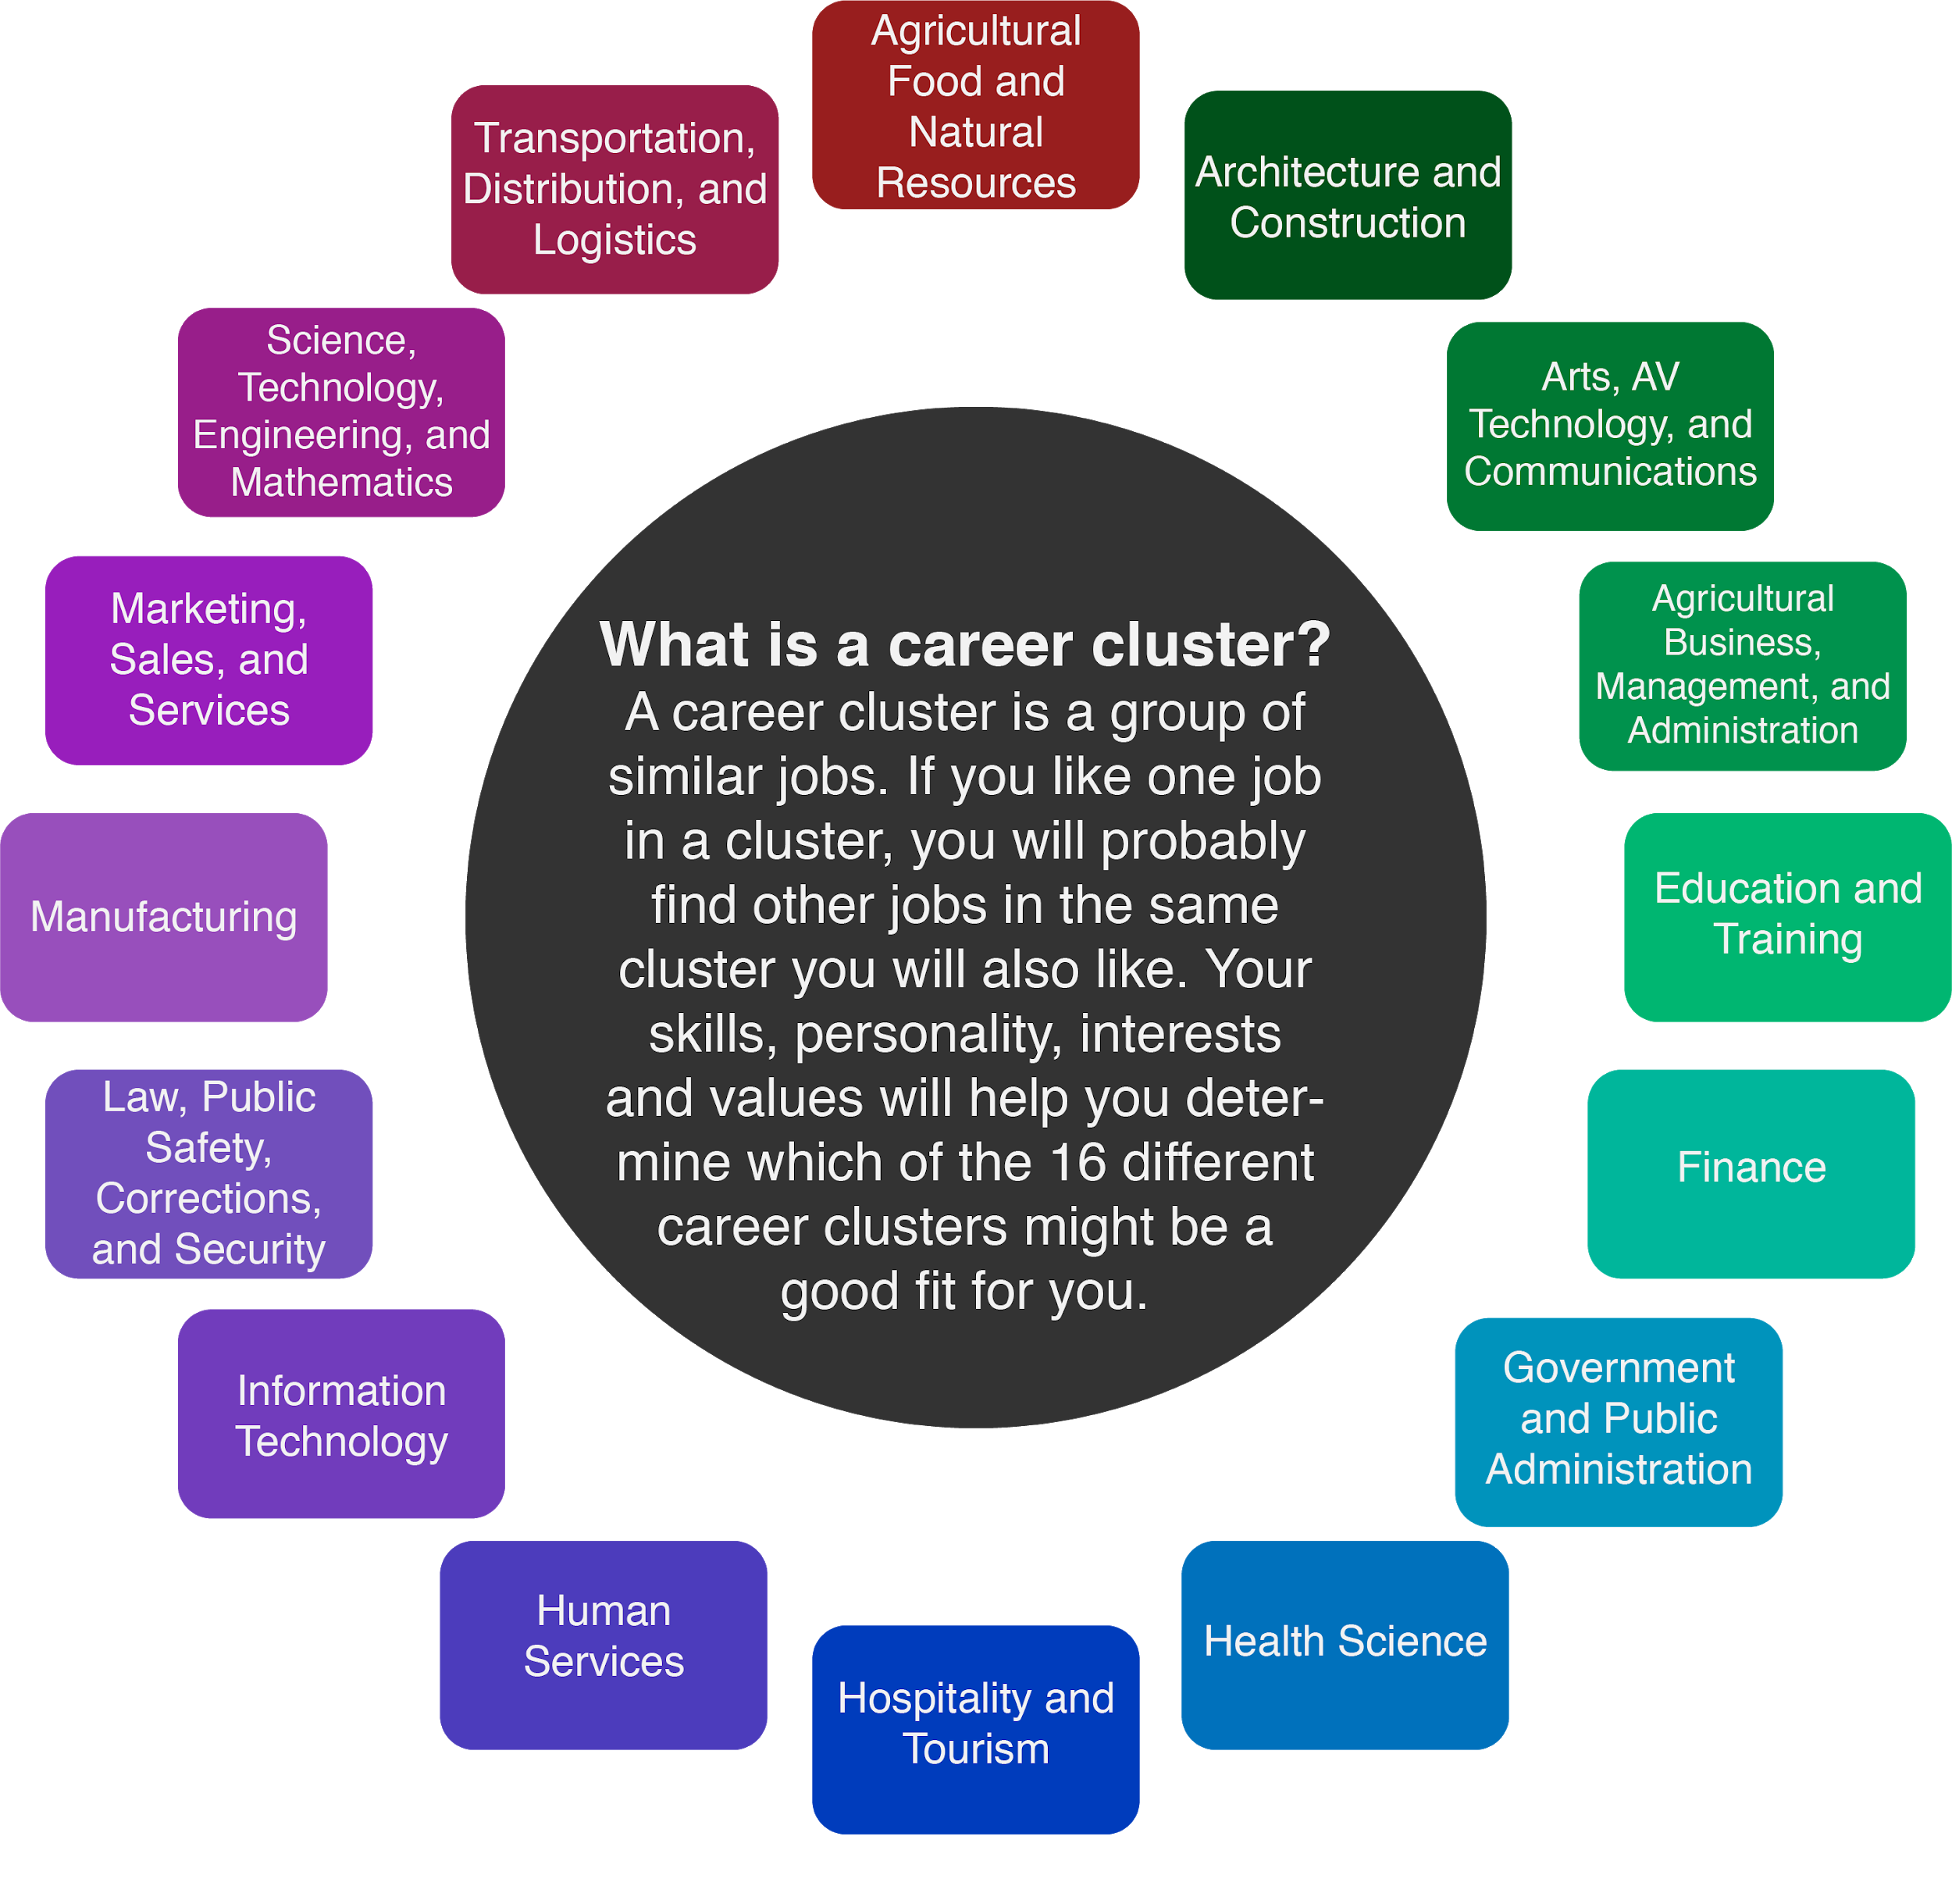

Travel agents are sometimes called destination specialists or travel consultants. As a travel agent, you help clients choose a place to take a special trip, research and schedule how your clients will travel and where they will stay, and help plan their activities and the places they will eat while they are traveling. Each day, travel agents help their clients plan trips all around the world, so they need to have a wide variety of knowledge and skills. Some of these skills include geographical knowledge, customer service (going out of your way to help people), active listening, and asking good questions. Additionally, travel agents look for ways to help people and understand their needs. It is also important to communicate with clients and pay attention to details to make sure you understand what they are looking for. The average salary for this career is around $41,000 per year.

Materials

- Activity 1: Travel Task Cards
- Activity 1: Travel Planner
- Activity 2: Vacation Budget Guide Sheet
- Device with Internet Access
- Something to write with
- A blank sheet of paper (optional)

Instructions
- Start with Activity 1: Travel Task Cards on page 5.
- Move to Activity 2: Trip for Your Teacher on page 10.
- After you finish both activities, complete the My Favorite Mistake reflection on page.
- Check out the additional travel agent activity and Hospitality and Tourism-based careers in the Extend section on page 11.

ACTIVITY 1: TRAVEL TASK CARDS
As a travel agent, you will meet different people with different travel needs and desires. For this activity, you will choose a client and plan a trip based on their wants, needs, interests, and other things to think about. Don’t worry about the cost of travel in this activity—just have fun exploring different places and making a plan to fit the needs of your client!
Materials:
- Travel Task Cards
- Travel Planner
- Device with Internet Access
- Pen or Pencil
- Blank sheet of paper (optional)

Instructions:
- Look at the Travel Task Cards below. There are four different clients you can choose to plan a trip for. Select one table and read what the client wants for their travel plans. Each client lives in Oklahoma City, Oklahoma.
- Using a device with internet access, start researching locations that would meet the needs of your client. Try using websites like Trip Advisor to help you get started.
- Print the Travel Planner template found in the attachments and use a pen or pencil to write in the details of the trip. If you cannot print the Travel Planner, use a blank piece of paper and pen or pencil to plan your trip. Remember, cost does not matter for this activity. The most important thing is to plan the trip based on the information your client has given to you! An example Travel Task Card and Travel Planner can be found below to help guide you with your own planning.
- Once you have completed your planning, share your work with a family member.
- You can choose another client to work for, or have a family member pretend to be a client and give you a new scenario to plan a vacation for them!

Example Travel Task Card
Your client is a family of four wanting to have a weekend hometown vacation in Oklahoma City, Oklahoma.
Ages of Children | 10 and 14 years old
Length of the Trip | 2 Days
Interests | "We like learning about places that are special to where we are visiting. If there are any hotels or museums special to Oklahoma City only, we would love to go there."
Things to Avoid | “Driving farther than 30 minutes away from Downtown Oklahoma City. Please keep all of our activities close to where we will be staying in the downtown area.”

Example Travel Planner
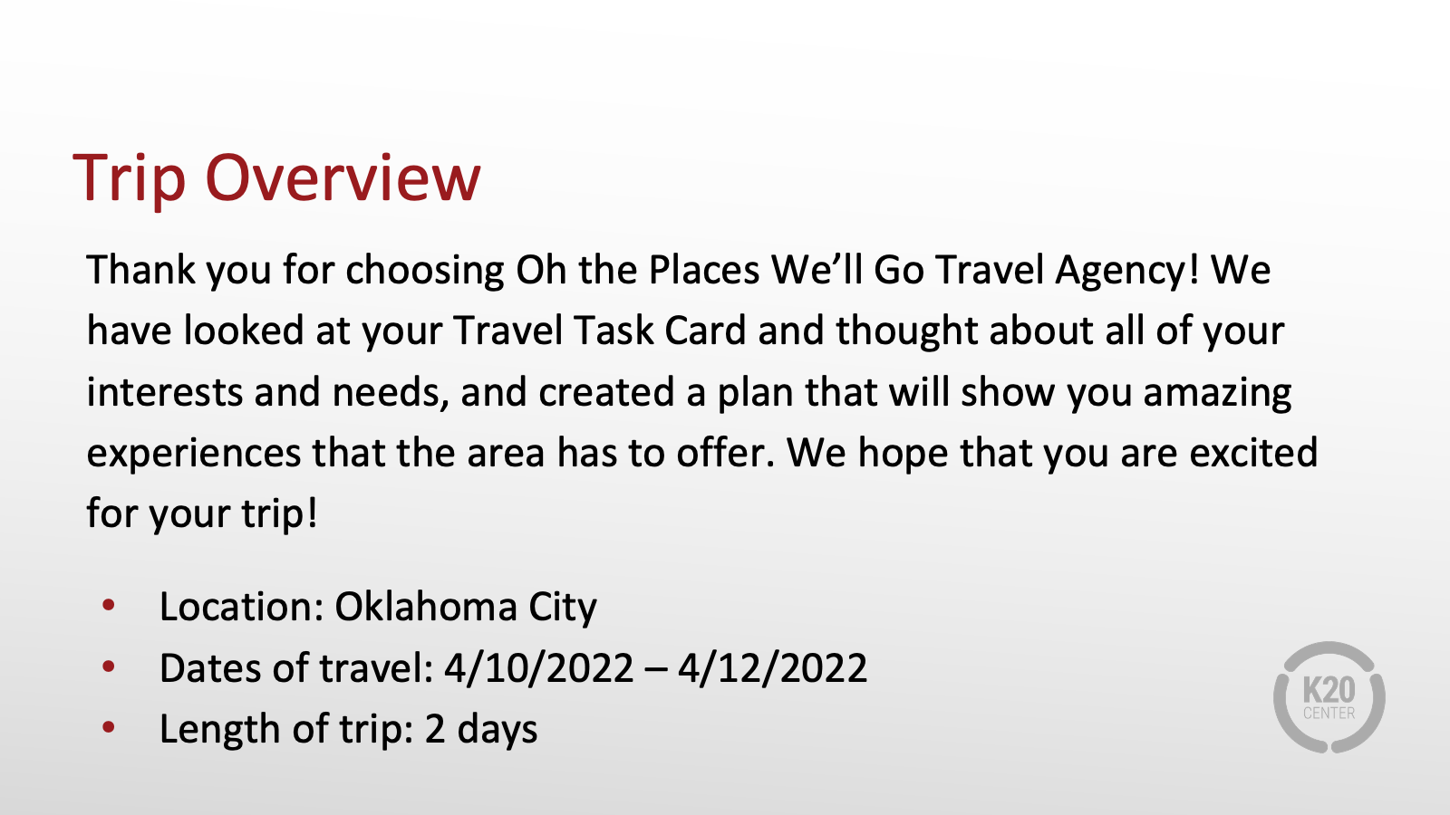
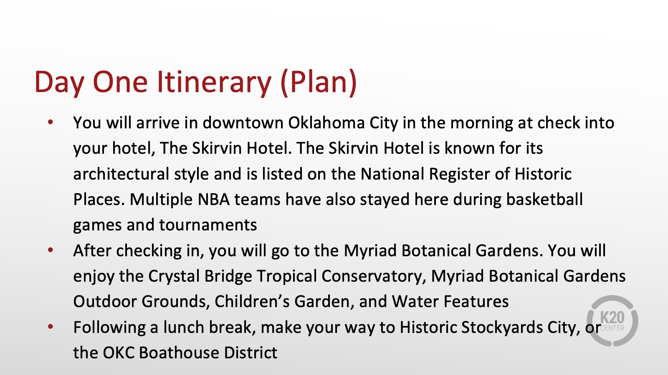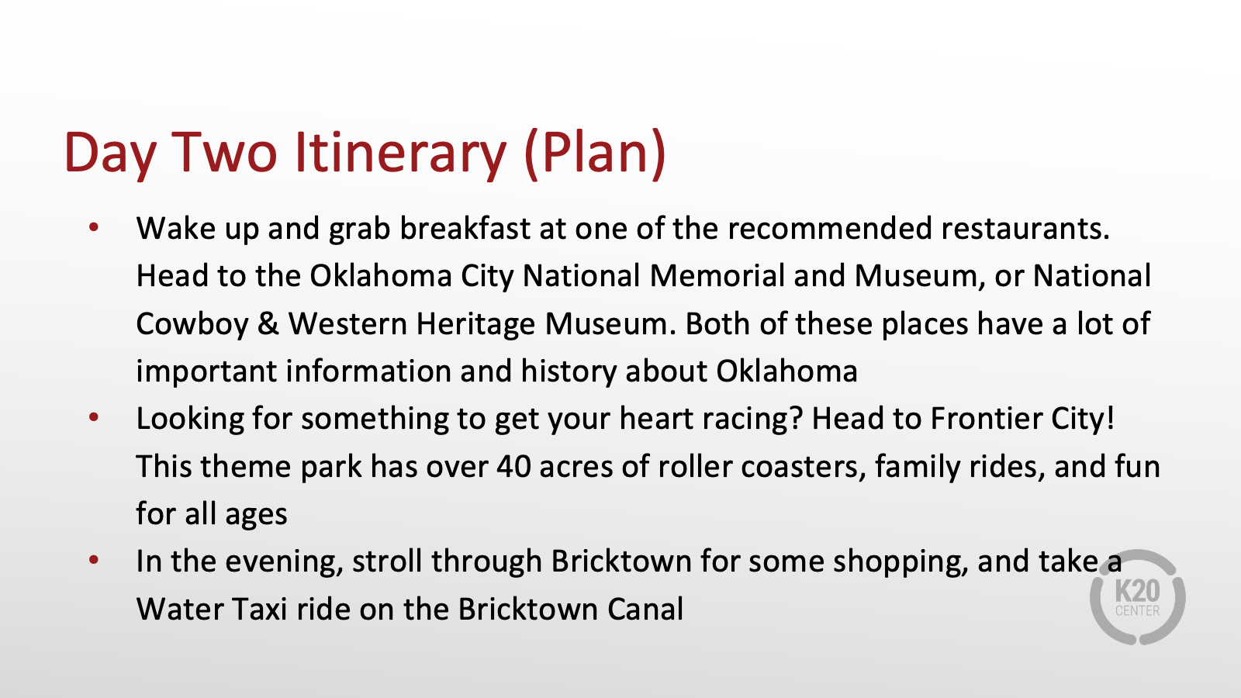
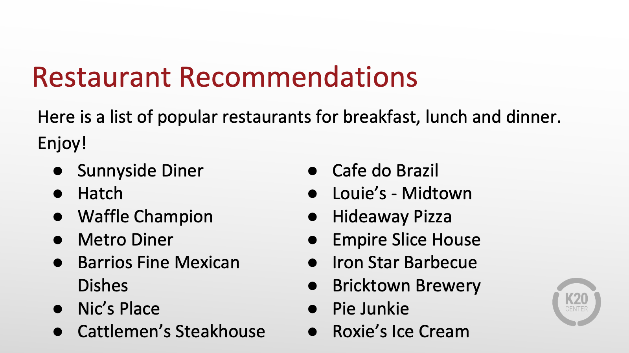

Travel Task Card 1

Your client is a woman wanting to take two children on a beach vacation in June.
Ages of Children | 11 and 15 years old
Length of Trip | 5 days
Interests | “We like to stay active and have a lot to do. We also like to learn about the culture of a place that we visit.”
Things to Avoid | Air travel longer than 10+ hours

Travel Task Card 2

Your client is a couple wanting to take a trip to the mountains to celebrate an anniversary in August.
Length of the Trip | 4 days
Interests | - Hiking  - Fishing  - Photography  “We really like spending time outdoors, but we also enjoy getting dressed up for a nice meal - especially since we are celebrating our 10th anniversary. If you could find some highly recommended restaurants in the area that would be great!”
Things to Consider | “We are open to traveling by airplane or by car, we just don’t want our travel time to take away too much of our vacation time.”

Travel Task Card 3

Your client is a group of four friends who just graduated college. They are wanting to travel in November to a different country and explore the culture, language, and customs it has to offer.
Length of the Trip | 8 days
Interests | Learning about the food, religion, and customs of the country they visit.
Things to Consider | “We want to visit somewhere that has several towns or cities close to each other that we can travel to during our trip that can be done by car or train.”

Travel Task Card 4

Your client is a Grandmother wanting to take her high-school aged grand-children (3) to a big city in a neighboring state for a short, summer trip in July.
Length of the Trip | 3 days
Interests | - Amusement Parks  - Shopping  - Museums
Things to Consider | “We don’t want our travel time to take too long, so we would like to go somewhere in a neighboring state and travel by car.”

ACTIVITY 2: TRIP FOR YOUR TEACHER
Budgeting, or planning on how much money to spend, is a very important part of travel planning, especially when you have limits on the amount of money to spend.

In this activity, you will be planning a special trip for your teacher who has won Teacher of the Year! Your teacher has been given $6,000 to travel to the location of their choice with one guest over the summer. The total amount of money must cover all transportation, lodging, food, and attractions for both travelers (your teacher and their one guest). Their trip must last for at least three days, but can be longer if you would like.

Think about a teacher you have had who would be deserving of this award. Think about their likes and interests when it comes to the location they might enjoy traveling to - you could even reach out and ask them! You complete this activity by estimating the vacation expenses, then looking up the actual information and see how close you were (and if you went over or under your budget)!
Materials:

- Vacation Budget Guide sheet
- Device with Internet Access
- Pen or Pencil
- Blank piece of paper (optional)
- Calculator (optional)

Instructions:
- Select a teacher you want to plan this Teacher of the Year trip for. On the budgeting sheet, write their name, location for their trip, and dates of travel. If you cannot print the Vacation Budget Guide sheet, use a blank piece of paper and pen or pencil to plan your trip.
- Start by estimating costs for each item on the budget planner. Remember, you are planning for your teacher AND a guest to be going on the trip. The estimates and totals need to reflect both travelers’ expenses.
- Total your estimates to see how close you were for your budget. Remember, you want to stay within your $6,000 budget.
- Now, using a device with internet access, research the cost for each of your estimated categories. (Tip: Look for special offers or discounts that may help you reduce costs.)
- Total up your actual trip costs to see if you stayed within your budget or went over your budget. Compare the actual costs to your estimates to see how you did.
- Once you have completed step 5, finish this activity by reflecting on your learning using the instructional strategy My Favorite Mistake:
  - Review your Vacation Budget Guide sheet and look for areas where your estimates were very different from the actual costs.
  - Select one example and write about your thought process for your estimate and what you learned from the actual cost. Share with a teacher or family member.

VACATION BUDGET GUIDE
Transportation | Estimated Cost | Actual Cost

Airfare

Bus/Train/Shuttle/Subway

Car Rental (Gasoline included in rental price)

Other Items

SUB TOTAL
Lodging | Estimated Cost | Actual Cost

Hotel/Motel/Campsite

Parking

Other Items

SUB TOTAL
Food and Drink | Estimated Cost | Actual Cost

Restaurant Meals

Coffee, Treats, Snacks, and Water

Groceries to Bring

Other Items

SUB TOTAL
Entertainment | Estimated Cost | Actual Cost

Theme Parks

Zoos and Parks

Museums and Aquariums

Equipment Rental

Movies and Shows

Souvenirs

Miscellaneous

SUB TOTAL

VACATION BUDGET TOTAL

EXTEND
One way to take everything you have learned about being a travel agent is to write a Future Occupation Bio-Poem! Creating an Occupation Bio-poem is a great activity to help imagine yourself in the career of your dreams.

Here is the format for the Occupational Bio-Poem:
Line 1 – Write your first name.
Line 2 – Write the title of the occupation.
Line 3 – “Who can…” [Write something important you will do in this occupation].
Line 4 – “Who earns…” [Write the salary information for this occupation].
Line 5 – “Who knows how to…” [Write knowledge necessary for this occupation].
Line 6 – “Who values…” [Write the work value(s) related to the occupation].
Line 7 – Write your last name.

Here is an example:
Ronnie
A physical therapist
Who can alleviate pain
Who earns $23 an hour
Who knows strength, motor development, and function
Who values active listening and helping people get well
Lewis

Want to learn more about what it means to be a travel agent? Check out My Next Move (https://tinyurl.com/MNMtravelagents) to discover more about travel agents, what they do, and the knowledge, skills, and abilities needed in the field.

Did you know that being a travel agent isn’t the only specialty in the Hospitality and Tourism cluster? Check out tinyurl.com/MNMallcareers to see all of the other career options in this cluster!

Sources
The sources that were linked throughout the activity are listed below. Providing a list of sources allows us to give credit for the work that someone else made.

Fun Career Planning Activities. (November 2017). https://guidancezchhs.blogspot.com/2017/11/fun-career-planning-activities-for.html?m=1
My Next Move. (n.d.) All careers. https://www.mynextmove.org/find/browse?c=0
My Next Move. (n.d.) Travel agents. https://www.mynextmove.org/profile/summary/41-3041.00
Tripadvisor. (n.d.). Retrieved December 04, 2020, from https://www.tripadvisor.com/

