MARKETING YOUR FUTURE

CONTENTS
Marketing Your Future Overview ___________________________________________________ | 3
Materials
Instructions  Activity 1: Marketing Mix _________________________________________________________ | 5
Activity 2: The Cola Wars _________________________________________________________ | 7
Activity 3: Reworking A Controversial Marketing Campaign ______________________________ | 10
Frayer Model Reflection __________________________________________________________ | 14
Extend ________________________________________________________________________ | 15
Sources _______________________________________________________________________ | 16

Overview
Are you a creative person who can problem solve and come up with ideas? Marketing might be the career for you. Marketing careers are great for people who love to help others and understand their needs in the form of products or services. A career in marketing requires you to be able to sort through and analyze data to make the best decision for customers.

What is Marketing?
“Marketing is the activity, set of institutions, and processes for creating, communicating, delivering, and exchanging offerings that have value for customers, clients, partners, and society at large.” (American Marketing Association [AMA], 2017).

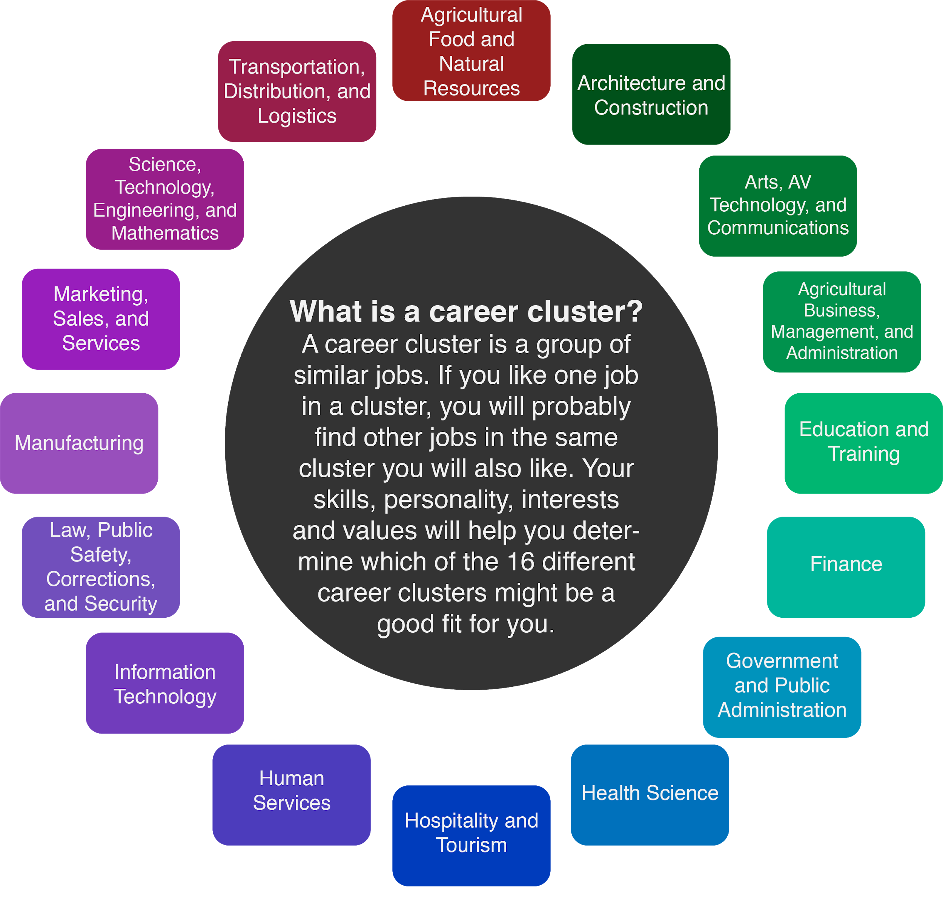

Understanding the Marketing Mix (Four P’s)
When it comes to marketing, the four P’s (product, price, place, and promotion) are essential to the job and understanding the basics of the four P’s is key to those in the field. Knowing how the marketing mix works is a step towards understanding how companies and organizations create products or services for customers. It’s important to understand the process that these companies go through when creating new goods and services.

Product - ideas, physical goods, a service provided, or a mixture of all three.
Price - the amount of money that one decides the good or service costs.
Place - sometimes called distribution, refers to the location or acts of carrying out where the goods or services are given.
Promotion - How the product or service is advertised to the target market or audience.

Marketing is used for products that you use every day. The video games you play, the make-up you wear, and the shoes you put on each day. The companies that created those products marketed them through the four P’s in some form or fashion. They had to first come up with the product, agree on a price based on similar goods, decide where the product will be sold, and lastly how they will promote the product to the consumer. Since marketing is used for many different items and services, the career field is in high demand. There are many types of marketing careers, such as marketing managers and market research analysts along with advertising careers which is another component of marketing.

Marketing careers require at least a bachelor’s degree and usually a master’s degree for higher positioned jobs. Jobs as a market research analyst average around $63,000 per year, while marketing managers can see salaries averaging up to $136,000 per year.

The following activities will guide you through your first look into marketing, as well as provide examples of some historical and recent marketing campaigns. While you work through these activities, think about the marketing campaigns and advertisements you have seen on TV, billboards, online, etc. and think about how they used the marketing mix to come up with those products.

Materials
- Internet access
- Marketing Mix Chart
- The Pepsi Challenge Video (https://tinyurl.com/PepsiVsCokeVideo)
- Burger King Foundation Link (https://tinyurl.com/BKFoundation)
- A blank sheet of paper (optional)
- Something to write with (optional)

Instructions
- Begin by using the Marketing Mix chart to create your own product, service, or good.
- Move onto the history of the Cola Wars (Coke vs Pepsi) and answer the reflection questions.
- Read through Burger King’s 2021 International Women’s Day Campaign and rework the campaign.
- Complete the _____ reflection strategy.
- Check out more information about Marketing careers in the Extend section.

Activity 1: Complete a Marketing Mix plan

In this activity you will be using the basic principles of the four P’s (product, price, place, and promotion) to come up with a product, good, or service. Use the marketing mix graph on the new page, or create your own on a separate sheet of paper, to fill out each of your four P’s, plus a target audience (who would buy or use this product, good, or service). You can come create anything you would like, realistic or not. Examples of these can be a flying car, a 3D tv, a futuristic video game console, etc. You can also come up with something more realistic like a candy, soda, or video game. Use this activity to unlock your creative thinking on how you would market your product.

Materials:
- Marketing Mix Chart (printed or drawn out on a blank sheet of paper)
- Pen or pencil
Instructions:
- First, come up with a product. Remember, this can be a physical good, idea, or a service. Explain the product and why we need it. Also give it a fun and creative name!
- Now that you have a product in mind, decide who your target audience is. In the middle of the chart put who you are targeting with your marketing mix.
- Now, give the product a price, explaining the reasoning why it’s priced that way (use similar product pricings for help).
- Next, describe how the product will be given to people. Will it be sold in stores, online, etc.
- Lastly, how will the product be promoted? Will you need a commercial for it, can you put ads on billboards for it, or will word of mouth be enough?

Marketing Mix Chart
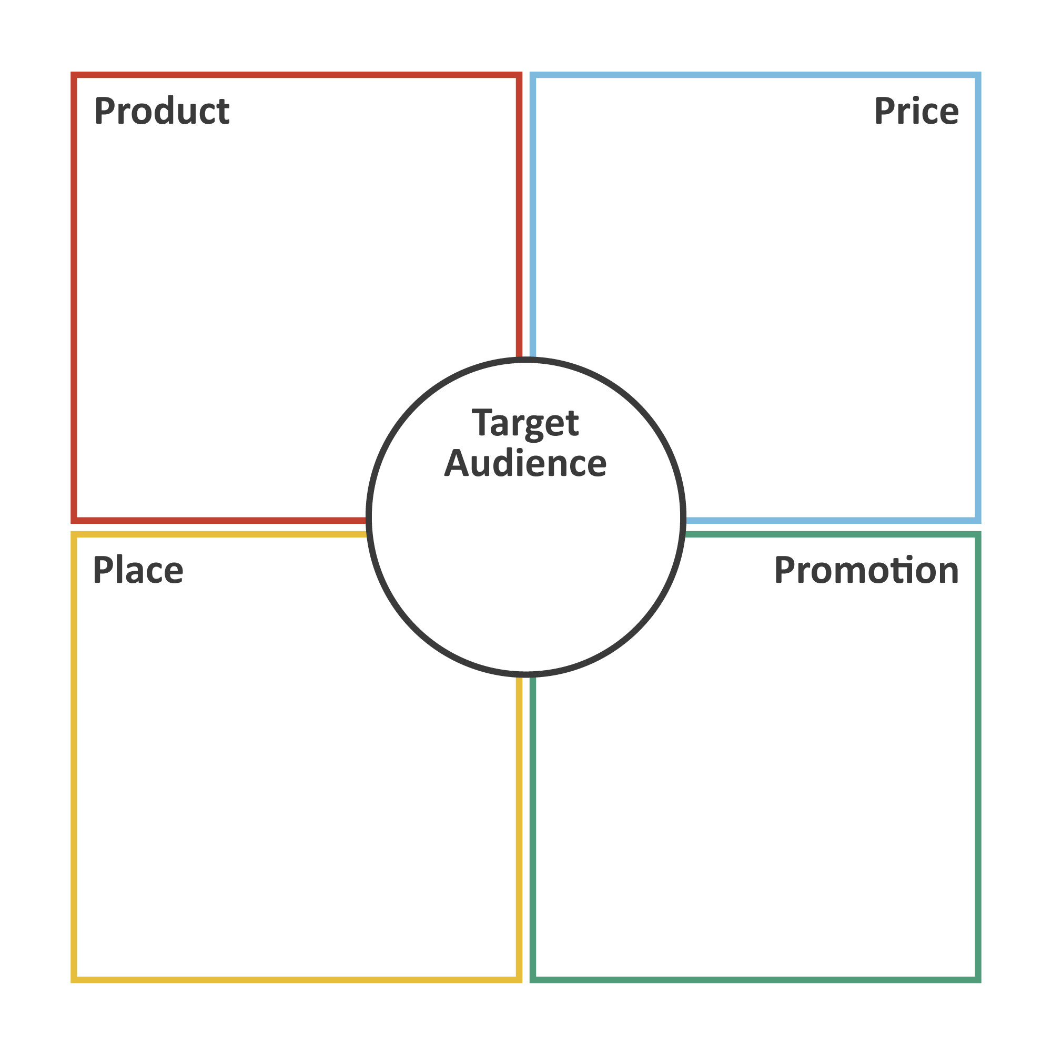

Activity 2: Pepsi versus Coke Case Study (The Cola Wars)

This activity showcases how different brands compete against one another. The Cola Wars ( Pepsi vs. Coke), has been a brand rivalry for many decades. You probably even have a preference for Pepsi or for Coke! There are many other brands that compete directly against one another. Think of Nike vs. Adidas, McDonald’s vs. Burger King, and Microsoft vs. Apple. Everyone has preferences about what they like and brands will market their products to show why their brand is superior to the others.

This activity will focus on the Cola Wars in the 1970’s. We can see the effects of this campaign war today as these brands still compete against one another.

Materials:
- Personal device
- Access to wifi/internet
- Reflection questions
- Pen or pencil

Instructions:
- Begin by watching a short video overviewing the Cola Wars here: https://tinyurl.com/PepsiVsCokeVideo
- Read about the 1975 Landmark Pepsi Challenge and the 1985 New Coke Failure in Response to Pepsi
- Answer the reflection questions

1975 Landmark Pepsi Challenge
In 1975 Pepsi launched a blind taste test marketing campaign for people to take a sip of two unknown sodas. Pepsi reported that during this “Take the Pepsi Challenge” campaign people preferred Pepsi over Coke. This led Coke to make a massive change.

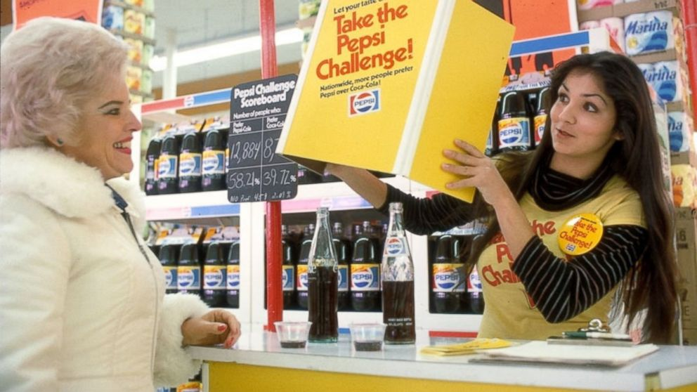
Kim, S. (2015, March 11). Pepsi Challenge Returns with a Bubbly Twist. Retrieved April 15, 2021, from https://abcnews.go.com/Business/pepsi-challenge-returns-bubbly-twist/story?id=29552172

1985 New Coke failure in response to Pepsi
In response to The Pepsi Challenge, Coke launched the “New coke” Campaign, now seen as a massive failure (www.coca-colacompany.com). The change in Coca-Cola’s recipe did not sit well with consumers. This failure led to Coke reverting their formula to its original recipe, creating Coke Classic.
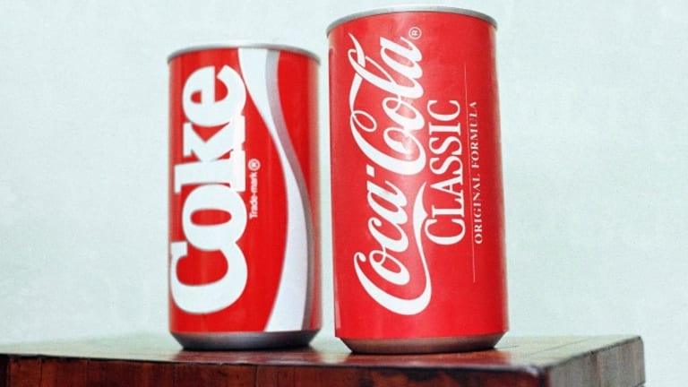
Klein, C. (2015, April 23). The new Coke Flop. Retrieved April 15, 2021, from https://www.history.com/news/why-coca-cola-new-coke-flopped
Reflections questions
Pepsi claims people liked Pepsi over Coke but, as the video explains, we know the added sweetness to Pepsi gave the effect that Pepsi tasted better. However, over the course of an entire can, people preferred Coke more. Below or on a separate sheet of paper answer the following questions.
- Was Pepsi’s campaign morally right? Was the campaign in good faith in your opinion?

- Did they mislead the public through their blind sip test? Why or why not?

- Even though Coke still had more market share over Pepsi, why do you think Coke felt they needed to change their formula to make New Coke?

Activity 3: Reworking A Controversial Marketing Campaign
It’s common for brands to work national holidays into their marketing campaigns. Sometimes these campaigns are hits and sometimes they are misses.

Materials:
- Personal device
- Access to wifi or internet
- Frayer Model Reflection Sheet
- Pen or pencil
Instructions:
- Read about the Burger King Foundation’s new scholarship opportunity and how their marketing campaign did quite have the impact they wanted.
- Act as if you are in charge of repromoting this scholarship fund. Take time to explore the foundations campaign page and think about new ways to promote the work.
- Complete the Frayer Model reflection.

During 2021’s International Women’s Day Burger King wanted to promote their foundation’s new scholarship. This scholarship was designed to help promote the culinary arts for women. According to the foundation’s website “women occupy only 24% of chef positions and less than 7% of head chef positions in the restaurant industry today” (Bkmclamorefoundation.org). Their mission states “since there aren’t enough women chefs in professional kitchens, we created the Burger King H.E.R. (Helping Equalize Restaurants) Scholarship to help BK® Team Members with a passion for food pursue a degree in culinary arts” (Bkmclamorefoundation.org).
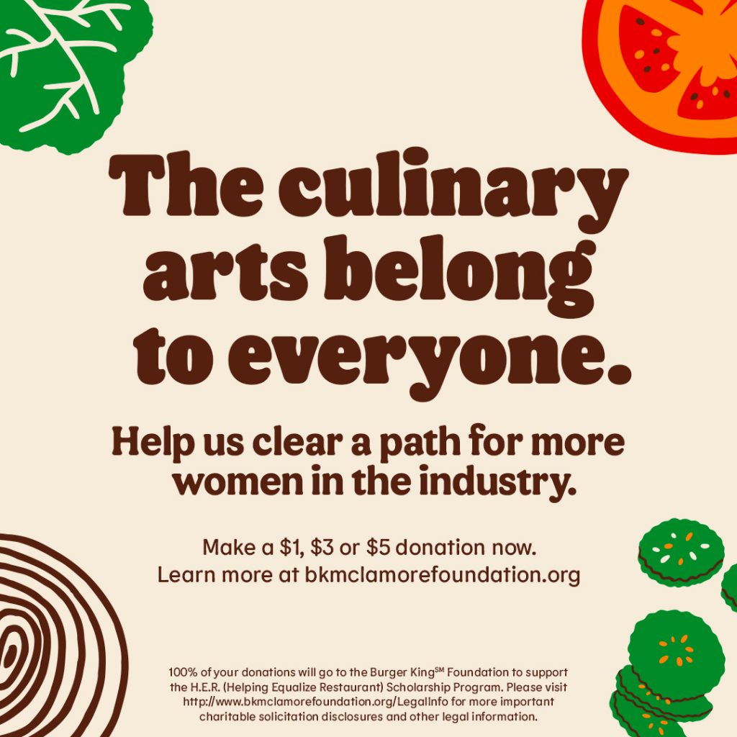
H.E.R. scholarships. (n.d.). Retrieved April 15, 2021, from https://bkmclamorefoundation.org/

Below is the marketing campaign Burger King released promoting their new scholarship during 2021’s International Women’s Day along with a tweet stating the same tagline.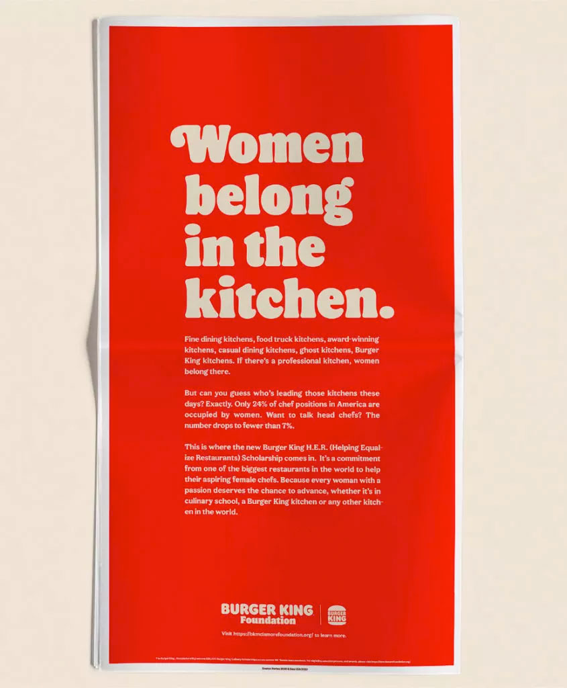
Burger King gets it all wrong FOR #IWD2021. (2021, March 09). Retrieved April 15, 2021, from https://wersm.com/burger-king-gets-it-all-wrong-for-international-womens-day/

After an uproar from the public, the campaign was halted and the original tweet was deleted. Below is an image of the tweet before it was taken down, along with follow up tweets explaining the scholarship and the inequality of women in chef positions.

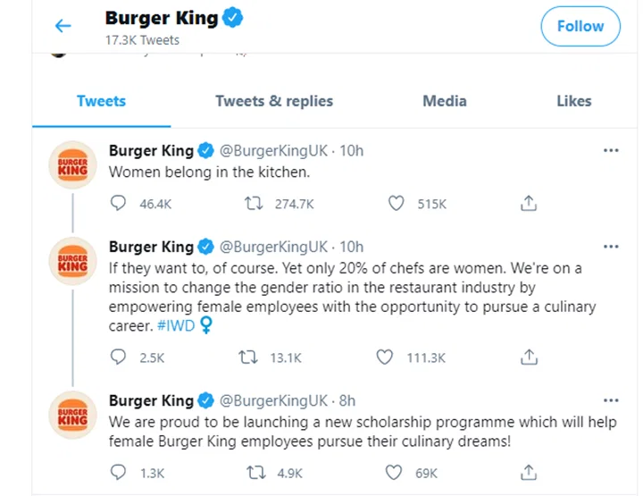
Elliott, J. K. (2021, March 09). Burger King gets grilled for 'WOMEN belong in the kitchen' tweet. Retrieved April 15, 2021, from https://globalnews.ca/news/7683800/burger-king-womens-day-kitchen-tweet/

Rework This Campaign
Act as if you are in charge of repromoting this scholarship fund. What would you do differently? How would you promote the inequity of women in the culinary arts? Which media platforms would you use and how would you rewrite the tag line? Explore Burger King Foundation’s website for details about this campaign here: https://tinyurl.com/BKFoundation.

Frayer Model Reflection

Now that you have explored aspects of the Marketing career cluster use the Frayer Model chart below to reflect on the following questions.
- Definition: Explain the definition of Marketing in your own words.
- Characteristics: What are the characteristics that one should have to be successful in a marketing career?
- Examples: What are some examples of good marketing campaigns that you have seen? These can be seen on TV, internet ads, or print campaigns.
- Non-examples: What are some examples of bad marketing campaigns that you have seen? These can be seen on TV, internet ads, or print campaigns.
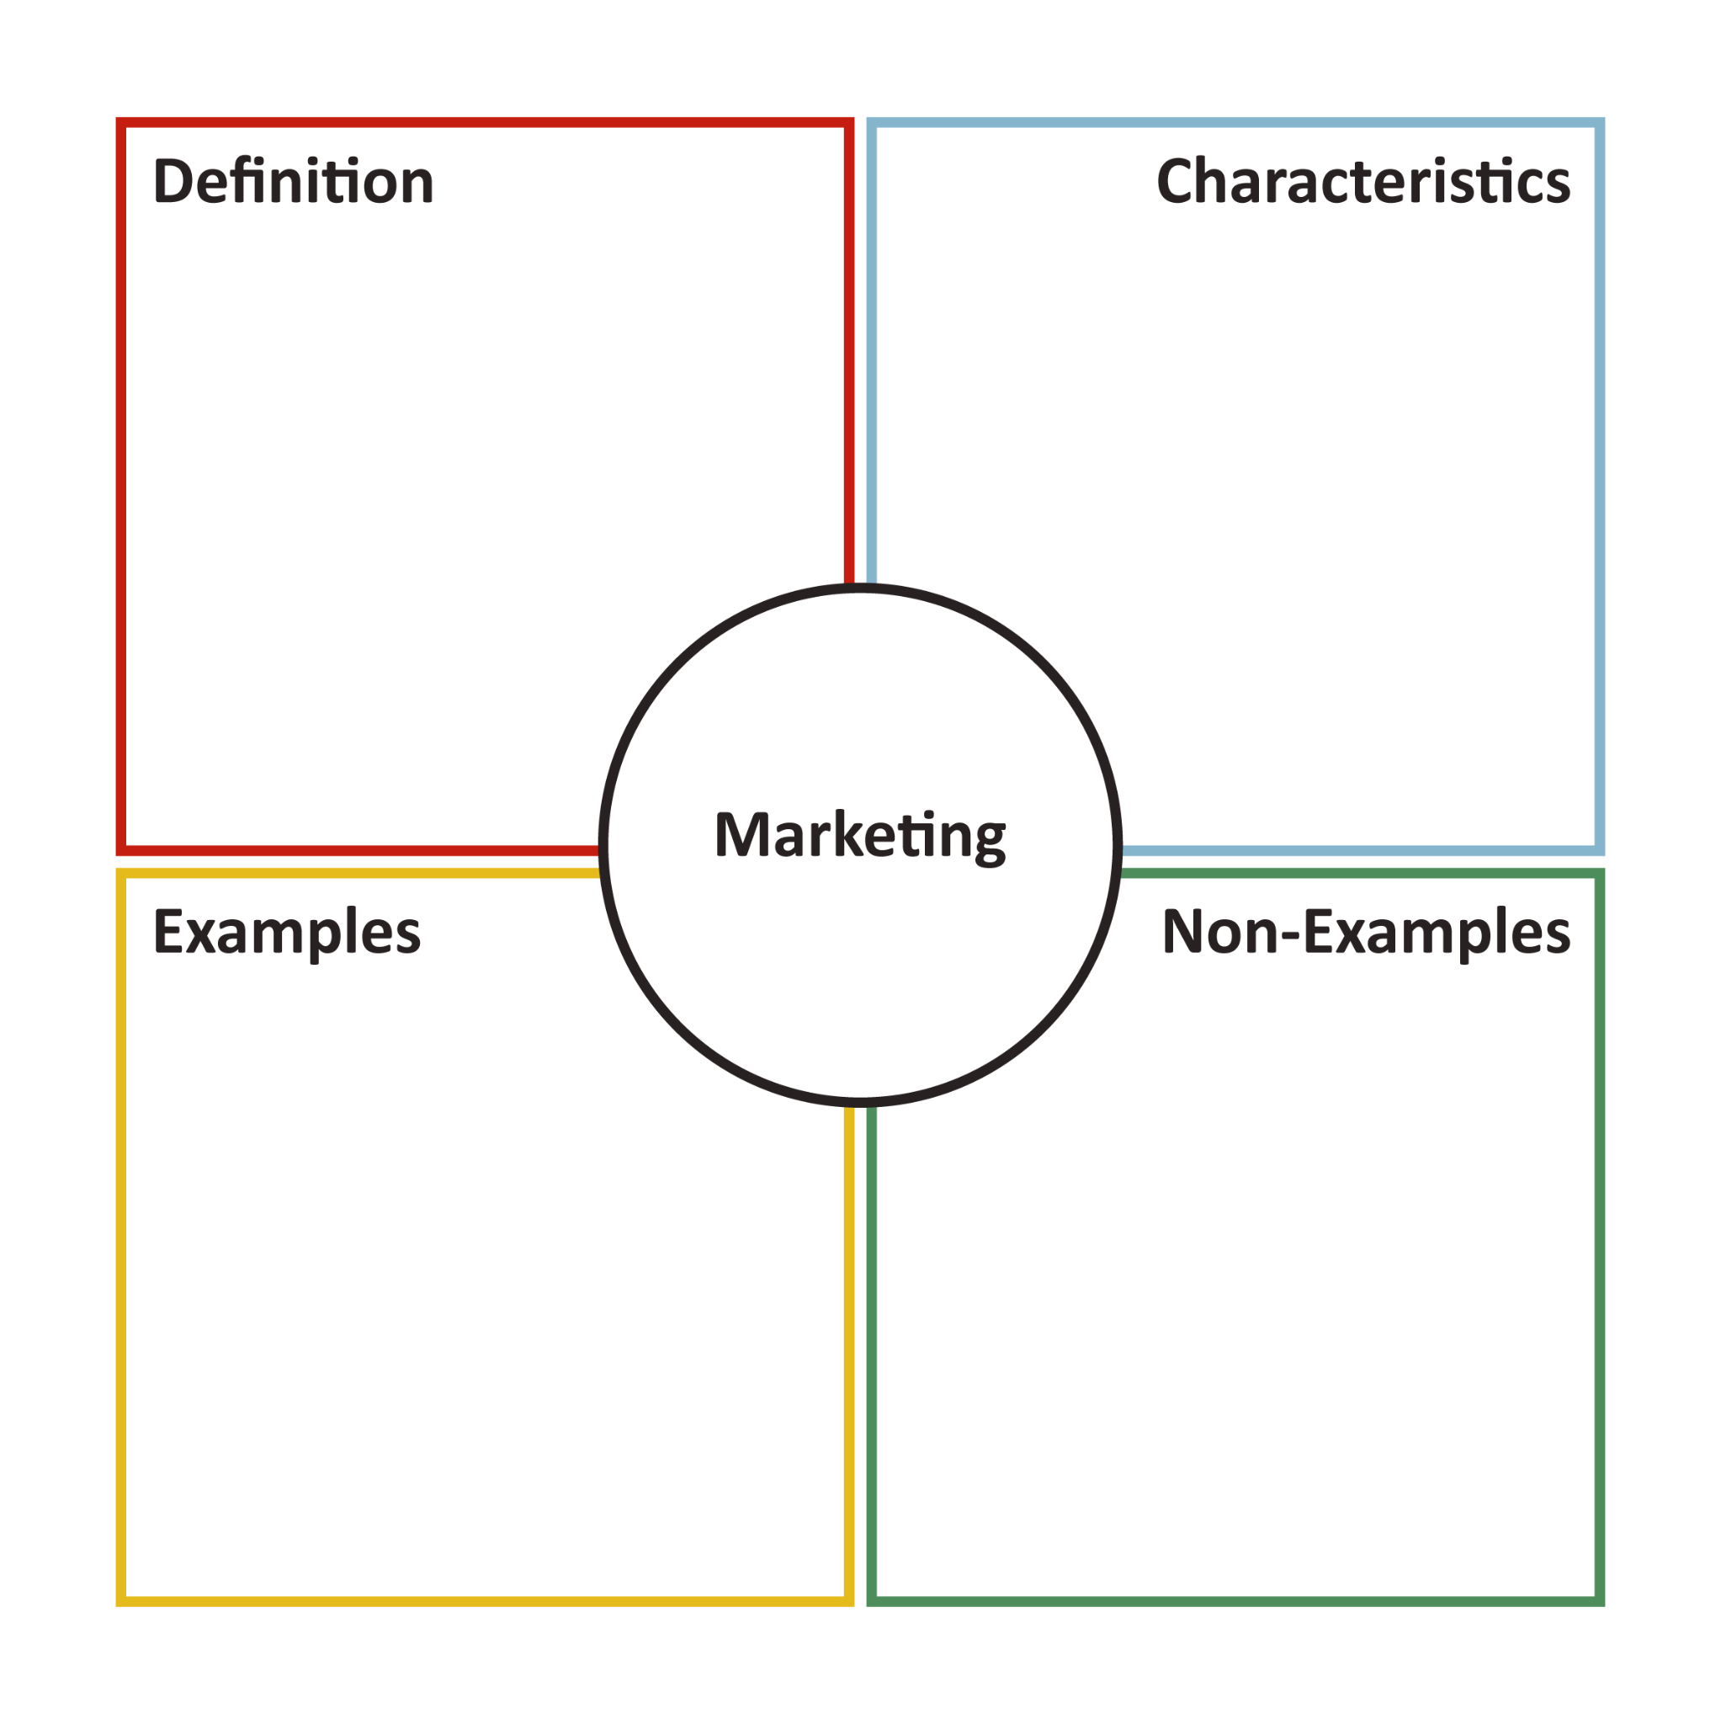
Extend
Want to learn more about Marketing careers? Explore different career options using My Next Move: https://tinyurl.com/MNMMarketing to learn the skills and degrees required to begin your career.

Check out the American Marketing Association’s Website (ama.org) to read about marketing news and learn more about marketing groups.

If you want to take a deeper dive into the Cola Wars watch this 15-minute documentary that takes a deeper dive into the history of the Cola Wars: https://tinyurl.com/ColaWarsDocumentary. In this video marketing experts weigh in on Coke and Pepsi campaigns and the reasons they did or did not work.

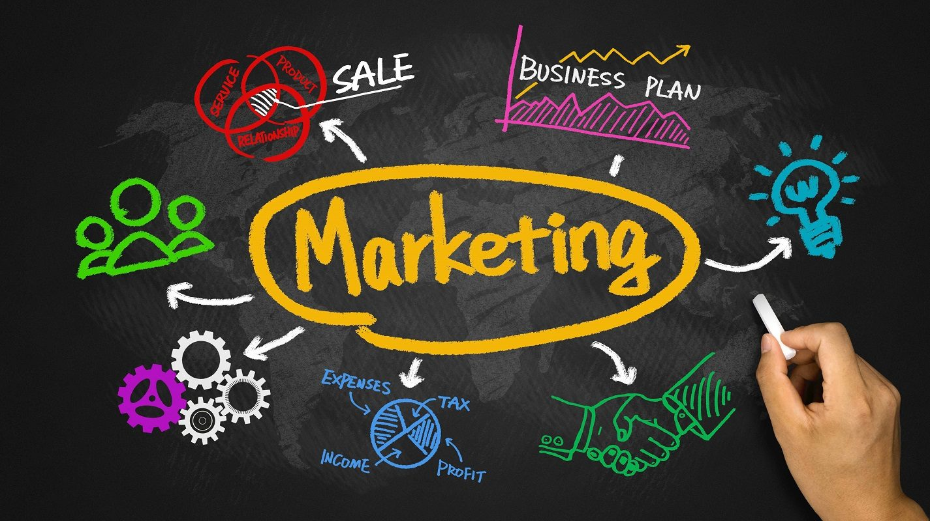
Team, E. (2020, August 21). Five steps to reach your most important marketing audience - Your CFO. Retrieved April 15, 2021, from https://www.1point21gws.com/insights/marketing/five-steps-to-reach-your-most-important-marketing-audience-your-cfo/

Sources
All of the sources that were linked throughout the activity are listed below. Providing a list of sources allows us to give credit for the work someone else made.

Burger King Gets It All Wrong For International Women's Day. WeRSM - We Are Social Media. https://wersm.com/burger-king-gets-it-all-wrong-fo r-international-womens-day/
Burger King Foundation – Creating Brighter Futures. (n.d.). Retrieved June 28, 2021 from https://bkmclamorefoundation.org/
H.E.R. (Helping Equalize Restaurants) Scholarship – Burger King Foundation. (n.d.). Retrieved June 28, 2021 from https://bkmclamorefoundation.org/who-we-are/progra ms/education/her-scholarships/
Elliott., J. (2021). Burger King gets grilled for ‘women belong in the kitchen’ tweet - National | Globalnews.ca. Global News. https://globalnews.ca/news/7683800/burger-king-wom ens-day-kitchen-tweet/
GenGlobal17 (Director). (2020, January 08). Why more people Choose Pepsi OVER Coke: In The Pepsi Challenge [Video file]. Retrieved April 15, 2021, from https://globalnews.ca/news/7683800/burger-king-wom ens-day-kitchen-tweet/
Klein, C. (2015). Why Coca-Cola's 'New Coke' Flopped - HISTORY. HISTORY. https://www.history.com/news/why-coca-cola-new-cok e-flopped
News, A. (2015). Pepsi Challenge Returns With a Bubbly Twist - ABC News. ABC News. https://abcnews.go.com/Business/pepsi-challenge-re turns-bubbly-twist/story?id=29552172
Search results for "marketing" at My Next Move. (n.d.). Retrieved June 28, 2021 from https://www.mynextmove.org/find/search?s=marketing
Team, E. Five steps to reach your most important marketing audience - Your CFO | Insights. Insights. https://www.1point21gws.com/insights/marketing/fiv e-steps-to-reach-your-most-important-marketing-aud ience-your-cfo/
The Story of One of the Most Memorable Marketing Blunders Ever - News & Articles. (n.d.). The Coca-Cola Company. Retrieved June 28, 2021 from https://www.coca-colacompany.com/company/history/t he-story-of-one-of-the-most-memorable-marketing-bl unders-ever
VanityFairMagazine (Director). (2018, August 27). Marketing experts break down the Coke vs. PEPSI rivalry | Vanity Fair [Video file]. Retrieved April 15, 2021, from https://www.youtube.com/watch?v=Mo8pCkQWR00
What is marketing? - the definition of marketing - ama. (2020, December 03). Retrieved April 15, 2021, from https://www.ama.org/the-definition-of-marketing-what-is-marketing/

