ARTI-FACTS: OVERVIEW

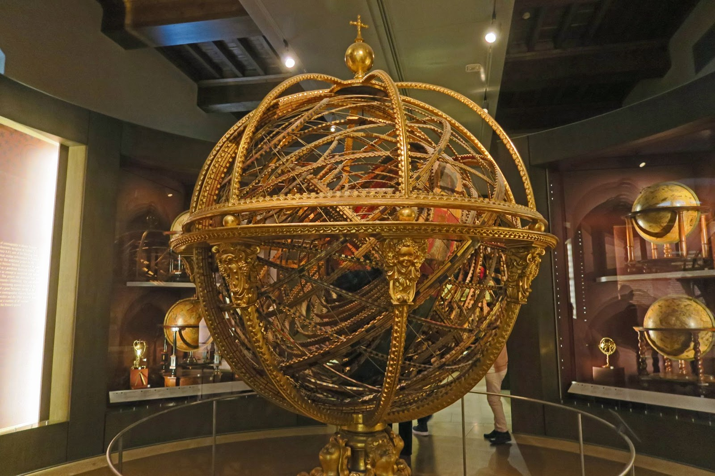
Kirk K. (2018, March 29). The Galileo Science Museum - Florence [Digital image]. Retrieved April 23, 2021, from https://www.flickr.com/photos/mmm-yoso/27310940997

Have you ever walked through a museum and wondered, “How did this stuff get here?” The world has so much art and so many artifacts, who decides how much of it goes into the museum? Who decides which items are on display, and what is on the little cards by each exhibit? Museum curators are the people who help to decide what items you see when you walk into a museum and what you will learn. It sounds like they have a lot of power, but it is a lot of work too. The following activities will give you a chance to see a little bit of what life is like as a museum curator and educator. If you are the kind of person who is curious about your world and likes to share the things you learn with others, this may be the job for you!

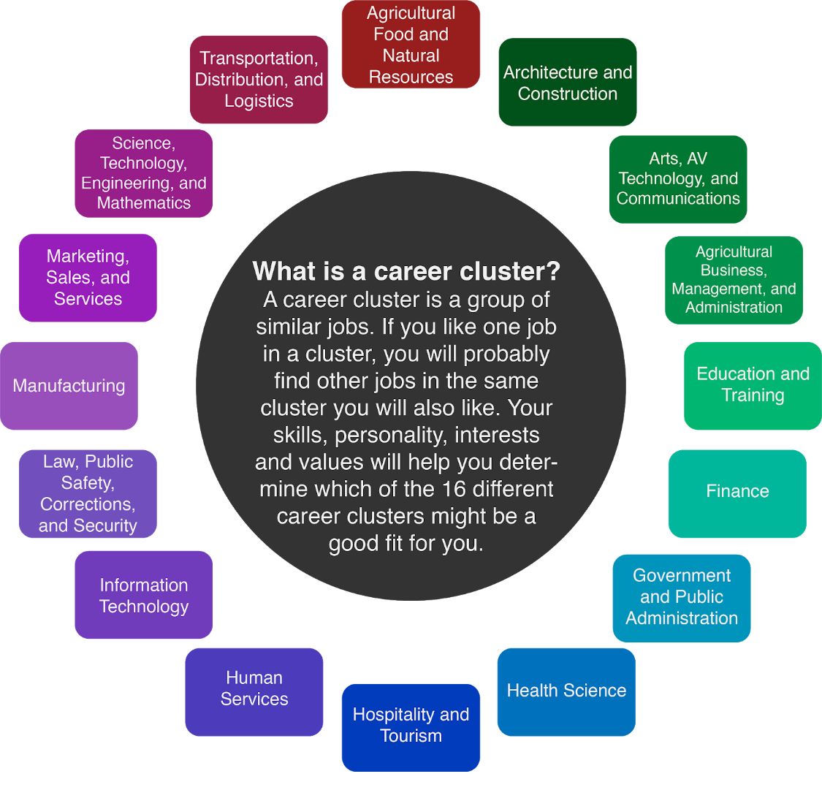

Museum curators and others who work within the museum field fall under the Education and Arts career clusters depending on the roles and responsibilities of their jobs. Some of these include planning and organizing collections that will be on display, selecting and designing themes of the exhibits, and planning and conducting instructional, research, and activities that people can come and experience. These roles and responsibilities can vary greatly because they cover a variety of information. This information can be categorized into one of five basic types of museums, general, natural history and natural science, science and technology, history, and art.
As a museum outreach or education coordinator, you would get the opportunity to select exhibits within your museum to teach students about when they come to visit your museum. These students can range from preschool age all the way up to college students which can make your day-to-day activities very interesting! Some skills you will need to have in order to be successful at this job are:

- Verbal
  - Communicate clearly through speaking
  - Listen and understand what people are saying
  - Listening without interrupting
  - Asking good questions
- Social
  - Understanding people's reactions
  - Looking for ways to help people
- Organized
- Decisive
- Problem Solver
- Research
Before you can become a museum outreach or education coordinator you will first need to complete at least a bachelor’s degree, but a master’s is preferred. Having basic knowledge in the following areas will really help as you navigate your day-to-day job:
- Arts and Humanities (culture)
- English language
- History
- Archeology - the study of human history and prehistory through the excavation of sites and the analysis of artifacts and other physical remains.
- Math and Science
- Sociology - the study of the development, structure, and functioning of human society.
- Anthropology - the study of human societies and cultures and their development.
- Geography
The salary for a museum outreach or education coordinator will vary greatly depending on where you go, but the average is around $55,000 a year.

Materials Needed for this Student Activity
- Computer or tablet
- Internet access
- Bento Box Template (handout)
- Concept Mapping Cards
- Museum Choice Board (handout)
- Types of Museums article (handout)
- Arti-Fact Overview (handout)
- Scissors
- Pencil or pen

Instructions
- Tour a virtual museum. Get an idea of what different museums are like and which ones you think are the most interesting. Once you have completed your virtual tour you will design a Bento Box to share what you have learned and found most interesting about your favorite museum.
- Design your own exhibit. Pick which artifacts you would include in your museum. Think about how they go together. What sort of museum do they belong in?
- Find out what it is like to work and teach in a museum. Learn about how museums work to bring history to life. Use your artifacts to tell a story.

