CONCEPT CARD MAPPING
ACTIVITY 2: ARTIFACT CARDS
In this activity you will be the curator of your own museum. You will use the artifact cards on this handout to design your own exhibit. The exhibit only has room for 5 pieces, but you have 10 artifact cards. It is your job to select 5 cards that are grouped in a way that will make sense and interest the visitors of your museum. After you have selected your cards, create a script that your museum tour guides could use to show off your exhibit to guests.
Materials
- Artifact Cards
- Scissors
- Pencil or pen

Instructions
- Cut out the artifact cards.
- Select which 5 cards you would put together in a museum exhibit.
- Use the space on the following page to write out a script for your museum tour guides so that they can share your exhibit with guests.

Tour Guide Script

Busójárás Mask
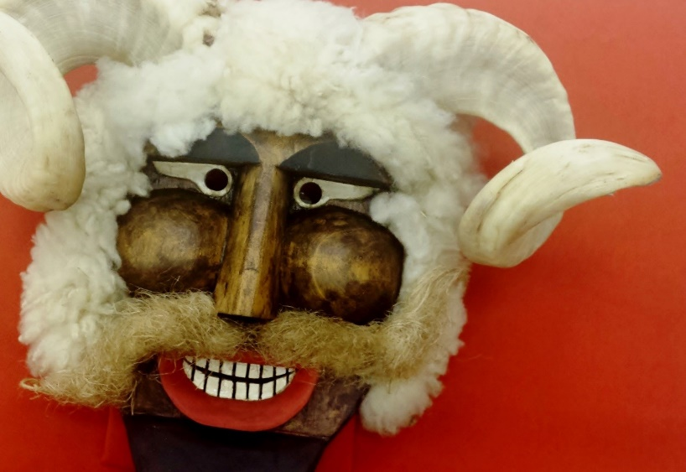
da Imigracao de São Paulo, Museu. (2015, February 1). Mascara busó. [image]. Wikimedia Commons. https://commons.wikimedia.org/wiki/File:Mascara_bus%C3%B3.jpg
Description
Region: Hungary, Europe; Date: 1950-1960; Materials: wood; Use: To celebrate winter/frighten away winter
Source: Museum of Cultural Masks. (2017-2018). Busójárás Mask. Second Face. https://www.maskmuseum.org/mask/busojaras-1/

Barong Macan
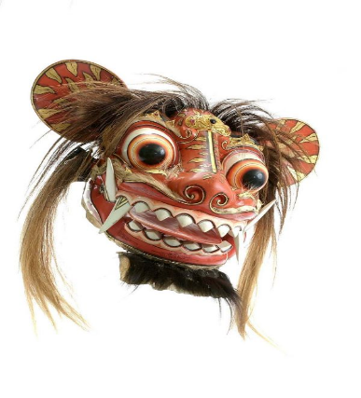
Juala, Nyoman. (1992). COLLECTIE TROPENMUSEUM Houten masker voorstellende Barong Macan TMnr 5572-32. [image]. Wikimedia Commons. https://commons.wikimedia.org/wiki/File:COLLECTIE_TROPENMUSEUM_Houten_masker_voorstellende_Barong_Macan_TMnr_5572-32.jpg
Description
Region: Indonesia, Asia; Date: 1992; Materials: wood; Use: To recreate a contest between good and evil
Second Face: Museum of Cultural Masks. (2017-2018). Barong Macan. Second Face. https://www.maskmuseum.org/mask/bali-barong-macan/

Makonde Lipiko Mask
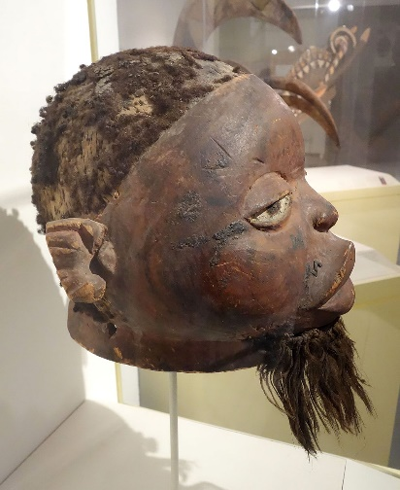
Daderot. (2013, October 30). Lipiko Mask, view 1 - Makonde people, Cabo Delgado province, Mozambique, 19th century, wood, human hair, fiber, pigment - Brooklyn Museum - Brooklyn, NY - DSC08578. [image]. Wikimedia Commons. https://commons.wikimedia.org/wiki/File:Lipiko_Mask,_view_1_-_Makonde_people,_Cabo_Delgado_province,_Mozambique,_19th_century,_wood,_human_hair,_fiber,_pigment_-_Brooklyn_Museum_-_Brooklyn,_NY_-_DSC08578.JPG
Description
Region: Mozambique, Africa; Date: 1800s; Materials: wood; Use: Channels the spirits of dead ancestors during ceremonial dances
Second Face: Museum of Cultural Masks. (2017-2018). Makonde Lipiko Mask. Second Face. https://www.maskmuseum.org/mask/lipiko-1/

Kwakwaka’wakw Bear
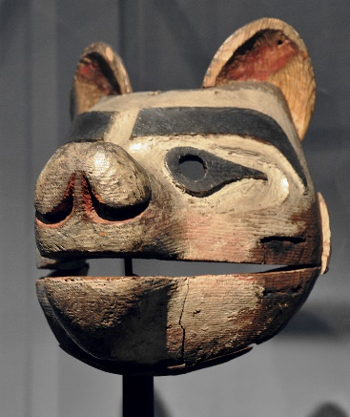
Praefcke, Andreas. (2011, August). Kwakiutl bear mask Museum Rietberg. [image]. Wikimedia Commons. https://commons.wikimedia.org/wiki/File:Kwakiutl_bear_mask_Museum_Rietberg.jpg
Description
Region: Canada, North America; Date: 1970s; Materials: wood; Use: Entertainment during a potlatch
Second Face: Museum of Cultural Masks. (2017-2018). Kwakwaka’wakw Bear. Second Face. https://www.maskmuseum.org/mask/kwakiutl-bear/

Viejita
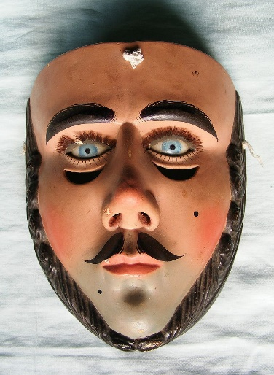
Molina, Luciano. (2010, August 18). Mascara de Parachico antigua. [image]. Wikimedia Commons. https://commons.wikimedia.org/wiki/File:Mascara_de_Parachico_antigua.JPG
Description
Region: Mexico, North America; Date: 2010; Materials: wood; Use: Dance celebrating village characters
Second Face: Museum of Cultural Masks. (2017-2018). Viejita. Second Face. https://www.maskmuseum.org/mask/guerrero-viejita-1/

Vejigante
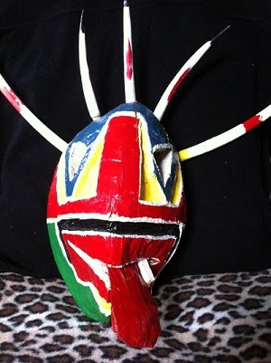
Y. (2012, July 30). Vejigante Mask from Loiza, Puerto Rico [Digital image]. Retrieved May 28, 2021, from https://commons.wikimedia.org/wiki/File:Vejigante_Mask_from_Loiza,_Puerto_Rico.jpg
Description
Region: Caribbean, Puerto Rico; Date: 2008; Materials: coconut husk, wood, and paint; Use: Carnival; Fiesta de Santiago el Apostól
Second Face: Museum of Cultural Masks. (2017-2018). Vijigante. Second Face. https://www.maskmuseum.org/mask/vejigante-loiza-1/

Abuelo Mask
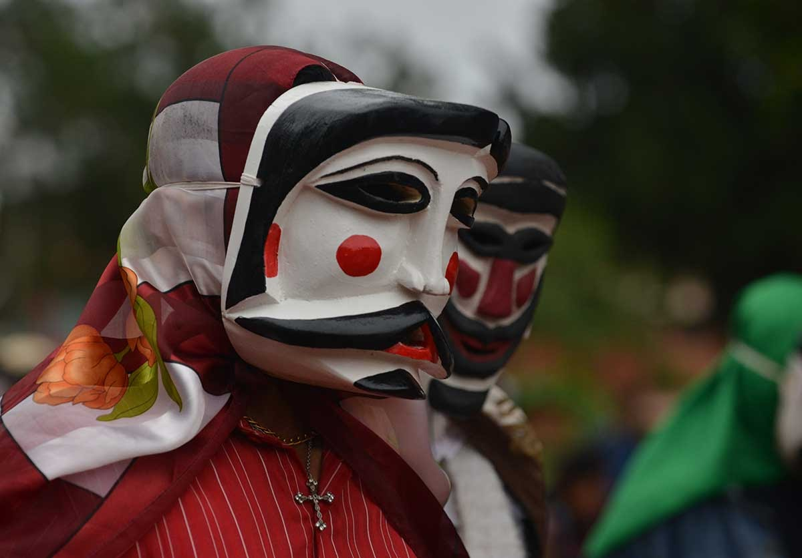
Leogomezr. (2014, February 21). La tradición de los abuelos en Santiago de Chiquitos [Digital image]. Retrieved May 28, 2021, from https://commons.wikimedia.org/wiki/File:La_tradici%C3%B3n_de_los_abuelos_en_Santiago_de_Chiquitos.jpg
Description
Region: Latin America, Bolivia Date: 2015; Materials: wood, and paint; Use: Carnival; Danza de los Abuelos
Second Face: Museum of Cultural Masks. (2017-2018). Abuelo mask. Second Face. https://www.maskmuseum.org/mask/bolivia-abuelo-1/

Bugaku Mask
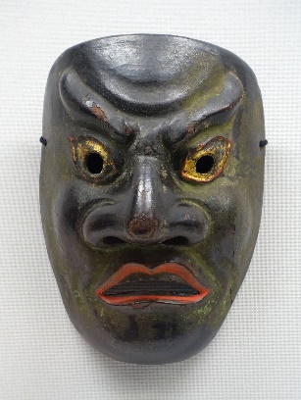
Daderot. (2017). Kitoku Bugaku Mask. https://commons.wikimedia.org/wiki/File:Kitoku_bugaku_mask,_lent_by_Masumida_Jinja,_Aichi,_Japan,_Kamakura_period,_dated_1211_AD,_wood_with_polychromy_-_Tokyo_National_Museum_-_Tokyo,_Japan_-_DSC09022.jpg.
Description
Region: Asia, Japan Date: 1211 AD; Materials: hinoki (Japanese cypress) wood, plaster, and water-based paint; Use: Bugaku official court dance
Second Face: Museum of Cultural Masks. (2017-2018). Bugaku sanju mask. Second Face. https://www.maskmuseum.org/mask/japan-sanju-1/

Yaqui Pasko’ola Mask
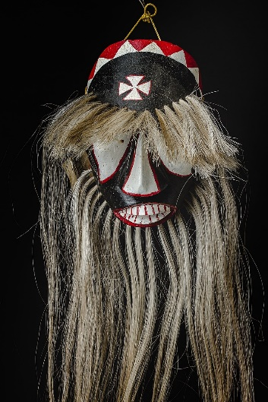
Yanes, A. (2017). Mascara de pascola yaqui. https://commons.wikimedia.org/wiki/File:Mascara_de_pascola_yaqui.jpg.
Description
Region: Latin America, Mexico Date: 1960-1970’s; Materials: cottonwood, paint, string, and horse hair; Use: celebration; entertainment; funeral; protection
Second Face: Museum of Cultural Masks. (2017-2018). Yaqui pasko’ola mask. Second Face. https://www.maskmuseum.org/mask/yaqui-pascola-2/

Kwele Antelope
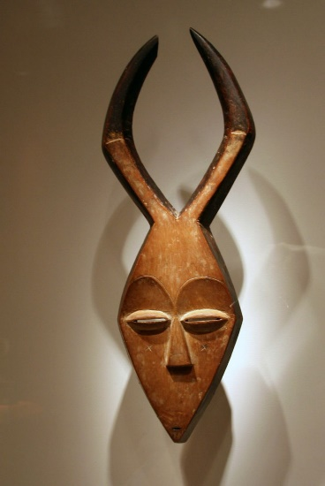
Cliff. (2008, September 21). Kwele mask-Gabon. [image]. Wikimedia Commons. https://commons.wikimedia.org/wiki/File:Kwele_mask-Gabon.jpg
Description
Region: Gabon, Africa; Date: 1990s; Materials: wood; Use: Adult initiation, funerals, protection from spirits
Second Face: Museum of Cultural Masks. (2017-2018). Kwele Antelope. Second Face. https://www.maskmuseum.org/mask/kwele-antelope-1/

